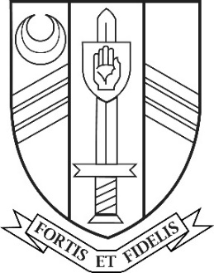

Job Vacancy

Modern Foreign Languages Teacher
(German with French) (0.4)

Main Scale

Sir John Nelthorpe School is a successful and popular 11-19 mixed comprehensive school with a rapidly growing roll (currently 748 students). It has a caring ethos and a long tradition of academic attainment.

We are seeking to appoint a dynamic, enthusiastic and well-qualified teacher who will join a successful and supportive faculty to teach Modern Foreign Languages (predominantly German but also some French) across Key Stages 3, 4 and 5 on a 0.4 fte timetable from September 2021 initially on a 12-month fixed term contract from September 2021 (an earlier start date may be available to the right candidate)

The post is suitable for experienced as well as newly and recently qualified teachers, including those who will have completed their training by September 1st 2021, with excellent induction programmes available at all levels.

If you have the range of skills and experience required for this post we look forward to receiving your application by post or by email to admin@nelthorpe.org.uk by 9:00am on Monday 7th May 2021.

Sir John Nelthorpe School is committed to safeguarding and promoting the welfare of children and young people and expects all staff and volunteers to share this commitment. The successful candidate will be subject to an enhanced DBS check and supportive references.

