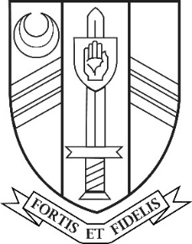

Job Vacancy

0.8 History Teacher
Maternity Cover – Initially fixed term from September 2021 to April 2022

Main Scale

Sir John Nelthorpe School is a successful and popular 11-19 mixed comprehensive school with a rapidly growing roll (currently 748 students). It has a caring ethos and a long tradition of academic attainment.

We are looking to appoint a History Teacher to teach across key stages 3 & 4 initially to cover maternity leave on a 0.8 timetable from 1st September 2021 to April 2022.

The post is suitable for newly and recently qualified teachers with an excellent induction and CPD programme available at all levels.

Amongst other things we are looking for someone who is dynamic, pro-active, engaging and who has the ability to work independently or as part of a team. If you have the range of skills and experience required for this post we look forward to receiving your application by post or by email to admin@nelthorpe.org.uk by
9:00am on Friday 7th May 2021.

Sir John Nelthorpe School is committed to safeguarding and promoting the welfare of children and young people and expects all staff and volunteers to share this commitment. The successful candidate will be subject to an enhanced DBS check and supportive references.

Further details and an application form can be found on the school Website www.sirjohnnelthorpe.org.uk

