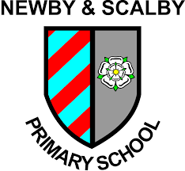

Working to Learn Together

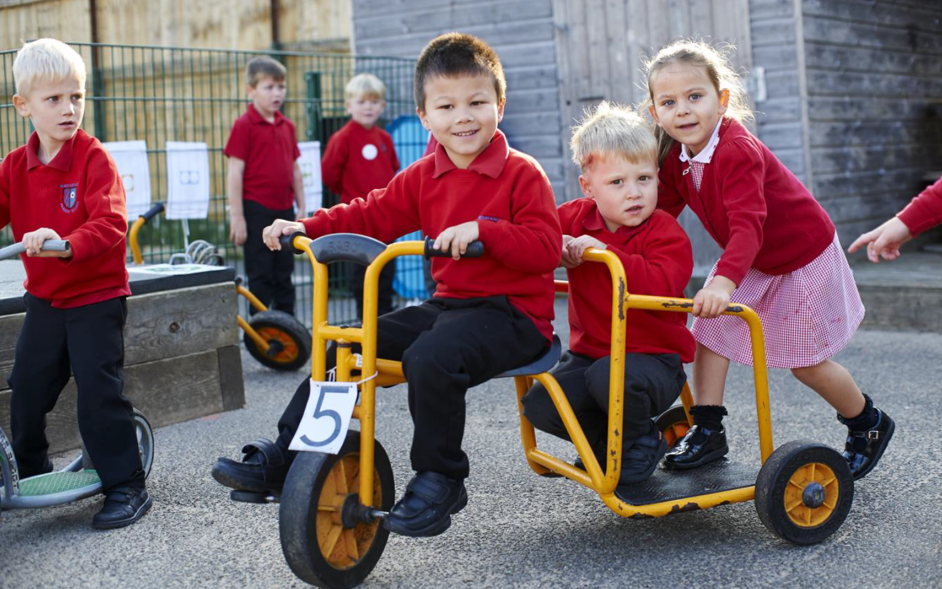

Class Teacher 1.0 FTE – Fixed Term until July 2022
Required January 2022
Recruitment Information Pack
Newby & Scalby Primary School
The Green, Scarborough, YO12 5JA

Contents

Welcome from the Headteacher 3
Our staff 4
Our schools 5
Application process and how to apply 6
Job Description and Person Specification 7-9

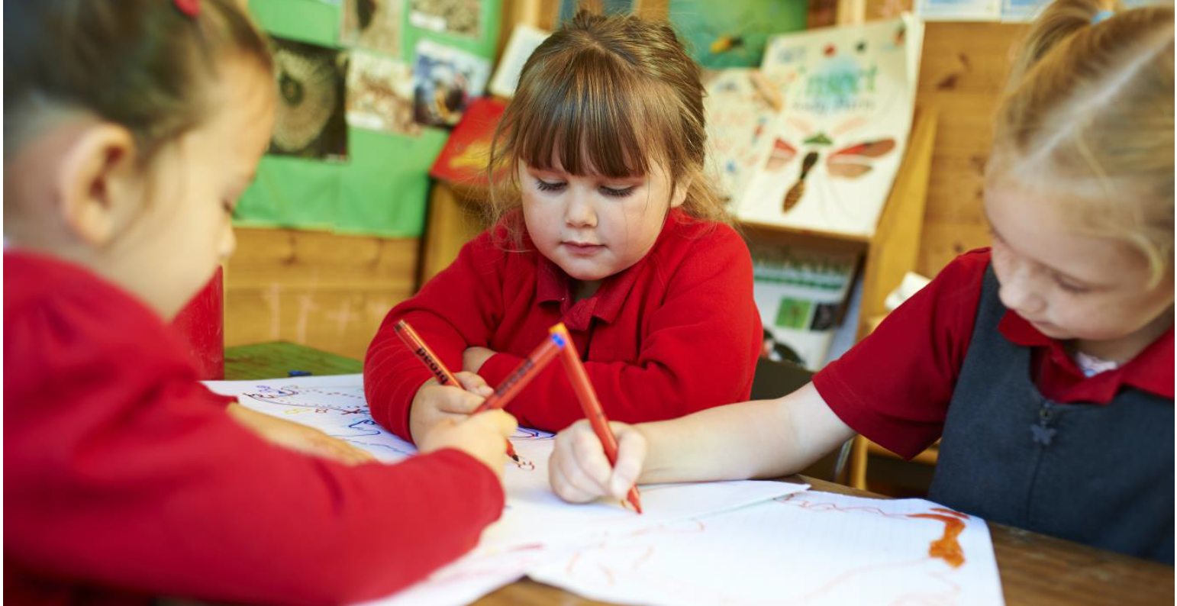

Dear applicant,

Allow me to extend a warm welcome from all governors, staff and children of Newby & Scalby Primary School. I am delighted you have shown interest in joining us and I look forward to sharing with you what makes our school a very special place to work.

Our children are delightful, happy, confident and energetic. They are passionate about their learning, be it in the classroom or through other areas of our developed curriculum such as dance, art, PE and music.

Over many years together we have built a learning community that puts the whole child and their development, along with harnessing the skills of our staff at our very heart. You will be joining a school with low staff turnover and high staff retention and as Headteacher it is my job to make sure colleagues are supported and challenged to be lifelong learners.

Working at Newby &Scalby is incredibly rewarding. Due to our well-deserved reputation across the area we place huge importance on developing talent – and in many ways our ‘research school’ ethos has resulted in many staff being developed as a support professional. I still get an incredible buzz from seeing our children reach their full potential through our staff training and development focus.

This is an exciting time to join us. As the founding primary member of the Coast and Vale Learning Trust (along with Scalby School) our team are working in partnership with our sister school Friarage Primary to share, learn and create a primary hub our area can be proud of. Through our Trust we are able to access the support and resources from our Teaching School, which means as a staff member you have a wide range of colleagues, tools and resources to help you develop not just in the classroom but beyond.

I hope that you will take the time to come and see and experience for yourself the warm and welcoming atmosphere which makes our vision a reality.

Good luck with your application. I look forward to reading it.

Chris Kirkham- Knowles
Headteacher

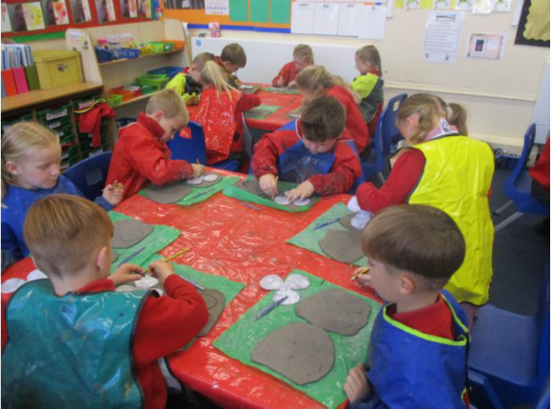
Our staff
Maddie Blakeley is an Early Career Teacher at Newby and Scalby Primary School in Scarborough. She has worked at the school since June 2017.
What do you enjoy most about your job?
I don't think there is any job that can be as varied as teaching is. You can't beat working with children: getting to know them as people; sharing their hopes and aspirations for the future; celebrating their successes and watching them finally get something they have been struggling with. That is when you truly know you have made a difference. Finding a school where this ethos is shared and where children are the driving force is what I have managed to do and I work alongside an incredible group of dedicated people that share that same goal. Not only have I found a group of work colleagues but also a group of friends that support me and make me laugh often.
What’s the best thing about the community that your school serves?
The community plays a large role in our teaching and learning and is a lovely area to work. We are lucky to work so closely with many services. Whether it be borrowing a book from the local library, visiting the local church for a tour of the war memorial or sharing harvest gifts with local residents, we gain a lot from this. Having open days and workshops means people are welcome to see how the school runs and how their children are getting on. It is a great way to get to know the school and teachers.
What would you say to a teacher thinking about moving to a school on the Yorkshire Coast?
I don't think you can beat working on the coast. Personally, I was brought up in Scarborough but after going to university in Lincoln and working in city schools and village schools I always knew that the coast would be where I ended up. Having the beach on your doorstep is ideal and I'm sure some of our children would agree, especially our Year 6s who have spent an afternoon surfing in the past with trained lifeguards. Trips to the beach and the local parks all add to the different experiences that children in our school are exposed to. We have a bit of everything that is only a walk or short drive away.

Our schools

Newby and Scalby Primary School

We are one of the schools of choice in our community and we are within commutable distance of Whitby, Teeside, York and surrounding areas. Ofsted in 2018 judged us to be ‘good’ in all areas and as a school we are very much outward facing both in terms of teaching and learning and in constantly thinking about how we can improve.
Since our “good” Ofsted, we continue to build on our successes and we are a family and a team, where everyone is given the challenge and support to be the best they can possible be in a safe, welcoming and positive environment. Children and staff will work and play together developing skills so that we all become ambitious and reflective lifelong learners as well as being respectful and respected members of the community.
To learn more about us please visit us at https://www.newbyandscalby.coastandvale.academy
Friarage Primary School

We are proud to serve the communities around the Castle Ward area of Scarborough as ‘Together we can’ make a real difference to the life chances of children and young people in Scarborough.

Children and staff will work and play together developing skills so that we all become ambitious and reflective lifelong learners as well as being respectful and respected members of the community.
We are committed to Restorative Practice Principles to nurture respect for all in our school community.

To learn more about us please visit us at https://www.friarage.coastandvale.academy

Scalby School

Scalby School is a successful and popular 11-16 community school and in recent years we have become the school of choice in our local community. We were judged ‘good’ by Ofsted in 2019 and in 2019 we celebrated sustained results. Our provisional P8 score has placed us in the top 20% of schools nationally. We are proud of our broad and balanced GCSE based curriculum.
To learn more about us please visit us at https://www.scalby.coastandvale.academy

Application Process
The closing date for all applications is 9am on Monday 6th December 2021

Interviews will be held on Friday 10th December 2021

Completed applications must be returned to Garry Morrison at garry.morrison@northyorks.gov.uk

If you do not receive confirmation of receipt of your application within one working day please call Garry on 07814935700

If you think you’re the person for the job, please complete the enclosed application form having looked at the job description and person specification.

An email will be sent to shortlisted candidates with details of the interview process. If you have not heard from us within a week of the closing date please assume your application has been unsuccessful.

Queries

We actively welcome you to contact Garry at North Yorkshire County Council to chat through the role and talk informally about the school/post and how working here will make a real difference to the children and young people on the coast.

Job Description

JOB TITLE: Teacher – 1.0 FTE
GRADE: MPS (M1-M6)
RESPONSIBLE TO: Senior Leadership Team

RESPONSIBLE FOR: Deployment of support staff and volunteer helpers allocated

JOB PURPOSE: Promote effective learning, appropriate achievement and educational, social and personal progress of all pupils for whom the teacher is designated as being responsible, consistent with the aims of the school and the unique needs of each individual. Take responsibility for promoting and safeguarding the welfare of children and young people within the school.

KEY RESPONSIBILITIES:

1. Develop and maintain an up-to-date knowledge and understanding of the areas of teaching and pupil support for which the post-holder is responsible

In line with school policies:

2. Plan work to meet the learning needs of allocated pupils in a consistent and effective way

3. Use appropriate teaching and classroom management strategies to motivate pupils and enable each to progress

4. Monitor the progress of pupils for whom the post holder is responsible to set expectations and give constructive feedback

5. Maintain appropriate records to demonstrate progress made by pupils

6. Participate fully in professional development activities to develop practice further, sharing the learning from these as appropriate

7. Make an active contribution to the policies and aspirations of the school

To fulfil all of the requirements and duties set out in the current Pay and Conditions Documents relating to the conditions of employment of teachers.

To fulfil all of the responsibilities and duties required by the School’s policies on teaching and learning.

To achieve any performance criteria or targets arising from the School’s Appraisal arrangements.

This job description will be reviewed annually.

Person Specification

Essential | Desirable | Assessment
A clear commitment to Safeguarding and promoting British Values |  | Application  Interview
Qualified Teacher Status | Education to degree level or beyond | Application  Reference
Able to take up the post at the beginning of January 2022 |  | Application
Recent experience in EYFS, Key Stage 1 and/or Key Stage 2 |  | Application
An ability to enthuse and engage learners |  | Application  Teaching Exercise  Interview
Positive references regarding classroom practice |  | Reference
In depth knowledge of the National Curriculum as relevant to the post | An ability to contribute to the delivery of music throughout school | Teaching Exercise  Interview  Teaching Exercise
Good standard of written and spoken English and numeracy |  | Teaching Exercise  Application  Interview  Skills Check
Excellent communication skills |  | Teaching Exercise  Application  Interview
Ability to utilise ICT to support effective teaching and learning | High level of knowledge of the use of ICT | Application  Interview
An understanding of the need for continuous professional development | A record of continuous professional development | Application  Interview
Highly effective classroom practice |  | Teaching Exercise  Reference  Interview
A clear philosophy of teaching and learning that reflects the school’s approach | Knowledge of Characteristics of Effective Learning | Application  Interview
Ability to assess pupils' progress and plan suitable activities based upon the findings |  | Teaching Exercise  Interview
Ability to evaluate their own teaching critically and use this to improve their effectiveness |  | Teaching Exercise  Interview
Ability to relate to and build relationships with pupils, parents and other members of the school community |  | Teaching Exercise  Application  Interview
Enthusiastic about teaching and learning |  | Teaching Exercise  Interview
A willingness to take part in all aspects of school life | Willing to contribute to sports or music extra-curricular programme | Application  Interview

We are committed to safeguarding and promoting the welfare of children and young people and expects all staff and volunteers to share this commitment.
This post is exempt from the Rehabilitation of Offenders Act 1974 and the appointment is subject to a satisfactory enhanced level disclosure and S128 clearance from the Disclosure & Barring Service (DBS).

