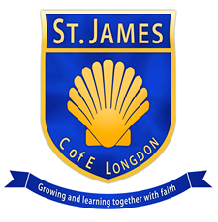
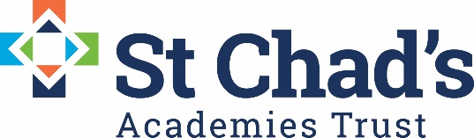

St James CE Primary Academy, Longdon, Rugeley, WS15 4PL
1:1 TA and additional needs lunchtime supervisor. 22.75 hours/week

Monday- 11am-3.20pm
Tuesday- 11am-3.20pm
Wedenesday 8.45am-3.20pm
Thursday- 11am-3.20pm
Friday- 11an-3.20pm

Salary: TA – Pro Rata FTE £18,198- £18,933 SCP 2-4.
This post will be Term Time only and a full time equivelent of 37 hours working week.

Contract: This is a fixed term contract for 12 months initially with a view to be extended. This post is dependent on EHCP funding being received by the school.

Start Date : 10/10/22

St James CE Primary Academy
Brook End, Longdon, Rugeley, Staffordshire, WS15 4PL

St James CE Primary Academy (part of St Chad's Academies Trust) is recruiting a caring and empathetic teaching assistant with experience working with primary aged children on the autistic spectrum to work with a pupil at this school who has diagnosis of autism and an EHCP.
The ideal candidate will have a proven track record in being able to effectively work with ASD children within a primary setting and demonstrate effective ways of working with pupils to raise their attainment and consistently increase their enthusiasm for learning.
We are looking for a teaching assistant who is:
- Qualified with a minimum of a level three childcare related qualification
- Experienced in working within an SEND setting, particularly ASD
- Resilient and able to overcome difficult situations
- Confident interacting with a wide range of personalities
- Able to work independently and confidently with children and young people of all ages
- Able to use their initiative and take on additional responsibilities as and when necessary
- A personable and caring individual who is committed to providing excellence to children in their Care.
We offer:
- Motivated, enthusiastic children with outstanding behaviour, who are eager to contribute, learn and are highly proud of their academy communities that live out their Christian values.
- Professional and dedicated colleagues
- A thorough and robust induction programme
- A welcoming environment
- Opportunities for training and professional development
- Supportive parents and Governors
- An academy with a clear vision for the future.
We welcome and encourage informal visits, so if you are interested in joining us please contact our school office on 01543 490378 to arrange an appointment. For further information and an application pack please contact office@st-james.staffs.sch.uk
Closing date for application: Midday Friday 30th September Short listing will take place shortly after. Interviews will be held week commencing Monday 3rd October.
The academy is committed to safeguarding and promoting the welfare of children and young people/ vulnerable adults and we expect all staff and volunteers to share this commitment.
The post is subject to an enhanced DBS disclosure check along with other relevant pre-employment checks.
St Chad's Academies Trust is committed and working towards equal opportunity in employment.

