12th February 2021

Dear Applicant,

- Class Teacher (MLD/SLD) Required: September 2021
- Class Teacher (Maternity) April/September 2021
(Post Threshold range considered for exceptional candidate)

Thank you for your interest in the above post; you will find the relevant information to assist you with your application in this pack.

Castlebar is an ‘Outstanding’ Special School for primary aged children and the lead school for the Ealing Primary Teaching School Alliance. We are very proud of our achievements, but more than anything we are very proud of the children we are privileged to work with.

We have two Class Teacher Posts available for April/September 2021 for an excellent Practitioner who wishes to join our fantastic team working with young children who have a range of complex learning difficulties including Autism, Global Delay, as well as some pupils who exhibit Challenging Behaviour.

Applications from mainstream and (Post Threshold range consider for an exceptional candidate)
teachers are welcome.

Please use the Person Specification as a plan for your letter of application. All statements of application must be typed and applications returned to Catherine Lambert via email: clambert@castlebar.ealing.sch.uk or call 0208 998 3135.

The closing date for applications is: Wednesday 18th March 2021
The Interview date is: Thursday 26th March 2021

We look forward to receiving your application; please do not hesitate to contact us if you require any assistance.

Visits to the school, are warmly welcomed by appointment through Catherine Lambert.

Yours sincerely

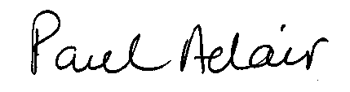

Paul Adair
Headteacher

