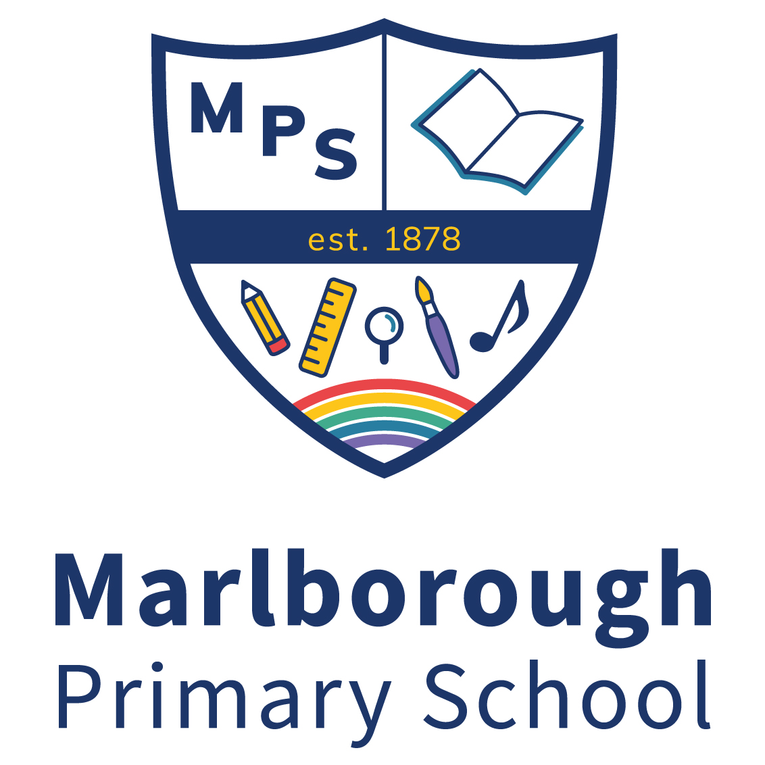

ECT CLASS TEACHERS
Full Time: M1-M6
SEPTEMBER 2024

Marlborough Primary School, is an ever improving, high performing school working towards achieving ‘outstanding’. We are committed to providing a broad, balanced and exciting educational experience for all our children in order to promote their full academic and social development.

We are seeking to appoint two Early Career Teachers to join our effective and able team who all benefit from support a quality CPD programme and individualised support. One teacher will join our EYFS Team in one of our Reception classes and the other will join our KS2 Team.

We have a diverse staff team and we continue to actively encourage and recruit candidates from underrepresented groups with protected characteristics.

Marlborough Primary School is federated with Colville Primary School which allows staff in both schools to benefit from the skills, expertise and colleagues are encouraged to share their good practise beyond the federation.

The post is initially temporary for 1 year, but could lead to a permanent position.

We are seeking to appoint a teacher who:
- is ambitious and energetic
- can ensure high quality provision
- is committed to ensuring achievement for all though equal access, opportunity and aspiration for all children
- has excellent interpersonal skills and qualities that motivate children

We can offer you:
- a state of the art school building with amazing facilities for learning
- a supportive, collegiate and motivated in-house team
- high quality CPD with opportunities for career progression
- enthusiastic, friendly children with a love of learning
- an inclusive school with a ‘can do’ ethos where success is expected
- strong and ambitious leadership with a clear sense of strategic direction
- an opportunity to innovate and take risks
- supportive parents and governors

Learn more about the school by visiting our website www.marlborough.rbkc.sch.uk or visiting our Instagram page @Marlborough.sw3

Please email janet.wallace@marlborough.rbkc.sch.uk for an application pack.

Closing date: Thursday, 28th March 2024 @ Noon
Interviews: After the Easter Break

We are committed to safeguarding and promoting the welfare of children. The successful candidate will undergo full DBS checks.

