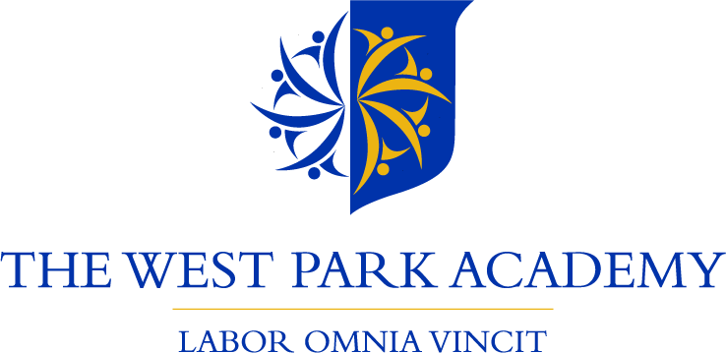

The FORGE Academy Trust Vision Statement:

Challenging educational orthodoxies so that every child makes good progress in core subjects;
all teachers are committed to personal improvement and fulfil their responsibilities;
all children receive a broad and balanced curriculum;
all academies strive to be outstanding.

2 x KS2 Class Teacher
Closing date: Friday 30th April 2021
Interview Date: Thursday 6th May 2021 (potentially Friday 7th May as an additional interview date depending on number of applications)
Type of vacancy: 1 Year initial (with prospect of becoming permanent)
Work pattern: Full Time from 1st September 2021
Location: The West Park Academy, Vernon Road, Kirkby-in-Ashfield, Nottinghamshire, NG17 8EE
Salary: Main Scale (We welcome applications from Newly Qualified Teachers)
Advert: We are looking for dedicated and ambitious Key Stage 2 practitioners to further strengthen our current teaching team. At The West Park Academy, we pride ourselves in promoting extremely high standards in all aspects of school life. Our ethos, and that of the The Forge Trust, is to encourage our children to be aspirational and maintain a work ethic that will help them achieve their future goals. As a result, we expect our staff to promote these values through their own practice.
The positions available are for teachers who possess the relentless drive and ambition to improve outcomes for children. The successful candidates will need to have:
- A commitment to helping all pupils achieve their best, regardless of their background or starting point;
- High expectations of behaviour and attitudes towards learning;
- A passion for teaching and learning;
In return, we can offer you:
- Class/group sizes of less than 20 children;
- A commitment to supporting your further development e.g. NPQML, NPQSL, Masters Degree;
- High quality CPD within The Forge Trust networks including a tailored programme for NQTs across the Trust
- An exciting opportunity to continue the transformation of The West Park Academy
About us: The FORGE Trust is a primary school led, multi-academy trust which was founded in September 2016 on the success of The Sir Donald Bailey Academy in Newark, Nottinghamshire.
There is a clear vision to provide the very best education for every pupil in our schools ensuring the quality of teaching is excellent and the environment for learning encourages all pupils to find their talent and succeed. We believe strongly in our mission to change the lives of these children and have the ambition to be the most successful multi-academy trust in the country!
The Trust specialises in working in communities which face disadvantage and challenge, and prides itself on having a transformational agenda to significantly impact on the life chances of children in the communities served by FORGE schools.
Visits to the school are warmly welcomed and encouraged. Please contact Mark Nunn - the Principal at The West Park Academy either by email: m.nunn@westparkacademy.co.uk or by telephone: 01623 460274 to arrange a mutually convenient appointment.
We are committed to safeguarding and promoting the welfare of children, young people and vulnerable adults and we expect all staff to share this commitment and undergo appropriate checks; therefore all posts within the trust are subject to an Enhanced Disclosure and Barring Check.
The trust welcomes applications from all, irrespective of gender, marital status, disability, race, age or sexual orientation.

