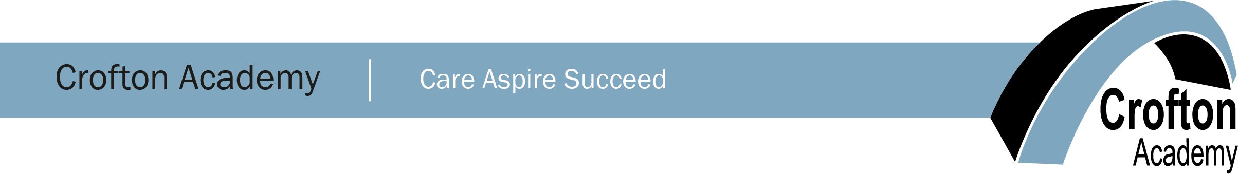

Academic/Intervention Mentor - English

35 hours per week – Term Time only
Grade 6 – Pro-rata Starting Salary £18,016
(FTE Salary Range – £22,571 - £25,419)

Crofton Academy are seeking to recruit an organised, positive, and enthusiastic Academic/Intervention Mentor to join our English Department and mentoring team from September 2022. The successful candidate will provide learning, motivation, and inspiration to encourage our students to achieve their best through focused intervention.

The primary responsibilities of the role will include:
- Mentoring individual and small groups of pupils providing ‘solution focused’ activities to overcome barriers to learning, both inside and outside school, and thereby assist them in achieving their full potential.
- Providing small group and one to one tutoring, support and challenge to enable pupils to meet or exceed their target grades in English.
- Responsibility for the planning and co-ordination of resources to ensure the smooth delivery of tutoring programmes.
- Assisting in the overall raising of pupil standards and achievements, through raising pupils’ esteem, expectations and aspirations.

The successful candidate will be/have:

- Excellent communication and listening skills.
- Experience of supporting, guiding and mentoring pupils/young adults.
- Excellent IT, Literacy and Numeracy skills.
- Ability to plan effective actions for pupils at risk of underachieving
- ability to use assessment and attainment data to improve standards and practices.
- Motivated, flexible and have a real passion for working with young adults at secondary school age.
- Confidence to work independently using initiative and drive, but also as part of a team.

Crofton Academy joined Castleford Academy Trust in 2020 and has since been on a rapid improvement journey supported by the leaders of the ‘Outstanding’ Ofsted rated Castleford Academy. Since joining the Trust leaders and staff at all levels have ambitiously worked towards improving the quality of education for pupils at the Academy and have responded positively to change.

We are able to offer staff a secure, supportive environment with continuous professional development. If you want to join an Academy where relationships for learning are fundamental to success, we would be delighted to hear from you.

The school is committed to safeguarding and promoting the welfare of children and young people and expects all staff to share this commitment. You will be required to undertake an enhanced DBS disclosure.

Headteacher: Mr Peter Walker.

All relevant academy information, job description, and application forms can be downloaded from the school website at www.croftonacademy.org.uk. For further enquiries, please contact Kim Hinchcliffe, at recruitment@croftonacademy.org.uk.

The closing date for fully completed applications is 4pm on 28th September 2022. The Academy reserves the right to interview suitable candidates prior to the closing date.

