Crowmoor Primary School & Nursery
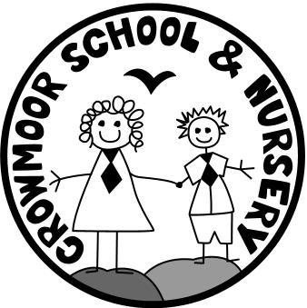
Crowmere Road
Shrewsbury
Shropshire
SY2 5JJ
Telephone: 01743 235549
Fax: 01743 243129

admin@crowmoorschool.co.uk
www.crowmoorschool.co.uk
Headteacher: Mr A J Parkhurst JP
Deputy Headteacher: Mrs J Parkhurst
School Business Manager: Miss H Cave

Advert

NTP Academic Mentor at Crowmoor Primary School
Salary up to £19,000 pa contract until 31/08/22 initially.

Crowmoor Primary School in Shrewsbury is an OFSTED rated Good school in the centre of Shrewsbury. It is proud to successfully serve a diverse community with high levels of deprivation. This makes use eligible for two Academic Mentors under the National Tutoring Programme.
We have seen the real difference these posts can make to our vulnerable pupils and wish to replace one of our original mentors (who has moved to a new post), with somebody equally committed.

Do you want to make a difference to some of the country’s most vulnerable pupils?
If yes this is the post for you, as at Crowmoor every pupil matters!

We are proud to be the only Gold Award winning UNICEF Rights Respecting School in Shropshire and to be a Co-operative Foundation School, teaching co-operative values.

We value diversity and we don't discriminate on the grounds of age, ethnicity, disability, gender, marital status, nationality, race, religion, sexual orientation or any other characteristics protected or otherwise. We are proud to be an equal opportunities employer that values diverse talent and encourages applications from people with diverse backgrounds and experiences.

We welcome showing interested candidates around our school and the Head is happy to discuss the post in more detail.

To download an application form, job description and person specification please visit: www.crowmoorschool.co.uk

Closing Date: Tuesday 19th October at noon Interviews: W/C 1st November

If you have not heard by close of business on the 21st October, please assume your application has been unsuccessful on this occasion.

The school is committed to safeguarding the welfare of its pupils and the successful applicant will be subject to a full DBS check.

If you are interested in a School viewing please contact the school office and we will arrange a viewing to comply with our COVID procedures.

