**JOB DESCRIPTION**

**Acorns Assistant**

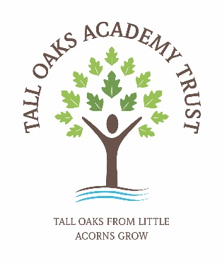

**REPORTS TO**

Head of School/Headteacher

**GRADE**

2.3

# JOB PURPOSE To provide support to the Acorns After-School Club

# MAIN RESPONSIBILITIES

# To assist with day to day tasks of the After-School Club, including preparation and serving of food and drink

# To assist with the setting up of and delivering activities under the guidance of the After-School Club Manager

# To tidy away at the end of After-School Club, ensuring the safe storage of equipment and consumables in accordance with health and safety and food hygiene regulations.

# To ensure the After-School Club area is tidy and hazard free at all times

# To ensure the health and safety of all children in the Club at all times, including keeping of registers, first aid, medicines, risk assessments and healthcare plans, security and fire regulations.

# To adhere to Trust policies and procedures at all times, including Health and Safety, Confidentiality and Safeguarding

# These are illustrative duties and the post holder will be expected to become involved in a wide range of work to enable the After-School Club to work effectively and efficiently.

# OTHER DUTIES

The duties and responsibilities in this job description are not exhaustive. The postholder may be required to undertake other duties that may be required from time to time within the general scope of the post. Any such duties should not substantially change the general character of the post. Duties and responsibilities outside of the general scope of this grade of post will be with

the consent of the postholder.

**EQUAL OPPORTUNITIES**

The postholder is required to carry out the duties in accordance with the Tall Oaks Academy Trust Equal Opportunities policies.

**HEALTH AND SAFETY**

The postholder is required to carry out the duties in accordance with the Tall Oaks Academy Trust Health and Safety policies and procedures.

**SAFEGUARDING**

All Trust staff have a responsibility to safeguard and promote the welfare of children and young

people across the Trust.

| **PERFORMANCE STANDARDS FRAMEWORK COMPETENCIES ESSENTIAL TO BASIC PERFORMANCE OF THE ROLE** | **ESSENTIAL** | **DESIRABLE** | **ASSESSMENT**  **A – Application Form I – Interview T - Test** |
| --- | --- | --- | --- |
| **EDUCATIONAL QUALIFICATIONS AND ACHIEVEMENTS** | | | |
| Level 3 NVQ or equivalent  Paediatric first aid trained  Food Hygiene Certificate | ✓ | ✓  ✓ | A |
| **KNOWLEDGE AND EXPERIENCE** |  |  |  |
| * Proven experience of working with children from age 4   Understanding of Safeguarding  Understanding of Health and Safety procedures  Experience of dealing with parents queries and issues providing solutions  Experience of a childcare/school setting  Experience of planning and organising age appropriate activities | ✓  ✓ | ✓  ✓  ✓  ✓ | A/I |
| **SKILLS AND ABILITIES** |  |  |  |
| Basic level of numeracy & literacy  Organisational skills  ICT literate  Ability to communicate to a variety of groups from children to parents and senior managers  Creative Skills  Knowledge/interest in art and craft  The ability to play/organise basic games/sporting activities | ✓  ✓  ✓  ✓ | ✓  ✓  ✓ | A/I |
| **ATTRIBUTES AND QUALITIES** |  |  |  |
| Develop positive relationships with staff, pupils and parents  Affinity with young children  Work individually and as a member of a team  Solution focused and a flexible approach to work  Punctuality and good time management  Professional appearance and manner  Able to use own initiative  Open to new ideas and willing to try different working practices  Willingness to undertake professional development | ✓  ✓  ✓  ✓  ✓  ✓ | ✓  ✓  ✓ | A/I |