
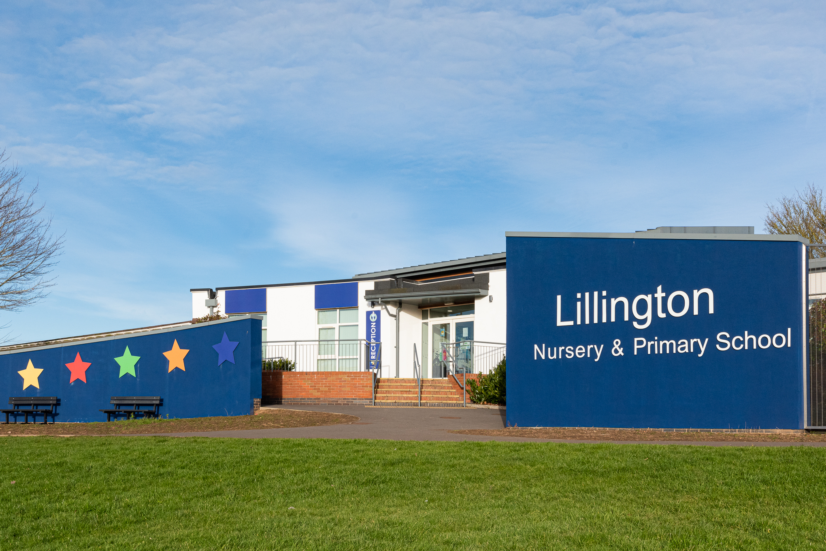

Dear Applicant,
Lillington Nursery &
Primary School
Kindness Honesty Respect
Teamwork Forgiveness Resilience
INFORMATION FOR CANDIDATES 2023-2024
We are delighted that you are considering applying for a role at Lillington Nursery & Primary School. I am privileged to lead my team in this truly exceptional community - where our mission is to pioneer, innovate and deliver a “World Class” education for all children, where the artificial barriers of stage and age are removed. Our education will aim to exceed the highest national and international benchmarks for academic achievement, whilst ensuring children develop a passion for learning in all its contexts and are ready to take their place as active members of our global community.
We believe that all adults who work in the school should have the time of their lives and we hope this candidate pack will assure you that this is the case. Staff retention is very high and that is due to the working environment, facilities, supportive culture, and many professional development opportunities offered. Many staff have worked in the school for most of their careers with the family ethos being evident, reflecting the culture of the school community. We value kindness, honesty, respect, teamwork, forgiveness, and resilience, which are at the heart of all our relationships, valuing the individual and the role we all play in school improvement and community development.
We will offer you:
- A supportive, collaborative, and friendly staff environment in a supportive school setting where you will have the chance to make a real and positive impact on the lives of Lillington Nursery & Primary School children.
- A world-class professional development programme through The Lion Alliance which offers a range of ITT, early careers, middle and senior leader development programmes through the National College, SSAT and the Chartered College of Teaching. There is a passion for teaching and learning evident and recent speakers have included Tom Sherrington, Dylan Wiliam, and Harry Fletcher-Wood.
- A range of health and wellbeing services through the MAT and external services.
- Free, on-site car parking.
- School social events.
- A commitment to staff well-being.

We are committed to Safer Recruitment practices and procedures and shortlisted applicants will be questioned about their commitment to the safeguarding of young people. The successful candidate will be subject to an enhanced DBS clearance.
Having read the candidate information, I hope that you feel excited by both the role itself and the chance to be part of Lillington Nursery & Primary School at a pivotal moment in its development. We welcome visits from prospective candidates and would be proud to show you round our wonderful school.

We look forward to hearing from you.


Mrs V Wallace – Headteacher

Our School
Lillington Nursery & Primary School’s goal is to equip our children with the skills and mind-set to thrive and then take on the world. Our school strives to enable all pupils to embrace learning, achieve their personal best and build their emotional, social, and physical well-being. We empower our pupils to acquire, demonstrate, articulate, and value knowledge and skills that will support them, as life-long learners, to participate in and contribute to the global world and practise the core values of the school.
I have taught in many schools (both in England and abroad) but none are as enjoyable and rewarding as working with the children and community at Lillington Nursery and Primary. This inclusive and exciting school has inspired me, both as an educator and a person, and I am extremely grateful to have both of my children attending it. Without any hesitation, I would whole-heartedly recommend Lillington Nursery and Primary to anyone who wants the best for their child, irrelevant of need. I am so proud to be part of the #LillingtonLegends movement!
(Teacher)
As Ofsted stated in October 2023, “There is a warm and inclusive welcome at Lillington Primary School. Pupils are happy, safe, and working hard”. Over the last four years, Lillington has been on a very exciting journey, which has seen the school go from ‘inadequate’ to ‘good’.
We are a 2-11 co-educational school with currently 1 form of entry, but our PAN will increase as of 2025. The school is based at Cubbington Road in the Lillington suburb and comprises some recently refurbished buildings. You genuinely need to see the school in action to appreciate the working environment.
The kids are very nice here, and we are taught nice values. The school is lots of fun and the teachers are very kind. Lillington is a fantastic school, and any child attending would be safe and happy here. (Pupil)
The school’s last inspection highlighted many of the positive things that are taking place in the school and has given us a firm platform from which to achieve our aims. Our school priorities for 2023-24 clearly focus on our culture for improvement and can be viewed on the next page.
“Finham Park MAT has provided me with a huge range of opportunities throughout my career as a teacher. Staff are incredibly supportive and the opportunities for CPD are fantastic, including a new ‘Leadership Pathways’ programme. I would thoroughly recommend working in the MAT to anyone and hope to continue to develop my career over the coming years.” (FPMAT employee)




We are very proud of our caring school community and place great emphasis on high standards of behaviour and respect for all through our key values of Respect, Resilience, Honesty, Kindness Forgiveness, and Teamwork. I urge you look at the school – you won’t regret it.



Lillington Nursery & Primary School Strategic Framework 2023-2026

WS1 EDUCATIONAL OUTCOMES  Our School will…  Provide a “World Class” learning experience for all through the development of outstanding & inspirational teaching:  Ensure that all students enjoy a “World Class” curriculum that is personalised and encourages outstanding contributions toward a cohesive community:  Ensure every learner achieves academic success and strives toward personal excellence | WS2 SUPPORT FOR ALL  Our School will…  Develop “World Class” support & guidance for our whole community where academic performance is underpinned by outstanding care, guidance and support for every student.  Collaborate at all levels to co-construct a “World Class” education for all our learners and support each other to overcome any challenges we may face. | WS3 THE EMPLOYER OF CHOICE  Our School will…  Offer “World Class” CPD and career development opportunities so that our students benefit from the best teaching, support and guidance and that staff are happy; secure; feel valued by everyone and achieve work-life balance. | WS4 ENABLING SUCCESSFUL SCHOOLS  Our School will…  Recruit, develop and maintain effective leadership & governance at all levels while succession planning for the future.  Benefit from high quality central services that will allow Governors and School Leaders to focus on education and provide excellent value for money. | WS5 GROWING THE TRUST  Our School will…  Demonstrate capacity for future growth by securing excellent outcomes in all our schools that are recognised by parents and community; wider partners; and the DfE  Develop the accommodation and resource to deliver our “World Class” education for the next 50 years. | WS6 EARLY YEARS  Our School will…  Ensure every learner across early years achieves academic as well as wider success and strives towards personal excellence.
WS1a  Further develop high quality transition support that has a positive impact on pupil’s aspirations and wellbeing.  MH | WS2a  Ensure behaviour, attendance and rewards policies are applied consistently & have high impact across the school (focus on eliminating low level disruption)  VW | WS3a  To develop a programme of high quality CPD through in house, collaboration with the Trust and external sources, including the enrolment of staff on NPQs  VW | WS4a  Develop effective governance and accountability through challenge and support, in partnership with the MAT Board and the MAT School Improvement Delivery  TC/KW | WS5a  To continue to build on pupil numbers through community events, open days and word of mouth to ensure full capacity in future years.  SLT | WS6a  To develop a clear and concise assessment system across Early years to ensure all pupils are making maximum progress.  JR
WS1b  Ensure all interventions and wider learning support across the school is focused, targeted and maximises progress.  SB | WS2b  To ensure effective working relationships with multiply outside agencies including SEN and safeguarding by consistent communication and being part of working parties/panels.  VW/SB | WS3b  Further develop pupil voice & Student Leadership programmes that have high impact around the school & within the wider community.  MH | WS4b  Ensure finance procedures and planning allow us to demonstrate excellent ‘value for money’.  SC | WS5b  To develop a sound marketing and communications policy in order to promote the school and Trust.  VW/SC | WS6b  To continue to build on pupil numbers through community events, open days and word of mouth to ensure full capacity in both 2- and 3-year-old provision.  JR/SC
WS1c  Develop the quality of teaching including responsive teaching through Instructional Coaching and educational research.  VW | WS2c  Deliver the highest standards of education and support for SEND pupils  SB | WS3c  Develop a culture of strategic leadership and reflection through a model of distributed leadership, CPD, Teaching School Alliance and leadership succession.  VW | WS4c  To embed new HR systems and policies to ensure consistency across school in line with Trust.  SC | WS5c  Develop external funding streams including opportunities for community use of buildings and facilities.  SC | WS6c  To identify pupils with SEND needs early in order to gain maximum support through external professionals.  SB
WS1d  To develop a clear and concise assessment system across Early years to ensure all pupils are making maximum progress.  JR | WS2d  Develop a systematic approach to closing gaps between groups of pupils, particularly disadvantaged pupils  SB | WS3d  Embed a culture where well-being is used as a foundation for school improvement and decision making.  SLT | WS4d  To develop the use of It across the curriculum to ensure children are exposed to new technology.  CP | WS5d  To develop connections with international schools to build on pupil’s experience and understanding of the world around them.  MH | WS6d  To ensure all Early years staff are appropriately qualified in order to meet ratio expectations, including those related to first aid.  SLT
WS1e  Ensure high quality assessment & moderation practice is in place and clearly understood by all stakeholders.  SLT | WS2e  Develop the individual identity of every child built on the school’s core values of ‘Teamwork, Respect, Resilience, Honesty, Forgiveness and Kindness’  SLT | WS3e  To work with the Trust to ensure all appraisal processes and pay policies are in line with STPCD.  VW | WS4e  Ensure the Lillington Nursery and Primary environment and resources are high quality and suitable to deliver a ‘World Class’ experience for all stakeholders.  SC | WS5e  Develop an integrated, co-constructed & personalised curriculum that reflects national changes, innovation, creativity and the best international practice.  MH/JR | WS6e  Ensure the early years curriculum is designed and implemented to meet the needs of all children including their personal and emotional development.  JR

Opportunities
We fully believe in creating a ‘culture of learning’ which encourages all to enquire, develop and share collaboratively across the education sector. We have dedicated co-planning and co-construction time built into our directed time budget so that teaching staff can work collaboratively within the school and across the MAT on teaching, learning and assessment. We also offer a range of in-house and nationally accredited courses through the Lion Alliance and some of these include:
Chartered Teaching Programme | TeachMeets | Lion Leadership Courses | ECT (Early Career Teacher) Programme
We are a registered learning partner for the Chartered College of Teaching and offer the CTP to colleagues within the alliance. | We host regular TeachMeet events that draw on our expert colleagues’ knowledge. This means we can be flexible and adapt to the changing needs of staff in schools. | We have 4 strands of leadership development courses. This includes Associate, Aspiring Middle, Middle and Senior Leaders courses. | The Head of the Lion Alliance is one of the regions ECT training facilitators; able to support newly qualified teachers as they begin their career.

We also have key speakers work with a huge range of world-renowned authors and teaching professionals; inviting them to speak at our school about the latest developments in their specialist area. Guests have included:

Tom Sherrington | Tom Bennett | Oliver Caviglioli | Mark Roberts
Adam Boxer | Matt Pinkett | Nina Jackson | And many more...

We also recruit and mentor PGCE students through a school-led PGCE programme (in partnership with the University of Warwick), meaning we can offer further opportunities in:
PGCE Mentoring | Working with us as an alliance | Working with our partner universities
There are opportunities to mentor PGCE students in your subject. This involves mentor training being provided by our University partners, and is a great way to nurture the next generation of teachers. | We have regular opportunities to get involved and share your expertise with colleagues in our alliance schools. | We work with the University of Warwick, Coventry University and Birmingham City University, where there are opportunities to help support and contribute to the wider higher education community.

Find out more by visiting www.thelionalliance.co.uk

https://thelionalliance.co.uk/continuing-professional-development-cpd/

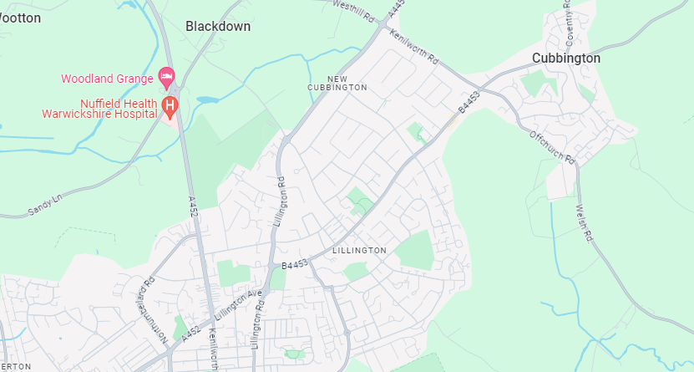
The area

Lillington is a suburb of Leamington Spa, in the civil parish of Royal Leamington Spa, in the Warwick District in the county of Warwickshire. Historically a village which existed before the time of the Domesday Book (1086), it was incorporated into the borough of Leamington in 1890. Lillington is a ward of Warwick District Council and Royal Leamington Spa Town Council. The Midland Oak by the junction of Lillington Avenue and Lillington Road marks the supposed very centre of England



01926 425114


Lillington Nursery & Primary School
Cubbington Road
Lillington
Leamington Spa
Warwickshire
CV32 7AG

https://www.lillingtonprimary.com/

admin@lillingtonprimary.com
hr@finhamparkmat.co.uk



,



