**Candidate Information Pack**

Administration Assistant



**Contents**

|  |  |
| --- | --- |
| About the Trust | 1 |
| About us | 2 |
| Our vision and values | 3 |
| Working at Bishop Alexander Academy | 4 |
| Benefits of being part of L.E.A.D. Academy Trust | 5 |
| How to apply | 7 |
| Job description and person specification | 8 |

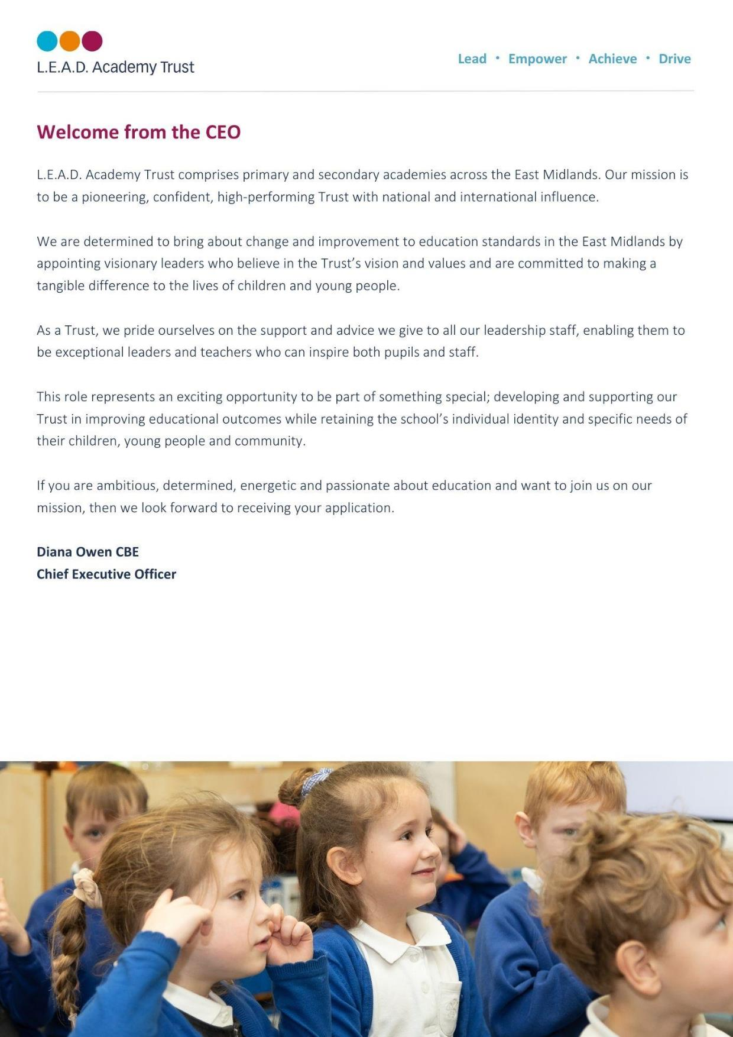

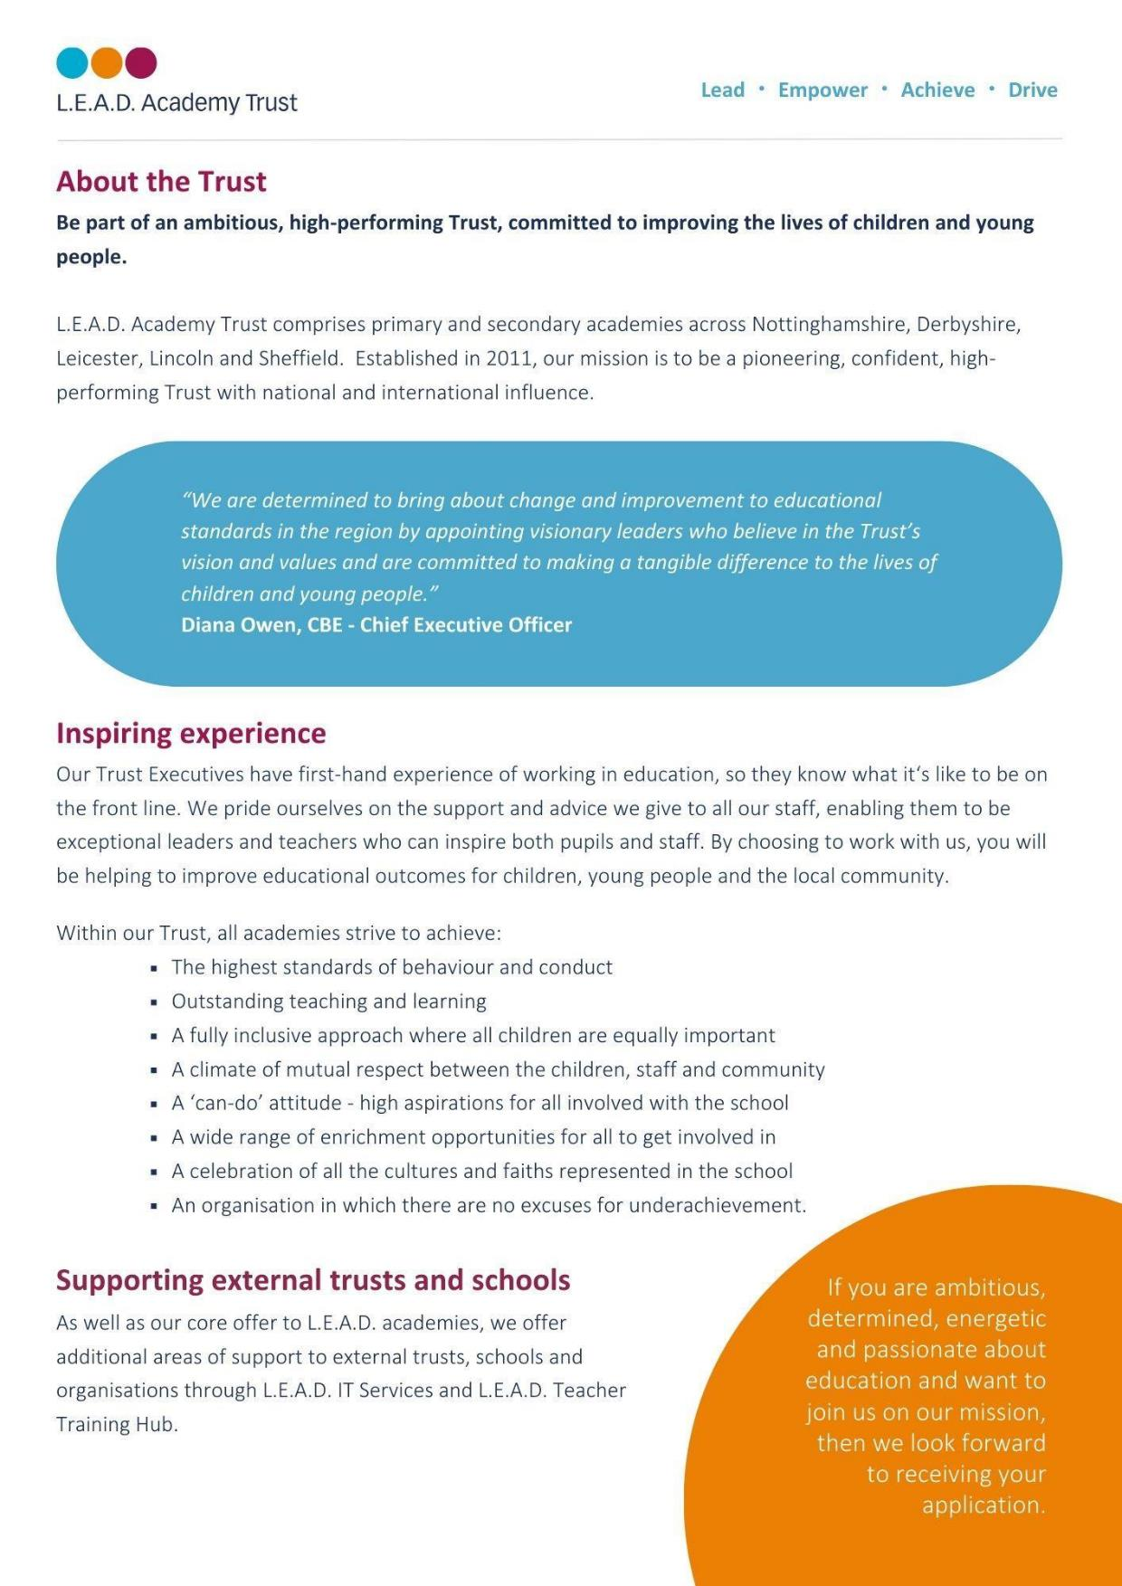

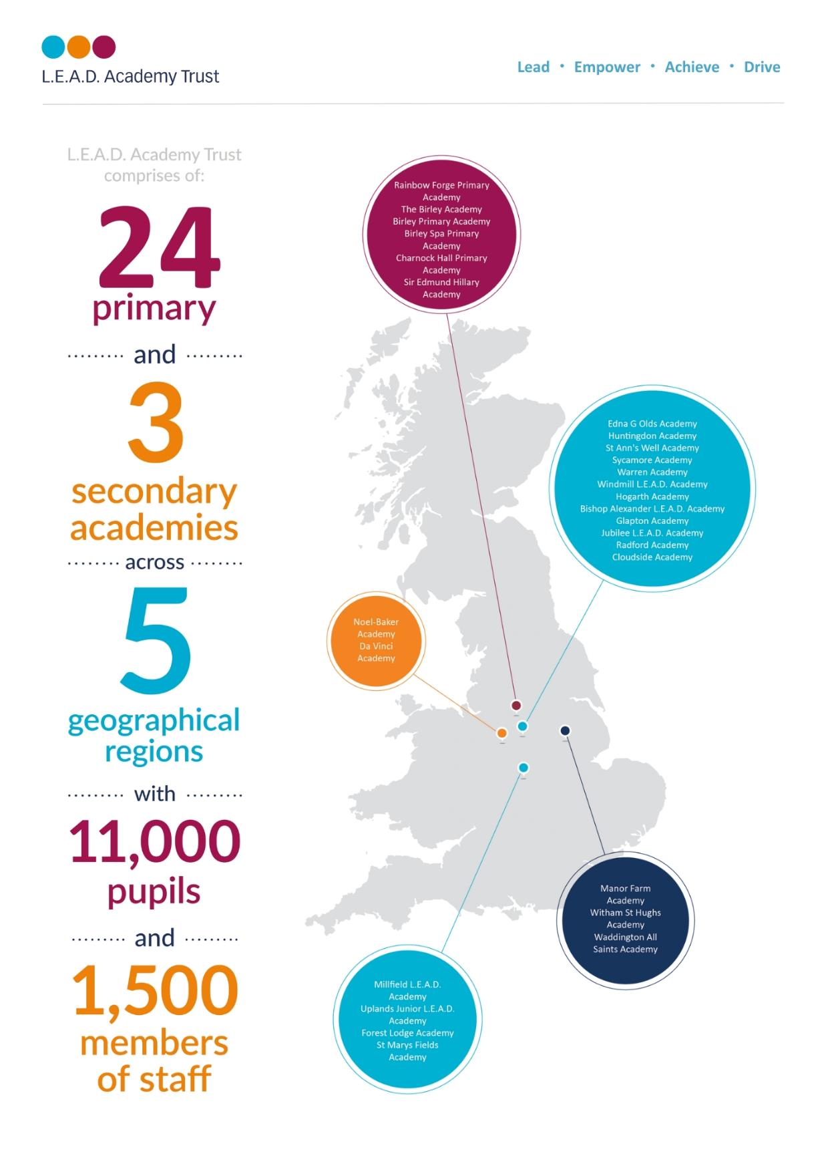

**A message from the Headteacher**

Thank you for your interest in this role.

I am proud to have been the Headteacher of Bishop Alexander Academy for 10 years, and consider myself lucky to work with remarkable pupils, dedicated staff and supportive families. The people are what makes this academy special!

The **pupils** are enthusiastic and committed to their learning and show resilience and aspiration in all they do. They understand the importance of making mistakes and recognise these as learning opportunities. They show care for each other, but also for other members of the community. We firmly believe that this school belongs to the pupils’, and their voice plays an essential part in the development of the academy. Pupils also undertake roles of responsibility such as Subject Ambassadors, Lunchtime Leaders ***Headteacher Mrs Nicky Spencelayh***

and Active Citizens.

We have a highly committed team of **staff**, who inspire and care for our pupils. Our **parents** say, ‘they are approachable staff’ and provide a place in which ‘their children flourish’. All staff are proud to be members of the Bishop Alexander team.

We believe that our pupils deserve the best education possible, and this is only possible through talented and well-trained staff. They have a wealth of CPD opportunities both within the academy and through L.E.A.D Teaching School Hub. Staff say they value these opportunities to develop.

The school is fortunate to have a strong and supportive **Governing Body**, who share our commitment to further strengthen teaching and learning and ensure that all children reach their full potential. They also share a keen interest in the staff and their welfare.

I strongly encourage you to visit the academy, and see our caring, yet challenging, ethos in practice

**Working at Bishop Alexander Academy**

We are a one-form entry academy with 220 pupils, which consists of a modern school building with extensive grounds. There is a diverse community, with 13 different home languages spoken, and pupils come from a range of backgrounds. We are passionate about pupils being able to ‘see’ themselves in our curriculum, and we pride ourselves on our inclusive ethos.

Our curriculum follows a two-year cycle and starts literally ‘on our doorstep’, in that it is about our local community and Newark itself. We feel that the children need a sense of belonging and pride in where they live before they learn and appreciate the wider world. Our curriculum themes are carefully chosen and

reflect the needs of our pupils. The whole school follow the same theme and come together at the end for a common purpose.

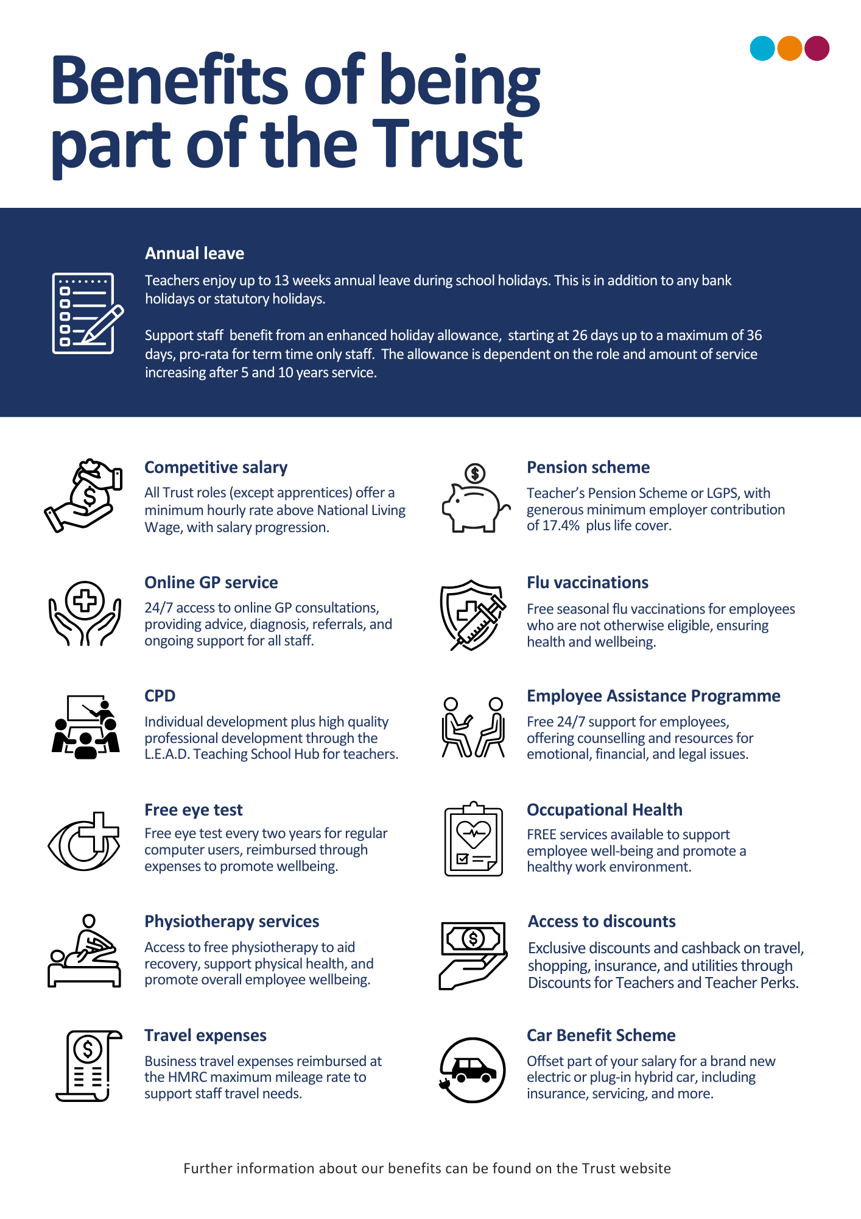



**OFSTED March 2024:**

***“Pupils feel happy and safe at this school.***

***Parents who share a view described***

***a welcoming environment,***

***approachable staff and a place in***

***which their children flourish.”***

**How to apply**

Please send a completed application form and covering letter explaining your interest in the role and how you meet the person specification to: **admin@bishopalexanderacademy.co.uk**

**CLOSING DATE**: Friday 17th January 2025

**INTERVIEWS**: We expect interviews to take placeweek commencing Monday 20th January 2025

Applications will be reviewed upon receipt, therefore shortlisted candidates may be contacted in advance of the closing date.

L.E.A.D. Academy Trust is committed to safeguarding and promoting the welfare of children and young people and we can expect all staff and volunteers to share this commitment. This post is subject to an enhanced DBS check.

For an informal, confidential discussion about this opportunity, please email: **admin@bishopalexanderacademy.co.uk**

  
  
  
  
  
  
  
  
  
  
  
  
  
  
  
  
  
  
  
  
  


**Job description**

**Key responsibilities and accountabilities**

**Administration Assistant**

**Start Date: February 2025**

**Working Hours: 37 per week**

**Salary: Scale NJC 5-10**

**Job purpose:**

To work as part of a team ensuring the school office runs efficiently, whilst maintaining a friendly and professional service to the community, colleagues and governors.

To role model high standards, as the first point of contact for most visitors and enquiries to the school.

**Duties and Responsibilities:**

* Ensuring that all visitors are welcomed in a polite and professional manner, maintaining full compliance with the Visitors/Contractors On-Site Checks.
* General administration duties, such as preparing letters, texts and handouts.
* Ensure that Keeping Children Safe in Education statutory guidance underpins all interaction with visitors, contractors and agency staff on site.
* E-mail management and responding where appropriate.
* To process the school dinner systems in place within the academy.
* Carry out first day absence calling and report to SLT unexplained absences.
* On occasion may be required to accompany another with home visits.
* Process holiday fines.
* Report collation and information gathering, general administration, business analysis and any other duties as required by school management (e.g.; persistent absence monitoring)
* Ensure pupil attendance is monitored and high light to SLT any areas of concern.
* Providing an accurate and confidential administrative service, including typing of correspondence, spreadsheets and presentations.
* Dealing with incoming correspondence including calls, post and e-mails in a professional manner.
* Hold a first aid certificate as required by the school.
* Assist with pupil first aid / welfare duties, looking after sick children, liaising with parents / staff etc. administering medication when necessary, in accordance with the school policy on administering medication.
* Undertaking ad hoc projects.
* Minute taking.
* Ensure the office and entrance area is well presented, tidy and organised.
* Process online payment system for parents to pay for trips/afterschool clubs etc.

**Influencing and Managing Relationships:**

• Headteacher

• L.E.A.D. Central Support

• External agencies

• Parents and carers

• Governors

• Senior Leadership Team

• Staff

As job descriptions cannot be exhaustive, the post-holder may be required to undertake other duties which are broadly in line with above key responsibilities.

The Trust is committed to safeguarding and promoting the welfare of children and young people and expects all staff and volunteers to share this commitment and individually take responsibility for doing so.

At L.E.A.D we have a strong vision and four core principles, to lead, empower, achieve and drive, which you will be expected to demonstrate in your working practices.

**Administration Assistant Person Specification**

This job description lists the competencies expected of an experienced/fully trained post-holder. The two right hand columns provide guidance for the appointment of new staff. (E = Essential criteria, D + Desirable criteria)

|  |  |  |  |
| --- | --- | --- | --- |
|  | | **E** | **D** |
| **Qualifications and Attainments** | * Studied to a minimum standard of GCSE (grade A* - C), or equivalent, in English and Maths * Further education qualifications in related fields, e.g.: NVQ Business Administration * To hold a first aid certificate or be willing to undertake training | E  E | D |
| **Skills and**  **knowledge** | * Ability to build and form good relationships with colleagues, senior leaders and external visitors * High level of oral and written communication skills * Able to use all MS Office programs particularly Word, Excel and Outlook * Able to work to tight deadlines, managing and prioritising time effectively * Self-starter, with an ability to work independently & use own initiative to overcome obstacles * Efficient and meticulous in organization * Ability to produce precedent letters from basic information | E  E  E  E  E  E  E |  |
| **Experience** | * Previous experience in a similar role * Experience of working in a school or academy trust environment |  | D  D |
| **Personal Attributes** | * Have an openness to learning and change * Have a positive attitude to personal development and training * Be able to work in ways that promote equality of opportunity, participation, diversity and responsibility | E  E  E |  |
| **Additional Requirements** | * This role is subject to an enhanced DBS | E |  |





**Email address:**

office2@bishopalexanderacademy.co.uk

**Phone number:**

01636 680040