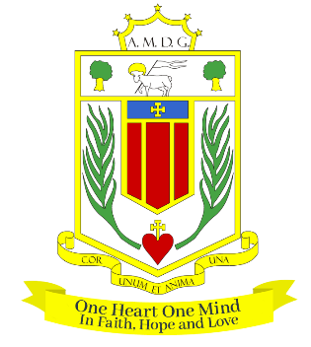
BROUGHTON HALL CATHOLIC HIGH SCHOOL
Yew Tree Lane

Liverpool, L12 9HJ

Telephone 0151 541 9440 / Fax 0151 259 8448
Email: smithg@broughtonhall.com
Head Teacher: Mrs S O’Rourke, B.A. (Hons), PGCE

ADMINISTRATIVE ASSISTANT – 2 POSITIONS
1 x Full Time (35 hours per week – 52 week contract)
1 x Part Time (20 hours per week – 39 week contract)

SALARY: NJC SCP 5-6 £24,790 to £25,183 full time equivalent
CONTRACT TYPE: Permanent to include Inset Days
CLOSING DATE: 4th March 2025
INTERVIEWS TO BE HELD: To be confirmed
START DATE: As soon as possible

Governors wish to appoint two administrative assistants to work within our busy administrative team acting as the first point of contact for visitors, pupils and staff. The successful candidate will provide efficient and professional clerical and administrative support.

The successful candidate will:-
- Have excellent communication and IT skills with the ability to work to deadlines
- Be able to demonstrate your ability to work effectively within a team
- Have excellent organisational skills, as well as being flexible and adaptable to change
- Be willing to support new initiatives within school

Induction, support and training will be offered to the successful candidate.

An application form, together with an information pack are available from the school’s website
www.broughtonhall.com

Our Trustees are the Sisters of Mercy.

How to Apply:- Please complete the school’s Application Form and email to smithg@broughtonhall.com

Broughton Hall Catholic High School is committed to safeguarding and promoting the welfare of children and we expect all staff and volunteers to share this commitment to keeping children safe. Any offer of employment will be subject to statutory pre-employment checks including satisfactory references and Enhanced DBS and Barred List checks. This post is exempt from the provisions of the Rehabilitation of Offenders Act - accessed here - and shortlisted candidates will be required to disclose any relevant criminal history prior to interview.

