ROLE: Administrative Assistant – 2 Positions

1 x Full Time (35 hours per week – 52 weeks contract)

1 x Part Time (20 hours per week – 39 weeks contract)

START DATE: As soon as possible

CLOSING DATE: 3rd March 2025

INTERVIEW DATE: To be confirmed

SALARY SCALE: NJC SCP 5 – 6 £24,790 - £25,183 (full time equivalent)

CONTRACT TERM: Permanent

**Broughton Hall Catholic High School**

Founded in 1928 under the trusteeship of the Sisters of Mercy, Broughton Hall Catholic High School, an all-girls Catholic secondary school in Liverpool, provides the very best in modern education based on the Gospel values of mutual respect and care.

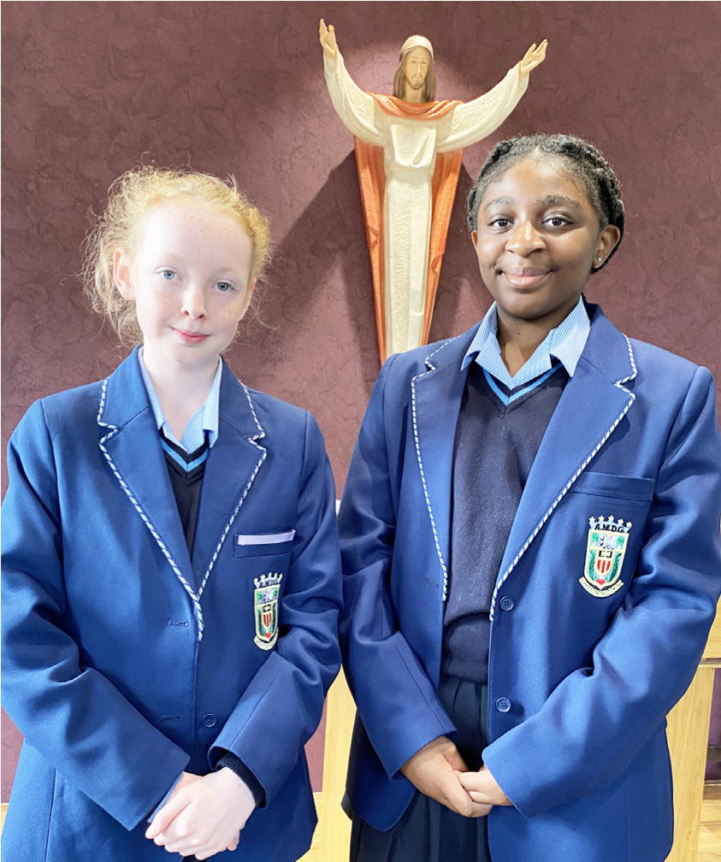

The central aim of our school is to provide excellent educational opportunities enabling each pupil to develop their God given talents, to grow in confidence and self-esteem and to fulfil their potential.

As a Catholic school Broughton Hall centres its mission on the person of Jesus Christ, and promotes the Gospel values throughout the school community and in all aspects of school life: spiritual, academic, pastoral, and personal. By proclaiming and living out the faith of the Catholic Church, we support each other in shared experiences of teaching and learning, prayer, worship and charity. Our mercy values permeate throughout our community.

Broughton Hall is Ofsted rated as a “Good” provider (November 2022).

Our facilities are bright, spacious, high tech and designed to meet the needs of all our pupils. We have a separate 6th Form facility, which is shared with our neighbouring boys school Cardinal Heenan Catholic High School. A full range of extra-curricular activities are provided to further the creative, sporting and academic talents of each pupil and offer Outward Bound and Duke of Edinburgh Award schemes as well as the opportunity to attend educational visits and residential trips.

We pride ourselves on our high expectations of all pupils and have an **‘Ambition for All’** policy. Whatever your role within the school, you will share these values and be able to encourage and motivate pupils with your passion, presence and personality.

Our school motto ‘**Cor Unum et Anima Una’** - One Heart and One Mind, reflects the strong sense of community amongst pupils, staff, parents and Governors.

School has a weekly Newsletter – please **click here** to view our latest edition. <https://www.broughtonhall.com/newsletter/>

**Welcome**

Thank you for your interest in the position of Administrative Assistant.

This pack has been designed to help you should you choose to submit an application form, which we sincerely hope you do. We hope it answers your initial questions, but if not, please do not hesitate to contact us and we will endeavour to help you through your application process.

Broughton Hall Catholic High School is the largest all-girls school in Liverpool and serves many different areas making us a vibrant a diverse school. Our aim is to be a good school in all areas and we are seeking staff to apply to work with to be of that journey. Ofsted rated the school as “Good” in November 2022.

We work hard to ensure Broughton Hall Catholic High School remains a friendly and welcoming environment for all those who work, study or visit here and hope that you are the person we are looking for to bring creativity and innovation to the role.

The school actively supports the training of middle leaders through well-respected Teaching Leaders’ programme. Opportunities for promotion exist for suitable candidates. Our staff are passionate about teaching and are committed to develop exciting and stimulating lessons that not only engage students.

We look forward to hearing from you.

**Sarah O’Rourke**

**Head Teacher**

**We Offer**

* Pensions Scheme – Teacher Pension Scheme for teaching staff or Merseyside Pension Fund for support staff
* Regular training and development programme
* An enhanced Occupational Health & Well-Being App (Smart Clinic) with access to a wide variety of services e.g.
* Virtual GP
* 24 hour employee assistance line
* Physiotherapy
* Mental Health Services
* Self-support and guidance tools
* Cycle2Work Scheme
* Tax Free Childcare Vouchers
* Supportive work environment where all staff are valued
* Continuous professional development for all staff and follow a whole school approach to staff performance and development

And that’s not all, we place the outcomes of the children in our school at the heart of everything we do, so you’ll wake every day in the knowledge that your role will have a significant positive impact on the lives of others.

**Equal Opportunities**

Broughton Hall Catholic High school is an equal opportunities employer.

We welcome applicants from all backgrounds and value everyone as an individual. We are committed to organisational practices, which promote diversity and inclusion for all employees and volunteers regardless of age, gender reassignment, marriage or civil partnership status, pregnancy and maternity status, disability, race (including colour, nationality, ethnic or national origin), religion or belief, sex, or sexual orientation. Connecting these differences creates a productive environment in which everyone feels valued.

Monitoring information in relation to job applicants will be to assist us in equality monitoring. The recruitment panel will not have access to job applicant’s monitoring information.

To assist us in monitoring the operation of equal opportunities policy, and for no other reason, please ensure you complete and submit the Equal Opportunities Monitoring Form with your application form.

**Safeguarding & Enhanced DBS Checks**

Broughton Hall Catholic High School is committed to safeguarding and promoting the welfare of young people and expect all pupils, staff, volunteers and visitors to share this commitment

All posts are subject to an enhanced DBS check and full pre-employment checks to comply with the current Keeping Children Safe in Education statutory guidance for schools.

All staff will be expected to follow Broughton Hall Catholic High School’s child protection policies, code of conducts and managing allegations against staff procedures.

All roles in school, including this post, are exempt from the Rehabilitation of Offenders Act (ROA) 1974. The Ministry of Justice’s guidance on Rehabilitation of Offenders Act 1974 and the Exceptions Order 1975 provides information about which convictions must be declared during job applications and can be accessed [here](https://www.gov.uk/government/publications/new-guidance-on-the-rehabilitation-of-offenders-act-1974).

All applicants must therefore declare all previous convictions and cautions, including those which would normally be considered ‘spent’ except those received for an offence committed in the United Kingdom if it has been filtered in accordance with the DBS filtering rules. Information about filtering offences can be found in the DBC Filtering Guide, which can be accessed [here](https://www.gov.uk/government/publications/dbs-filtering-guidance).

By engaging in this recruitment process, shortlisted candidates consent to an online search in line with the Keeping Children Safe in Education Statutory Guidance 2022.

A copy of our Child Protection Policy and Procedures can be access at <https://www.broughtonhall.com/documents/BroughtonHall_CP_Policy.pdf>

**Advert**

**ADMINISTRATIVE ASSISTANT – 2 POSITIONS**

**1 x Full Time (35 hours per week – 52 weeks contract)**

**1 x Part Time (20 hours per week – 39 weeks contract)**

**SALARY:** NJC SCP 5-6 £24,790 to £25,183 full time equivalent

**CONTRACT TYPE:** Permanent to include Inset Days

**CLOSING DATE:** 3rd March 2025

**INTERVIEWS TO BE HELD:** To be confirmed

**START DATE:** As soon as possible

Governors wish to appoint two administrative assistants to work within our busy administrative team acting as the first point of contact for visitors, pupils and staff. The successful candidate will provide efficient and professional clerical and administrative support.

The successful candidate will:-

* Have excellent communication and IT skills with the ability to work to deadlines
* Be able to demonstrate your ability to work effectively within a team
* Have excellent organisational skills, as well as being flexible and adaptable to change
* Be willing to support new initiatives within school

Induction, support and training will be offered to the successful candidate.

An application form, together with an information pack are available from the school’s website

[www.broughtonhall.com](http://www.broughtonhall.com)

Our Trustees are the Sisters of Mercy.

**How to Apply:-** Please complete the school’s Application Form and email to smithg@broughtonhall.com

*Broughton Hall Catholic High School is committed to safeguarding and promoting the welfare of children and we expect all staff and volunteers to share this commitment to keeping children safe. Any offer of employment will be subject to statutory pre-employment checks including satisfactory references and Enhanced DBS and Barred List checks. This post is exempt from the provisions of the Rehabilitation of Offenders Act* - *accessed* [*here*](https://www.gov.uk/government/publications/new-guidance-on-the-rehabilitation-of-offenders-act-1974) *- and shortlisted candidates will be required to disclose any relevant criminal history prior to interview.*

**Job Description**

**ADMINISTRATIVE ASSISTANT**

|  |  |
| --- | --- |
| **Reporting to:** | Headteacher, Senior Leadership Team and Office Manager as appropriate. |
|  |  |
| **Purpose:** | The first point of contact for greeting visitors, answering telephone calls and providing information to parents and pupils.  Working closely with the Headteacher, Office Manager and other members of staff to provide a broad range of general clerical and administrative duties.  To provide support for pupils, teachers and the whole school. |
|  |  |
| **Areas of Responsibility:** | **Reception Duties:**   * Welcoming, receiving, signing in and dealing with and directing staff, pupils, parents, school governors, school visitors and other stakeholders as appropriate. * Managing the staff, pupil, parents and visitor school entry system ensuring fully in line with school policy and expectations including producing and issuing visitor badges. * Operating the school’s main telephone, transferring calls, or taking and delivering messages as appropriate. * Managing the school’s main inbox, replying, forwarding messages and making appointments for staff as appropriate. * Managing the school’s public noticeboard, adding and removing content as appropriate.   **Administrative Support:**   * Receiving and sorting incoming mail for delivery to appropriate staff. * Recording, franking/ stamping and posting outgoing mail * Routine word processing, as and when required. * Assisting with the administration of Statutory Free School Meals and other local and global school meals schemes. * Assisting with the maintenance of Parent Pay and co-ordination of school trips and activities together with other administrative support as required. * Assisting with the maintenance of the school's confidential computerised database of information (Management Information System: SIMS) on pupils and producing reports as required. * Assisting in the maintenance of the school’s filing and archiving systems. * General clerical and administrative tasks such as photocopying, printing, faxing, laminating etc. * Providing reprographic support to the school. * Receiving and checking orders by matching Delivery Notes with Purchase Orders and informing the Finance Team of any discrepancies including chasing up missing items, returning damaged items etc.   **Safeguarding:**   * To have due regard for safeguarding and promoting the welfare of children and young people and to follow the child protection procedures adopted by Broughton Hall Catholic High School as outlined in the school’s Child Protection Policy. * To assist the Office Manager in enforcing the school vetting procedure, obtaining visitors’ vetting details e.g. DBS certificate, Photographic ID etc. for the Single Central Record. * To assist staff in the day-to-day implementation of the school Visitor Policy. * To carry out designated school fire evacuation role and adhere to fire evacuation procedure in the event of a fire and during a fire drill. * To adhere to the school Health and Safety Policy and Lockdown Procedures.   **Supporting School:**   * To play a full part in the life of the school community, to support and contribute to its Catholic mission and ethos and to encourage and ensure staff and students follow this example. * To foster links between home and school. * To contact parents regarding absence and attendance. * To attend relevant in-service training. * Actively promote, comply and adhere to all school policies * Demonstrate willingness to support new initiatives within the school. * To respect the confidential nature of the work being undertaken and any knowledge about individual student's personal and educational circumstances. * Participate fully in training, learning development and the school’s performance management system for support staff. * To be a First Aider |
|  |  |
| **Supervision:** | To work under the supervision of the Office Manager |
|  |  |
| **Disclosure level:** | Enhanced with Barred List Check |

|  |
| --- |
| Whilst every effort has been made to explain the main duties and responsibilities of the post, each individual task undertaken may not be identified. |

|  |
| --- |
| This job description is current at the date shown, but, in consultation with you, may be changed by the Head Teacher to reflect or anticipate changes in the job commensurate with the grade and job title. |

**Person Specification**

|  |  |  |
| --- | --- | --- |
| **Qualifications** | **Essential** | **Desirable** |
| NVQ 2 or equivalent qualifications or relevant experience | **🗸** |  |
| 5 GCSE’s or equivalent, Grade C/ 4 or above, including English, Maths and Science grade | **🗸** |  |
| First aid training (or willingness to undertake) | **🗸** |  |
| **Experience** | **Essential** | **Desirable** |
| Working as part of an office environment | **🗸** |  |
| Working as part of a team | **✓** |  |
| Working in a school office environment |  | **✓** |
| Experience of using ParentPay, SIMS and parent communication apps (e.g. Edulink) |  | **✓** |
| **Knowledge & Skills** | **Essential** | **Desirable** |
| Strong written language/communication skills | **🗸** |  |
| Strong numeracy skills | **🗸** |  |
| Excellent interpersonal skills | **✓** |  |
| Excellent telephone manner | **🗸** |  |
| Excellent written and oral skills | **🗸** |  |
| **Personal Qualities** | **Essential** | **Desirable** |
| Works well as a member of a team | **🗸** |  |
| Good communication skills | **🗸** |  |
| Flexible | **🗸** |  |
| Patient, positive, approachable and friendly | **🗸** |  |
| Strong behaviour management | **🗸** |  |
| Maintains confidentiality | **🗸** |  |
| Ability to relate well to children and adults | **🗸** |  |
| Display commitment to protection and safeguarding of children and young people | **🗸** |  |



