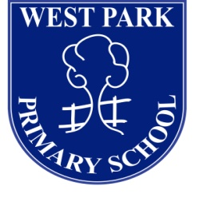
Administrative Assistant

West Park Primary School
Coniscliffe Road
Hartlepool
TS26 0BU

To provide maternity leave cover in our school office, the heart of our friendly and welcoming school. We would like the successful candidate to commence as soon as possible.

Administrative Assistant (Band 5) Spinal Column Point 5 £11,373.27 per annum (pro rata), 26 hours per week (a working schedule 8.30am – 12.30pm each day and Thursday and Friday afternoons to 1pm - 4pm), term time only (190 days per year) until 9th July 2022.

Candidates will have previous administration experience and will be able to demonstrate good organisational and IT skills, including use of MS Office. Candidates will also need to demonstrate the ability to communicate with a range of people, which include parents and children.

Candidates should be suitably qualified and experienced and0 meet the criteria detailed on the person specification.

West Park Primary School has been judged as ‘good’ with elements of “outstanding” practice by Ofsted in November 2018. The Personal Development, Behaviour and Welfare of pupils, as well as all staff, is “outstanding” and reflects the ethos of the Head Teacher and school governors.

West Park School is a part of Ad Astra Multi Academy Trust. The Trust works with a number of schools in the region, and we believe by working for Ad Astra Academy Trust that employees thrive. This post may well lead to further opportunities in the future.

For an informal discussion about the position please contact Miss A. Hall on 01429 282090.
Candidates must only apply using the application form provided; CV’s will not be accepted.

Closing date for receipt of applications is 9am, Friday 28th January 2022

Interviews will be held during the week commencing 31st January 2022

West Park Primary School is committed to safeguarding and promoting the welfare of children and young people and expects all staff and volunteers to share this commitment. As such the successful candidates will be required to undergo an enhanced DBS check.

Requesting an application form

Application forms and further details are available via the Ad Astra website site:
http://www.adastraacademytrust.com/careers/

Completed application forms to be emailed to recruitment@adastraacademytrust.com

