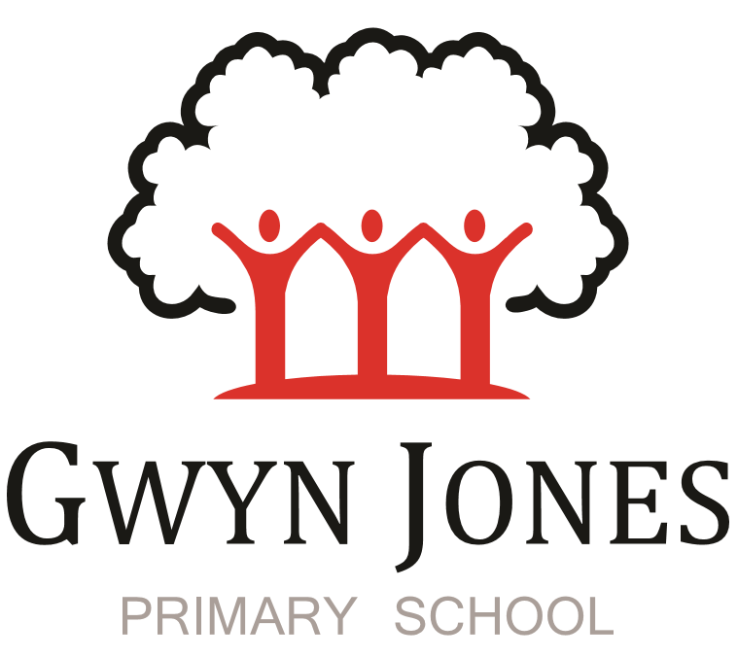



Recruitment Pack

Admissions and general admin

Permanent
Scale 4
Point: 7-11 (£26,351 - 27901 pro rata salary)
(£30,288 - £32070 FTE salary)

45.05 weeks including 5 INSET DAYS contract
36 hours & 15 Minutes per week

Hours of work: 7:45am-3:30 Monday to Friday with 30 minute lunch break


Dear Applicant,

Thank you for your interest in this exciting opportunity to join Gwyn Jones Primary School as a member of team in the role of Admissions and General Admin.

We are a two-form entry, culturally diverse school based in East London and we are very proud of our school. Visitors comment on the warmth of the school and the friendliness of both staff and pupils alike. Our dedicated staff team are incredibly hard working and are committed to creating a happy, secure and stimulating environment in which every child can achieve their potential and develop a life-long love of learning.

At Gwyn Jones Primary School we are a Rights Respecting School and we actively teach our children about the rights of the child. The Rights Respecting ethos permeates all parts of school life and into our school motto “Inspired and Empowered”. This motto epitomises the staff’s genuine commitment to provide a rich, creative and challenging curriculum which inspires children’s curiosity and empowers our pupils to have a voice and be knowledgeable, active global citizens. We strive to ensure that every child thrives academically whilst benefiting from excellent pastoral care that nurtures and develops emotional wellbeing.

We are looking for someone who:
- will co-ordinate all in year admissions and process bulk admissions for the September intake for reception and nursery.
- Prepare pupil and workforce cenus
- Will coordinate safer recruitment processes from advertising, pre-employment checks, keeping the SCR up to date. This is a demanding and important post. Attention to detail is essential as is the ability to work to tight deadlines.

Although not essential, experience working with admissions or data could be advantageous but full training will be given.

The ideal candidate will: -
- be highly organised
- be a proficient IT user with the ability to work efficiently with a high degree of accuracy
- have excellent communication skills that allow you to inform, coach and advise others
- want to make a difference to the children in our care

I hope this application pack and the information available generally on our website and on social media will give you a flavour of our School. I would be delighted to show you around our friendly and caring school. To arrange a visit please contact the school office on 02085567904 or email: HR@gwynjones.waltham.sch.uk

I look forward to meeting with you
Sian Boutalbi
Headteacher


Dear Applicant,
Thank you for your interest in the position of Admissions and General Admin at Gwyn Jones Primary School.
Gwyn Jones is a successful and very popular school within the local area. We are fortunate in having an engaged and culturally diverse community, a hardworking and talented staff team and amazing pupils.
As Governors, we work alongside the Head and her dedicated team in our common belief in the fundamental importance of Primary Education as the foundation for developing a lifelong love of learning in our children. Our Governing Board is keen to develop its skills and knowledge of the school and its community and supports the drive within school for continuous improvement within a nurturing and supportive environment.
Our curriculum is rich, diverse and challenging and aims to provide a range of exciting and meaningful experiences which foster confidence and provide aspirations. Staff plan for children to be academically challenged, creatively inspired and supported in their personal development.
Gwyn Jones maintains strong links with other local schools within Waltham Forest. As a member of our staff team you would receive ongoing support and development in your role.
If the thought of this role in our school excites you, we look forward to receiving your application.
Liz Jackson
Chair of Governor

Vision and Values

At Gwyn Jones, we are committed to ensuring that every member of our school community is inspired and empowered each day.
We aim to inspire and empower our children by:
- Providing excellent teaching which nurtures our children’s innate curiosity, allowing them opportunities to take risks and to think for themselves.
- Supporting our children to have responsibility for their own learning; to have their own opinions and the skills to articulate them.
- Allowing all children access to a rich and broad curriculum which fully prepares them to be active, global citizens.
- Ensuring all children participate in a variety of trips and visitors in their local and wider community.
- Acting as role models who respect others and enjoy the rich diversity of our school family.
- Insisting that every child is known well, safe and nurtured to achieve their personal best.
We aim to inspire and empower our staff by:
- Providing a wide range of relevant and innovative professional learning in school which focuses on collaboration and sharing good practice, including lesson study, planning support, team teacher and action research.
- Forging strong links with external agencies to deliver professional development - teaching schools, higher education institutes etc.
- Giving developmental feedback with clear and specific actions for staff and leaders.
- Establishing coaching and mentoring relationships which encourage reflection.
- Identifying and nurturing leadership talent.

Rights Respecting School 

What is UNICEF's Rights Respecting Schools?
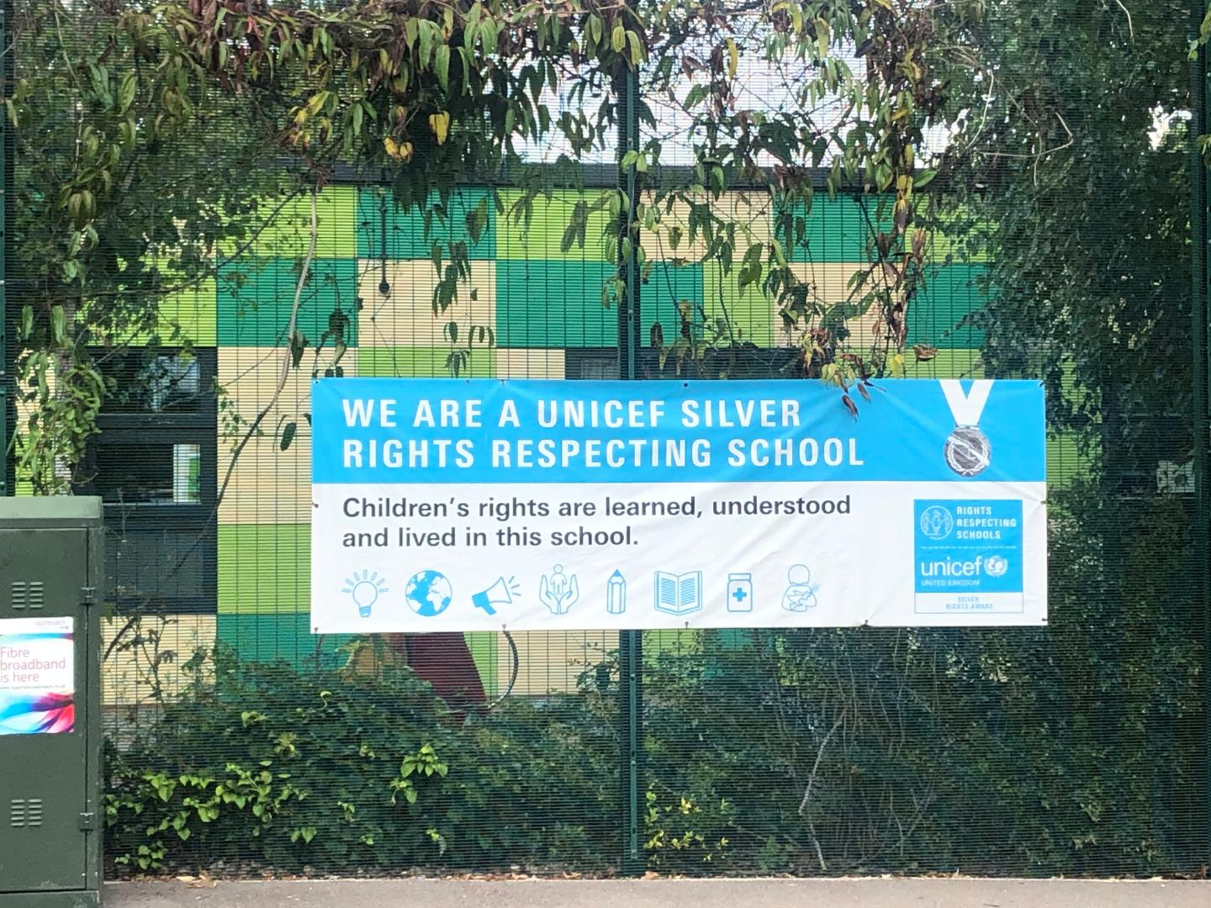

We are committed to placing the UN Convention on the Rights of the Child at the heart of our core values and ethos; believing children’s participation is integral to all aspects of school life. This results in empowered and self-confident children who can advocate for the rights of children everywhere.
This ethos further fosters a sense of community, respect and responsibility. It encourages the children to be active and informed citizens, who look to develop a positive future for all; campaigning and raising awareness.
The children’s experiences at Gwyn Jones Primary ensure the children know that they have the Rights of the Child and that these rights are inalienable. They also understand responsibilities they have as members of our local and global society.
How to Apply
Should you wish to apply for the post, please complete an application form and include a personal statement, which clearly demonstrates your suitability for this role. Please send your completed applications to HR@gwynjones.waltham.sch.uk

Closing Date
Friday 20th March 2026 at 9am.

Shortlisting
Shortlisting will take place on Friday 20th 2026, if you have not heard from us by Monday 23rd March 2026 please assume that unfortunately, on this occasion, your application has not been successful.

Interview
Interviews will take place on Wednesday 25th March 2026.

Safeguarding
Applicants called for interview are kindly requested to contact their referees so that references are received ahead of the interview dates.
Gwyn Jones Primary School is committed to safeguarding and promoting the welfare of children and young people and expects all staff and volunteers to share this commitment. The school follows safer recruitment practices and the successful applicants will be required to apply for an Enhanced Disclosure and Barring Service check. A copy of our Safeguarding Policy is available to view on our website.
Following KCSIE guidance 2025 an online search may be conducted on publicly available social media for shortlisted candidates only prior to interview.
Location
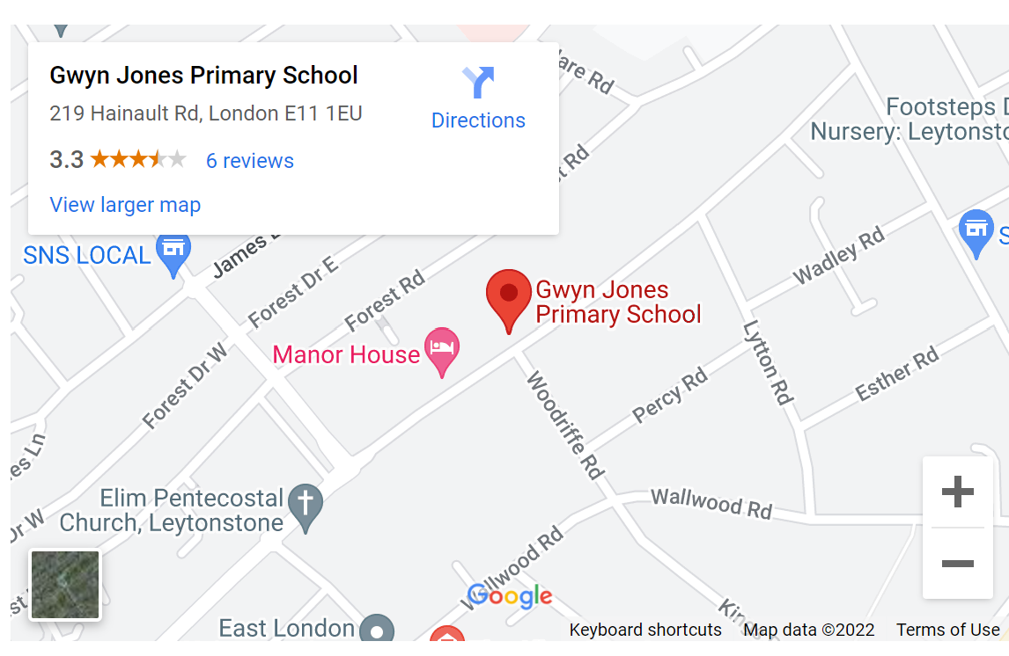

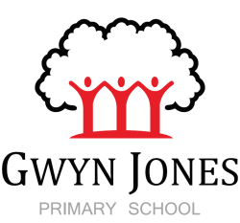
Gwyn Jones Primary School
Job description: Admissions and admin role
Terms of Employment
Grade Range: Scale 4: point 7-11
Responsible to: School Business Manager
Responsible for: no-one

Core Duties and Responsibilities
School Admissions and Leavers
- Maintain and collate pupil records and reports
- Input of all pupils on SIMS in a timely fashion
- Ensure all forms and paperwork is received in a timely fashion and accordance with procedure
- Complete all FSM, EYPP and pupil premium checks weekly and update regularly using local and national website
- Correspond/liaise with pupil admissions, ensure school has passed on and received relevant information
- Prepare the school census
- Maintain and update pupil admission packs
- Positively promote school to all enquirers
- Ensure all data is stored confidentially in line with GDPR.
- Prepare pupil information for census.
- Manage year 6 leavers procedures, assist parents with applications to secondary schools, ensuring all children are registered to a suitable establishment, liaising with the head of year to support a smooth transition.
- Complete off roll processes safely in line with policies.
- Request Safeguarding records from previous school for all new admissions and pass onto DSL.
- Responsibility for updating and maintaining the Pre-School Nursery waiting list.
- Assist with the smooth co-ordination of pre-school/nursery and reception admissions
- Managing the nursery childcare portal, checking funding arrangements are correct and up todate.
- Liaise with finance assistant about Nursery invoices

Communication
- Communicate clearly, consistently and proactively with parents
- Maintain a communication calendar to ensure all communication is conducted in a timely fashion
- Maintain and populate the school calendar and the website

HR

- To apply carry out DBS and other relevant pre-employment and vetting checks and update/maintain the Single Central Record accordingly.
- To play an active role in the recruitment of staff e.g. collecting references and managing the personal files
- To maintain SIMS information about staff and prepare for School Workforce Census.
- Oversee HR recruitment process with SBM
- To manage the volunteers and work experience process eg DBS checks, ensure induction has been complete, obtain references, maintain files ect

Admin
- To provide general administrative support for Senior Leadership Team
- When required, undertake reception duties such as, answering telephones and face to face enquiries.
- To participate in school emergencies as required, including co-ordinating arrangements
- Operate relevant equipment/ICT packages (e.g. word, excel, databases, spreadsheets, Internet)
- Operate office equipment e.g. photocopier, computer
- To ensure all information is treated confidentially and to have absolute discretion at all times.
- To ensure visitors sign in and are provided with a visitor's badge in accordance with the schools security procedures.
- To carry out robust checks on visitor's identification in accordance with the school safeguarding policy.
- To be responsible for checking in daily supply cover and completing all necessary vetting
documents

Responsibilities
- To work in accordance with and contribute to the values, culture, ethos, equalities and inclusion policies of the school proactively promoting anti-racist, anti-sexist and anti-discriminatory behaviours in the day-to-day operation of the job;
- Be aware of and comply with all policies and procedures including those relating to child protection and safeguarding, health, safety and security, confidentiality, equal opportunities and data protection, reporting all concerns to an appropriate person;
- To take appropriate action to identify, evaluate and minimise any risks to health, safety and security in the immediate working environment;
- Appreciate and support the role of other professionals;
- Ensure the development and progression of equality within the sphere of responsibility to this post and the fair and equal treatment of all colleagues, children, parents and visitors;

Personal & Professional Development
- Attend and participate in relevant meetings and professional learning activities as required.

Confidentiality and Data Protection
- To treat all information acquired through employment, both formally and informally, in strict confidence;
- Be aware of and comply with policies and procedures relating to child protection and safeguarding, reporting all concerns to an appropriate person
- To be alert to issues of child protection, ensuring that the welfare and safety of children attending the School/Nursery is promoted and safeguarded and to report any child protection concerns to the person responsible for child protection using safeguarding policies procedures and practice.
- Prevent, identify and minimise risk of interpersonal abuse or violence, safeguarding children and other vulnerable people.

The above-mentioned duties are neither exclusive nor exhaustive and the post holder may be required to carry out other relevant and/or reasonable duties as directed by their Head Teacher/Line Manager commensurate with the skills, abilities and grade of the post.

Person Specification

Criteria | Qualities | Desirable | Essential
Qualifications  and training | - GCSE English and Maths (or equivalent) |  | x
Qualifications  and training | - NVQ Level 2 or equivalent qualification or experience | x
Experience | - General clerical, administrative and financial tasks |  | x
Experience | - Dealing with face-to-face and telephone interactions |  | x
Experience | - Working with children or young people | x
Experience | - Working and collaborating within a team |  | x
Skills & knowledge | - Good oral and written communications skills |  | x
Skills & knowledge | - Ability to respond quickly and effectively to issues that arise |  | x
Skills & knowledge | - Ability to plan, organise and prioritise to meet deadlines |  | x
Skills & knowledge | - Ability to use own initiative and take action accordingly |  | x
Skills & knowledge | - Excellent attention to detail |  | x
Skills & knowledge | - Ability to use IT packages including word processing and spreadsheets, and a willingness to learn how to use school systems such as Sims and Parentmail |  | x
Skills & knowledge | - Ability to build effective working relationships with colleagues |  | x
Skills & knowledge | - Understanding data protection and confidentiality |  | x
Skills & knowledge | - Understanding of safeguarding |  | x
Personal qualities | - Commitment to promoting the ethos and values of the school and getting the best outcomes for all pupils |  | x
Personal qualities | - Commitment to acting with integrity, honesty, loyalty and fairness to safeguard the assets, financial probity and reputation of the school |  | x
Personal qualities | - Ability to work under pressure and prioritise effectively |  | x
Personal qualities | - Commitment to maintaining confidentiality at all times |  | x
Personal qualities | - Commitment to safeguarding and equality |  | x
Personal qualities | - Embraces change well |  | x
Personal qualities | - Deals with difficult situations effectively |  | x

