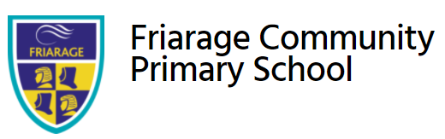

Together We Can

Advanced Teaching Assistant
Friarage Community Primary School
Friargate, Scarborough, YO11 1HS

Contents

Welcome from the Headteacher 3
Our schools 4-5
Application process 6
Job Description and Person Specification 7-12

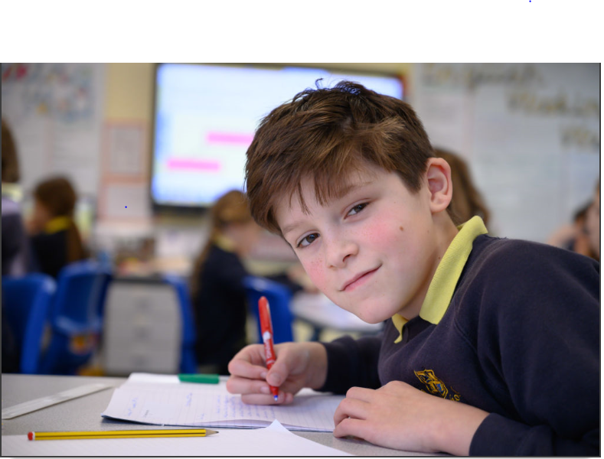

Dear applicant,

Allow me to extend a warm welcome from all governors, staff and children of Friarage Community Primary School. I am delighted you have shown interest in joining us and I look forward to sharing with you what makes our school a very special place to work.

I am proud to be the Headteacher of an inclusive school which provides a nurturing, safe and inspiring place of learning to our children at the very heart of Scarborough town. Yes we have challenges within our context but at our very heart is a desire, commitment and teamwork that makes our vision ‘together we can’ a reality.

As a school we officially joined the Coast and Vale Learning Trust in September 2019 which is a hugely positive step on our improvement journey. All colleagues at all levels are working closely with our sister school Newby & Scalby Primary and the Trust – and you will find a real buzz about our school and a palpable sense of energy, excitement and a love of teaching and children.

This teaching post is incredibly important for our journey, and we are looking for a colleague who shares the same ethos and values, understands our local context and can provide the inspired teaching our children thrive on and deserve!

This is an exciting time to join us. As part of the Coast and Vale Learning Trust (along with Newby &Scalby Primar, Scalby Secondary School and Lady Lumley’s School) we are working together to share, learn and create a primary hub our area can be proud of. Through our Trust we are able to access the support and resources from our Teaching Alliance, which means as a staff member you have a wide range of colleagues, tools and resources to help you develop not just in the classroom but beyond.

I hope that you will take the time to come and see and experience for yourself the warm and welcoming atmosphere which makes our vision a reality.

Good luck with your application. I look forward to reading it.

Cheryl Cappleman
Headteacher

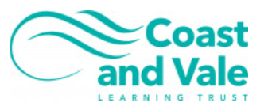

Our Schools

Newby and Scalby Primary School
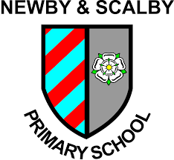
We are one of the schools of choice in our community and we are within commutable distance of Whitby, Teesside, York and surrounding areas. Ofsted in 2018 judged us to be ‘good’ in all areas and as a school we are very much outward facing both in terms of teaching and learning and in constantly thinking about how we can improve.
Our learning environment, outcomes and curriculum that is offered to our 420 children is second to none and we are a school with low staff turnover and high staff retention.
Our ethos is very much about our community ‘working to learn together’ and our teaching and support staff are central to this. Teaching is the best job in the world and as a school we encourage all staff to take opportunities to lead on whole school projects through our ‘research school’ ethos.
To learn more about us please visit us at Newby and Scalby Primary School - Home (coastandvale.academy)

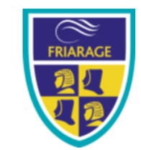
Friarage Primary School

We are proud to serve the communities around the Castle Ward area of Scarborough as ‘Together we can’ make a real difference to the life chances of children and young people in Scarborough.

Children and staff will work and play together developing skills so that we all become ambitious and reflective lifelong learners as well as being respectful and respected members of the community.
We are committed to Restorative Practice Principles to nurture respect for all in our school community.

To learn more about us please visit us at Friarage Community Primary School - Home (coastandvale.academy)

Scalby School
Scalby School is a successful and popular 11-16 community school and in recent years we have become the school of choice in our local community. We were judged ‘good’ by Ofsted in 2019 and in 2019 we celebrated sustained results. Our provisional P8 score has placed us in the top 20% of schools nationally. We are proud of our broad and balanced GCSE based curriculum.

To learn more about us please visit us at Scalby School - Home (coastandvale.academy)

Lady Lumley’s School
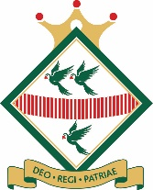

Lady Lumley’s School (11-18) in Pickering is on a transformational journey. We are a school that is popular with parents and is easily accessible across North Yorkshire, East Riding and Wolds and Vale. The communities we serve around the Pickering, Ryedale and wider Coastal area deserve and need our school to play a leading role in terms of teaching, learning, progress and outcomes.

In April 2020 we welcomed our new Headteacher Clair Foden who joined us at the same time we joined our Trust - Coast and Vale Learning Trust. Lady Lumley’s is on an ambitious journey of school improvement.

To learn more about us please visit us at Lady Lumley's School - Home (coastandvale.academy)

Application Process
The closing date for all applications is 9am on Friday 7th January 2022

Interviews will be held PM on Wednesday 12th January 2022

Completed applications must be returned to Garry Morrison at garry.morrison@northyorks.gov.uk

If you do not receive confirmation of receipt of your application within one working day please call Garry on 07814935700.

If you think you’re the person for the job, please complete the enclosed application form to the email address above by the closing date.

An email will be sent to shortlisted candidates with details of the interview process. If you have not heard from us within a week of the closing date please assume your application has been unsuccessful.

Queries
Visits are warmly welcome. Please contact Garry to arrange.

We actively welcome you to contact James at North Yorkshire County Council to chat through the role and talk informally about the school/post and how working here will make a real difference to the children and young people on the coast.

JOB DESCRIPTION

POST: |  | Advanced Teaching Assistant (ATA)
GRADE: |  | Grade D
RESPONSIBLE TO: |  | Head Teacher / Senior SENCO
RESPONSIBLE FOR: |  | None
POST REF: |  |  | JOB FAMILY: 7
JOB PURPOSE: | To work, under the direction of the SENCO and other appropriate staff, in assisting in and contributing to the planning, delivery and evaluation of the learning process. The post holder will work 1-1 or in small groups, locations with access to support and guidance,.
JOB CONTEXT: | This school is committed to safeguarding and promoting the welfare of our pupils and young people. We have a robust Child Protection Policy and all staff will receive training relevant to their role at induction and throughout employment at the School. We expect all staff and volunteers to share this commitment. This post is subject to a satisfactory enhanced Disclosure and Barring Service criminal records check for work with children.  An ability to fulfil all spoken aspects of the role with confidence through the medium of English
ACCOUNTABILITIES / MAIN RESPONSIBILITIES
Supporting Learning & Development | - . Deliver a language intervention programme for individuals and groups of pupils under the professional direction and supervision of a qualified teacher, differentiating and adapting learning programmes to support the needs of allocated pupils  - Monitor and record pupil responses and learning achievements and give appropriate feedback to teachers towards the overall assessment of pupil progress and attainment made by the teacher and other professionals  - Interact with pupils in ways that support the development of their ability to think and learn, including the use of careful questioning  - Support and assist in the development and implementation of appropriate behaviour management strategies  - Take account of the effects of different parenting approaches, backgrounds and routines, and be involved in home school liaison, as directed by the class/subject teacher  - Support pupils in their social and emotional wellbeing in implementing relevant social, health, and physical programmes, including for those with health, social and physical needs  - Escort and supervise pupils on educational visits and out of schools activities under the supervision of a teacher  - Undertake break supervision as required
Communication | - Establish rapport and respectful, trusting relationships and communicate effectively with pupils, their families and carers, and other agencies / professionals  - Initiate appropriate and effective communication with the class teacher, and other professionals, forging and sustaining relationships across agencies
Sharing Information | - Assess, record and report on pupils’ attainment and progress within assessment and reporting processes  - Participate in meetings with other staff, external professionals and parents regarding pupils, in a support capacity to the teacher, who will normally lead on such matters  - Pay due regard to professional boundaries, maintaining appropriate levels of confidentiality  - Participate in staff meetings where appropriate  - Share information confidentially about pupils with teachers and other professionals as required
Safeguarding and Promoting the Welfare of Children & Young People | - Carry out tasks associated with pupil’s personal hygiene and welfare, including personal intimate care, physical and medical needs, whilst encouraging independence  - Be responsible for promoting and safeguarding the welfare of pupils in line with policy and legislation, raising concerns as appropriate
Administration/Other | - Support the use of ICT and adhere to relevant policies  - Supervise and provide access arrangement for pupils sitting internal and external examinations and tests, ensuring that examinations comply with Examination Board Regulations  - Participate in appraisal, training and other learning activities
Data Protection | - To comply with the Coast and Vale Learning Trust’s policies and supporting documentation in relation to Information Governance this includes Data Protection, Information Security and Confidentiality
Health and Safety | - Be aware of and implement your health and safety responsibilities as an employee and where appropriate any additional specialist or managerial health and safety responsibilities as defined in the Health and Safety policy and procedure  - Work with colleagues and others to maintain health, safety and welfare within the working environment
Equalities | - Promote inclusion and acceptance of all pupils  - Within own area of responsibility work in accordance with the aims of the Equality Policy, treating individuals with respect for their diversity, culture and values
Flexibility | - Coast and Vale Learning Trust provides front line services, which recognises the need to respond flexibly to changing demands and circumstances. Whilst this job outline provides a summary of the post, this may need to be adapted or adjusted to meet changing circumstances. Such changes would be commensurate with the grading of the post and would be subject to consultation. All staff are required to comply with Scalby Learning Trust’s Policies and Procedures
Customer Service | - The Coast and Vale Learning Trust requires a commitment to equity of access and outcomes, this will include due regard to equality, diversity, dignity, respect and human rights and working with others to keep vulnerable people safe from abuse and mistreatment  - The Coast and Vale Learning Trust requires that staff offer the best level of service to their customers and behave in a way that gives them confidence. Customers will be treated as individuals, with respect for their diversity, culture and values

Essential upon appointment | Desirable on appointment
Knowledge  - Good understanding of child/ young people’s development and learning processes  - Understanding of individual children and young people’s needs  - An understanding that children/Young people have differing needs and knowledge of inclusive practice | - Knowledge of Behaviour Management techniques  - Knowledge of Child Protection policies & Procedures  - Knowledge of Health & Safety legislation
Experience  - Appropriate experience working with children in an education setting | - Experience in other relevant skills e.g. art/music/sport  - Experience of delivering evidence based interventions that accelerate learning
Occupational Skills  - Good written and verbal communication skills: able to communicate effectively and clearly and build relationships with a range of staff, children, young people, their families and carers  - Behaviour management  - Good reading, writing and numeracy skills | - Demonstrable ICT skills and ability to use them as part of the learning process, or, the ability to develop ICT skills in a reasonable timeframe
Qualifications  - Relevant NVQ Level 3 or equivalent | - Appropriate first aid training (Dependent on the schools needs - insert as appropriate)
Personal Qualities  - Demonstrable interpersonal skills  - Ability to work successfully in a team  - Able to exercise judgement  - Confidentiality  - Flexibility | - Creativity
Other Requirements
- Enhanced DBS clearance
- To be committed to the school's policies and ethos
- To be committed to Continuing Professional Development
- Motivation to work with children and young people
- Ability to form and maintain appropriate relationships and personal boundaries with children and young people
- Emotional resilience in working with challenging behaviours and attitudes
- Ability to use authority and maintaining discipline
- An empathy for equality & diversity
- The ability to converse at ease with customers and provide advice in accurate spoken English is essential for the post

