Gladstone Road Primary – Advanced Teaching Assistant (KS2)
Required for January 2022 or asap

I am delighted you are interested in joining our teaching team here at Gladstone Primary School. You will be joining a highly ambitious, aspirational group of professionals who are raising standards and significantly improving the life chances of the children of Scarborough and the Yorkshire Coast.

Our motto ‘Learning to Succeed’ is at the heart of everything we do. We live the values necessary for children to contribute positively to the world they will inherit and lead one day. Our children feel valued and accepted as individuals. Our aim is that they will be able to function in the wider community in which they have respect for themselves, others, and their environment.

We are fortunate to have a school environment that mixes the traditional school feel along with making sure we have a tailored and creative curriculum that allows us to give our children the opportunities that they deserve.

Staff morale is high and we have a commitment to recognise individual potential and to provide support, CPD and training for colleagues joining our school at all levels; you will never feel unsupported or alone in our school.

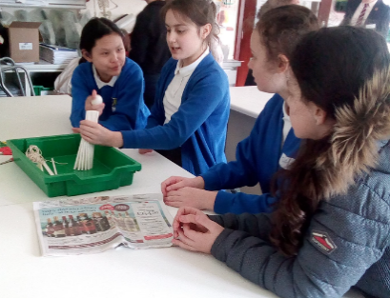
As a school we are secure and share resources, teaching, curriculum ideas and partnerships with other schools to maximise the benefits to our children, staff and the community.

We are looking for an experienced ATA to join our KS2 team, supporting the class teacher in providing the best possible opportunities for our children.

We are really proud of our school and the progress we are making. Please take the time to come and visit us – we’d love to show you around.

Garry Johnson (Head teacher)

Our Staff
Helen Halliday is our Deputy Headteacher
Hello! My name is Mrs Halliday and I am the Deputy Headteacher here at Gladstone Road Primary School.

I have worked here for a number of years now (almost 12 years) and that is because it is an absolute pleasure to work in such a dynamic environment and within such a warm and amazing community.

Every day is different and my role entails an array of different things but what I particularly enjoy is the time I spend with the children when I visit classrooms. Each and every day I visit several if not all classrooms to say hello to the children.

What inspires me most and makes me feel incredibly happy is how the children at Gladstone Road love to learn and love to be at school. They are all so proud of their achievements no matter how great or small.

Another highlight for me is when I take the Year 6 children to London for 4 days in the Summer term. Although tiring, it is the most spectacular trip I have ever taken children on and I have worked in several schools. We visit all the sights, go to a theatre show and visit Harry Potter World as well as many

other things! This is definitely one of my favourite things I do as part of my role.

I also enjoy working with a team of staff who are constantly striving to provide the very best education we can for all of our children.

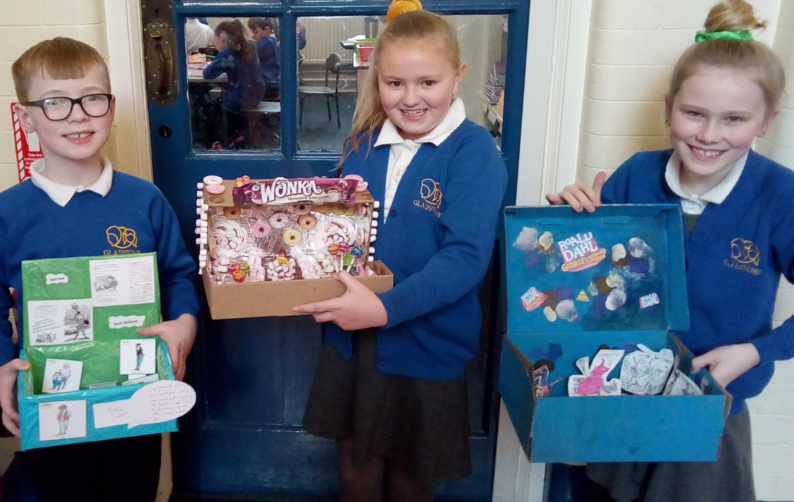

Job details
Advanced Teaching Assistant

All posts at Gladstone Road Primary involve at all times, a view to further the mission, values and strategic aims of the school; accepting responsibility for the implementation of school policy, procedures and other guidance, as set out in the Staff Handbook and elsewhere; working positively, flexibly and co-operatively both with colleagues and as appropriate with those outside school; and the setting of high standards.

All roles involve responsibilities and expectations as set out in the appropriate national standards and in the school's role specifications and documentation.

All members of staff are expected to promote and safeguard the welfare of students in accordance with the Safeguarding Children in Education Act,

Including maintaining clear professional boundaries in all relationships; to promote an anti-racist, multi-cultural approach; in line with school policy. Additional duties may be asked of members of staff by the Head teacher as occasion requires.

The generic role specifications are offered in good faith as a guide to professional practice in the expectation that staff will seek to approach them in a professional manner. All role specifications are subject to revision in the light of changing circumstances.

Good luck with your application!

Application Process
Please request further details from:
Garry Morrison at garry.morrison@northyorks.gov.uk
Telephone: 07966261249

Applications Accepted By:
Email:  Email applications accepted to  garry.morrison@northyorks.gov.uk  Please Include:  - Fully completed application form  - Letter of application addressed to Garry Johnson, Head teacher, covering no more than two sides of A4. | Mail:  Helen Duck  Business Manager  Gladstone Road Primary School  Wooler Street  Scarborough  YO12 7DD

