Advanced Teaching Assistants – to start as soon as possible
Full time/part time hours available – (8.30-3.25 daily or 8.30-1.30 daily)

I am delighted you are interested in joining our team here at Gladstone Primary School. You will be joining a highly ambitious, aspirational group of professionals who are raising standards and significantly improving the life chances of the children of Scarborough and the Yorkshire Coast.

Our motto ‘Learning to Succeed’ is at the heart of everything we do. We live the values necessary for children to contribute positively to the world they will inherit and lead one day. Our children feel valued and accepted as individuals. Our aim is that they will be able to function in the wider community in which they have respect for themselves, others, and their environment.

We are fortunate to have a school environment that mixes the traditional school feel along with making sure we have a tailored and creative curriculum that allows us to give our children the opportunities that they deserve.

Staff morale is high and we have a commitment to recognise individual potential and to provide support, CPD and training for colleagues joining our school at all levels; you will never feel unsupported or alone in our school.

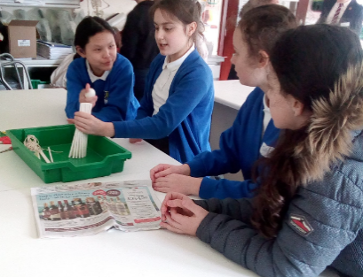
As a school we are secure and share resources, teaching, curriculum ideas and partnerships with other schools to maximise the benefits to our children, staff and the community.

The children at Gladstone Road are delightful, happy, confident and energetic. They are passionate about their learning, be it in the traditional classroom or through other areas of the curriculum such as dance, art, PE and music.
We are really proud of our school and the progress we are making. Please take the time to come and visit is – we’d love to show you around.

Garry Johnson (Head teacher)

Our staff
Mrs Brown is one of our Class Teachers
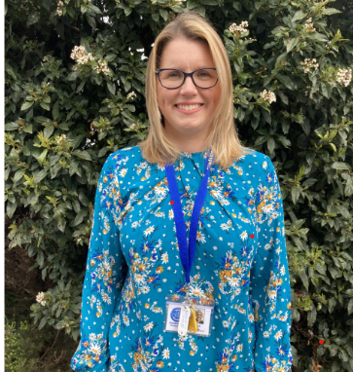
Hello, I’m Miss Brown and I have been a teacher and KS2 Music Coordinator here at Gladstone Road since 2001.

One of my favourite things about teaching is spending time with my class, and getting to know all of the children as individuals with their unique personalities and contributions to school and classroom life.
The subjects I most enjoy teaching are DT, maths and music, and my favourite subjects to learn about are history and geography.
I also love being part of our school orchestra and seeing those children who take up musical instruments in year 3/4 become proficient enough to play their first notes at orchestra rehearsals, pass their music exams and even perform their first solos in a school assembly or concert.
The best part of teaching at Gladstone Road though is taking the children out and about on the various trips and visits we provide: these experiences are always memorable with never a dull moment!

Mrs Gill is our Assistant Headteacher (KS2)

Hi I’m Miss Gill and I’m one of the Assistant Headteacher’s. I have worked at Gladstone Road Primary School for five years and I really love my job! I returned to my home town after teaching in Hull for many years!
I work with amazing children who inspire me to be the best leader I can be. Every day I learn something new from the brilliant team of staff that work in our school.
Up until now I have worked as the Lower school Assistant Headteacher but I am now the Assistant Head for KS2. I can usually be found on the playground or popping into classrooms. I spend lots of time talking to pupils, parents and staff so I know exactly what’s going on in school and if needed I help to sort out any problems.
I love baking and sharing what I make! The outdoors is important to me and this is something I want to make better for our school but I will only do that by listening to the children who help guide me.

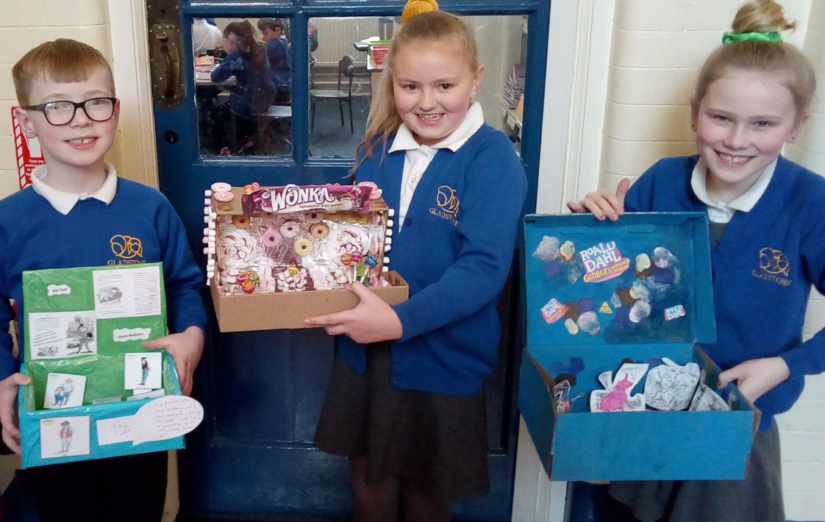

Job details
- Advanced Teaching Assistants

All posts at Gladstone Road Primary involve at all times, a view to further the mission, values and strategic aims of the school; accepting responsibility for the implementation of school policy, procedures and other guidance, as set out in the Staff Handbook and elsewhere; working positively, flexibly and co-operatively both with colleagues and as appropriate with those outside school; and the setting of high standards.

All roles involve responsibilities and expectations as set out in the appropriate national standards and in the school's role specifications and documentation.

All members of staff are expected to promote and safeguard the welfare of students in accordance with the Safeguarding Children in Education Act, including maintaining clear professional boundaries in all relationships; to promote an anti-racist, multi-cultural approach; in line with school policy. Additional duties may be asked of members of staff by the Head teacher as occasion requires.

The generic role specifications below are offered in good faith as a guide to professional practice in the expectation that staff will seek to approach them in a professional manner. All role specifications are subject to revision in the light of changing circumstances.

Good luck with your application!

Application Process
Application forms, job description, and person specifications are available to download from our website at www.gladstoneschool.co.uk by clicking on vacancies and are also available to download from the NYCC jobs advert

Applications Accepted By:
Email:  Email applications accepted to  James.annetts@northyorks.gov.uk  Please Include:  - Fully completed application form and any supporting information | Mail:  Caroline Sarney  Business Manager  Gladstone Road Primary School  Wooler Street  Scarborough  YO12 7DD

Job Description:
POST: |  |  | Advanced Teaching Assistant (ATA)
GRADE:
RESPONSIBLE TO: |  |  | Senior Leadership Team/ Class Teacher/ Higher Level Teaching Assistant / SENCO/Inclusion Manager
RESPONSIBLE FOR: |  |  | None
POST REF: |  |  |  | JOB FAMILY: 7
JOB PURPOSE: |  | To work, under the direction of the class teacher and other appropriate staff, in assisting in and contributing to the planning, delivery and evaluation of the learning process. The post holder will work in classes, or other appropriate locations with access to support and guidance, supervising groups and /or individual pupils.
ACCOUNTABILITIES / MAIN RESPONSIBILITIES
Supporting Learning & Development | - Assist in the planning and evaluation of learning activities with the teacher. Deliver learning activities for individuals and groups of pupils under the professional direction and supervision of a qualified teacher, differentiating and adapting learning programmes to support the needs of allocated pupils  - With the class/subject teacher, plan and deliver small group interventions, with clear objectives and appropriate learning outcomes  - Monitor and record pupil responses and learning achievements and give appropriate feedback to teachers towards the overall assessment of pupil progress and attainment made by the teacher and other professionals  - Interact with pupils in ways that support the development of their ability to think and learn, including the use of careful questioning  - Support and assist in the development and implementation of appropriate behaviour management strategies  - Take account of the effects of different parenting approaches, backgrounds and routines, and be involved in home school liaison, as directed by the class/subject teacher  - Support pupils in their social and emotional wellbeing in implementing relevant social, health, and physical programmes, including for those with health, social and physical needs  - Escort and supervise pupils on educational visits and out of schools activities under the supervision of a teacher  - Undertake break supervision as required
Communication - Establish rapport and respectful, trusting relationships and communicate effectively with pupils, their families and carers, and other agencies / professionals - Initiate appropriate and effective communication with the class teacher, and other professionals, forging and sustaining relationships across agencies  Sharing Information - Assess, record and report on pupils’ attainment and progress within assessment and reporting processes - Participate in meetings with other staff, external professionals and parents regarding pupils, in a support capacity to the teacher, who will normally lead on such matters - Assist in the induction and development of classroom support staff, cascading information and good practice - Pay due regard to professional boundaries, maintaining appropriate levels of confidentiality - Participate in staff meetings - Share information confidentially about pupils with teachers and other professionals as required  Safeguarding and Promoting the Welfare of Children & Young People - Carry out tasks associated with pupil’s personal hygiene and welfare, including personal intimate care, physical and medical needs, whilst encouraging independence - Be responsible for promoting and safeguarding the welfare of pupils in line with policy and legislation, raising concerns as appropriate  Administration/Other - Assist the teacher and work as directed in preparation of the classroom and resources for planned work to take place - Undertake routine clerical duties as required - Support the use of ICT and adhere to relevant policies - Supervise and provide access arrangement for pupils sitting internal and external examinations and tests, ensuring that examinations comply with Examination Board Regulations - Participate in appraisal, training and other learning activities  Data Protection - To comply with the County Council’s policies and supporting documentation in relation to Information Governance this includes Data Protection, Information Security and Confidentiality  Health and Safety - Be aware of and implement your health and safety responsibilities as an employee and where appropriate any additional specialist or managerial health and safety responsibilities as defined in the Health and Safety policy and procedure - Work with colleagues and others to maintain health, safety and welfare within the working environment  Equalities - Promote inclusion and acceptance of all pupils - Within own area of responsibility work in accordance with the aims of the Equality Policy, treating individuals with respect for their diversity, culture and values  Flexibility North Yorkshire County Council provides front line services, which recognises the need to respond flexibly to changing demands and circumstances. Whilst this job outline provides a summary of the post, this may need to be adapted or adjusted to meet changing circumstances. Such changes would be commensurate with the grading of the post and would be subject to consultation. All staff are required to comply with County Council Policies and Procedures  Customer Service The County Council requires a commitment to equity of access and outcomes, this will include due regard to equality, diversity, dignity, respect and human rights and working with others to keep vulnerable people safe from abuse and mistreatment - The County Council requires that staff offer the best level of service to their customers and behave in a way that gives them confidence. Customers will be treated as individuals, with respect for their diversity, culture and values  Date of Issue: | - Establish rapport and respectful, trusting relationships and communicate effectively with pupils, their families and carers, and other agencies / professionals  - Initiate appropriate and effective communication with the class teacher, and other professionals, forging and sustaining relationships across agencies
At Gladstone Road Primary we expect our Teaching Assistants to adhere to the Professional Standards for Teaching Assistants. These are outlined below:

Personal and professional conduct

Teaching assistants should uphold public trust in the education profession by:
- Having proper and professional regard for the ethos, policies and practices of the school in which they work as professional members of staff.
- Demonstrating positive attitudes, values and behaviours to develop and sustain effective relationships with the school community.
- Having regard for the need to safeguard pupils’ well-being by following relevant statutory guidance along with school policies and practice.
- Upholding values consistent with those required from teachers by respecting individual differences and cultural diversity.
- Committing to improve their own practice through self-evaluation and awareness.

Knowledge and understanding

Teaching assistants are expected to:
- Share responsibility for ensuring that their own knowledge and understanding is relevant and up to date by reflecting on their own practice, liaising with school leaders, and identifying relevant professional development to improve personal effectiveness.
- Take opportunities to acquire the appropriate skills, qualifications, and/or experience required for the teaching assistant role, with support from the school/employer.
- Demonstrate expertise and skills in understanding the needs of all pupils (including specialist expertise as appropriate) and know how to contribute effectively to the adaptation and delivery of support to meet individual needs.
- Demonstrate a level of subject and curriculum knowledge relevant to their role and apply this effectively in supporting teachers and pupils.
- Understand their roles and responsibilities within the classroom and whole school context recognising that these may extend beyond a direct support role.

Teaching and learning

Teaching assistants are expected to:
- Demonstrate an informed and efficient approach to teaching and learning by adopting relevant strategies to support the work of the teacher and increase achievement of all pupils including, where appropriate, those with special educational needs and disabilities.
- Promote, support and facilitate inclusion by encouraging participation of all pupils in learning and extracurricular activities.
- Use effective behaviour management strategies consistently in line with the school’s policy and procedures.
- Contribute to effective assessment and planning by supporting the monitoring, recording and reporting of pupil performance and progress as appropriate to the level of the role.
- Communicate effectively and sensitively with pupils to adapt to their needs and support their learning.
- Maintain a stimulating and safe learning environment by organising and managing physical teaching space and resources.

Working with others
Teaching assistants are expected to:
- Recognise and respect the role and contribution of other professionals, parents and carers by liaising effectively and working in partnership with them.
- With the class teacher, keep other professionals accurately informed of performance and progress or concerns they may have about the pupils they work with.
- Understand their responsibility to share knowledge to inform planning and decision making.
- Understand their role in order to be able to work collaboratively with classroom teachers and other colleagues, including specialist advisory teachers.
- Communicate their knowledge and understanding of pupils to other school staff and education, health and social care professionals, so that informed decision making can take place on intervention and provision.

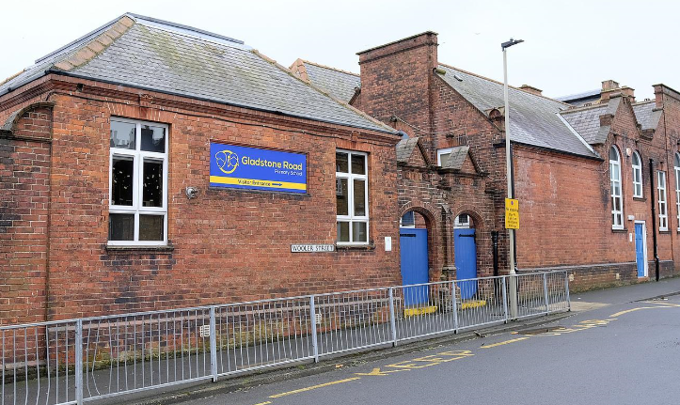

Person Specification

Essential upon appointment | Desirable on appointment (if not attained, development may be provided for successful candidate)
Knowledge
- Good understanding of child/ young people’s development and learning processes  - Understanding of individual children and young people’s needs  - An understanding that children/Young people have differing needs and knowledge of inclusive practice  - Understanding of the expectations of Teaching Assistant Standards and how to apply them | - Knowledge of Behaviour Management techniques  - Knowledge of Child Protection policies & Procedures  - Knowledge of Health & Safety legislation
Experience
- Appropriate experience working with children in an education setting | - Experience in other relevant skills e.g. art/music/sport  - Experience of delivering evidence based interventions that accelerate learning
Personal Qualities
- Demonstrable interpersonal skills  - Ability to work successfully in a team  - Able to exercise judgement  - Confidentiality  - Flexibility | - Creativity
Occupational Skills
- Good written and verbal communication skills: able to communicate effectively and clearly and build relationships with a range of staff, children, young people, their families and carers  - Behaviour management  - Good reading, writing and numeracy skills | - Demonstrable ICT skills and ability to use them as part of the learning process, or, the ability to develop ICT skills in a reasonable timeframe
Qualifications
- Relevant NVQ Level 3 or equivalent  - Maths and English GCSE at grade C or equivalent | - Appropriate first aid training (Dependent on the school’s needs - insert as appropriate)
Other Requirements
- Enhanced DBS clearance
- To be committed to the school's policies and ethos
- To be committed to Continuing Professional Development
- Motivation to work with children and young people
- Ability to form and maintain appropriate relationships and personal boundaries with children and young people
- Emotional resilience in working with challenging behaviours and attitudes
- Ability to use authority and maintaining discipline
- An empathy for equality & diversity
- The ability to converse at ease with customers and provide advice in accurate spoken English is essential for the post

NB – Assessment criteria for recruitment will be notified separately.

