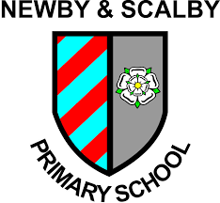

Working to Learn Together

Advanced Teaching Assistants/SEN x 2
Required for as soon as possible
Recruitment Information Pack
Newby & Scalby Primary School
The Green, Scarborough, YO12 5JA

Contents

Welcome from the Headteacher 3
Our staff 4
Our schools 5
Application process and how to apply 6
Job Description and Person Specification 7-11

Dear applicant,

Allow me to extend a warm welcome from all governors, staff and children of Newby & Scalby Primary School. I am delighted you have shown interest in joining us and I look forward to sharing with you what makes our school a very special place to work.

Our children are delightful, happy, confident and energetic. They are passionate about their learning, be it in the classroom or through other areas of our developed curriculum such as dance, art, PE and music.

Over many years together we have built a learning community that puts the whole child and their development, along with harnessing the skills of our staff at our very heart. You will be joining a school with low staff turnover and high staff retention and as Headteacher it is my job to make sure colleagues are supported and challenged to be lifelong learners.

Working at Newby &Scalby is incredibly rewarding. Due to our well-deserved reputation across the area we place huge importance on developing talent – and in many ways our ‘research school’ ethos has resulted in many staff being developed as a support professional. I still get an incredible buzz from seeing our children reach their full potential through our staff training and development focus.

This is an exciting time to join us. As the founding primary member of the Scalby Learning Trust (along with Scalby School) our team are working in partnership with our sister school Friarage Primary to share, learn and create a primary hub our area can be proud of. Through our Trust we are able to access the support and resources from our Teaching School, which means as a staff member you have a wide range of colleagues, tools and resources to help you develop not just in the classroom but beyond.

I hope that you will take the time to come and see and experience for yourself the warm and welcoming atmosphere which makes our vision a reality.

Good luck with your application. I look forward to reading it.

Chris Kirkham- Knowles
Headteacher

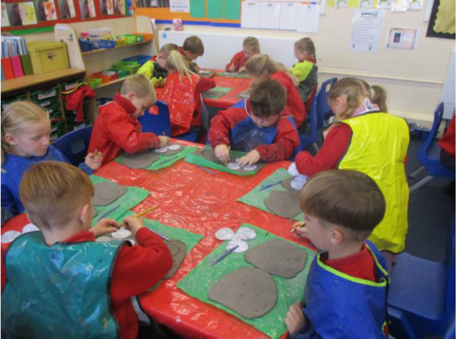
Our staff
Maddie Blakeley is an Early Career Teacher at Newby and Scalby Primary School in Scarborough. She has worked at the school since June 2017.
What do you enjoy most about your job?
I don't think there is any job that can be as varied as teaching is. You can't beat working with children: getting to know them as people; sharing their hopes and aspirations for the future; celebrating their successes and watching them finally get something they have been struggling with. That is when you truly know you have made a difference. Finding a school where this ethos is shared and where children are the driving force is what I have managed to do and I work alongside an incredible group of dedicated people that share that same goal. Not only have I found a group of work colleagues but also a group of friends that support me and make me laugh often.
What’s the best thing about the community that your school serves?
The community plays a large role in our teaching and learning and is a lovely area to work. We are lucky to work so closely with many services. Whether it be borrowing a book from the local library, visiting the local church for a tour of the war memorial or sharing harvest gifts with local residents, we gain a lot from this. Having open days and workshops means people are welcome to see how the school runs and how their children are getting on. It is a great way to get to know the school and teachers.
What would you say to a teacher thinking about moving to a school on the Yorkshire Coast?
I don't think you can beat working on the coast. Personally, I was brought up in Scarborough but after going to university in Lincoln and working in city schools and village schools I always knew that the coast would be where I ended up. Having the beach on your doorstep is ideal and I'm sure some of our children would agree, especially our Year 6s who have spent an afternoon surfing in the past with trained lifeguards. Trips to the beach and the local parks all add to the different experiences that children in our school are exposed to. We have a bit of everything that is only a walk or short drive away.

Our schools

Newby and Scalby Primary School

We are one of the schools of choice in our community and we are within commutable distance of Whitby, Teeside, York and surrounding areas. Ofsted in 2018 judged us to be ‘good’ in all areas and as a school we are very much outward facing both in terms of teaching and learning and in constantly thinking about how we can improve.
Since our “good” Ofsted, we continue to build on our successes and we are a family and a team, where everyone is given the challenge and support to be the best they can possible be in a safe, welcoming and positive environment. Children and staff will work and play together developing skills so that we all become ambitious and reflective lifelong learners as well as being respectful and respected members of the community.
To learn more about us please visit us at http://www.thelifecloud.net/schools/NewbyandScalbyPrimarySchool
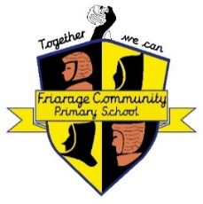
Friarage Primary School

We are proud to serve the communities around the Castle Ward area of Scarborough as ‘Together we can’ make a real difference to the life chances of children and young people in Scarborough.

Children and staff will work and play together developing skills so that we all become ambitious and reflective lifelong learners as well as being respectful and respected members of the community.
We are committed to Restorative Practice Principles to nurture respect for all in our school community.

To learn more about us please visit us at https://friarageprimary.org.uk/

Scalby School

Scalby School is a successful and popular 11-16 community school and in recent years we have become the school of choice in our local community. We were judged ‘good’ by Ofsted in 2019 and in 2019 we celebrated sustained results. Our provisional P8 score has placed us in the top 20% of schools nationally. We are proud of our broad and balanced GCSE based curriculum.
To learn more about us please visit us at http://www.scalbyschool.org.uk/

Application Process
The closing date for all applications is Monday 29th November 2021 at 9am

Interviews will be held on Wednesday 1st December 2021

Completed applications must be returned to Garry Morrison at garry.morrison@northyorks.gov.uk

If you do not receive confirmation of receipt of your application within one working day please call Garry on 07814935700

If you think you’re the person for the job, please complete the enclosed application form having looked at the job description and person specification.

An email will be sent to shortlisted candidates with details of the interview process. If you have not heard from us within a week of the closing date please assume your application has been unsuccessful.

Queries

We actively welcome you to contact Garry at North Yorkshire County Council to chat through the role and talk informally about the school/post and how working here will make a real difference to the children and young people on the coast.

JOB DESCRIPTION

JOB TITLE: Advanced Teaching Assistant + SEN
WORKING: 32.5 hours per week (TTO)
RESPONSIBLE TO: Teaching Staff and Deputy Headteacher

JOB PURPOSE
To work, under the direction of the Inclusion Manager and any appropriate staff, in assisting the delivery of the learning process. Working wholly or mainly with pupils with special educational needs, the post holder will assist in the planning, preparation and delivery of learning activities, as well as with monitoring, recording and reporting on students. Take responsibility for promoting and safeguarding the welfare of children and young people within the school.

ACCOUNTABILITIES/MAIN RESPONSIBILITIES
Supporting and Delivering Learning

- Assist in and contribute to the planning and evaluation of the learning process.
- Assist in the delivery of the learning process within the year group team.
- Offer structured judgement and feedback on attainment and progress within assessment and reporting processes.
- Providing educational, emotional and physical support to pupils.

Behaviour/Guidance/Support

- Supervising groups and individual students as required.
- Undertaking playground supervision under the general direction of the class teacher.
- Take part in establishing constructive relationships with parents/carers and with other agencies/professionals.
- Support and assist in the development and implementation of appropriate behaviour management strategies.

Curriculum Resource Support

- Provide structured feedback on pupils’ achievement/progress.
- Contribute to the provision of appropriate advice and guidance as required.
- Plan and prepare materials, and undertake minor clerical duties.
- Participate in relevant training as appropriate, including attendance at school staff development days.
- Be aware of and comply with policies and procedures relating to child protection, health, safety and security.
- Assist in the induction and development of classroom support staff.
- Assist with resource management throughout the school.

Whilst this job outline provides a summary of the post, it is not a comprehensive list or description and the job will evolve to meet changing circumstances. Such changes would be commensurate with the grading and conditions of service of the post and would be subject to discussion and consultation. All staff are required to comply with the school’s policies, procedures and ethos.

In relation to Data Protection, Information Security and Confidentiality, all staff are required to comply with the school’s policies and supporting documentation in respect of these issues.

Equal Opportunities

Coast and Vale Learning Trust supports the principle of equality of opportunity in employment and has a clearly stated policy for Equalities.

Person Specification

Advanced Teaching Assistant + SEN (Inclusion Team)

 | Essential | Desirable
Child Care Qualification at Level 4 (or equivalent) |  | X
English and Maths at GCSE ‘C’ grade or above (or be working towards this) | X
Recent experience within a school setting | X
Good written and verbal communication skills | X
Ability to form and maintain appropriate relationships with children | X
Knowledge of, and ability to implement, a wide range of interventions to assist pupils to access learning at an appropriate level | X
Ability to plan and organise the learning environment |  | X
Ability to work successfully as part of the inclusion team | X
Emotional resilience when working with children with a range of needs | X
To have enthusiasm and a sense of humour | X
Ability to show initiative | X
Ability to understand and work within health and safety guidelines | X
Ability to understand and work within child protection guidelines | X
Behaviour management skills | X
Able to apply confidentiality | X
Able to demonstrate committment to the school’s policies and ethos | X
To be committed to Continuing Professional Development | X

