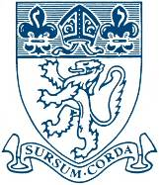
The Piggott School

Person Specification

Advice and Guidance Mentor – Pastoral Support and Careers

Professional Attributes: | Essential | Desirable
Excellent communication and interpersonal skills, be positive and approachable

Good literacy, numeracy and computer skills
Ability to work within a team working environment and also able to work independently

Confidentiality at all times
Educated to degree level
Experience of working in business environments

Personal Attributes: | Essential | Desirable
Be able to support and promote the Christian ethos, vision and values of the school and the mission statement ‘to be a school which inspires and encourages the highest achievement and attainment’
Have effective organisational and time management skills
Have the ability to prioritise, plan, monitor and evaluate
Have genuine respect for all members of our school community
Have enthusiasm for being involved in the life of a busy school
Be aware of safeguarding children issues and good practice in E-Safety
Be calm under pressure, adaptable and energetic
Have a sense of responsibility

Have a sense of humour
Be flexible and able to use initiative

