


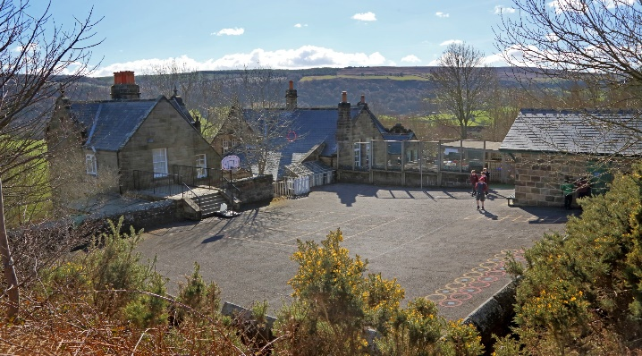

After School Club Leader
Glaisdale Primary School
Recruitment Information Pack

Glaisdale
Whitby
North Yorkshire
YO21 2PZ
www.glaisdaleprimaryschool.co.uk

Contents

Welcome from the Headteacher 3
Our vision and values 4
YEAT Schools 5
Application process 8
Job Description and Person Specification 9

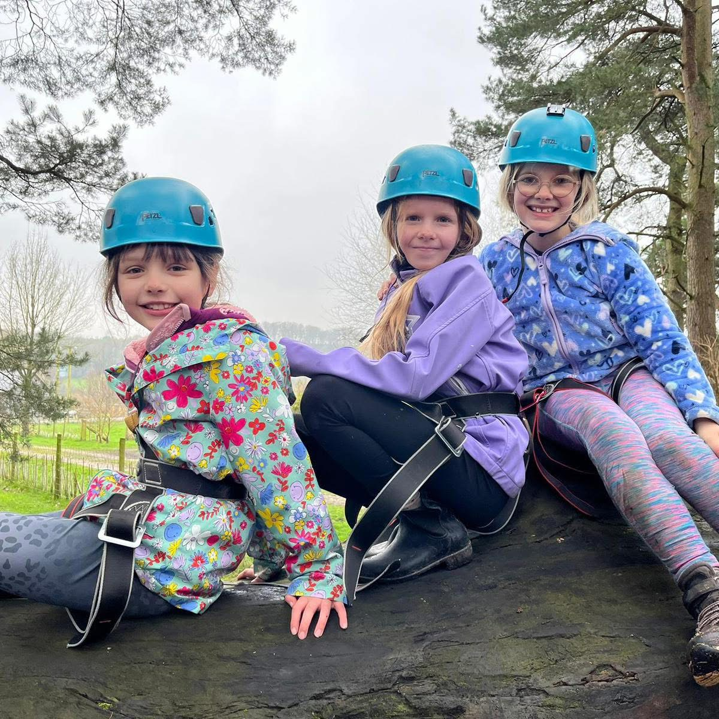

Welcome from the Headteacher

Dear applicant,

Allow me to extend a warm welcome from all governors, staff and children of both Glaisdale and Castleton Primary Schools. I am delighted you have shown interest in joining us and I look forward to sharing with you what makes our schools very special places to work.

Our children are delightful, happy, confident and energetic. They are passionate about their learning and enjoy a wide curriculum, with access to 1:1 iPads, outdoor learning areas and well-stocked libraries. Through the pandemic, they have demonstrated incredible resilience, adapting to new ways of learning, including contributing to live virtual lessons. Our children have many talents and we pride ourselves in providing lots of opportunities for every child to contribute to the wider school community. We are looking for a teacher and developing leader who can take the love of learning that our children come to school with each day and use it to inspire awe and wonder; someone who can embrace all aspects of the curriculum.

Castleton, Glaisdale and Lealholm schools work very closely together and the staff teams across all three are passionate about their work and supportive of each other. Flexibility is crucial, particularly within our small school settings, and the successful candidates will need to lead by example in this respect.

This is an exciting time to join us. As part of the Yorkshire Endeavour Academy Trust, our team are working in partnership across the Whitby area to share, learn and inspire. Through our Trust we are able to access support, training and resources from the Esk Valley Alliance and Yorkshire Endeavour English Hub, which means staff members have a wide range of colleagues, tools and resources to help them develop not just in the classroom but beyond.

I hope that you will take the time to find out more about our schools. Good luck with your application. I look forward to reading it.

Olly Cooper,
Headteacher of Castleton and Glaisdale Primary Schools

Yorkshire Endeavour Academy Trust
Our Vision and Values
Vision
- Ethical action for a world class education.
- Nurturing relationships at the heart of our communities.
- Brave leadership in a changing landscape.

Values
- Providing world-class education to all children through an ambitious curriculum.
- Encouraging curiosity and a lifelong love of learning.
- Wrapping around our community through an inclusive nurturing approach.
- Taking pride in local heritage whilst preparing our children to be global citizens.
- Collaborating with partners in education and universal services to support each child’s unique journey.
- Highlighting and sharing excellent educational practice for the benefit of all.
- Growing and developing people in all roles to be their very best.

Schools in Yorkshire Endeavour Academy Trust
Airy Hill Primary School

Pupils succeed and flourish at our school. They achieve well across the whole curriculum. Our children love the outdoor spaces at school and they say learning at Airy Hill is fun. We are a nurturing, rights-respecting and pupil centred school. Our school vision runs deeply through the life of Airy Hill and is easily identified by anyone visiting us. We ensure our pupils have broad and exciting learning experiences and this is reflected in the way our pupils talk about school. Children learn about their local heritage as well as aspects of culture from around the globe – they value and celebrate the differences in each other. We work together so every child succeeds.
For more information about Airy Hill, please visit our website.

Castleton Community Primary School

Castleton currently has 53 pupils on roll across two classes: Acorns (EYFS/KS1) and Oaks (KS2). Outdoor learning is a key feature of our provision and children have regular opportunities to participate in a range of outdoor activities. Hidden behind our historic building are extensive grounds, which include tiered gardens featuring a pond, greenhouse, adventure play area, stage, quiet zone, forest school site and an outdoor classroom. Our children are also interested in music and the arts. Our parents are very keen to be involved in the life of the school and we have an active PTFA.
For more information about Castleton, please visit our website.

Glaisdale Primary School
Glaisdale school currently has 27 pupils on roll across two classes: Explorers (EYFS/KS1) and Adventurers (KS2). We have an established new staff team who have worked hard to develop our curriculum, sports offer, rights respecting schools and EYFS provision. As a result, the school has recently received an Outstanding judgement in its recent Ofsted inspection.
Our children love the great outdoors, and our rural location provides lots of opportunities for sport and adventurous activities. You can see what our pupils have been up to recently by visiting our Facebook page.
Staff have developed excellent relationships with our parents and 100% of those completing a recent survey said they would recommend Glaisdale to other parents.
For more information about Glaisdale, please visit our website.


Lealholm Primary School
Lealholm is a very welcoming school with a friendly atmosphere. The small pupil numbers encourage a family feel, where pupils from Reception to Year 6 happily learn, play, eat and celebrate together. All pupils can identify trusted adults within school, including those in non-teaching roles, to whom they could turn to if they had any worries. Positive attitudes and kind behaviour are celebrated and awarded in weekly assemblies.
Pupils have access to a wide range of activities, as well as taking on leadership responsibilities, including being on the school council and being reading buddy. Opportunities to work collaboratively with pupils from other schools within the Trust are actively planned into the school year. This provides pupils from our small village community with useful opportunities to develop confidence and build relationships with their peers beyond Lealholm, in preparation for their eventual transition to secondary school in the nearest town, almost 10 miles away.
For more information about Lealholm, please visit our website.

Oakridge Community Primary School

Oakridge Community Primary School is situated in a most beautiful part of the country: the village of Hinderwell located between the North Yorkshire Moors and the North Sea coast.
We are a designated Community Primary School, including a nursery and cater for children between the ages of 3 and 11. The children are organised into two classes: Dolphin Class for KS2 pupils and Seahorse Class for EYFS and KS1 pupils.
We provide a rich and exciting curriculum in a safe and caring environment, where children flourish and have the opportunity to build positive relationships, make reputable choices and be inspired to become innovative life-long learners.
We recognise that parents and carers are an integral part of our family of schools, and we strive to work with them to make positive contributions to our local communities.
For more information about Oakridge, please visit our website.


West Cliff Primary School
West Cliff Primary School is a warm and friendly community school that provides education from children aged 2-11. It currently has around 200 children on roll, divided into 8 classes (one for each year group). We also have the Rockpool, which is our Targeted Mainstream Provision for children with high level social, emotional and mental health needs. The school mainly takes children from the west side and the centre of Whitby but is accessible from all parts of the town.
We pride ourselves on providing a warm and welcoming environment for children and adults alike, and we strive to provide the very best standard of education possible for our children. The six principles of nurture run through our school.
We are a Beach School as we believe that the beach is a fantastic resource that can be used, both to learn and have fun on. We are located a short walk from the beach and you can even see the sea from our upper-floor classrooms!
For more information about West Cliff, please visit our website.

Application Process

The closing date for all applications is 11:59pm Sunday 25th January 2026

Interviews will be held week commencing 2nd February.

An email will be sent to candidates with the outcome of the shortlisting process.

Application Process
Please apply online via NYC Jobs

An email will be sent to candidates with details of the shortlisting process.
We do not accept CV’s.

Queries / Visits
Please contact Chloe Bullen via chloe.bullen@northyorks.gov.uk or on 01609 536 964. Chloe has been engaged to support us with recruiting to this exciting opportunity.
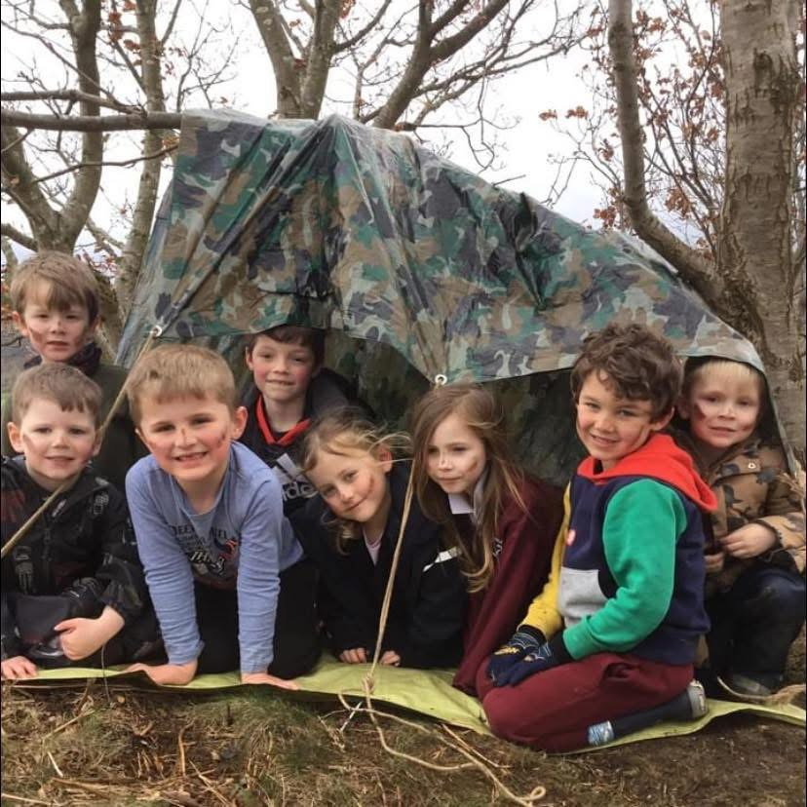

Job Description & Person Specification
Post title: | After School Club Assistant
Grade: | CD
Responsible to: | Headteacher
Staff managed: | None
Directorate: | Children and Young People's Service
School name: | Glaisdale Primary School
Job family: | E - Education/School
Date of issue: | August 2023
Safeguarding Statement
- The out of hours school club provides a safe environment for children prior or after school and encourages health eating and creative play opportunities.
- Enhanced DBS clearance is required for this post.

Job Purpose: | - The core focus of this job is to assist with supporting the school with the provision of extended care. The post holder will do this by supervising children and organising activities.
Operational Issues: | - Maintain a register of children  - Prepare and provide a healthy Breakfast/snacks/refreshments to the children following food hygiene practices, and clean up afterwards  - Prepare and set up room as required  - Administer basic first aid as required  - Undertake the personal care of children as required, including toileting, dressing, sickness  - Ensure the children and young persons are supervised at all times
Communications: | - Close liaison with parents, colleagues, pupils  - Encourage parental involvement and support  - Communicate with school staff as appropriate
Resource management/  Buildings and Infrastructure: | - Collect monies from parents as required  - Assist in the purchase of resources, including food/drink  - Ensure the building is safe and secure for the children and young persons at all times  - Ensures play equipment and materials are properly used, maintained and stored and report any damages to senior staff
Systems and Information: | - Maintain accurate records as required, to include completion of accident book, register of child’s attendance, up to date emergency contact details
Planning and Organising: | - Plan and provide a variety of safe, creative and appropriate play opportunities Participate in appraisal, training and other learning activities
Safeguarding: | - Responsible for promoting and safeguarding the welfare of the children and young people
Health and Safety: | - Be aware of and implement your health and safety responsibilities as an employee and where appropriate any additional specialist or managerial health and safety responsibilities as defined in the Health and Safety policy and procedure  - To work with colleagues and others to maintain health, safety and welfare within the working environment  - Ensure all accidents and emergencies are dealt with according to the policy  - Assist in ensuring the safety of all children in the event of a fire/drill or other emergency

Person Specification:
Essential | Desirable
Knowledge and Experience  - An understanding of and commitment to the provision of good quality childcare  - An understanding of food hygiene rules  - Health & safety knowledge, including lifting and handling and fire prevention  - A sound understanding of safeguarding procedures  - Knowledge of healthy eating  - Some experience of working with children in a play work or educational setting | - Knowledge of school policies and procedures  - Knowledge of child development & learning processes
Occupational Skills  - Ability to plan and deliver safe activities relevant to the age of the children  - Ability to work on own initiative and use common sense  - Ability to communicate effectively with parents and colleagues, verbally and in writing  - Ability to maintain confidentiality  - Ability to work effectively in a team  - Committed to continuing professional development  - Emotional resilience  - Ability to form and maintain appropriate relationships and personal boundaries with children and young people | - Behaviour management skills  - Basic ICT skills
Behaviours
- link
Professional Qualifications  - Current first aid certificate  - Literacy skills for accurate record keeping | - Food Hygiene certificate  - Childcare qualification
Other Requirements
- DBS check

IMPORTANT ADVICE ON COMPLETING THIS APPLICATION

Your application form plays an important part in your selection. Please ensure you address all the essential requirements listed in the specifications. The following advice should help you to complete the application form as effectively as possible.

Rehabilitation of Offenders
The post you are applying for requires you to have an enhanced Disclosure and Barring Service criminal records check for work with children, with a barred list check if you work in regulated activity. This check for disclosure of criminal history will include spent convictions, pending prosecutions / current court proceeding and police enquiries.

Should you be shortlisted, you will be asked to disclose full details of your criminal history prior to your interview. This includes any information deemed relevant as part of Keeping Children Safe in Education which may arise in an online search undertaken on shortlisted candidates. This information may be discussed with you at your interview in order to assess job related risks, but we emphasise that your application will be considered on merit and ability and you will not be discriminated against unfairly. Failure to disclose this information will result in any offer of employment being withdrawn.

Please also see the policy statement on the Recruitment of Ex-offenders below.

Information in Support of your Application
Every post advertised is supported by a full person specification. The specification lists all the essential skills, experience and qualifications which are necessary for the job and the criteria against which you will be assessed, both through your application form and at interview.

As part of the application process, you may have been asked to demonstrate within this application form how you meet some or all of the criteria or key competencies outlined in the person specification. Rather than simply repeating your career history, look at the skills and experience required by the job and provide evidence that you possess them by giving specific and detailed examples which include a focus on outcomes and on your own contribution to the scenario. Try to use different and varied examples wherever possible.

When completing these sections, do not forget the skills and experience you have gained outside full-time work. Outlining your previous work experience or other responsibilities may help you to uncover skills which you have taken for granted and which are clear signs of your ability to do the job.

Canvassing
You must not try to influence an elected Council Member, any council employee or a member of the school governing body, to act in your favour, as this will disqualify you. If you are related to a Councillor, a Council employee or a governor you must indicate this in the relevant section of the application form.

Policy Statement on the Recruitment of Ex-offenders (Source www.gov.uk)
- As an organisation assessing applicants’ suitability for positions which are included in the Rehabilitation of Offenders Act 1974 (Exceptions) Order using criminal record checks processed through the Disclosure and Barring Service (DBS), this school complies fully with the DBS code of practice and undertakes to treat all applicants for positions fairly.

- This school undertakes not to discriminate unfairly against any subject of a criminal record check on the basis of a conviction or other information revealed.

- This school can only ask an individual to provide details of convictions and cautions that it is legally entitled to know about. Where a DBS certificate can legally be requested (where the position is one that is included in the Rehabilitation of Offenders Act 1974 (Exceptions) order 1975 as amended, and where appropriate Policy Act Regulations as amended) this school can only ask an individual about convictions and cautions that are not protected.

- This school is committed to the fair treatment of its staff and potential staff, regardless of race, gender, religion, sexual orientation, responsibilities for dependents, age, physical/mental disability or offending background.

- This school has this written policy on the recruitment of ex-offenders, which is made available to all DBS applicants at the start of the recruitment process.

- This school actively promotes equality of opportunity for all with the right mix of talent, skills and potential and welcome applications from a wide range of candidates, including those with criminal records. Candidates are selected for interview based on their skills, qualifications and experience and criminal record information is only requested from short-listed candidates.

- A disclosure is only requested from the DBS after a thorough risk assessment has indicated that one is both proportionate and relevant to the position concerned. For those positions where a criminal record check is identified as necessary, all application forms, job adverts and recruitment briefs will contain a statement that a DBS certificate will be requested in the event of the individual being offered the position.

- This school ensures that all those who are involved in the recruitment process have been suitably trained to identify and assess the relevance and circumstances of offences.

- This school also ensures that they have received appropriate guidance and training in the relevant legislation relating to the employment of ex-offenders, e.g. the Rehabilitation of Offenders Act 1974.

- At interview, or in a separate discussion, this school ensures that an open and measured discussion takes place on the subject of any offences or other matter that might be relevant to the position. Failure to reveal information that is directly relevant to the position sought could lead to withdrawal of an offer of employment.

- This school makes every subject of a criminal record check submitted to DBS aware of the existence of the code of practice and makes a copy available on request.

This school undertakes to discuss any matter revealed on a DBS certificate with the individual seeking the position before withdrawing a conditional offer.

