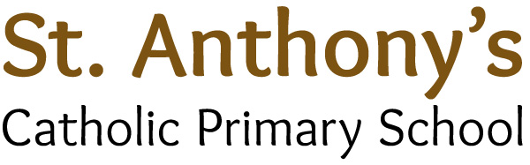

Address: Barkly Road, Beeston, Leeds, LS11 7JS
Head Teacher: Miss L S Leonard BA (HONS) QTS NPQH
Tel: (0113) 2776944
Fax: (0113) 2772633
Website: stanthonysleeds.co.uk
E-mail: l.leonard@stanthonyleeds.org.uk

“Growing together on a journey with Jesus”

Permanent After School Club Playworker
Salary: Leeds City Council A1 Scale Point 2 (£2566.00 p.a. pro rata)

Term time only (5 hours weekly 3.10pm-4.10pm)

Start Date: 1st October 2024
St Anthony’s Catholic Primary School is a thriving and inclusive school at the very heart of the community and parish it serves. As a recently inspected Ofsted ‘outstanding’ school (2024), we are seeking to appoint a playworker to support and lead after school clubs for one hour daily from 3.10pm-4.10pm.
We are looking for someone who is:
- Committed to sustaining the strong Catholic Ethos of the school.
- Able to demonstrate high levels of IT, English, Maths and communication skills.
- Reliable and trustworthy and able to maintain confidentiality at all times.
- Highly motivated, with passion, patience and positivity.
- Emotionally intelligent, placing immense value on working with children.
- Able to communicate effectively with children, parents and colleagues.
- Be able to work effectively as part of a team.

We can offer you:
- Enthusiastic, highly motivated and cherished children who take great pride in attending St Anthony’s.
- A fantastic team of dedicated and supportive staff.
- A perfect balance of care and support with high expectations.
- Supportive and committed parents and governors.
- A dedicated leadership team.

All applicants who can demonstrate strong skills and experience will be welcomed.

Prospective candidates are encouraged to visit the school prior to application; visits can be arranged (and are positively welcomed) by contacting the school on 0113 2776944 or by emailing head@stanthonysleeds.org.uk.
Application packs are available to download from our school website. Please use the CES application form.

Closing date: Friday 13th September 2024 at noon
Interview dates: Wednesday 18th September 2024

St Anthony’s Catholic Primary School is committed to safeguarding and promoting the welfare of children and expects all staff and volunteers to share this commitment. Our GDPR guidelines and policies are adhered to and displayed on our school website.
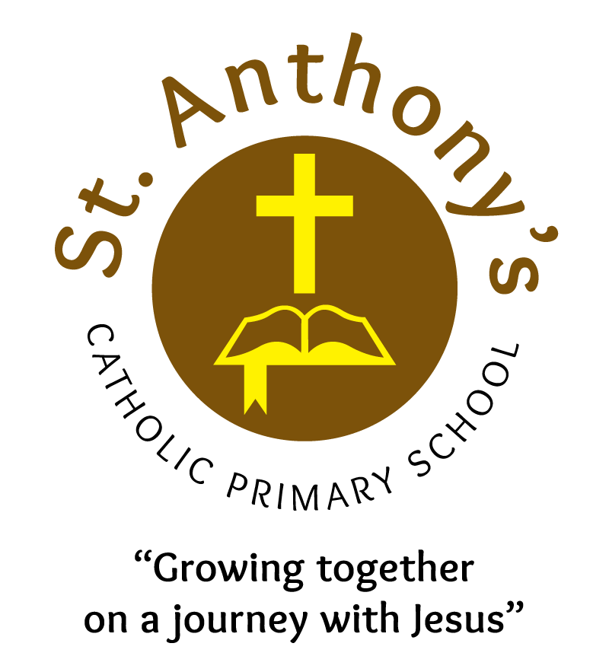
The successful candidate will be subject to an enhanced DBS disclosure and must be prepared to apply for ISA registration if required.
We promote diversity and desire a workforce that reflects the population of Leeds.

