



Overdale Community Primary School

After School Club Supervisor & Assistant
Recruitment Information Pack





Contents

About the School & Headteacher’s Welcome 3
Application Process 4
Job Description and Person Specification 5
Applying for a job with North Yorkshire Council 10



About the School and Headteacher's Welcome

Welcome to Overdale Community Primary School and on behalf of our children and staff thank you for taking an interest in the learning team. We are very proud of our school and our ethos of positivity; where the welfare, wellbeing and achievement of our children are firmly embedded.

We are incredibly proud of our calm and happy learning community in facilities which were purpose built in 2021 to support our existing and new families that have moved into the growing community of new builds within the Middle Deepdale area. The new building is state of the art in terms of being eco-friendly and operating a high standard of technology. Alongside this, we have spacious classrooms benefitting from natural light and ventilation, creating the best possible learning environment for our children, and working environment for our staff. Outdoors, we have two football pitches, a rounders pitch and a one mile running track, along with an environmental area and quiet place with logs and other features. We use our outdoor space for orienteering and problem solving. We can teach numeracy and phonics outdoors, for example, and we also have two outdoor gyms. The school now has double the capacity of the old building on the former site and the new location provides a link between the older parts of Eastfield and the new housing developments in Middle Deepdale to the north.

Overdale serves a large community with a range of children from different backgrounds. The role of a teacher in our school brings its challenges but it is extremely rewarding. We have benefited from considerable investment over the years – specifically in terms of Speech and Language Development and EYFS. We have recently expanded and welcomed 8 2-year-olds in January.

Learning at Overdale means you will have a real opportunity to deliver quality education within the culture of ‘The Three R’s’ and enjoy the coastal community. The Three R’s - "Respect, Responsibility, Resilience" - are important to the ethos of our school community and hence we have a set of values that reflect this, that our children will come to know, understand, and implement these within our school family. Our wonderful team of staff are key to driving these values and work together along with our wider school community to ensure each child is nurtured and given every opportunity to thrive and achieve their potential. We are delighted to have just received our Nurture UK award, which is testament to our hard work in creating an enriching learning environment, and we have just welcomed our newest staff member aiding us in this area, Buddy, our therapy dog!

Here at Overdale Community Primary School we are proud to be a leading school in the area. Together we have built a school that has the highest aspirations for our children to shine, but also one that supports and celebrates our amazing community that we are proud to serve. I very much hope that you will apply to join our team at this exciting time as we develop our EYFS provision.

Mr Robert Bowman
Headteacher
For more information, please visit the school website.

Application Process

The closing date for all applications is 11:59pm Sunday 23rd August

Interviews will be held on Wednesday 9th September

An email will be sent to shortlisted candidates with details of the interview process.

Queries
Please contact NYES.Resourcing@northyorks.gov.uk
NYES Resourcing Solutions has been engaged to support us with recruiting to this exciting opportunity.
We actively welcome you to contact us to chat through the role and talk informally about the school/post and how working here will make a real difference to the children and young people in the area.
When applying please take into account the following:
Employment History
In line with KCSIE requirements, please complete your full employment history to ensure any gaps in your education and career history are accounted for.
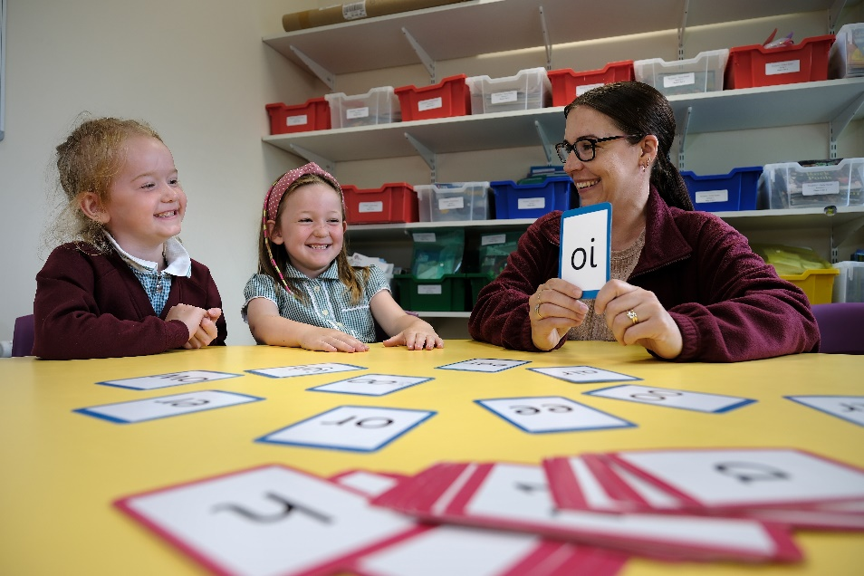
Suitable References
When completing your application, please provide two employment referees. Generally, this should be your current and most recent Headteacher or line manager.

Please note if your former Headteacher or line manager has since left, please use an alternative current senior staff member as they need to be in post at your former location to be able to confirm your details in full.

Unfortunately, we cannot accept personal references or personal email addresses.

Please get in touch for any queries if you are unsure.

Supporting Information
The supporting information section of your application should clearly evidence your ability to meet the requirements we have outlined in the job description & person specification. This will be used to shortlist applicants for this role and therefore it is imperative that you provide evidence as requested.

School Club Supervisor Job Description
Post title: | School Club Supervisor
Grade: | E
Responsible to: | Headteacher
Staff managed: | Playworkers/ before/after school club assistants
Job family: | E - Education/School

Safeguarding Statement
- The out of hours school club provides a safe environment for children prior or after school, and encourages health eating and creative play opportunities.
- Enhanced DBS clearance is required for this post

Job Purpose: | The core focus of this job is to ensure the provision of high quality out of hours school provision for children, within a positive, safe & happy environment. The post holder will do this by organising and providing an appropriate range of activities and food. Take a lead role in running the club.

Operational Management: | - Maintain a register of children  - Prepare and provide a healthy Breakfast/snacks/refreshments to the children following food hygiene practices, and clean up afterwards  - Prepare and set up room  - Administer basic first aid as required  - Undertake the personal care of children as required, including toileting, dressing, sickness  - Ensure the children and young persons are supervised at all times  - Contribute to the development of club policies, procedures, aims and objectives  - Promote the club by creating promotional displays  - Ensures the equipment is maintained and stored appropriately
Communications: | - Close liaison with parents, colleagues, pupils  - Encourage parental involvement and support  - Promote healthy eating  - Report on the progress of the club and any issues of concern to school leadership team
Partnership and Corporate Working: | - Communicate with school staff, parents and children/young people as appropriate
Resource management/  Buildings and Infrastructure: | - Collect monies from parents as required and record accurately  - Responsible for the purchase of resources, including food/drink & equipment  - Ensure the building is safe and secure for the children and young persons at all times  - Encourage, lead and support a team of playworkers/assistants ensuring good performance all the time  - Address performance or conduct issues promptly  - Provide induction and training to new staff members  - Ensure the building is safe and secure for the children and young persons at all times  - Ensures play equipment and materials are properly used, maintained and stored and report any damages to the Playleader/Supervisor
Systems and Information: | - Maintain accurate records as required, to include completion of accident book, register of child’s attendance, up to date emergency contact details
Planning and Organising: | - Take a lead role in the planning of a variety of safe, creative and appropriate play opportunities  - Monitor and evaluate the effectiveness of the club
Safeguarding: | - Responsible for promoting and safeguarding the welfare of the children and young people.  - Be able to recognise when a child or young person is in danger or at risk of harm and take action to protect them.
Health and Safety: | - Be aware of and implement your health and safety responsibilities as an employee and where appropriate any additional specialist or managerial health and safety responsibilities as defined in the Health and Safety policy and procedure.  - To work with colleagues and others to maintain health, safety and welfare within the working environment.  - Ensure the safety of all children in the event of a fire/drill or other emergency  - Ensure all accidents and emergencies are dealt with according to the policy



Supervisor Person Specification:
Essential | Desirable
Knowledge and Experience  - An understanding of and commitment to the provision of good quality childcare  - An understanding of food hygiene rules  - Health & safety knowledge, including lifting and handling and fire prevention  - A sound understanding of safeguarding procedures  - Knowledge of healthy eating  - Significant experience of working with children in a play work or educational setting  - Experience of keeping records, including financial records | - Knowledge of school policies and procedures  - Knowledge of child development & learning processes  - Staff supervision experience
Occupational Skills
- Ability to plan, deliver and evaluate safe activities relevant to the age of the children
- Organisational skills
- Ability to work on own initiative and use common sense
- Ability to communicate effectively with parents and colleagues, verbally and in writing
- Ability to maintain confidentiality
- Ability to work effectively in a team
- Committed to continuing professional development
- Emotional resilience
- Ability to form and maintain appropriate relationships and personal boundaries with children and young people
- Behaviour management skills
- ICT skills
- Ability to lead a small team
Behaviours
- link
Professional Qualifications  - Recognised childcare qualification at level 3 or equivalent  - Current first aid certificate | - Food Hygiene certificate
Other Requirements
- DBS clearance

School Club Assistant Job Description
Post title: | School Club Assistant
Grade: | CD
Responsible to: | Club Supervisor
Staff managed: | None
Job family: | E - Education/School
Safeguarding Statement
- The out of hours school club provides a safe environment for children prior or after school, and encourages health eating and creative play opportunities.
- Enhanced DBS clearance is required for this post

Job Purpose: | The core focus of this job is to assist with supporting the school with the provision of extended care. The post holder will do this by supervising children and organising activities.

Operational Issues: | - Maintain a register of children  - Prepare and provide a healthy Breakfast/snacks/refreshments to the children following food hygiene practices, and clean up afterwards  - Prepare and set up room as required  - Administer basic first aid as required  - Undertake the personal care of children as required, including toileting, dressing, sickness  - Ensure the children and young persons are supervised at all times
Communications: | - Close liaison with parents, colleagues, pupils  - Encourage parental involvement and support  - Communicate with school staff as appropriate
Resource management/  Buildings and Infrastructure: | - Collect monies from parents as required  - Assist in the purchase of resources, including food/drink  - Ensure the building is safe and secure for the children and young persons at all times  - Ensures play equipment and materials are properly used, maintained and stored and report any damages to the Playleader/Supervisor
Systems and Information: | - Maintain accurate records as required, to include completion of accident book, register of child’s attendance, up to date emergency contact details
Planning and Organising: | - Plan and provide a variety of safe, creative and appropriate play opportunities Participate in appraisal, training and other learning activities
Safeguarding: | - Responsible for promoting and safeguarding the welfare of the children and young people.
Health and Safety: | - Be aware of and implement your health and safety responsibilities as an employee and where appropriate any additional specialist or managerial health and safety responsibilities as defined in the Health and Safety policy and procedure.  - To work with colleagues and others to maintain health, safety and welfare within the working environment.  - Ensure all accidents and emergencies are dealt with according to the policy  - Assist in ensuring the safety of all children in the event of a fire/drill or other emergency

School Club Assistant Person Specification:
Essential | Desirable
Knowledge and Experience  - An understanding of and commitment to the provision of good quality childcare  - An understanding of food hygiene rules  - Health & safety knowledge, including lifting and handling and fire prevention  - A sound understanding of safeguarding procedures  - Knowledge of healthy eating  - Some experience of working with children in a play work or educational setting | - Knowledge of school policies and procedures  - Knowledge of child development & learning processes
Occupational Skills  - Ability to plan and deliver safe activities relevant to the age of the children  - Ability to work on own initiative and use common sense  - Ability to communicate effectively with parents and colleagues, verbally and in writing  - Ability to maintain confidentiality  - Ability to work effectively in a team  - Committed to continuing professional development  - Emotional resilience  - Ability to form and maintain appropriate relationships and personal boundaries with children and young people | - Behaviour management skills  - Basic ICT skills
Behaviours
- link
Professional Qualifications  - Current first aid certificate  - Literacy skills for accurate record keeping | - Food Hygiene certificate  - Childcare qualification
Other Requirements
- DBS check

We are committed to meeting the needs of our diverse community and aim to have a workforce reflecting this diversity. We are also committed to safeguarding and promoting the welfare of children, young people and adults. We have a robust child protection policy and all staff will receive training relevant to their role at induction and throughout employment at the school. We expect all staff and volunteers to share this commitment.

Please note this post is in regulated activity and exempt from the rehabilitation of Offenders Act 1974 and subject to satisfactory references and an enhanced DBS criminal records and barred list check for work with children. An online search may be undertaken as part of the recruitment process on information available in the public domain. Candidates should disclose anything that may be relevant in line with Keeping Children Safe in Education.

APPLYING FOR A JOB WITH NORTH YORKSHIRE COUNCIL

IMPORTANT ADVICE ON COMPLETING THIS APPLICATION

Your application form plays an important part in your selection. Please ensure you address all the essential requirements listed in the specifications. The following advice should help you to complete the application form as effectively as possible.
Data Protection
The information that you state on this application form will be used by the school and the Council to consider you for a job vacancy. To find out about how we use your personal data for the purposes of recruitment please see our Privacy Notice at www.northyorks.gov.uk/working-us.

Rehabilitation of Offenders
The post you are applying for requires you to have an enhanced Disclosure and Barring Service criminal records check for work with children, with a barred list check if you work in regulated activity. This check for disclosure of criminal history will include spent convictions, pending prosecutions / current court proceeding and police enquiries.

Should you be shortlisted, you will be asked to disclose full details of your criminal history prior to your interview. This includes any information deemed relevant as part of Keeping Children Safe in Education which may arise in an online search undertaken on shortlisted candidates. This information may be discussed with you at your interview in order to assess job related risks, but we emphasise that your application will be considered on merit and ability and you will not be discriminated against unfairly. Failure to disclose this information will result in any offer of employment being withdrawn.

Please also see the policy statement on the Recruitment of Ex-offenders below.

Information in Support of your Application
Every post advertised is supported by a full person specification. The specification lists all the essential skills, experience and qualifications which are necessary for the job and the criteria against which you will be assessed, both through your application form and at interview.

As part of the application process, you may have been asked to demonstrate within this application form how you meet some or all of the criteria or key competencies outlined in the person specification. Rather than simply repeating your career history, look at the skills and experience required by the job and provide evidence that you possess them by giving specific and detailed examples which include a focus on outcomes and on your own contribution to the scenario. Try to use different and varied examples wherever possible.

When completing these sections, do not forget the skills and experience you have gained outside full-time work. Outlining your previous work experience or other responsibilities may help you to uncover skills which you have taken for granted and which are clear signs of your ability to do the job.

Canvassing
You must not try to influence an elected Council Member, any council employee or a member of the school governing body, to act in your favour, as this will disqualify you. If you are related to a Councillor, a Council employee or a governor you must indicate this in the relevant section of the application form.

Policy Statement on the Recruitment of Ex-offenders (Source www.gov.uk)
- As an organisation assessing applicants’ suitability for positions which are included in the Rehabilitation of Offenders Act 1974 (Exceptions) Order using criminal record checks processed through the Disclosure and Barring Service (DBS), this school complies fully with the DBS code of practice and undertakes to treat all applicants for positions fairly.

- This school undertakes not to discriminate unfairly against any subject of a criminal record check on the basis of a conviction or other information revealed.

- This school can only ask an individual to provide details of convictions and cautions that it is legally entitled to know about. Where a DBS certificate can legally be requested (where the position is one that is included in the Rehabilitation of Offenders Act 1974 (Exceptions) order 1975 as amended, and where appropriate Policy Act Regulations as amended) this school can only ask an individual about convictions and cautions that are not protected.

- This school is committed to the fair treatment of its staff and potential staff, regardless of race, gender, religion, sexual orientation, responsibilities for dependents, age, physical/mental disability or offending background.

- This school has this written policy on the recruitment of ex-offenders, which is made available to all DBS applicants at the start of the recruitment process.

- This school actively promotes equality of opportunity for all with the right mix of talent, skills and potential and welcome applications from a wide range of candidates, including those with criminal records. Candidates are selected for interview based on their skills, qualifications and experience and criminal record information is only requested from short-listed candidates.

- A disclosure is only requested from the DBS after a thorough risk assessment has indicated that one is both proportionate and relevant to the position concerned. For those positions where a criminal record check is identified as necessary, all application forms, job adverts and recruitment briefs will contain a statement that a DBS certificate will be requested in the event of the individual being offered the position.

- This school ensures that all those who are involved in the recruitment process have been suitably trained to identify and assess the relevance and circumstances of offences.

- This school also ensures that they have received appropriate guidance and training in the relevant legislation relating to the employment of ex-offenders, e.g. the Rehabilitation of Offenders Act 1974.

- At interview, or in a separate discussion, this school ensures that an open and measured discussion takes place on the subject of any offences or other matter that might be relevant to the position. Failure to reveal information that is directly relevant to the position sought could lead to withdrawal of an offer of employment.

- This school makes every subject of a criminal record check submitted to DBS aware of the existence of the code of practice and makes a copy available on request.

This school undertakes to discuss any matter revealed on a DBS certificate with the individual seeking the position before withdrawing a conditional offer of employment

