
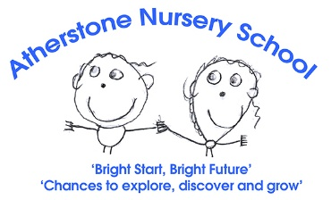

Person Specification: Level 3 Early Years Educator Apprentice Vacancy
 | Essential | Desirable
Qualifications | - For 16–19-year-old applicants an Early Years Educator Level 3 requirement to pass is a Level 2 Functional skills /Grade 4. Support can be given to pass functional skills level 2/Grade 4 if you do not hold this qualification in English and Maths.  - Hold an NVQ Level 2 in Early Years or have a wide range of experience in the sector to start a Level 3 qualification.  - Experience of working within an early year setting working with children aged 2–5-year-old.  From 1 September 2014, all level 2&3 qualifications must meet the early years educator criteria. Please check:  https://www.gov.uk/guidance/early-years-qualifications-finder to see if your qualification is recognised | - Early Years Level 2 qualified (qualification to meet the government approved qualification requirement)  - Safeguarding Training and PREVENT Training  - First Aid training.  - Basic Food Hygiene training.  - Allergy Awareness training.  - SEND training.
Experience / knowledge | - Able to teach activities planned in partnership with colleagues to individuals and small groups  - Able to maintain and complete records and documentation to a high standard.  - Understand how to support and differentiate activities to help children with their learning.  - Encourage children to develop new skills.  - Follow relevant policies and codes of practice | - Minimum of 2 years’ experience working within the EYFS age range.  - Experience of being a keyperson.  - Look for new ideas to introduce into the curriculum.  - Experience of, and commitment to, outdoor learning  - Understanding and use of a range of behaviour management strategies  - Knowledge of the EYFS.  - Partnership working with professionals and families.  - To ensure that all duties and services are provided in accordance with the schools Equal Opportunities Policy.
Skills | - Ability to promote positive behaviour.  - Good observation skills.  - Good oral and written communication.  - Good ICT Skills across Microsoft office packages  - Able to maintain the rights of the child and create and inclusive practice.  - Manage time effectively and meet time related targets | - Creative and able to develop learning environments and resources to meet individual needs
Attitudes | - Be reflective and learn from past experiences  - Show resilience and an ability to work under pressure  - Be organised, self-disciplined, reliable, conscientious, hard working and honest.  - Flexible in approach and respond to change with a positive attitude  - Friendly, approachable and kind with the ability to sustain good personal relationships across a team  - Commitment to inclusive education of children and genuine enjoyment ensuring all children achieve their potential.  - Uphold our commitment to safeguarding. | - Keen to access opportunities to grow and develop within the role  - Prepared to go the extra mile to contribute to the continued success of the team

