
job description
Apprentice/Trainee Teacher of Science
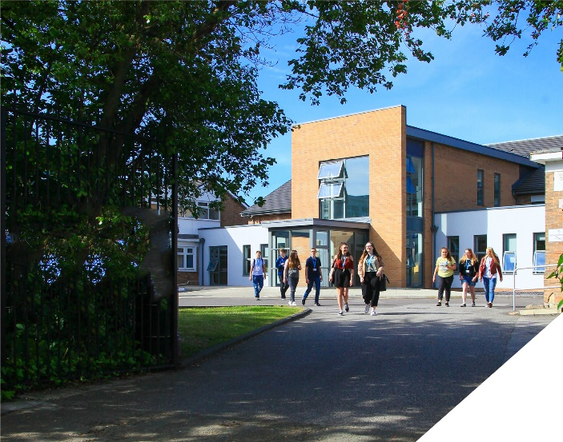
Exciting opportunity to get your teaching qualification whilst starting a new career as a paid Science Teacher. Ideal for those seeking a career change or recent Science graduates.
Role: Apprentice/Trainee Teacher of Science
Reports to: Head of BTEC Science
Hours: Full time, term time
Contract: Initially 15 months with view to a permanent post.
Salary: £28,000-£30,000
start date: 20th August 2024
An exciting opportunity has arisen for a graduate who is enthusiastic and self-motivated, and who wants to start their career as a teacher in a well-established Science faculty with an experienced team in an outstanding Sixth Form College.

You will be supported on the Graduate Teacher Programme (GTP) to gain Qualified Teacher Status (QTS) with a Post Graduate Teacher Apprenticeship (PGTA) over a 13-15 month programme. The GTP includes the opportunity to gain a PGCE with Master’s Credits. This comprehensive academic programme will be delivered on-line by the University of Buckingham, the largest provider of teacher training apprenticeships in the UK. It will include 20 afternoon remote university lectures; monthly on-line meetings and termly visits to school. The programme will prepare you for an End Point Assessment in the fourth and final term, after which you will gain Qualified Teacher Status.

This is a fully funded programme to support you as an apprentice teacher at the College in the BePART Trust where excellence in teaching is fundamental to our ethos. Birkenhead Sixth Form College has extensive experience in delivering excellence in teacher training and you will be assigned a qualified and experienced in-college Mentor who will support you in your on-the-job training.

The main priority of the College is to secure the highest quality learning through the provision of high quality teaching in the classroom. This teaching apprenticeship is a key post in an ambitious and well supported faculty and will give you an excellent grounding at the start of your career.

The Teaching:
The teaching apprentice will:
- Be supported to teach on a reduced timetable of between 50% to 70% of a full teaching timetable.
- Be supported with 10% time off timetable, to plan and prepare lessons;
- Be supported with 20% off-the-job attendance on the university programme, including the on-line lectures; remote university tutor meetings and in-college mentor meetings.

Scope of the teaching role:
The teaching apprentice will:
- Be supported to promote the general progress, well-being and attendance of individual students and of any class or group of students assigned to them.
- Be supported to provide guidance and advice to students on educational and social matters and on their further education and future careers, including information about sources of more expert advice on specific questions; making relevant records and reports;
- Be supported to make records of and reports on the personal and social needs of students;
- Be supported to communicate and consult with the parents of students;
- Be supported to communicate and co-operate with persons or bodies outside the college;
- Be supported to participate in meetings arranged for any of the purposes described above.
- Be supported to provide or contribute to oral and written assessments, reports and references relating to individual students and groups of students.
- Be supported to maintain good order and discipline among the students and safeguard their health and safety.
- Be supported to participate in meetings at the college which relate to the curriculum for the college; or the administration or organisation of the college, including pastoral arrangements.
- Be supported to prepare students for external examinations; assess students for the purposes of such examinations and record and report such assessments;
- Be supported to participate in administrative and organisational tasks related to such duties as are described above.
- Promote the college’s core values, undertake duties and perform other tasks commensurate with the post as reasonably requested by the Principal.

person specification.

Qualifications | essential | desirable
- Degree in a Science related discipline | 
- English and Maths pass at GCSE/O-Level or equivalent | 
- The right to live and work in the UK without restrictions | 
- To have lived in the UK for more than 2 years | 
- To have the ability to teach a minimum of 15 hours/50% timetable per week | 
Personal Attributes
- Commitment to safeguarding and the promotion of the physical and emotional health and well-being of young people. | 
- Flexibility and adaptability. | 
- Ability to demonstrate effective time and line management. | 
- Ability to work in line with the core values and vision of the College and Trust. | 
- High personal standards in terms of attendance, punctuality and meeting deadlines. | 
- Energy, resilience, vision and enthusiasm and the ability to perform well under pressure. | 
- Commitment to inclusive education. | 
- Good sense of humour | 

About the College.

You will be joining a highly successful, innovative and nationally recognised sixth form college. The College is currently College of Year awarded by Educate and has been graded outstanding in all areas by OFSTED in December 2016. All staff play a vital role in the experience that students have with us and ultimately their success.

The College currently has a 16 to 19-year-old student population of 1550. Demand for places for places at the college is very high and as a result the college has recently expanded with two new state of the art teaching blocks in September 2021. A further brand new 3 storey classroom block opened in April 2023 as part of the college’s expansion project.

In response to the pandemic and disruption to the learning of students the college introduced a new timetable in 2021/2022 to combat the deficits that students have. This includes teaching time increasing by 60 minutes each week we are confident that the 5.5 hours students receive each week is one of, if not the highest in the country. Whilst student teaching time has increased the new timetable has reduced the overall teaching time for teachers each week. Full time teachers will teach a maximum of 4 classes, 4 times a week and teachers have their own groups, we do not have shared teaching groups at the college.

The College is committed to its core values of Positivity, Ambition, Resilience and Thoughtfulness, and these values shape everything we do. Our ethos is centred on the scientific evidence that tells us that everyone can achieve success through purposeful hard work as opposed to the talent myth, and this enables learners to make rapid progress unshackled by any limits previously placed upon them.

how to apply.

- Complete Application form
Please complete the Trainee Teachers Application Form which is available on the College website: www.bsfc.ac.uk
Completed applications should be returned to the HR department by e-mail to hr@bsfc.ac.uk

Closing date: Midday on Thursday 13th June 2024
Interviews: AM: Friday 14th June 2024

We look forward to receiving your application


