
HIGH S
HASTINGS HIGH SCHOOL
Art and Design Support
Salary: Grade 5 – Grade 6 (Dependant on experience) Actual Salary: £21,563 - £22,604
Term Time + 1 week – 37 hours per week
To start: 20th August 2026
Application Deadline: July 1st 2026
Interview date: July 3rd 2026
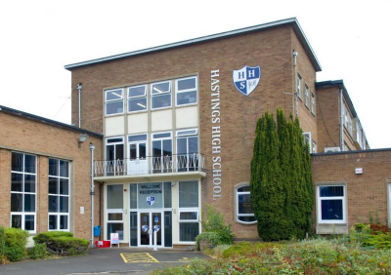

HASTINGS HIGH SCHOOL
Care and Excellence for All
June 2026
Why join the Hastings Family?
At Hastings, we live by our motto: Care and Excellence for All.
We are a thriving, oversubscribed community school with a strong academic record and a reputation for nurturing ambition, responsibility, and self-development in every pupil. ● Ofsted: Judged “Good” with outstanding pupil behaviour and relationships. ● Academic success: Progress 8 consistently above average (+0.40 last year). ● Facilities: Multi-million investment in 2025, including 8 new classrooms, a sports hall, and redeveloped pastoral and dining areas.
● Community: A supportive, ambitious, and enriching environment for staff and pupils alike. What We Offer You
● Comprehensive induction programme – tailored support for ECTs and new staff. ● Professional development – ongoing training, appraisal, and opportunities to grow. ● Wellbeing focus – a culture of care and respect for staff.
● Collaborative team spirit – work alongside talented, reflective practitioners. ● Enriching curriculum – access to a wide range of resources, facilities, and extracurricular opportunities.
How to Apply
Please submit:
1. Completed application form
2. Letter of application (max 2 sides of A4, font size 11)
Send to: Mrs. Sarah Brown – HR Manager ��sarah.brown@hastings.school
Closing date: 9am, 1st July 2026
Interviews: 3rd July 2026
(If you have not heard from us by 3rd July, please assume your application was unsuccessful.) We love showing off our school! Prospective candidates are warmly invited to arrange a visit. We very much hope you will apply and look forward to receiving your application. Yours sincerely,

Miss C Bradley and Mr S Shipman
(Co-Headteachers)

HASTINGS HIGH SCHOOL
Care and Excellence for All
OUR HASTINGS FAMILY
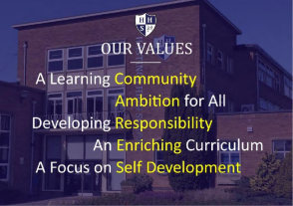
All employees of Hastings High School are expected to live and breathe the school’s CARES values so that they act as role models for our pupils and hold themselves and each other to high standards.
● Community: to demonstrate a collaborative, team working approach so that we can instil a sense of belonging to something that is greater than any one individual – the Hastings Family.
● Ambition: to believe that every pupil deserves to be given the opportunity and the tools so that they may become the best version of themselves.
● Responsibility: for personal professional growth and development, keeping up-to-date with national research and engaging with professional organisations.
● Enriching: a commitment to helping our young people develop existing interests and try something new which will shape experiences and memories that will stay with them for life. ● Self-development: demonstrates the capacity to be a self-reflective leader and practitioner and treats feedback as an opportunity to become even better.
A word from our pupils
�� “Hastings is an amazing community of pupils and teachers who work together in striving for excellence.”
�� “Hastings has helped me become ambitious and motivated to succeed.” �� “Relationships between staff and pupils are very positive. Staff are strong role models.”
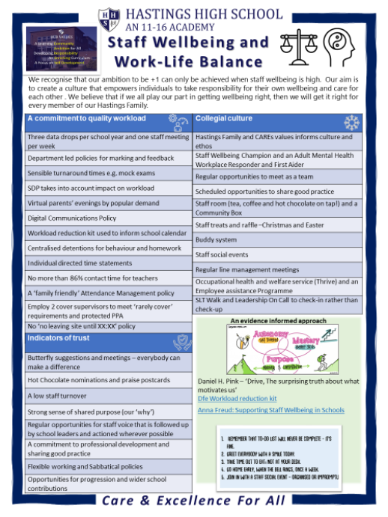
HASTINGS HIGH SCHOOL
Care and Excellence for All
THE ART and DESIGN DEPARTMENT
The Art &Design Faculty is a well-organised and mutually supportive team of enthusiastic teaching staff. There are 4 fully-equipped classrooms, each catering for a specialist area including; Fine Art, Polymers & Computer-Aided Design, Timbers & Metals, and Textiles. ICT rooms are available through a school centralised booking system, and computers and modern provision for our students is at the heart of our offering.
Pupils are taught in smaller mixed ability groups during Years 7 and 8, and rotate around each area following pre-planned projects. At the end of Year 8, pupils go through an Options process, selecting two subjects to specialise in during Year 9.
The uptake in these subjects at KS4 is large, with approximately six GCSE classes in each yeargroup, and continues to grow.
The faculty offers numerous extra-curricular and co-curricular activities throughout the year including ‘Makers Club’, Easter Revision and Coursework Catch-Up sessions.
The faculty has strong links with the school’s SEND team and selected pupils receive extensive help in terms of class support. We constantly strive to adapt our teaching styles to accommodate all students. We are constantly evolving our professional contacts beyond the department to strengthen our offering and careers provision.
We are looking to appoint a member of our team who will continue to build on our positive professional relationships and encourage all pupils to be involved in Art & Design during their time at Hastings.
Our curriculum has undergone recent change, and is emerging as progressive, ambitious scheme of learning for our students. Should you wish to see more about the school’s previous curriculum offer, please click on the link below:
https://sites.google.com/hastings.leics.sch.uk/home/our-school/curriculum/subjects
HASTINGS HIGH SCHOOL
PERSONNEL SPECIFICATION – Art & Design Support
Criteria | Essential | Desirable | Evidence
Qualifications & Knowledge | Knowledge of Microsoft/Google applications including word  publishers and spreadsheets  Professional communication via email and telephone  IT organisation  Good knowledge of relevant Health & Safety practices  Knowledge of using relevant  educational Art and Design  equipment, including hand tools, machinery and computer-aided design (CAD)  Good standard of literacy and  numeracy | Excellent standard of ICT skills  Completion of Health & Safety course and/or a recent formal machine induction  Maths and English NVQ2 or equivalent  LSA/TA qualification  DATA qualification  Photography and camera usage  Knowledge of CAD software including: Photoshop, Techsoft, TinkerCAD, or similar  Current 1st aid certificate | Application  Form
Application | Well-constructed and well-presented application, addressing the specific requirements of this post |  | Letter
Experience | Experience of providing technical support, preferably in a school setting  Ability to undertake a range of basic repair and maintenance tasks  including visual Health & Safety checks  Ability to follow a risk assessment and mitigate risk in a practical environment  A love of creative industries, craft or hobby showing commitment to the arts | Experience of working in a School & supporting the Art and Design curriculum and pupils  Experience in ordering, stock management and fulfilment  An experience of ‘Care of  Substances Hazardous to  Health’ (CoSHH)  A portfolio or photographic samples of work in any  associated creative field - Fine Art, Textiles, Ceramics,  Photography, Web Design, Product Design, etc. | Letter /  References /  Photographic  Evidence

Criteria | Essential | Desirable | Evidence
Professional Skills | Ability to work accurately under pressure and meet deadlines  Highly organised professionally, with a desire to organise and support others in the team  Excellent oral and written  communication skills for navigating interactions with pupils and  colleagues  Willingness to learn and continue professional development | Mature and logical approach to problem solving  Proven ability to work  independently and as part of a dynamic team | Letter /  Interview  References /  task
Personal Qualities | Ability to work using own initiative  Ability to work co-operatively and flexibly as part of a team – a clear communicator and listener  Ability to organise one’s own tasks with minimum supervision  Excellent health, attendance and punctuality record  Evidence of a sense of humour, enthusiasm and commitment  Understand and uphold the school’s policies and procedures  Ambition to promote the faculty’s values of diversity, celebrating difference through creativity and self-expression | Flexible approach to working patterns  Ability to remain calm under pressure or during unexpected circumstances | References /  Interview
Safeguarding | Commitment to promoting the welfare of our pupils | Recent relevant safeguarding training  Experience of handling  safeguarding disclosures or following safeguarding process | Interview

HASTINGS HIGH SCHOOL
JOB TITLE
Art and Design Support – Grade 5/6
JOB SUMMARY
Under the direction and supervision of the Head of Faculty provide technical, administrative and pupil support to teaching staff in the Art and Design Department.
OBJECTIVES
● Ensure the rooms are equipped with the necessary apparatus to carry out practical work.
● To keep pupil records up to date and maintain stock within the Department.
● Provide a safe working environment for pupils, staff and visitors to the Art and Design rooms.
PRINCIPAL  RESPONSIBILITY AREAS | KEY TASKS
Assist in meeting the practical needs of the Art and Design  curriculum. | ● Assist teaching staff in the classroom by overseeing small group activities, and /or assisting individual pupils during practical work to ensure safe working practices at all times ● From timetables and/or teachers’ instructions ensure all materials and equipment required for practical lessons and theory work are available in a timely manner  ● Clean and maintain equipment and learning spaces to ensure that it is available and ready to use when required  ● After training, undertake repairs and maintenance of equipment in-line with faculty process ● To assist in the preparations required to certify and pass key safety tests including PAT testing, LEV testing and other essential maintenance over holiday periods (dates to be agreed)  ● To complete daily machine checks, termly and annual checks on key equipment in the faculty under instruction from the HoF.  ● Enrichment support
Provide administrative assistance to the Art and Design Department | ● Accurately enter data (including pupil assessments, ordering and administration if required) into spreadsheets and online forms  ● Maintain the faculty’s online filing system.  ● Maintain records of stock usage and current levels, liaise with subject leader and, if required, undertake ordering to ensure that adequate stocks are available for all types of lessons, and within budget.  ● Collate/source student voice data and support in the ‘Options’ process and Open Evening events  ● Undertake reprographic and display work required by the Department.
Health and Safety | ● Ensure hand tools and hand-held battery and power tools are kept in a state of good repair and ensure that they are always safe to use, in-line with faculty policy.  ● To observe and support in the Lone Working Guidance for the faculty  ● To liaise with site  ● To ensure all material storage areas are safe, compliant, and easily navigable by staff and students  ● To assist in the unpacking and moving of materials including but not limited to large boards, clay and sharps  ● Maintain all areas of the Art and Design rooms ensuring they are in a tidy condition (including corridors and inside cupboards)  ● Provide advice, as necessary, on Health & Safety issues to staff and pupils  ● Alert staff or HoF as necessary to any ‘unsafe’ practices by pupils, to reduce the possibility of accidents or injury  ● To follow RIDDOR as implemented by the faculty  ● To complete satisfactory faculty induction training  ● To carry out the duties placed on employees by the Health and Safety at Work Act 1974 ● To adhere to all policies relating to Health & Safety and Equal Opportunities as determined by the Governors of the School


HASTINGS HIGH SCHOOL
Care and Excellence for All
LOCATION AND CONTACT DETAILS
St Catherine’s Close
Burbage
Leicestershire
LE10 2QE
Telephone: 01455 239414
Email: reception@hastings.school
Website: www.hastings.school
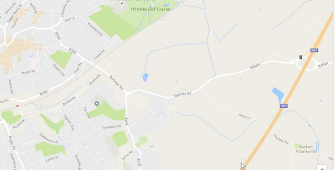HASTINGS HIGH SCHOOLReception: 