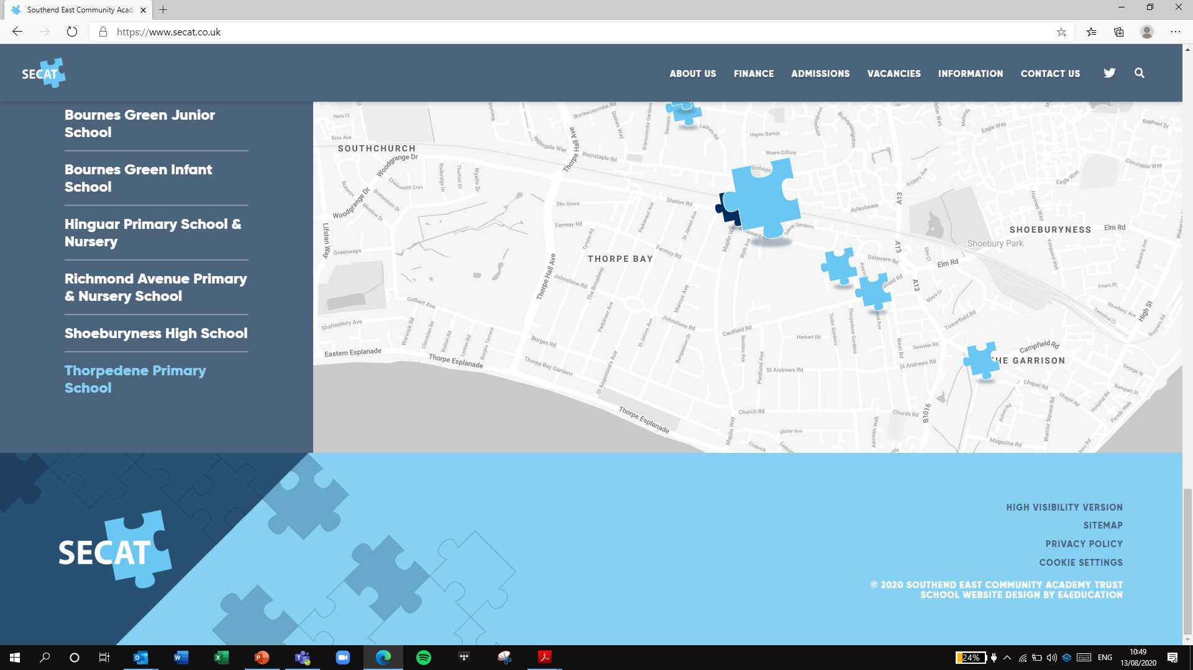

*Building strong schools*

*Building strong partnerships*

*Building strong communities*

**SOUTHEND EAST COMMUNITY ACADEMY TRUST**

**Thank you for your interest in the Teacher of Art position at Shoeburyness High School.**

**Please visit our online recruitment platform via** [**www.secat.co.uk**](http://www.secat.co.uk) **to complete the online application process.**

**We look forward to receiving your application.**