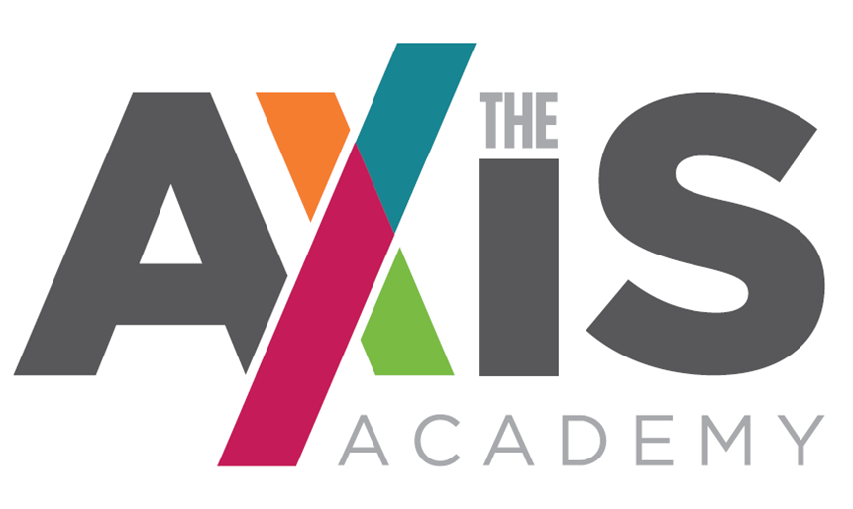

A specialist provision for students with Social, Emotional and Mental Health needs, with specific focus on mental health difficulties.

ART TEACHER RECRUITMENT PACK

ART TEACHER
Pay Scale: MPS

The Axis Academy
Lodgefields Drive
Crewe
Cheshire
CW2 8TU
CONTENTS

- Letter from Head teacher
- Application + Selection process and schedule
- The Axis Academy story and vision
- Art Teacher Role and Job Description
- Art Teacher Person Specification and assessment criteria
- Safer Recruitment and Selection Policy Statement
- Note re: Free school building and location
- School Holidays

Dear Applicant

Thank you for your interest in our Art Teacher vacancy.

This vacancy at The Axis Academy is an outstanding opportunity. If successful, you will play a key role in setting up a brand new Art curriculum in a brand new specialist school. This is a unique opportunity to become part of a team that will change the lives of children with Social, Emotional and Mental Health needs (SEMH).

We are working hard to build a reputation of being extremely versatile, developing personalised programmes of study so all achieve. The Axis Academy opened September 2020 for students aged 10 - 14. As a specialist school this is a rare opportunity that will give you the chance to help develop an education system that truly focuses on the individual.

The Axis Academy will become a beacon of outstanding practice in SEMH specialist provision and this role will provide an exceptional prospect to help craft the foundations of successful education.

We are looking for someone who will enjoy challenge along with the tremendous opportunity to join an incredibly hard-working staff team and help create an outstanding provision. We want our staff to empower children to succeed and show a patient and nurturing approach in order to unlock a child’s potential.

The Art Teacher will bring fresh ideas and stimulus to our already successful plans. You have the opportunity to create an inclusive curriculum which will inspire and excite.

If you feel that The Axis Academy may be the right place for you, I hope you will consider applying for the post. If you have any further questions, or would like to have an informal chat, then please do not hesitate to get in touch.

I look forward to hearing from you.

Yours sincerely

Emma Colley
Head teacher
The Axis Academy Art Teacher Recruitment and Selection Process

- You are asked to complete The Axis Academy Application Form which is attached.

- You are asked to include as part of or separate from the Application Form, a Letter of Application that addresses the items listed under desirable criteria on the attached Art teacher Person Specification & Assessment Criteria. Please keep this letter as brief and to the point as possible (no more than 2 sides).

- You are asked to return your Application Form & Letter of Application by email to;

FAO: Mrs. Emma Colley to admin@theaxisacademy.org

The deadline for applications is: Midday on Friday 2nd July 2021

Interviews will be held: Week Commencing Monday 5th July 2021

Start Date: 1st September 2021

If you would like further information please contact admin@theaxisacademy.org or alternatively telephone: 07761 510 969

The Axis Academy Educational Vision

Our Mission and Vision.

It is our mission to provide children with a wealth of education which doesn’t just focus on academic achievements. It is our drive to implement a holistic approach to supporting children in order for them to feel safe, develop self-worth, be happy and have true informed perspective, through quality education.
We will offer a wide and varied curriculum which will inspire and excite them so that children feel ambitious and empowered to succeed. Ultimately we want to unlock every child’s potential, reaching out to every possibility within them, making sure we have the most impact for their future.
Through a diverse and carefully tailored curriculum, and positive, understanding and empathetic staff students’ anxieties will reduce and their emotional well-being will improve and students will become confident and functioning members of society.
We want to motivate children, to inspire their minds and encourage them to think outside of the box. We want children to believe in their dreams, to believe that it is possible for them to accomplish anything they want and make it a reality, giving children a purpose in life and the confidence to believe in themselves. This is not just an aim but a devout commitment.

To deliver the vision the Art Teacher will work in collaboration with the Head teacher focusing on three key themes:

Re-connecting raising aspiration and motivating
  - A whole education, recognising that essential pre-cursors to academic success are personal and emotional development, independent living and decision-making skills and discovering meaningful interests and goals
  - A personalised curriculum including specific engagement activities based on the interests of each individual learner
  - Positive and trusted adult role models in the form of Learning Mentors and qualified teachers recruited for their enthusiasm for working with disconnected young people and their ability to understand and adapt, in order to meet the needs of the students
  - Opportunities to support social and emotional needs through individualised programmes and a varied curriculum

Unlocking every child’s potential
- The curriculum will determine the knowledge and skills students will learn at each stage. It will be planned efficiently to deliver exceptional lessons where students make outstanding progress, and are able to relate their learning to the wider world
- Individualised learning programmes, based on the interests and skills of the students, and which draw upon the diverse range of pastoral, vocational, engagement and personal and social development activities
- Small groups of students (max 1:10) with capability to offer 1 to 1 student support
- Practical application of English and Maths to develop skills that prepare for accreditation and work towards independence and social integration

Recognising and celebrating achievement
- Positive learning environments with praise for success and recognition of achievement
- Regular liaison with parents and carers to involve them fully in the education of their children including weekly progress telephone calls
- Celebration of success through weekly celebrations with students and staff, rewards for targeted elements and high profile annual celebration events
- Relevant vocational learning that broadens the curriculum offer to students providing the opportunity to support their classroom learning by gaining practical skills in the workplace, and ultimately allowing them to achieve recognised qualifications

English Teacher Job Description

Key Priorities

- Support the vision and direction of the school

- Provide an engaging Art curriculum within the academy

- Deliver and Maintain effective learning and teaching throughout school

- Undertake Performance Management & Line Management responsibilities for a learning mentor

- Deploy resources efficiently and effectively to meet specific objectives in line with English strategic plans.

- Ensure effective pastoral care and emotional wellbeing support throughout the school

- To be responsible for the day to day impact of English across the curriculum

- Willingness to demonstrate a flexible approach to the curriculum to meet school requirements

Teaching and Learning

The Art teacher of The Axis Academy will help secure and sustain effective teaching and learning throughout the Academy, monitor and evaluate the progress made in Art and present students’ achievement, effectively using baselines to track set targets for improvements. He/she will:

- Deliver the teaching of Art within the school and other subjects throughout the school as and when required

- Support and maintain an environment and a code of behaviour and discipline which promotes and secures good teaching, effective learning and high standards of achievement

- Support and maintain the mental health and Wellbeing of the students which promotes and secures good teaching, effective learning and high standards of achievement

- Help organise the Art Curriculum and its assessment and work with the SLT to monitor and evaluate it in order to identify areas for improvement

- Ensure that the curriculum and assessments meet National Curriculum requirements

- Ensure that improvements in literacy, numeracy and are priority targets for all students across school

- Deliver and support the PHSRE programmes across the school

Partnership Working

- Support in establishing a culture and Art curriculum which fulfils the aims and requirements of the whole school community as set out in the vision

- Seek opportunities to invite parents and carers, into The Axis Academy to enrich student experience and to promote The Axis Academy’s value to the wider community

- Collaborate with staff, to actively promote the British values, academic, spiritual, moral, social, emotional and cultural well-being of students and their families

- Represent The Axis Academy at relevant meetings, as and when required

Health and Safety / Child Protection

- To help ensure that health and safety standards meet statutory requirements, monitoring health and safety matters within the school, particularly ensuring that all members of staff take reasonable care for the health and safety of themselves and others

- To help ensure that Child Protection and Safeguarding procedures and Department of Health assessments of Children in Need are rigorously complied with, and that the welfare and health and safety of students are of prime consideration

- To promote the safety and well-being of students and staff

- To ensure good order and discipline of students and staff

ENGLISH TEACHER
The Axis Academy

Accountable to: School Senior Leadership Team
PERSON SPECIFICATION

Criteria | Essential | Desirable | Evidence
Qualifications/  Education | - Qualified Teacher Status  - A degree or equivalent  - Evidence of further professional development | - Recognised behaviour / curriculum / SEMH qualification | - Application/Interview/  Certificate
Teaching Experience | Proven ability to :  - Set high expectation which inspire, motivate and challenge students  - Promote good progress and outcomes by students  - Demonstrate full subject and curriculum knowledge  - Plan and teach well-structured lessons  - Adapt teaching to respond to the strengths and needs of all students  - Make accurate and productive use of assessment  - Manage behaviour effectively to ensure a good and safe learning environment  - Fulfil wider professional responsibilities  - Communicate and work effectively in a multi-disciplinary school team including parents/guardians and other external agencies  - Commitment to school-wide focus on student attainment  - Ability to motivate and inspire | - Evidence of having led whole school learning and teach strategy.  - Demonstration of high expectations  - Success with students who are below expected levels  - Work with disconnected students | - Application/ Interview/  References
Professional /Personal Skills | Proven ability to:  - Demonstrate the ability to deliver at least good classroom practice  - Good organisational skills  - Use assessment effectively to inform student’s progress and to analyse data to help the target setting process.  - Generate enthusiasm for new ideas in both students and staff  - Inspire others with confidence  - Communicate effectively to groups and individuals, orally and in writing  - Resolve conflict through active listening and negotiation  - Demonstrate a flexible approach and a willingness to listen to others  - Provide advice and guidance to parents and carers in a positive and clear manner  - Remain calm when working under pressure  - Ability to show patience and empathy | - Evidence of coaching and/or mentoring  - Able to effectively resolve personnel issues  - Training and understanding of child protection  - Training and experience of working with students with a variety of mental health needs | - Application/ Interview/  References
Curriculum & Personal Management | - Ability to analyse situations, prioritise and help to implement realistic solutions  - Ability to establish and develop good relationships with all involved in the school  - Commitment to the school’s wider community  - Willingness to deliver and support extra-curricular activities  - Ability to inspire all in a love of learning for your subject | - Proven ability in leading a staff CPD session on a subject area  - Experience of supporting staff  - Effective liaison with Governors and a good understanding of their role | - Application/ Interview/  References
Knowledge and understanding | - Demonstrate a good level and understanding of ICT  - Knowledge of how to deal with safeguarding issues in school  - Awareness of current developments in education and the implications of these.  - Understand how to plan appropriate interventions  - Behaviour management techniques for groups and individuals  - Know how to develop effective rapport with students, this being based on high expectations and establish a purposeful learning environment | - Knowledge and experience of current good practice and development in special education provision  - Knowledge of successful practice in teaching hard to reach students.  - Knowledge of how to promote independence for young people with complex needs  - Behaviour Management training  - Mental Health training  - Knowledge of OFSTED Framework | - Application/ Interview/  References
Shaping the Future /Philosophy | - Demonstrate and communicate clear ideas to promote the schools vision and ethos  - Expectation of high achievement of all students  - Evidence and understanding and commitment to equality of opportunity  - Respect for students’ individual difference  - Commitment to parental partnership in education and developing links between school, home and the community |  | - Application / Interview

Criteria | Essential | Desirable | Evidence
Developing Self and Working with Others | - Excellent interpersonal skills  - Commitment to one’s own continuing professional development  - Ability to work as part of a team  - Ability to make and take decisions and set priorities  - Able to gain and maintain the confidence and respect of colleagues, students, parents and multi professionals  - An ability to work in partnership with those agencies that work with the school  - Have energy and perseverance  - Be confident and enthusiastic  - Be reliable and have integrity | - Evidence of delivering staff training for staff, Governors and Parents | - Application / Interview/  References
Securing Accountability | - Application of the need to delegate responsibility with accountability for area of responsibility  - Communicate to staff teams effectively |  | - Application /Interview  /References
Strengthening Community | - An ability to establish and maintain positive partnerships with parents, students and communities  - Awareness of the need to develop a school culture responsive to the nature of the school’s communities | - Work in the wider community. | - Application / Interview  - Application / Interview
Other Requirements | - Positive recommendation from present employer  - Good attendance record |  | - Letter  - Reference

The successful candidate would be expected to maintain a well-organised, creative, safe and friendly environment for living and learning and hence enhance the ethos of the school. Candidates are asked to address as many of the person specifications as possible in their application.

Note re Free School building and location
The school is located on Lodgefields Drive in Crewe and opened September 2020.

Note re: Free School holidays

Before applying, please be aware that The Axis Academy will adopt a different holiday calendar to other schools. Each half term will be approximately six weeks in duration with a two week break in between. This will mean that summer break will be approximately 4 weeks in duration. For further clarification please contact admin@theaxisacademy.org

