
WALTHAMSTOW SCHOOL FOR GIRLS
Art, Design and Technology Faculty Information

The faculty is responsible for the teaching of a number of different subjects.
At Key stage 3 – years 7, 8 and 9 all pupils are taught the following:
Art – 2 hours per fortnight
Design and Technology 2 hours per fortnight
Food Technology - 1 hour per fortnight
At KS3 Group sizes for D&T and Food are 23 students. Art groups have 30 students.
At Key stage 4 GCSE’s are offered in the following subjects:
- Art & Design: Fine Art
- Art & Design: Textile design
- Food and Nutrition
- Design & Technology
We aim to have D&T group sizes of no more than 20; however, the popularity of the subject sometimes means that we exceed this. Art has up to 25 in a group for GCSE.
Students are free to choose a combination of these subjects dependent on their strengths and personal preferences. However, they cannot choose Fine Art and Textile Design. They should choose one or the other as these will only count as one GCSE.
Each option has 5 hours of lessons over a period of a fortnight.
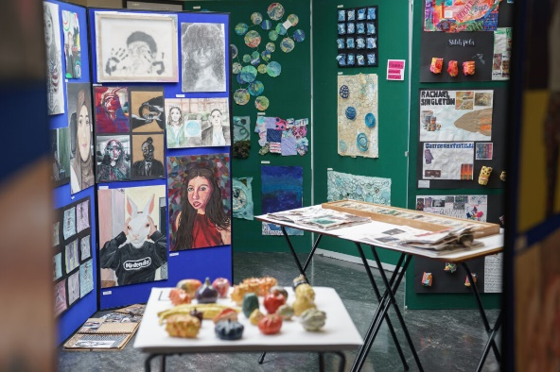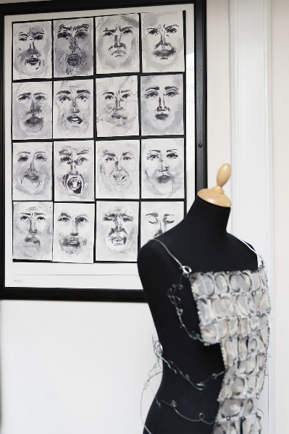

Currently there are five teaching staff. Two Art; two Design & Technology and one Food teacher, working with three technicians. Technician support varies but each subject area has dedicated technician support time.
The faculty has benefited from some good quality funding and has some excellent resources including Two fully quipped Art studios; Two fully equipped workshops; A specialist Food Technology room; Computer Aided Design and Manufacturing equipment (Laser cutter, vinyl cutter, heat press, CNC Milling Machine, 3d printer, embroidery machine), Laser Image transfer for printing full colour images onto a variety of materials and surfaces, print making facilities in Art, 3d ceramics (potters wheel), kiln, access to PC’s etc. We aim to develop our resources each year and are keen to continue to do so.
The school has high expectations of students and the faculty achieves excellent GCSE results. Controlled Assessment work is of a consistently high standard.
The faculty benefits from having six light, spacious, modern and well- equipped rooms that have easy access to a shared faculty staff base room.
September 2025
