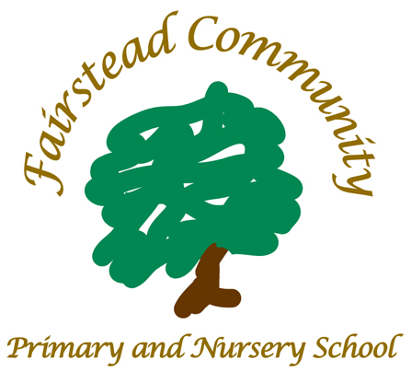
At Fairstead Community Primary and Nursery School, we nurture and invest in our relationships. We identify each individual’s potential and work as a team to create a safe environment for everyone to grow and succeed.

Fairstead Community Primary
and Nursery School
William Booth Road, King’s Lynn
Norfolk PE30 4RR
Telephone: 01553 774666
Email: office@fairstead.norfolk.sch.uk

Email: office@fairstead.norfolk.sch.uk

‘Unless someone like you cares a whole awful lot, nothing is going to get better. It’s not.’ – Dr. Seuss

ASD Specialist CLASS TEACHER REQUIRED
September 2024 or sooner if available

MPR/ UPR + SEN Allowance

We are seeking a highly effective SEND teacher to join our friendly, ambitious and forward-thinking inclusion team. The ideal SEND teacher will be driven to succeed and teach children with Autism and complex needs.

You will have the enthusiasm and purpose to want to make a difference. We’re looking for a dedicated, passionate and experienced individual who is knowledgeable about Autism, with a track record of supporting children with additional needs. This role will, with the support of our Inclusion team, create a therapeutically appropriate environment to enable all children to progress inline with personalised next steps.

We offer an excellent caring environment in a bright, well-resourced school where you will have the opportunity to either start or advance your career within a supportive community school. We have enthusiastic and polite children, whose excellent behaviour is often commented on.

Cultural Fit

Our school is developing all the time. We have implemented a curriculum whose drivers are possibilities, community and independence. We are a school at the heart of our community, and we feel it is important for our children to have a developed sense of their locality and be proud to be part of it.

Our curriculum and our pedagogic principles underpin the school culture.

- We believe we can all improve, children learn from staff as well as from each other.
- We believe in the potential of all children to learn
- We engage in deep thought about challenge and quality
- We provide opportunities to practise skills that have been learnt so that over time automaticity is achieved.
- We sequence all learning in to small steps with children’s starting points taken in to account
- We have an openness to feedback
- We develop worked models that communicate quality and success
- We take ratio in to account where over time learners take on more of the learning load
- We believe that children should be given feedback at all points of the learning journey
We focus single-mindedly upon providing the best teaching we possibly can for our children. If you want to become an even better teacher than you are now and want to work hard on your practice, then this will be the school for you.
Working in a school where you are not aligned with the culture can be a miserable experience. So…we both need to have alignment if you come to work here!
We can offer:

- An induction package to support successful integration
- A forward thinking school, which is committed to improvement through evidence based research
- Friendly and supportive staff
- A workload and wellbeing team
- More opportunities to grow your career with our focused CPD programmes
- Norfolk Rewards – staff discount programme
- Leadership development – working with colleagues to improving outcomes across the learning community supported by NPQ or equivalent courses
- Part of the Viscount Nelson Education Network (VNET) incorporating a tailored package of bespoke in-school support as well as a wide range of CPD opportunities across Norfolk and beyond.
- An Emotional Literacy Support Assistant (ELSA)
- HLTA and TA support throughout school
- Supervision
- A focus on supporting good mental health, working closely with the MHST
- SSS Safeguarding suite training package ensuring that training for safeguarding is highly effective

Visits to the school are encouraged. If you would like to visit the school, you will be assured a warm welcome. Please contact Kerry Tucker, School Business Manager, who will be more than happy to arrange your visit.

Fairstead Community Primary and Nursery School is committed to safeguarding the welfare of children and young people and expects all staff to share this commitment.

Enhanced DBS disclosure is required for appointment to this post. We are unable to accept CVs in place of application forms. Please visit our school website for an application form www.fairsteadprimaryschool.co.uk/information/vacancies/

Completed application forms should be returned either by email to admin@fairstead.norfolk.sch.uk or by post to Kerry Tucker, Fairstead Community Primary and Nursery School, William Booth Road, Kings Lynn, Norfolk, PE30 4RR.

We are an equal opportunities employer. If you require any additional support to enable you to make an application please contact Kerry Tucker, School Business Manager by email to admin@fairstead.norfolk.sch.uk or phone: 01553 774666.

Closing date: 12/06/2024

