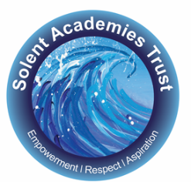
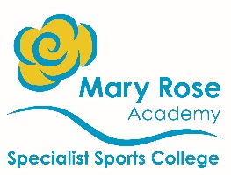
Empowering our community, within and beyond Mary Rose
to achieve great things; experience awe and wonder and to have our voices heard, now and for the future.
Autism Teachers Vacancy Permanent
Mainscale + SEN Allowance

Mary Rose Academy is looking to recruit inspiring teachers to join our amazing team from September 2024 in our Autism classes.

As the founding school of Solent Academies Trust, Mary Rose is a consistently 'Outstanding' Specialist Sports College which caters for pupils aged 3-19. All pupils attending Mary Rose have profound or severe learning difficulties alongside a diverse range of diagnoses and needs, including Autism and highly complex medical conditions.

We are seeking teachers who care passionately about the education and wellbeing of pupils with special educational needs and their families.

You will have the opportunity to be innovative, creative and have fun, whilst making a real difference to the lives of our pupils who face significant challenges in their learning and development.
By joining the Mary Rose Academy team, we offer you:

- SEN Allowance, which increases after 3 and 5 years of service
- Excellent staff induction with a commitment to high quality professional development
- The opportunity to be part of an innovative and forward thinking Trust
- Superb resources
- A happy, committed and supportive community
- Confidential Counselling & Wellbeing Support Service
- Life Insurance - 3 times annual salary (for members of the pension scheme)
- Wellbeing Inset Day to support the wellbeing of our staff
- Commitment to continuing CPD opportunities to support career progression
- High quality coaching and support
- Free onsite parking
- Employee Referral Scheme
- Employee Benefit Platform
- EarlyPay

For more details about the post please visit our website http://solent-trust.net.
Please complete a Solent Academies Trust teaching application form accompanied by a letter of application. In your letter, please describe the contribution you feel you can make to the achievement of pupils in our school.
If you have any questions at all or wish to submit an application please email recruitment@solentacademiestrust.info.
Please note we will only accept applications completed on our Solent Academies Trust application form.

Closing date for applications is Monday 6th May 2024.

Interviews will be held on Friday 10th May 2024.

Solent Academies Trust welcome applications regardless of age, gender, ethnicity or religion. Only applications submitted on the academy’s application form will be accepted Solent Academies are committed to safeguarding and promoting the welfare of children and young people and expect all staff and volunteers to share this commitment. We will ensure that all our recruitment and selection practices reflect this commitment. All successful candidates will be subject to an enhanced Disclosure and Barring Service checks along with other relevant employment checks.

