Job Description
Assistant Exams Officer & Cover Administrator

Post Title: | Assistant Exams Officer & Cover Administrator (maternity cover)
Base: | Woldgate School & Sixth Form College
Salary: | SCP6 £26,847 (pro rata for term time working)
Line Management: | Assistant Headteacher – Intervention and Data Analysis
Contract: | 37hrs per week – term time plus 5 days

Core Purpose:
- Assisting our Examinations Officer with the management of all examinations (internal and external).
- To work closely with and deputise for the Examinations Officer in their absence.
- Administration in respect of the School’s Management Information System to provide and analyse data on relevant pupil/student performance to inform school leaders, teaching colleagues and school governors.
- Administer, monitor and maintain the school’s daily cover system, liaising closely with the People and Culture Lead and Classroom Practitioner team.

Duties & Responsibilities:
Key responsibilities
- Administration and analysis of whole school data (tracking, monitoring and reporting).
- Communication with all staff, parents, pupils, to ensure effective communication and action.
- Day to day administrative use of school systems in support of the Assistant Headteacher for Intervention and Data Analysis.
- Administration of pupil personal data and admissions.
- Supporting the Examination Officer in the co-ordination and implementation of exams, parents’ evenings and other events.
- Co-ordination of data entry with members of staff to ensure timely collection of pupil data.
- Supporting the Assistant Headteacher for Intervention and Data Analysis with the whole school census, the school timetable and the administration of options processes.
- Update and monitor the school’s cover supervision system daily and liaise with external agencies to provide staff teaching cover where necessary.
- To work with the People & Culture Lead in arranging cover for planned staff absences and school events, deploying Classroom Practitioners and external agency teachers where necessary.
- Ensuring arrangements for cover for the following day are in place by the end of the working day.
- To monitor cover lesson plans and resources submitted by teachers in advance, to ensure pupils receive high-quality cover lessons.
- To meet and induct any agency teachers each morning to our safeguarding practises and other school policies and escort to first lesson.
- To ensure each morning that the Classroom Practitioner team and any external agency teachers are clear on their timetable for the day ahead and can access any resources necessary to deliver lessons.
- To liaise with agencies to ensure invoices are accurate, and to liaise with the People & Culture Lead and Finance Manager in ensuring these are processed.
- To work with the Senior Leadership Team in planning for cover required during school events, and liaising with appropriate colleagues as necessary.
- To administer cover using the school Management Information System (MIS) (full training will be provided).
- To undertake other similar duties commensurate with the grade, provided that such duties are within the competence of the post-holder.
Any other duties commensurate with the general level of responsibility of the post that the Headteacher may from time to time ask the post-holder to perform.

PERSON SPECIFICATION

Criteria | Essential | Desirable | Evidence
Qualifications
GCSE in English Language and Maths (or equivalent) at Grade C or above | X |  | A/C
 |  | X | A/C
Experience
Recent experience in an administrative role | X |  | A/I
Previous experience of working within schools or similar environments |  | X | A/I
Experience of using Microsoft Office and Excel | X |  | A/I
Experience of using SIMS or other MIS systems |  | X | A/I
Experience of working effectively as part of a team | X
Knowledge and Understanding
Strong organisational skills, with the ability to plan, organise and prioritise to meet deadlines. Can work effectively in a busy environment | X |  | A/I/R
Ability to work under direction and on own initiative |  | X | A/I/R
Ability to build effective working relationships with colleagues. Able to work independently and as part of a team | X |  | A/I/R
Ability to use own initiative and to problem solve | X |  | A/I
Understanding of data protection and confidentiality | X |  | A/I
Understanding of Safeguarding in schools, and suitable to work with children and young people | X |  | A/I
Commitment to comply with school policy | X |  | A/I
Personal Skills & Attributes
Commitment to the Trust’s ethos and values and a willingness to support the school’s policies and procedures in all areas. | X |  | A/I
A good level of literacy & numeracy | X |  | A/I
Friendly and approachable personality | X |  | A/I
Excellent administrative and organisational skills | X |  | A/I
Deals with difficult situations effectively | X |  | A/I
Good team player | X |  | A/I
Safeguarding
A commitment to safeguarding and promoting the welfare of children and young people | X |  | A/R/I

A= Application; C = Certificate; R = Reference; I = Interview

Note - This person specification is not necessarily a comprehensive definition of the post. It may be subject to modification and amendment after consultation with the post-holder.

The school is committed to safeguarding and promoting the welfare of young people and expects all members of staff to share this commitment. An enhanced DBS disclosure is required for all posts.

How to apply
If you would like to apply for this vacancy, please download a form from Wonder Learning Partnership website.
Applications should be returned to Ceri King, People & Culture Lead, Woldgate School & Sixth Form College cking@woldgate.net
The school is committed to safeguarding and promoting the welfare of young people and expects all members of staff to share this commitment. An enhanced DBS disclosure is required for all posts.
CLOSING DATE: 23rd October 2026 9am

How to Find Us
Woldgate School and Sixth Form College, 92 Kilnwick Road, Pocklington, York. YO42 2LZ Tel: 01759 302395

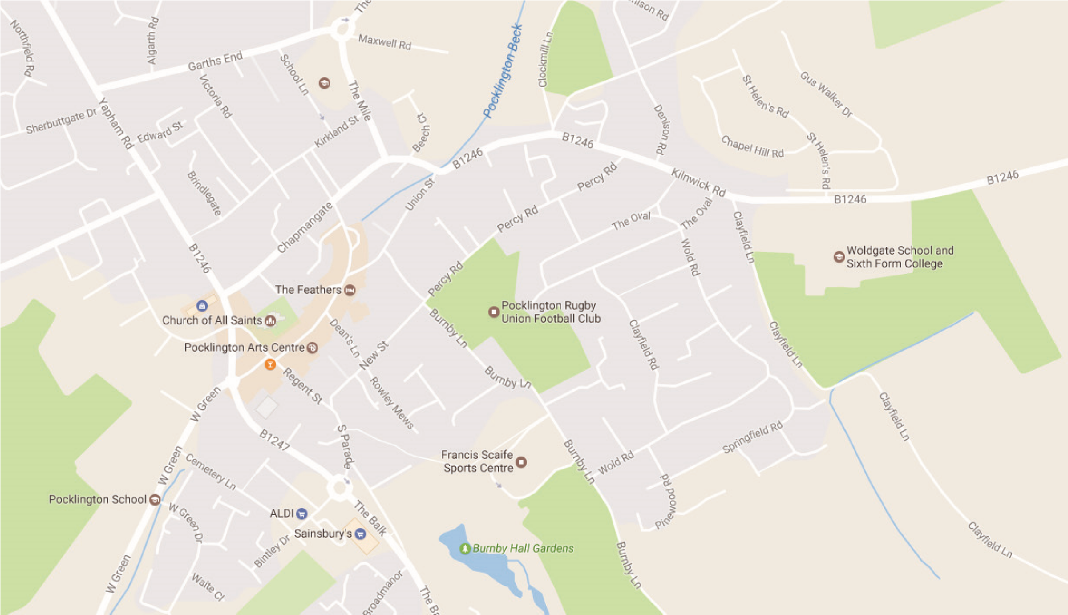

A. From Hull - Take the A1079 including the by-passes of Beverley and Market Weighton
- Take the right-hand fork from Pocklington at the Yorkway Hotel
- Take the 3rd exit from the roundabout, past the Rugby field on your right.
- Turn right at the B1246 signposted Warter, Driffield, Bridlington
- Woldgate School is the last building on the right as you leave the town.

B. From Humber Bridge - Take the Westward route towards Leeds along the A63
- Leave the A63 at the slip road and bridge over signposted for Market Weighton, Bridlington
- Pass through villages of South Cave and Sancton
- Turn west at Market Weighton bypass, A1079 towards York
- Follow instructions A3, A4, A5

C. From Leeds - Take A64, York by-pass towards Scarborough
- Leave A64 at Grimston Bar roundabout signposted York, Bridlington, Hull
- Exit from roundabout onto A1079 towards Hull
- Twelve miles approximately along A1079 after Pocklington Industrial Estate, turn left for Pocklington, just after Bonds International.
- Pass Pocklington School on left, at roundabout take 3rd exit past bus station, fire station.
- Take the first exit from the roundabout.
- Follow instructions A4, A5

D. From North-East England - Take A19 southwards until Northern by-pass of York
- Follow signs for Hull, Bridlington
- At A64 turn West for Leeds
- Follow instructions C2, C3, C4, C5, C6

E. From Scarborough, Bridlington - Follow sign from Driffield
- Bypass Driffield along North and West side
- Leave bypass where signposted for M62, Market Weighton
- At Bainton roundabout take second exit along B1246 towards North Dalton, Warter, Pocklington.
- Woldgate is the first building on the left as you reach Pocklington.

