Candidate Information Pack
Assistant Head of School

Contents
About the Trust | 1
About us | 2
Our vision and values | 3
Working at Birley Spa Primary Academy | 4
Benefits of being part of L.E.A.D. Academy Trust | 5
How to apply | 6
Job description and Person specification | 7

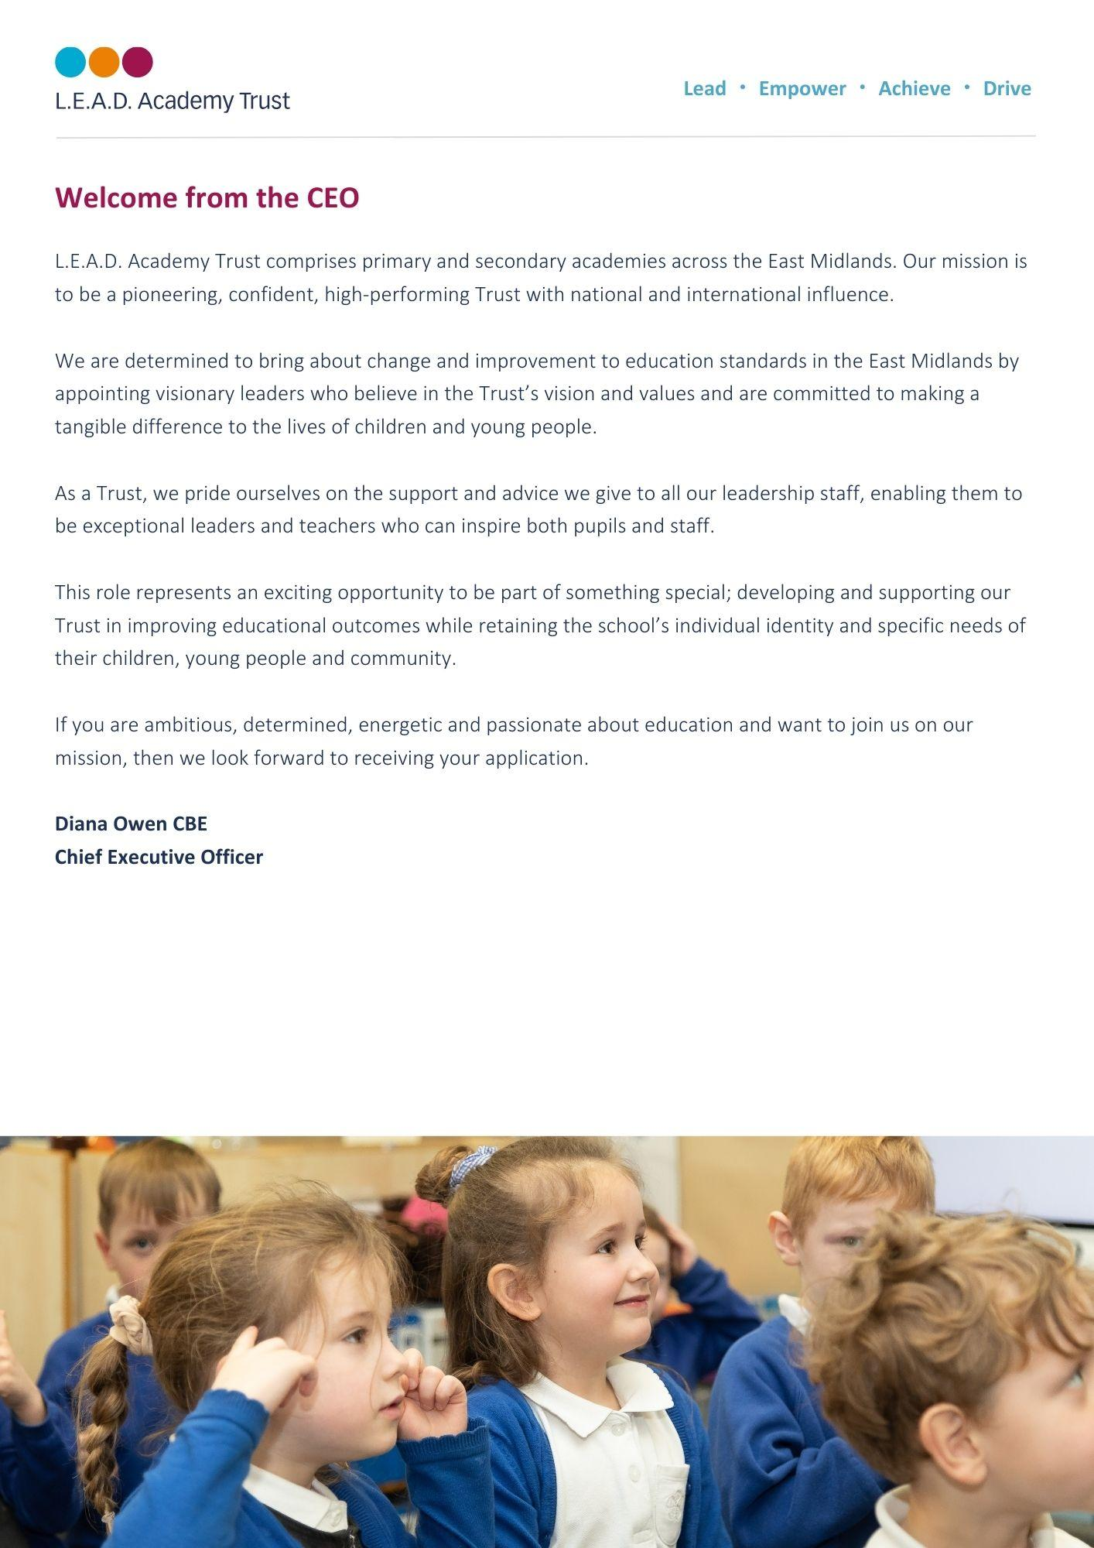
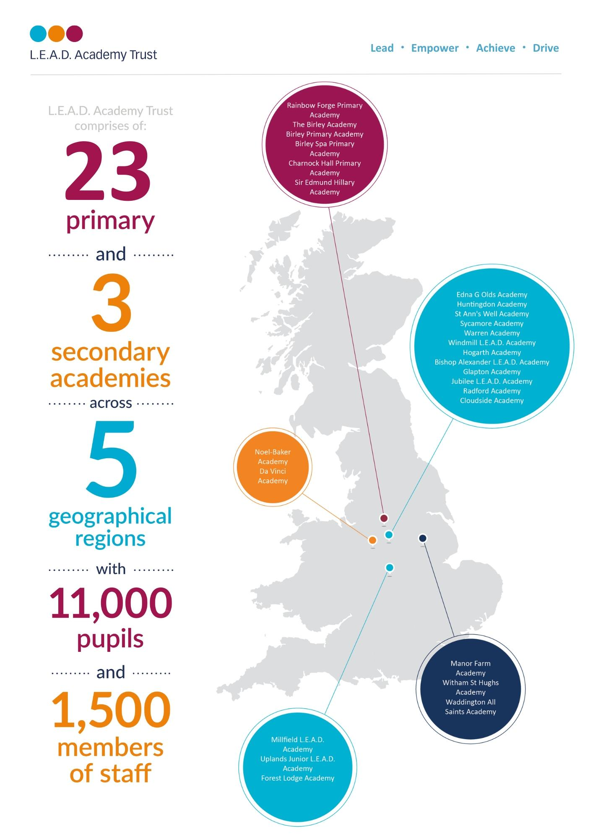
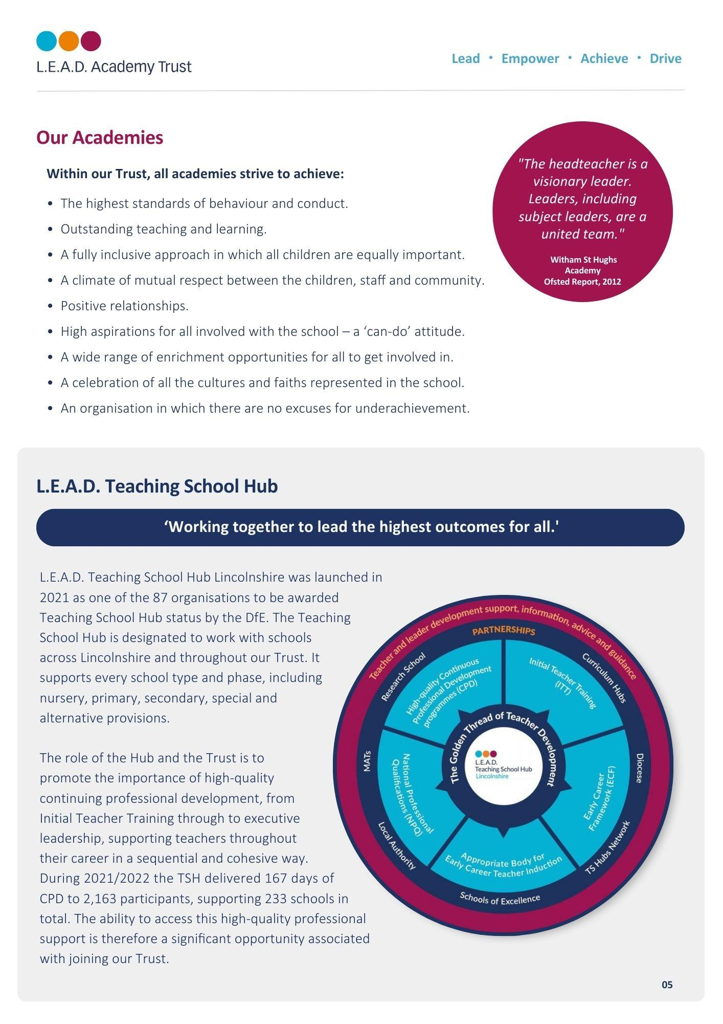

A message from the Headteachers
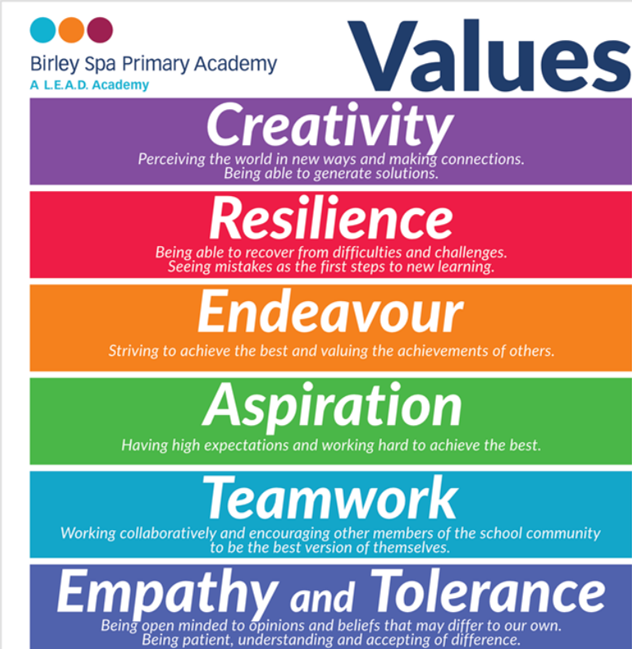
We are a busy and friendly school with lots going on. We are delighted to have the opportunity to recruit an Assistant Head of School to compliment our dedicated and forward-thinking leadership team. Birley Spa is a passionate community of life-long learners who strive for excellence. We are inspired by each other’s achievement and success. We constantly develop and update our resources and curriculum offer to ensure that our pupils can succeed now and in the future.
We warmly welcome visits to the school to discuss this exciting opportunity.
Melany Pemberton Cathy Gibson
Executive Headteacher Head of School

About Birley Spa Primary Academy
Our School Values equip every child with the core strength and resilience to confidently burst through barriers to learning and become confident, conscious citizens, equipped for the challenges of the modern world. We create an aspirational cultural climate in which every member of Birley Spa Primary Academy thrives and articulates a passion for inspiring leadership beyond learning.
Through the pursuit of excellence, our children, no matter their age or need, are encouraged to become ambassadors with the highest aspirations. Learners who confidently express themselves and articulate their knowledge with passion.
Our inspirational learning environments motivate our children to develop a desire and love of learning in our “Everyone is a Leader” community.
Our children pride themselves on the range of responsibilities they have within the classroom and the school. They develop a sense of pride in their community and independence. They learn to understand and balance risk to challenge themselves and grow as learners. Children demonstrate initiative to question, lead and explore from the first day of their Birley Spa journey until they move onto secondary education.

Pupils learn how to be leaders. They are tolerant of, and respectful to, others. Pupils embrace different ideas and cultures. It matters to pupils that everyone should feel included in their community.

OFSTED 2023
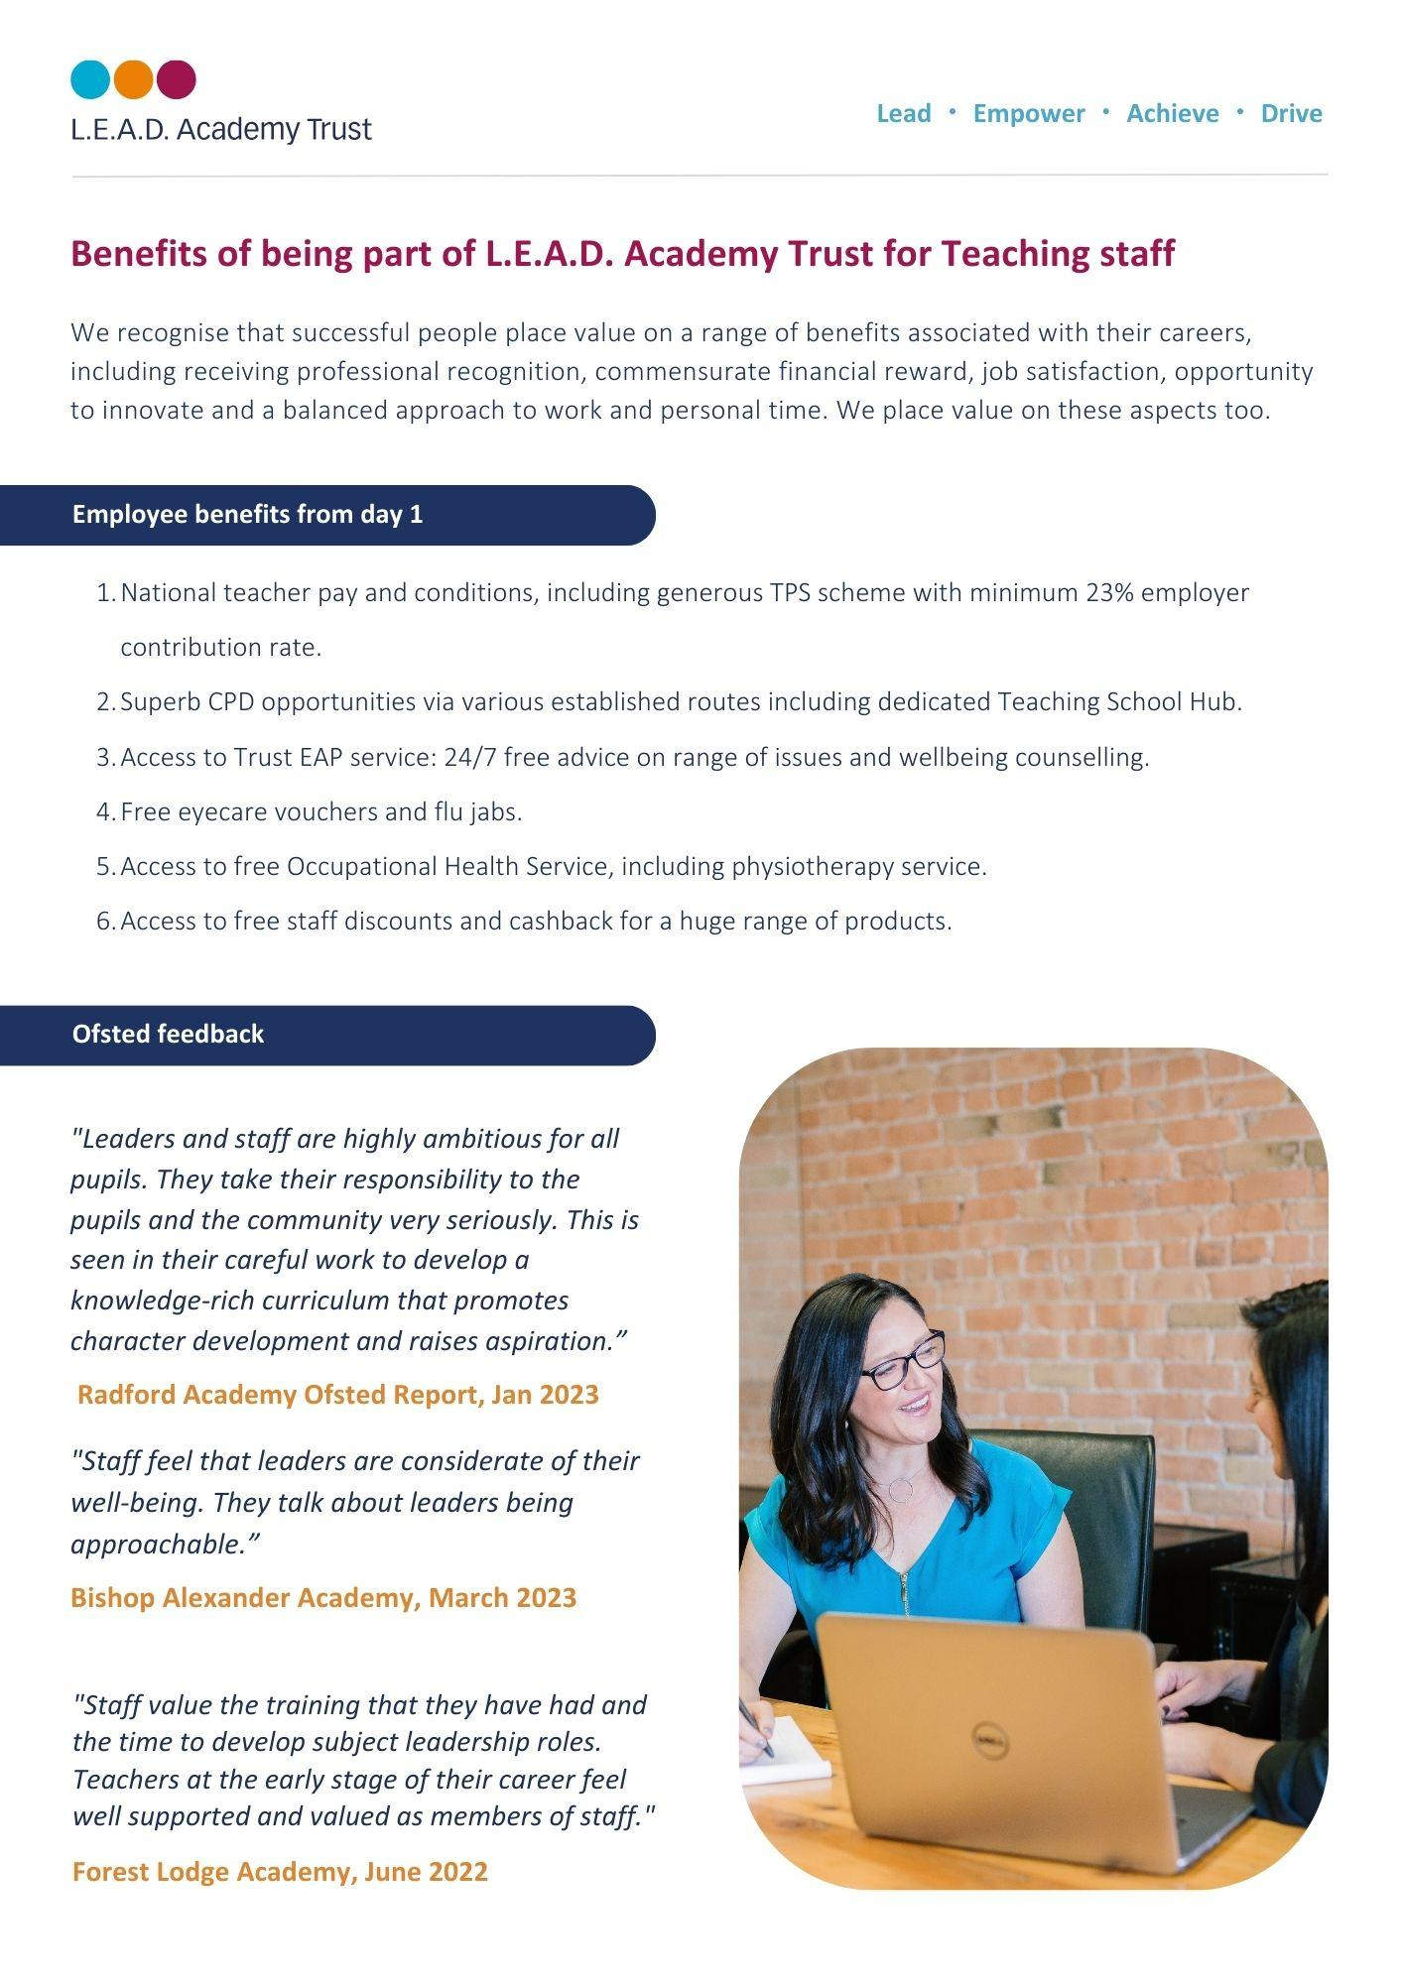
The school has high expectations for pupils’ achievement.
The school’s provision for pupils’ personal development is strong. Pupils take full advantage of the wide range of activities on offer at the school.

Trust and school leaders work with a shared purpose and vision.
Pupils become confident and resilient. Pupils with SEND are fully involved in all aspects of school life. The school identifies the additional needs of pupils with SEND well.

How to apply
Please send a completed application form and covering letter explaining your interest in the role and how you meet the person specification to : leannemoore@birleyprimaryacademy.co.uk
CLOSING DATE: 14/04/2024

Applications will be reviewed upon receipt, therefore shortlisted candidates may be contacted in advance of the closing date.
L.E.A.D. Academy Trust is committed to safeguarding and promoting the welfare of children and young people and we can expect all staff and volunteers to share this commitment. This post is subject to an enhanced DBS check.
For an informal, confidential discussion about this opportunity, please email: enquiries@birleyspaacademy.co.uk
Job description
Key responsibilities and accountabilities
Assistant Headteacher
Salary: L4-L8

Main Responsibilities:
A person appointed as a deputy or assistant Headteacher in a school, in addition to carrying out the professional duties of a teacher other than a Headteacher including those duties particularly assigned by the Headteacher, must play a major role under the overall direction of the Headteacher in:
a) formulating the aims and objectives of the school;
b) establishing the policies through which they are to be achieved;
c) managing staff and resources to that end;
d) monitoring progress towards their achievement; and undertake any professional duties of the Headteacher reasonably delegated by the Headteacher.
48.2. If the Headteacher is absent from the school a deputised Headteacher must undertake their professional duties to the extent required by the Headteacher or the relevant body or, in the case of a foundation, voluntary aided or foundation special school, the governing body
Taken from the Teachers’ Pay and Conditions Document 2020 DfE

Job Purpose:

- To provide inspirational, creative and professional leadership and management for the academy.
- To support the Headteacher in establishing high quality systems and policies.
- To support the Headteacher in establishing high quality education through effective leadership of teaching and learning. As a leading professional, exemplify high quality teaching that supports outstanding progress in pupils’/students’ learning.
- To support the Headteacher in establishing a culture that promotes excellence, equality and high expectations of all pupils.
- To ensure that strategic planning is informed by rigorous self-evaluation and that it continuously improves learning and pastoral outcomes.
- To ensure that the academy provides a safe and happy environment that promotes the welfare of children.
- To ensure all safeguarding and child protection policies are understood and adhered to and everyone, including staff, parents and visitors accept their responsibility to protect pupils.
- To take responsibility for leading the school in the absence of the Headteacher or Deputy Headteacher and ensure the effective day to day running of the academy.

Duties and Responsibilities:

Strategic direction and development of the school
- As part of the Senior Leadership Team, provide inspiring, creative and purposeful leadership for the staff and pupils/students.
- To work in partnership with the Senior Leadership Team, the governing body, staff and parents, generating the ethos and values which will underpin the academy.
- To co-create and implement a Development Plan which will secure continuous academy improvement and support the principles of LEAD Trust.
- To keep up to date with current research into education, particularly teaching and learning and to contribute this academy improvement planning.
- To monitor and evaluate the performance of selected areas of the academy and respond and report to the Headteacher, Deputy Headteacher and the governing body as required.
- To lead on developing selected policies and practices and ensure that they take account of national, local and academy requirements and apply sound educational practice through evidence based pedagogy.
- To regularly monitor, evaluate and review the impact of selected policies, priorities and targets and take action if necessary.
- To inspire all those involved in the academy to commit to its aims, stay motivated to achieve them and involved in meeting long, medium and short term objectives to secure the educational success of the academy.

Teaching and learning
- As part of the Senior Leadership Team, continue to maintain an environment that promotes and secures outstanding teaching, effective learning and high standards of achievement, behaviour and attendance.
- Determine, organise, implement and monitor selected areas of the curriculum and its assessment and ensure that statutory requirements are met.
- Meticulously plan and teach engaging and challenging lessons to exemplify high standards of teaching and learning expected by the academy.
- Ensure that pupils/students develop study skills in order to learn more effectively and with increasing independence.
- As part of the Senior Leadership Team, plan and implement a policy for the personal, social and moral development of pupils/students.
- Monitor and evaluate the quality of teaching and learning and achievement of selected pupil/student groups through appropriate methods. Devise clear, rigorous and precise plans to address any weaknesses in a timely manner.
- Exemplify excellent practice in delivering inclusion, diversity and equality of access.

Leading and managing staff
- Plan, allocate, support and evaluate work undertaken by groups, teams and individuals, ensuring clear delegation of tasks and devolution of responsibilities.
- As part of the Senior Leadership Team, implement and sustain effective systems for the management of staff performance, incorporating performance management and target setting.
- Promote and monitor the continuing professional development of staff.
- Hold selected staff to account for their professional conduct and practice, both contractually and where relevant as specified in the Terms and Conditions of Service of teachers.

Efficient and effective deployment of staff and resources
- As part of the Senior Leadership Team, recruit, retain, deploy and develop staff of the highest quality.
- Monitor appropriate expenditure, allocation of funds/resources and effective administration for selected areas of responsibility in order to improve the quality of education, pupils’ achievements and ensure efficiency and secure value for money.

Accountability
- As part of the Senior Leadership Team, continue to develop an organisation in which all staff recognise that they are accountable for the success of the academy.
- Present a coherent and accurate account of the school’s performance in selected areas in a form appropriate to the range of audiences, including the Headteacher, governors, parents, OFSTED and others to enable them to play their part effectively.
- Ensure that parents/carers and pupils/students are well informed about the curriculum, attainment and progress and about the contribution they can make in supporting their child’s learning.

Influencing and Managing Relationships:

- Senior Leadership Team within the Academy
- Director of Schools
- All teaching and support staff
- Parents and Carers
- Other third party organisations as required

Other Academy Specific Responsibilities

- Support the Headteacher by undertaking any management duties to support the efficient and effective running of the school.
- To undertake any professional duties reasonably delegated by the Headteacher. The responsibilities reflected in paragraph 58.4 of the School Teachers’ Pay and Conditions document may also be applicable as part of this role.

As job descriptions cannot be exhaustive, the post-holder may be required to undertake other duties which are broadly in line with above key responsibilities.

The Trust is committed to safeguarding and promoting the welfare of children and young people and expects all staff and volunteers to share this commitment and individually take responsibility for doing so.

This job description is current at the date shown, but in consultation with you may be changed to reflect or anticipate changes in the job, commensurate with the grade and job title. This includes changes to National Teacher Standards and requirements of the professional role.

At L.E.A.D. we have a strong vision and four core principles, to lead, empower, achieve and drive, which you will be expected to demonstrate in your working practices.

Person specification
The person specification listed below outlines the competences, knowledge and behaviour of candidates who would be suitable for this role. The two right-hand columns provide guidance as to whether these items are essential (E) or desirable (D) criteria.

 |  | E | D
Qualifications and Attainments | - Qualified Teacher Status  - Evidence of recent and relevant further professional development  - NPQSL/NPQML or equivalent | E  E | D
Skills and  knowledge | - In depth knowledge of statutory education frameworks  - Evidence of l, recent and successful leadership experience  - Evidence of the ability to hold staff to account in the pursuit of improving standards  - Experience of the appraisal process  - Effective strategies for promoting student welfare  - Confident use of ICT communication skills  - Knowledge and understanding of data analysis and the ability to use data to set targets for improvement  - Experience in whole school self-evaluation  - Up to date knowledge & understanding of the current national education agenda  - The effective use of support structures and resources to aid student progress  - Knowledge of child protection and safeguarding legislation  - Strategies for ensuring inclusive practice across all areas of the curriculum | E  E  E  E  E  E  E  E | D  D  D  D
Experience | - Significant experience with a record of excellent teaching  - Leadership of an area or phase or inclusion including responsibility for raising standards across the whole school  - Proven track record of raising achievement  - Evidence of impact beyond own area of responsibility  - Experience of teaching in more than one key stage  - Experience of leading initiatives with in the school  - Demonstration of high expectations including leading by example as a teacher  - Evidence of contributing to effective staff training, both on an individual and whole school level  - Understanding of learning with regard to stages of basic skills development of children | E  E  E  E  E  E  E | D  D  D  D
Personal Attributes | - Approachable, enthusiastic and creative  - Leads by example, demonstrating integrity, resilience and clarity  - Passionate about education  - Ability to work under pressure, think creatively and to anticipate and solve problems  - Commitment to the encouragement, empowerment and training of all staff  - Deal sensitively with people and resolve conflicts  - Demonstrate flexibility and an ability to adapt to changing circumstances and new ideas | E  E  E  E  E  E  E
Additional Requirements | - This role is subject to an enhanced DBS  - May be required to travel to other Trust locations or third party services as part of the role  - Hold a driving licence and have access to own vehicle | E  E | D

Email address:
enquiries@birleyspaacademy.co.uk
Phone number:
0114 2399106

