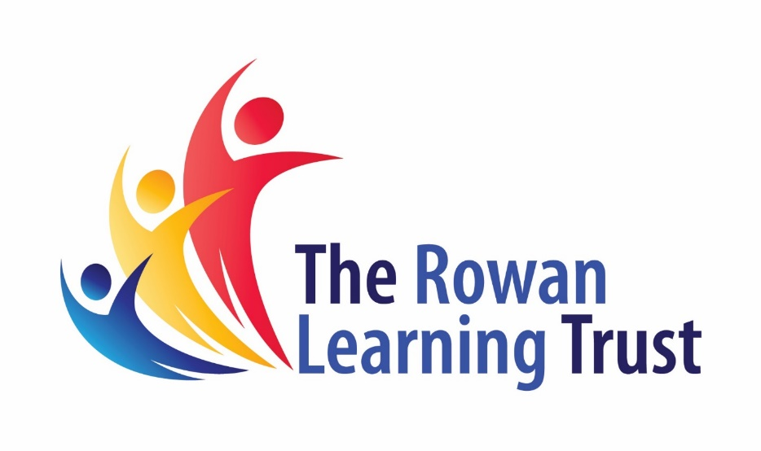

**Assistant Head of Science**



**Recruitment Pack**

Please submit the enclosed application form and a supporting statement of no more than two sides of A4 outlining why you are interested in the opportunity and how your application addresses the requirements for the role.

Applications should be returned electronically to c.smith@theheys.school

Closing Date: 3rd February 2022

Interviews week beginning the 7th February TBC

**How to Apply**



**Welcome**

*Dear Applicant,*

*Thank you for your interest in the post.*

*We are seeking to appoint a dedicated and enthusiastic individual who is ambitious and has an excellent work ethic to join our team.*

*We promote a culture of high expectations, within a supportive environment, based upon our core values of, ‘Be Respectful, Be Kind, Be Determined’. These core values are intrinsic to the school; they form the basis of how we work together as a family and how pupils are rewarded for the fantastic things they do.*

*To help you decide if the job would suit you, please find enclosed some details, which we hope will give you a flavour of what The Heys School and The Rowan Learning Trust are about.*

*If your values and ambitions mirror ours and you believe you can deliver that vision, then we would be delighted to receive an application from you.*

*Visits to our school are welcome and can be arranged by contacting Charlotte Smith on 0161 773 2052 or email c.smith@theheys.school.*

*We are committed to safeguarding all members of our community; therefore, all posts are subject to enhanced disclosure procedures and pre-employment checks.*

*Yours faithfully,*

Miss R Evans

cid:image001.jpg@01D6CFDA.725D0FD0

Headteacher

The Heys School

**CONTENTS**

Letter from Headteacher

About us

Job Description

Person Specification

How to Apply

Application Form

**The Heys School** 

We are a smaller than average school with a family feel. We know our students well and do all we can to ensure they have every opportunity to make the most of themselves and ***Realise their Greatness***.

At The Heys School, we focus on students’ academic progress and believe that it is important to develop the child as a whole. We offer a number of different pathways to support our students and work with a number of local providers to ensure they have every opportunity available to them. These range from work with a hairdressing academy, the local farm and many more. We are passionate about developing well rounded students who have a clear focus on their future goals and ambitions we work to enhance their cultural capital through the work with our charity program, in school foodbank and through the recently developed pledge program.

The Heys School is a diverse and exciting place to work and learn and our students always see this as a strength of the school. Our students believe that at the Heys everyone is treated equally.

We have a clear focus on ensuring that our students make good and sustained progress, regardless of their starting point.  We are so proud of the amazing things that our students achieve every day and we are constantly looking for new ways to celebrate their successes. Our pupils are individuals and we celebrate them for being Heys Heroes.

We believe that education is a journey and we are committed to ensuring every student has the skills to meet the obstacles they face head on.  We believe in the importance of grit, perseverance and resilience and of showing our pupils the value of getting back up and trying again if they don’t succeed the first-time round.

In the Heys family we value determination, respect and above all kindness. We are looking for committed staff who value the sense of family and are determined to support our pupils in any way they can.

**The Rowan Learning Trust**

The Rowan Learning Trust (RLT) was established as a Multi-Academy Trust in 2012 to maximise potential of all children, students and adults in our schools and to support them in their journey to become outstanding.

Currently the RLT family comprises six schools: three high schools, an all-through alternative provision academy and two primary schools. Together we share a set of common values:

* Mutual respect
* Fairness
* Equality of opportunity
* Individual growth
* Kindness

We believe in an inclusive workplace – one that is built on fairness, merit and respect to help our employees perform to their greatest potential.

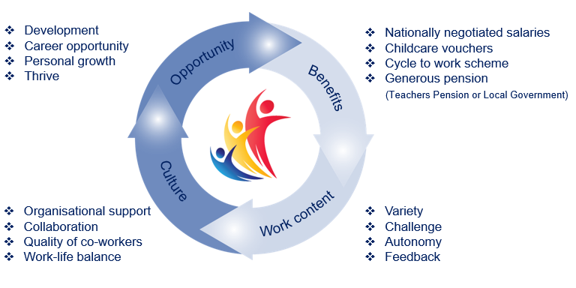

**Job Description **

**Generic and Specific Responsibilities :**

The successful candidate will be expected to assist the Head of Faculty by leading, developing and enhancing the quality of teaching and learning within the faculty by:

**Teaching and Learning**

* Setting and maintaining high standards of teaching and learning across the age and ability range.
* In the absence of the Head of Faculty, ensuring that appropriate and meaningful work is supplied for the use of the Cover Supervisors, supply or substitute staff, for either the Head of Faculty or other absent staff.
* Developing strategies to monitor and promote effective transition arrangements in Science to ensure continuity and progression for all pupils from KS2 to KS3, and to liaise with the appropriate member of staff responsible for transition in this respect.
* Assisting the Head of Faculty in reviewing, developing and refining schemes of work for KS3 and KS4 Science units by leading and managing other staff in the Faculty to extend and improve current resources.
* Developing and co-ordinating curricular links with primary schools and external agencies.

**ASSISTANT HEAD OF SCIENCE: Negotiable**

Reports to: Head Teacher

Location: Heys Road, Prestwich

Salary: Classroom Teachers’ Pay Scale plus TLR2b

Hours: Full time



**Standards and Quality Assurance**

* Assist in the Head of Faculty in ensuring that the quality procedures across the subject faculty meet the requirements of the school’s self evaluation strategy and the Improvement plan. Lead self-evaluation at the faculty level and use the outcomes to inform whole school strategic priorities.
* Liaising with appropriate external agencies, organisations and other schools to ensure the maintenance of high
* standards within the faculty.
* Attending and participating in open & parents evenings, assisting the Head of Faculty in managing the faculty
* contribution to these events.
* Attending team and staff meetings as appropriate.

**Leadership**

* Assisting the Head of Faculty to develop the faculty position statement and faculty improvement plan to monitor, evaluate and improve the quality of teaching and learning through
* a structured, rigorous and recorded programme of lesson observation, learning walks and drop ins for all staff;
* providing feedback and advice on improvement as appropriate
* completing self-evaluation audits to identify strengths and areas for improvement
* ensuring that this process informs improvement planning within the Faculty
* developing and formalising arrangements for the scrutiny of pupil’s work and staff planning
* Assisting the Head of Faculty in the production of a detailed Faculty Improvement Plan, in line with agreed whole school priorities.
* Assisting in the school Appraisal process, as required.
* Deputising for the Head of Faculty in the event of absence: take responsibility for the day-to-day management issues in this event. To deputise for the Head of Faculty, or represent the Faculty at meetings or on working parties as and when required.
* To lead whole school provision for STEM in order to engage, excite and inspire students.
* To work with the CEIAG team to ensure representation from external STEM professionals at all careers events.

**Person Specification **

**Essential**

* Qualified Teacher Status
* Graduate status, with appropriate levels of attainment and qualifications in Science
* Excellent subject knowledge
* Have a secure knowledge and understanding of the Science curriculum and related pedagogy
* Ability to teach Science to KS3 and KS4
* Proven track record as a highly effective classroom teacher
* A passionate interest in all aspects of the subject
* An interest in promoting the subject outside the classroom
* Highly professional standards in the classroom and when working with colleagues
* Energy, enthusiasm and a concern for quality in all aspects of work
* A capacity to work successfully as part of a team
* The ability to enthuse, excite and engage students
* An awareness of diversity and inclusion issues, and a determination to promote equal opportunities
* The ability to use assessment data to identify underperformance and advise reactive strategies
* A passion for inclusive education and a drive to ensure every student has the opportunity to realise their greatness
* This school is committed to safeguarding and promoting the welfare of children and young people and expects all staff and volunteers to share this commitment.
* The ability to develop effective working relationship with students
* The ability to command the respect of staff and students alike
* The ability to work as a supportive team member
* Excellent classroom teaching & management skills
* A high degree of organisational ability both in a classroom and during practical lessons
* A commitment to continued professional development
* A willingness to share best practice and learn from others
* A commitment to ensuring student progress, by participating in extra-curricular activities
* A desire and willingness to explore innovative methods of curriculum delivery to capture the imagination of students
* Career teacher, interested in developing further insight into whole school approaches to Science
* Understanding of how to mark to GCSE level in the subject
* Understanding of how to give effective feedback using assessment for learning within the subject
* Experience of planning in accordance with specific assessment objectives (GCSE) and/or Assessment Focuses (KS3)

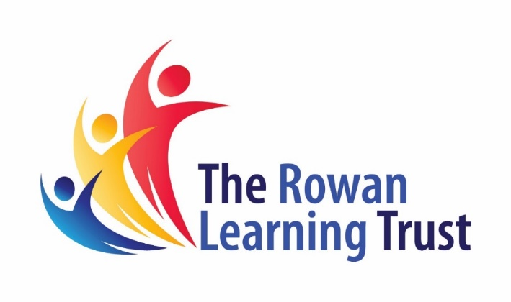

The Trust will make any necessary reasonable adjustments to the job and the working environment to enable access to employment opportunities for disabled job applicants or continued employment for any employee who develops a disabling condition.

All appointments are subject to satisfactory references, proof of qualifications and eligibility to work in the UK.

The Trust is committed to safeguarding and promoting the welfare of all children and young people and expects all staff to share this commitment. An enhanced DBS check will be required.

The Trust will make any necessary reasonable adjustments to the job and the working environment to enable access to employment opportunities for disabled job applicants or continued employment for any employee who develops a disabling condition.

All appointments are subject to satisfactory references and eligibility to work in the UK.

The Trust is committed to safeguarding and promoting the welfare of all children and young people and expects all staff to share this commitment. An enhanced DBS check will be required.



The Rowan Learning Trust

Registered Office: Carr Lane, Wigan, WN3 5NY

Company Number 8010464