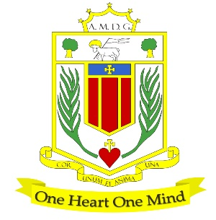
BROUGHTON HALL CATHOLIC HIGH SCHOOL
Yew Tree Lane

Liverpool

L12 9HJ

Telephone 0151 541 9440 / Fax 0151 259 8448
E.mail:admin@broughtonhall.com
Head Teacher: Mr G Preston, B.A. (Hons), NPQH, PGCE
Number on Roll 1211 including 182 in Sixth Form.

ASSISTANT HEAD OF SUBJECT: RELIGIOUS EDUCATION
WITH OVERISGHT OF KS3 & GENERAL R.E. WITH TLR 2b £4,781

CONTRACT: Permanent/Full-Time
CLOSING DATE FOR APPLICATIONS: 12 noon on 14th May
REQUIRED TO START: September 2021

The Governors wish to appoint a first rate, enthusiastic Assistant Head of Subject for Religious Education with the skill to teach across the full age and ability range. If you are highly motivated, have a passion for R.E. and have the ability to inspire our pupils then we would love to hear from you.

The RE department at Broughton Hall is innovative and forward thinking. At GCSE students are taught EDUQAS Route B, and at A level OCR Philosophy, Ethics, and Development in Christian Thought is also taught. Recently the RE department have revised the KS3 curriculum and require a candidate who can continue this journey with them. The RE team ensures that there are no barriers to learning and enable our students to make outstanding progress academically whilst, simultaneously encouraging them to succeed in their future aspirations.

The successful candidate will be:

- An RE specialist with excellent subject knowledge
- An outstanding classroom practitioner with a dedication and desire for teaching and learning
- Someone who is passionate about RE and has the ability to inspire and foster a love of learning
- Committed to the school’s vision and demonstrating compassion through the mission statement
- Dedicated in ensuring students achieve the best outcomes

About Broughton Hall Catholic High School
Broughton Hall is a Catholic High School, proud of its strong Catholic ethos and values. The school has an excellent reputation and promotes an inclusive education which develops creativity, confidence and independence. The school is committed to the continuous professional development of all staff including our Aspiring Leaders, NPQML and NPQSL programmes.

The Trustees are the Sisters of Mercy

For further information and an application pack please visit our website at www.broughtonhall.com
The post will be subject to an enhanced DBS clearance

Broughton Hall Catholic High School actively supports continuous professional development for all staff and follows a whole school approach to staff performance and development.

Broughton Hall Catholic High School is committed to safeguarding and promoting the welfare of children and young people and expects all staff and volunteers to share this commitment.

