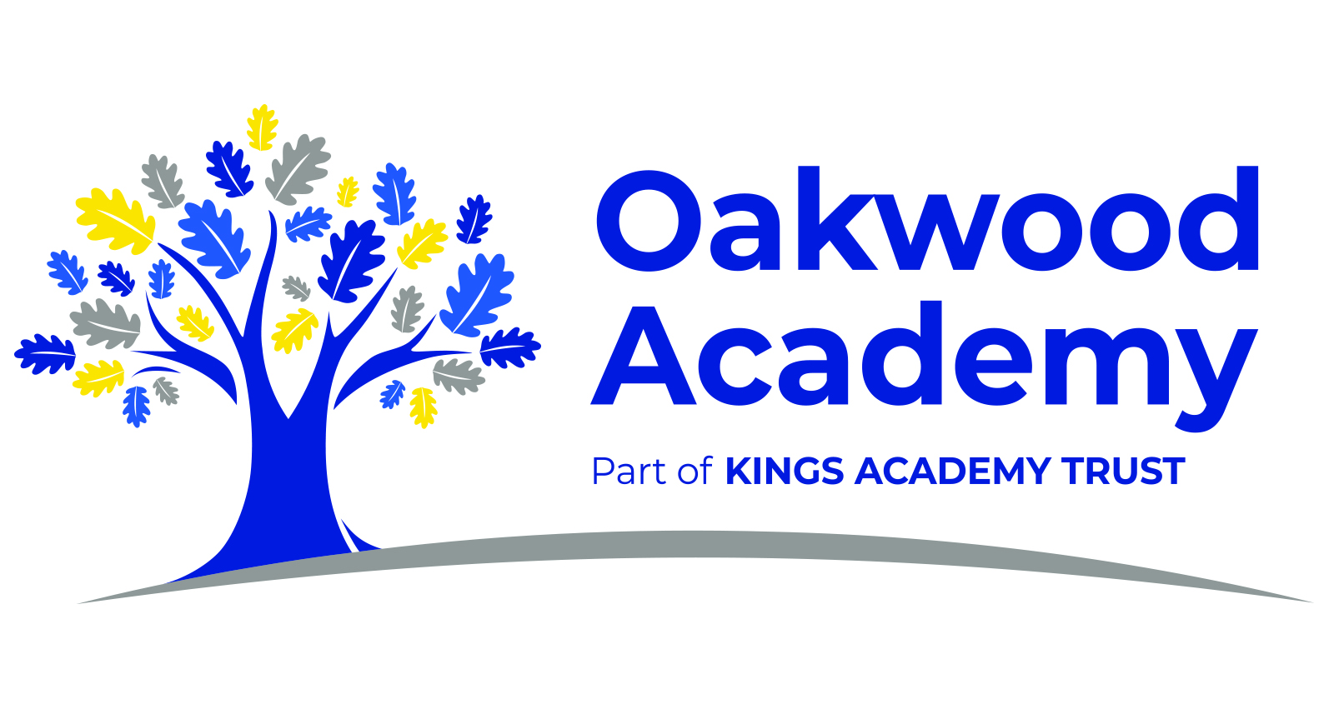

Job Title: Assistant Head Teacher

Salary: L9 - L13
Working Pattern: Permanent, full time

Closing date: Tuesday 20th May, 12:00pm
Short listing: Tuesday 20th May
Interview process to begin: Friday 23rd May, 2025

Head of School: Mr Darren Jones
To start September 2025
Are you a dynamic and passionate leader with a proven track record of improving behaviour and attendance outcomes? Do you have the vision, resilience, and drive to make a difference in the lives of pupils with special educational needs?
Oakwood Academy is seeking an exceptional Assistant Head Teacher to join our ambitious and dedicated leadership team from September 2025. This is a strategic role with whole-school responsibility for leading behaviour and attendance, ensuring that all pupils can thrive in a calm, consistent and supportive learning environment.
We are a successful special school for pupils aged 9–19 years with a range of moderate and/or complex learning difficulties, including autism and associated communication or social needs. Part of Kings Academy Trust, we benefit from working closely with other schools across the MAT, offering excellent opportunities for collaboration and professional development.
Ofsted has judged Oakwood Academy as ‘Outstanding’ in its four most recent inspections (most recently in January 2024). We offer a broad and balanced curriculum in a nurturing environment, supported by cutting-edge facilities and a dedicated team of staff.

At Oakwood Academy we understand the enormous responsibility of preparing our pupils for their future lives. Our hope is that we can help children to become responsible citizens who will make a positive contribution to our ever changing society.

Key Responsibilities:
- Provide strategic leadership and operational management of behaviour and attendance across the academy.
- Drive forward our inclusive behaviour culture, ensuring it reflects our values of respect, resilience and responsibility.
- Lead and develop our behaviour support team, ensuring high expectations, restorative approaches, and consistent systems are embedded across the school.
- Analyse attendance data to inform intervention strategies and reduce persistent absence.
- Work closely with families, external agencies, and pastoral teams to ensure effective support for pupils.
- Contribute to the wider leadership of the school, including safeguarding, staff development, and school improvement priorities.

We are looking for someone who:
- Is an experienced senior or middle leader with a strong understanding of SEMH and SEND.
- Has a clear vision and proven impact in improving behaviour and attendance.
- Brings high expectations, professional curiosity, and a commitment to inclusive education.
- Is an excellent communicator and relationship-builder, both with pupils and adults.
- Has a proactive, strategic mindset and can lead teams to implement meaningful change.

In return, we offer:
- A welcoming and supportive school community committed to staff wellbeing.
- A forward-thinking leadership team with a shared vision for excellence.
- Opportunities for professional development and leadership growth.
- A chance to play a pivotal role in shaping the future of a vibrant and values-driven special school.

Visits & Applications:
We warmly welcome visits to our school, which can be arranged by contacting our School Business Manager, Mrs Sarah Egan, at:
📧 enquiries@oakwoodacademy.co.uk
Please address all applications to:
Mr Darren Jones
Head of School
Oakwood Academy
Chatsworth Road, Ellesmere Park
Eccles, Manchester. M30 9DY
📧 Or email: enquiries@oakwoodacademy.co.uk

Safeguarding Statement:
Oakwood Academy is committed to safeguarding and promoting the welfare of children and young people and expects all staff and volunteers to share this commitment. This post is subject to a fully enhanced DBS check.

