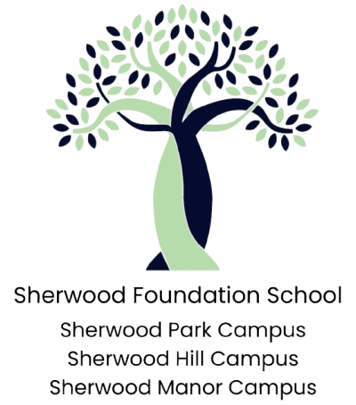

Sherwood Foundation School
Assistant Headteacher - Sherwood Park Campus

Salary: Leadership Pay Scale, L8 to L15 £65,642 to £77,209
Contract: Full time
Start date: Summer Term 2026
Closing date: Friday 8th May 12pm

Sherwood Foundation School is a Foundation Special School located in the London Borough of Sutton and made up of three campuses:
Sherwood Park Campus: This is a specialist school for learners aged 3 - 19 years who have severe, multiple and complex learning difficulties and/or disabilities. This includes learners who have highly complex access needs resulting from their physical and/or health conditions. All learners require high levels of adult support to access learning.
Sherwood Hill Campus: This is a specialist school for autistic learners aged 3 - 19 years who have multiple and complex barriers to learning, requiring high levels of support to access education and learning around their peers. Many of our learners may also have severe learning difficulties and /or struggle to maintain a regulated state for learning.
Sherwood Manor Campus: This is a specialist school primarily for Autistic learners aged 11 - 19 years who have moderate to severe barriers to learning. Most of our pupils can access a highly adapted formal learning environment with high levels of adult support. Some of our learners struggle to deal with the demands of an adult led learning environment so may need a highly individualised learning offer to meet their academic potential.
Our curriculum ensures that our pupils, who come from a wide range of backgrounds, have exceptional opportunities to excel and access exciting opportunities in school, and beyond school, to develop their physical, social and emotional well-being.

We are a senior leadership team who have enormous ambition for our pupils and are looking for a senior leader with a growth mindset and passion for supporting our children to achieve their full potential, to join our team.
We will expect you to assist the Head of School in the oversight of the day to day running of the school. You would be expected to work effectively as a member of the Senior Leadership Team and wider school teams to demonstrate and articulate the school vision and values in day-to-day practice.

You will have:
• A National Professional Qualification for Middle Leaders (NPQML), degree, management qualification or equivalent
• A proven track record of developing appropriate personalised curriculum for pupils with special educational needs leading to positive academic, personal and social outcomes
• Successful experience of leading a department
• Experience of regularly delivering consistently good and outstanding teaching.
• The ability to engage, motivate and successfully manage staff to deliver an established vision, values and aspirations
Safeguarding Recruitment Statement
Sherwood Foundation School is committed to equal opportunities, safeguarding and promoting the welfare of children, young people, and vulnerable adults and expects all staff and volunteers to share this commitment. All appointments are made subject to receipt of a completed application, satisfactory references and an Enhanced DBS check.
For an informal discussion about the post please contact Human Resources on recruitment@sherwoodpark.org.uk
TES website www.tes.com. Alternatively, please contact the SFS via email on recruitment@sherwoodpark.org.uk
Please note applicants must demonstrate how they meet all sections and subsections of the person specification for this role. Although you will be employed by Sherwood Foundation School. If you could please specify a preference as to which campus you think you would be best suited to.

Closing Dates for Applications: Friday 8th May 12pm
Interviews: Week commencing 18 May, 2026

