

Assistant Head Teacher
Candidate Information Pack
2025-2026
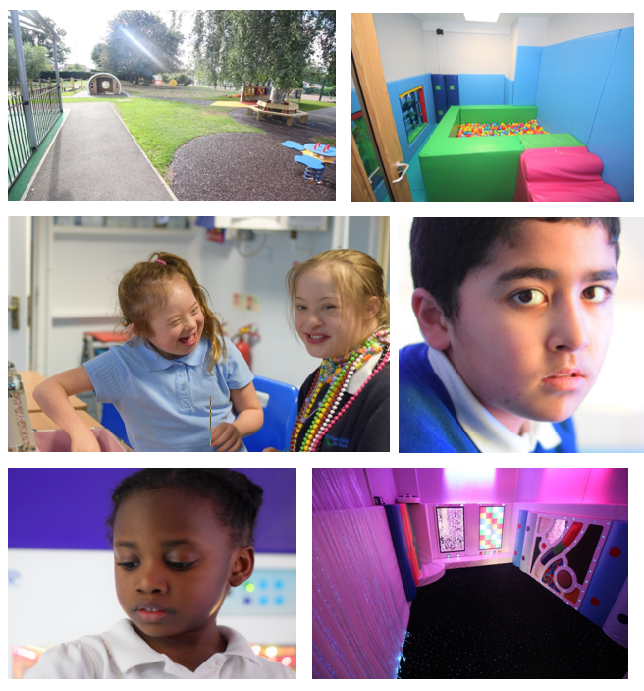
Contents
Within this pack you will find both information and advice on applying for a role within Brackenfield SEND School.
- Welcome from the Executive Headteacher & information about Brackenfield SEND School

- Job Advertisement

- Job Description and Person Specification

- How to Apply

- Outline of Selection Process

- Safeguarding and Checks

Executive headteacher

trish turner


Thank you for your interest in applying for the post here at Brackenfield SEND School. The school has expanded over the last 9 years from 62 pupils to 284 at this current time. Within this time our designation has also been changed from 4yr-16yrs to 3yrs-19yrs. We continue to expand as a school, as our Post 16 which opened in Sept 2025 grows to capacity over the next two years. Our school is based over two sites The Grove and The Orchard located 300yards apart on Bracken Road. We are excited to recruit an experienced and enthusiastic teacher to our Outstanding team.

As a school we meet the needs of children from our local community and surrounding areas. Pupils attend the school from Derbyshire, Derby City and Nottinghamshire, Nottingham City, Leicestershire and Rutland local authorities.

Brackenfield is an oversubscribed local authority maintained special school. Over the last 9 years we have streamlined our offer to become a specialist school for pupils with severe and complex learning needs and we have a growing population of children with profound and multiple learning needs and disabilities. All our pupils are significantly cognitively impaired operating developmentally between 0 – 6 years of age. We support pupils’ learning and journey into adulthood through a curriculum based on life skills and skill generalisation. The school benefits from a dedicated Children’s Services Team which oversees safeguarding and family support, a Health Care Team, including registered nurses, which support the medical and care needs of our pupils and a Therapies Team, including onsite Speech and Language Therapists (SALTs) and Occupational Therapists (OTs) which support with assessment and interventions. These teams work with our highly skilled teaching team to shape the provision around our young people.

Our vision is to support our pupils to reach their potential and become functionally and emotionally literate young adults. Through a curriculum with functional life skills at its core, we are developing our pupils to become young adults who can safely navigate and contribute to society- with independence appropriate to their needs. We are fully committed to the safeguarding of all pupils, this is embedded through all aspects of school life, with strong home-school links. We are committed to developing pupil voice to enable our students to make positive choices, share their opinions and preferences whilst demonstrating an understanding of British Values. We have strong belief and ethos of character education, which is used to support our pupils development a self-recognition of character, alongside providing a curriculum that is ambitious and designed to give our young people the knowledge, self-belief and cultural capital they need to succeed and be happy in life. Pupils leave Brackenfield being the best version of themselves. We work with pupils and families to ensure that pupils are happy, safe and reach their potential during their time with us.

Brackenfield was last inspected November 2024 by Ofsted in a graded inspection. Inspection findings showed that Brackenfield SEND school is Outstanding in all 5 areas of the Education Inspection Framework. Please read out latest Ofsted report https://reports.ofsted.gov.uk/provider/25/113031

The East Midlands SEND Training Hub is an integral part of Brackenfield Special School and has been created to support and formalise our outreach work to schools, (both mainstream and special). The hub provides and brokers high quality training and provides work experience and professional placements for education and health professional/students/graduates.

Job advert

Brackenfield SEND School is a succesful and expanding special school in the South of Derbyshire. The Executive Headteacher and Governors are looking to appoint a passionate and committed Assistant Headteacher to join our established, experienced leadership team. The successful candidate will work with the Executive Headteacher, Head of Site and Deputy Headteachers to strategically and operationally lead the school.

We are a school for children with complex learning and communication needs ranging from 3-19yrs. Brackenfield is a research based school and we work with external partners to ensure that our approaches reflect best practice in preparing young people with complex needs for adulthood.

We welcome applications from established senior leaders exploring new challenges or ambitious middle leaders looking to progress their career. We have a commitment to staff development and high quality CPD which is provided to our staff through the East Midlands SEND Training Hub which is based at the school.

Applicants are encouraged to come and meet the Executive Headteacher and Head of Site and have a tour of the school (please see contact below).

Brackenfield SEND School is committed to the safeguarding of all children. Due to this post having access to children and/or vulnerable adults, the successful candidate will be required to undertake a Disclosure and Barring Service check. The possession of a criminal record will not necessarily prevent an applicant from obtaining this post, as all cases are judged individually according to the nature of the role and information provided. Brackenfield SEND School is committed to promoting equality of opportunity, preventing unlawful discrimination in all of its activities and to valuing diversity.

If you would like more information please contact recruitment@brackenfield.derbyshire.sch.uk

Job description

Job Description- Assistant Head Teacher
Scale: Leadership Scale 8-12

Post Objectives
To work as part of the leadership to strategically lead Brackenfield SEND School. To work in a distributed leadership structure to support development, quality assurance and show impact of aspects across the school, including behaviour and wellbeing support, curriculum, quality assurance, Post 16, Preparation for Adulthood, interventions and transitions.
Reporting to
Deputy Head Teacher
Responsible for:
Supporting the leadership team in the strategic leadership development and operational running of the school.
Liaising with
The school’s senior leadership team
School Governing Body
Derbyshire County Council / External Agencies
OFSTED
Working Time
As per Teacher Pay and Conditions for leadership pay spine
Disclosure Level
Enhanced DBS and Over Seas Police Check if necessary

Principle Responsibilities
Leadership
- Assist the Executive Headteacher, Head of Site and Deputies in the leadership and management of the school
- Deputise for the Deputy Heads in their absence
- To work with the leadership team to develop the SIP and SEF
- To take a strategic lead on one or more areas of the SIP, be accountable for the outcomes in the area, track progress towards the action plan and reporting progress to the leadership team, Executive Head, Head of Site and Governors
- Reporting to stakeholders including completing MERly (12 weekly) analysis of performance data to the Governing Body
- To work as a budget holder
- Take day to day responsibilities for the operational running of the school as part of a distributed leadership platform
- Line manage Pathway Leads- ensuring the operational aspects of pathway leadership are adhered to and data is gathered effectively through rigorous and timely QA
- Analyse outcomes from ongoing quality assurance of teaching and learning (including assessment, recording, planning and reporting) - drawing trends, areas of strength, development and measuring impact. Responding to internal and external scrutiny and working strategically to ensure outcomes are outstanding across the school
- Reporting attainment and pupil information to statutory bodies, ensuring compliance for government directed assessment and delivery e.g. EYFS, Engagement Model
- Develop and update policy, practice and Handbooks as required
- Stay updated with research led practice in Education and aspects of SEND
- Deliver inset and training to staff across the school. Monitor impact of CPD provided and identify area of need for individuals, teams and the full staff body
- Undertake the duties of an EVC
- Undertake training as DSL and where delegated by the Headteacher or Head of Pastoral Care support with safeguarding concerns
- Adopt a research-based approach informing own and whole school leadership practice to ensure high quality provision and outcomes for pupils with complex SEND needs
Teaching and Learning

- In a reduced teaching capacity work alongside a partner teacher to lead and manage a class team
- Identify and adopt the most effective teaching approaches for pupils with a range of complex SEN
- Model expertly informed practice through semiformal and informal approaches
- Monitor teaching and learning activities to meet the needs of pupils with SEND, ensuring learning is tailored and ‘sticky’ and supports pupils to prepare for adulthood
- Plan and deliver effective sequences of lessons and generate medium- and long-term plans to support this
- Identify and teach skills that will develop pupils' ability to engage, make choice, be independent and functional
- Apply and demonstrate a range of appropriate teaching methods as recognised by the school and best practice research

Behaviour and Safety

- To personify the ethos of Brackenfield as a ‘take care’ school- where we are always kind and take care of each other
- Respond to behaviour policies, protocols and plans and with regards to individual students
- Establish a safe, purposeful and stimulating environment for pupils, rooted in kindness and mutual respect, supporting the dignity of our pupils. Establish an environment for the support and promotion of effective co and self-regulation
- Manage effectively, using approaches which are appropriate to pupils’ needs in order to engage, inspire, motivate and challenge pupils
- Maintain good relationships with pupils, staff and parents
- Be a positive role model and demonstrate consistently the positive attitudes, values and behaviour, which are expected of pupils and staff
- Have high expectations of behaviour, promoting self and co-regulation and independence of all learners and staff
- Be responsible for promoting and safeguarding the welfare of children and young people within the school, raising any concerns following school protocol/procedures
- Be responsible for writing and updating personal risk assessment for pupils
- Work in line with the school’s attachment aware best practise model

Team Working and Collaboration

- Participate in any relevant meetings/professional development opportunities at the school, which relate to the learners, curriculum or organisation of the school
- Work as a team member and identify opportunities for working with colleagues and sharing the development of effective practice with them
- Ensure that colleagues working with you are appropriately involved in supporting learning and understand the roles they are expected to fulfil
- Take part as required in the review, development and management of the activities relating to the curriculum, organisation and pastoral functions of the school

Recording and Assessment

- Accurately access pupil progress
- Set effective and meaningful Personal Learning Intentions (PLIs) for class pupils, moderate PLIs school wide
- Through data dialogue- collect and interpret key data for pupils for PLIs, age related attainment, attendance, wellbeing (J2L) , sensory (Sensory Toolkit), communication (Speech and Language) and behaviour
- Complete quality annotation and/or marking to support accurate assessment
- Update the leadership team on the impact of the curriculum on pupil progress
- Have a firm understanding of complex learning needs and the importance of personalised and relevant curriculum targeted to prepare all learners for adulthood
- Attend meetings and consultation evenings and keep parents informed about their child's progress

Standards and Quality Assurance

- Support the aims and ethos of the school
- Set a good example in terms of dress, punctuality and attendance adhering to the code of conduct
- Attend and participate in open evenings and school events
- Uphold the school's behaviour policy
- Participate in staff training and development
- Attend team and staff meetings
- Develop links with Governors, LEAs and neighbouring schools

Other Duties and Responsibilities
- Other duties that the Executive Headteacher may from time to time ask the post-holder to perform and which fall into school teachers’ terms and conditions

person SPECIFICATION

Person Specification

 | Essential | Desirable
Qualifications and Experience
Qualified Teacher Status | x
Detailed knowledge of current best practice in curriculum development and inclusive approaches for students with the full range of special educational needs and disabilities | x
Has worked with children with complex needs | x
An outstanding classroom practitioner | x
Evidence of appropriate in-service training | x
Post-qualification additional training or equivalent in special education or leadership |  | x
Knowledge, Understanding, Skills and Abilities
A sound understanding of Quality First Teaching, the obstacles complex needs students may face to learning | x
A firm understanding of how pupils with SEND learn effectively through a semi-formal or informal approach |  | x
A sound understanding of best practice in teaching and learning and how to achieve high standards for children with complex learning and communication needs | x
Can demonstrate an understanding of attachment awareness and an ability to co-regulate others |  | x
Ability to demonstrate a commitment to safeguarding, pastoral care and the promotion of high standards of positive behaviour | x
High levels of communication skills both oral, written and in ICT | x
Experience of mentoring, supervising and supporting teams of staff and supporting their development and training | x
Ability to prioritise, evaluate and manage financial and human resources | x
Experience of budget management and setting |  | x
Ability to forge strong working relationships with a variety of stakeholders, e.g. Local Authorities, parents and other professional agencies, and to work with multi-professional teams | x
Leadership/Personal Qualities
A confident leader with the ability to deliver clear messages, even with challenging content | x
An effective, flexible and enthusiastic leader, always prepared to put the children’s needs first | x
Interest in young people as individuals and in how they learn | x
A vision for continuous school improvement and development; understanding of the skills needed to lead in a climate of constant change | x
Confident in sensitively but assertively addressing under-performance | x
A team player respected by others | x
Ability to listen and effectively communicate with a variety of audiences | x
Ability to act quickly and sensitively under pressure, to keep calm in difficult situations, deal with stress and absorb pressure | x
Diplomacy, openness and positivity, accepting of feedback and always willing to learn | x
Excellent interpersonal skills, a sense of humour and a willingness to make him/herself approachable to all members of the school and the wider community; a ‘can do’ positive approach | x
Commitment to development of own professional skills | x
Commitment to the principles and practice of equal opportunities | x

how to apply

Please apply for this post via the Derbyshire Local Authority website: Derbyshire - Jobs and careers
Online applications
There are a number of benefits for you from applying online which include:
The information you give us when you register on the job site, and before you apply for a job such as in the 'employment history' section, is automatically included in your online application, saving you time - you can update the information held in these sections whenever you need to.
You can part complete an application form, save it and come back to it, and work on it and submit it later or on another day - you can also print off a copy at home. Applying online gives you access to your application form, advert, and any other recruitment documents throughout the recruitment process, even after the job has closed.
You can track the progress of your application online, for example, to see if you have been shortlisted. You'll receive communications about the recruitment process more quickly, by email rather than letter, including any invitations to interview.You'll be able to view any communication as soon as it is sent to you by logging into your account.
You can search for specific types of jobs and then set up a job alert which will ensure you receive an email anytime a similar post is advertised
Other ways to apply
There are still ways to apply if you're unable to do so online. If you do apply offline, please provide your email address if you have one, as this will ensure we send you any communication by email so you receive it as quickly as possible. You can complete either a PDF or Word version of our online application form. These are attached to: Ways to apply - Derbyshire County Council
This form can be printed out, completed by you and then sent by post to:
Derbyshire County Council
Shared Services Centre
John Hadfield House
Dale Road
Matlock
Derbyshire
DE4 3RD
Or completed as a Word document and emailed to jobs@derbyshire.gov.uk
If applying by post or email please make sure that:
- the vacancy reference number is entered on the form
- we receive your application before the closing date
You can request an application pack by telephone.
You can also request an application pack by contacting Call Derbyshire tel: 01629 533190, quoting the reference number of the vacancy.
Please make sure there is enough time between you requesting an application pack and the closing date as it will take a minimum of 2 working days to receive your pack through the post.
Completed applications should be returned to:
Derbyshire County Council
Shared Services Centre
John Hadfield House
Dale Road
Matlock
Derbyshire
DE4 3RD

Help to complete your application
If you have any problems filling in either your registration or your application form, email recruitment@derbyshire.gov.uk or tel: 01629 535118 and select option 1.
Help if you're disabled
We are a Disability Confident Employer. If you're disabled and looking for employment with us, we're keen to hear from you. If you meet the essential criteria for a job, we guarantee to give you an interview.
If you need advice or support with your application or need the recruitment documents in another format such as audio, Easy Read or braille, or wish to discuss related issues, please contact the Disability Employment Service email disabilityemploymentservice@derbyshire.gov.uk
They offer general help with job searches, applications and reasonable adjustments.

selection process

Shortlisting
All shortlisting is completed by a panel; with at least one person holds safer recruitment training. Shortlisting is completed by RAG rating against the following criteria:
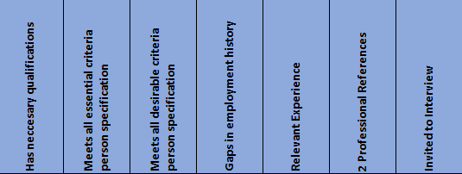
After shortlisting, successful applicants will be invited to interview. In the case of a large field of successful applicants there might be an informal discussion via Microsoft Teams before being brought forward to interview at the school. References will be requested prior to applicants being brought forward to interview.
Interview Process
The same panel members from shortlisting also take part in the interview day. This day may include:
- Tour of the School
- Pupil Panel
- Staff Panel
- In Tray Tasks
- Formal Interview
- Time in classes / Teaching (for Teaching and Learning based posts)
During the interview process each question is RAG rated by each panel member using the below RAG.
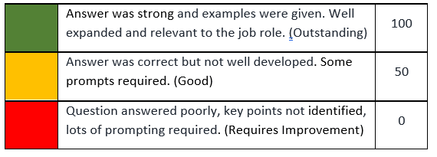
All elements of the day are taken into consideration as well as the application form and references prior to decisions being made.

safeguarding and checks

COMPULSORY checks for all applicants

Brackenfield SEND School and Derbyshire County Council are committed to safeguarding and promoting the welfare of all its pupils. We expect all staff, volunteers and agency staff to share this commitment. The successful candidate will be required to undertake a Disclosure and Barring Service (DBS) check. The possession of a criminal record will not necessarily prevent an applicant from obtaining this post, as all cases are judged individually according to the nature of the role and information provided.

Brackenfield SEND School’s Safeguarding Policy applies to all adults, including volunteers and agency staff, working in or on behalf of the school. Each pupil’s welfare is of paramount importance. We recognise that some children may be especially vulnerable to abuse e.g. those with special educational needs and disabilities, those living in adverse circumstances. We recognise that children who are abused or neglected may find it difficult to develop a sense of self-worth and to view the world positively. We recognise that some children who have experienced abuse may harm others. We will always take a considered and sensitive approach in order that we can support all students within our academies.

The school pays full regard to the DfE ‘Keeping Children Safe in Education September 2018’ guidance. We ensure that all appropriate measures are applied in relation to everyone who works for the school who is likely to be perceived by the students as a safe and trustworthy adult including volunteers and agency staff.

As part of our safer recruiting practises, we scrutinise applicants; verify their identity, academic or vocational qualifications, obtain professional and personal references, check full employment history and ensure the applicant’s health and physical capacity is suitable to undertake the role. Interviews and DBS checks are also undertaken. This post is exempt from the Rehabilitation of Offenders Act 1974 and therefore all convictions, cautions and bind-overs, including those regarded as “spent” must be declared.

If you are currently working with children, either paid or voluntary, your current employer will be asked about disciplinary offences, including those related to children or young people (whether disciplinary sanction is current or time-expired), and whether you have been the subject of any child protection allegations or concerns and, if so, the outcome of any investigation or disciplinary proceedings.

If you are not currently working with children, but have done in the past, that previous employer will be asked about these issues.

Where neither your current or previous employment has involved working with children or young people, your current employer will be asked about your suitability to work with children and young people, although it may be answered “not applicable”, where appropriate, if your work has not brought you in to contact with children or young people.

