

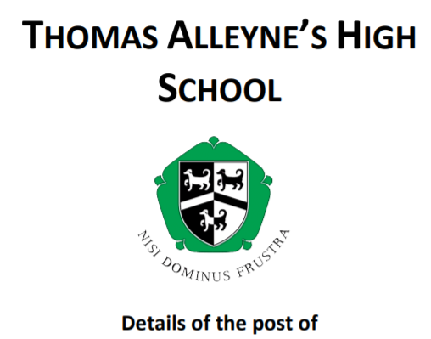

**Assistant Headteacher - Academic – Quality of Curriculum**

**Permanent, Full-time**

**Required from April 2024**

Thomas Alleyne’s High School is a 13 – 18 school at the heart of its community, which provides a broad and balanced curriculum for students**.** We are committed to ensuring that every child has access to an outstanding education. Our successful track record of ensuring students make excellent progress has ensured improved outcomes for young people.

An opportunity has arisen for an enthusiastic, outstanding teacher and leader to join our senior team. The successful candidate will have a firm commitment to raising whole-school achievement; have a professional approach to staff development; high expectations; and a determination to succeed. The post is offered on Senior Leadership (L10 – L14).

**About the role**

The Assistant Headteacher will take lead responsibility for ensuring the best possible curriculum offer, provision, well-being, progress and achievement for all pupils through careful monitoring and holding staff to account for the progress their pupils make.

**Main duties**

* Be a member of the senior leadership team and contribute to the school development plan with specific responsibility for the quality of education and continued development of the curriculum offer.
* Maintaining an overview of recent changes and developments for curriculum content and lead on the implementation of this.
* Lead and manage operational aspects of the school particularly pertaining to the timetable and reporting, including managing cover and resources required for the curriculum to be delivered effectively, including ICT and allocation of rooms.
* Undertake any such duties as are delegated by the Headteacher.
* Play a strategic role under the overall direction of the Headteacher in formulating and reviewing the school development plan and the aims and objectives of the school by: -
* Establishing the policies through which they shall be achieved.
* Seeking and developing appropriate CPD opportunities for teaching staff.
* Leading, managing and developing staff including quality assuring their performance.
* Monitoring the effectiveness of the curriculum by regularly assessing schemes of work, unit planners, progression across key stages and reviewing the adaptation of the curriculum offer to respond to the pupil’s additional needs within the EHCP’s.

We are passionate about staff development and are looking to develop future leaders, and have a proven track record of appointments to leadership positions. We offer a comprehensive CPD programme to develop teaching practice as well as supporting emerging leaders, both through internal development and the NPQ programmes.

For an informal, conﬁdential discussion regarding any queries, please contact: Julie Rudge Headteacher on 01889 561820.

For more information and an application pack:

**Visit our website**: <http://www.thomasalleynes.uk/page/?title=Vacancies&pid=134>

**e-mail:** [personnel@tahs.org.uk](mailto:personnel@tahs.org.uk)

**Telephone:** 01889 561820

**Closing Date:** Monday 19th February 2024 at 2.00pm

I**nterviews**: Monday 26th February 2024

**Please email applications to:** [personnel@tahs.org.uk](mailto:personnel@tahs.org.uk)

**Uttoxeter Learning Trust is committed to safeguarding and promoting the welfare of young people and expect all staff and volunteers to share this commitment. This position is subject to a criminal record check from the Disclosure and Barring Service (DBS, formerly CRB) which will require you to disclose details of all unspent and unfiltered spent reprimands, formal warnings, cautions and convictions in your application form.   All staff are also required to complete safeguarding training.**