FALINGE PARK HIGH SCHOOL

Assistant Headteacher – Additional Needs: Specialist and Alternative Provision

Date of Taking up Post: September 2022

Organisation Chart from September 2022

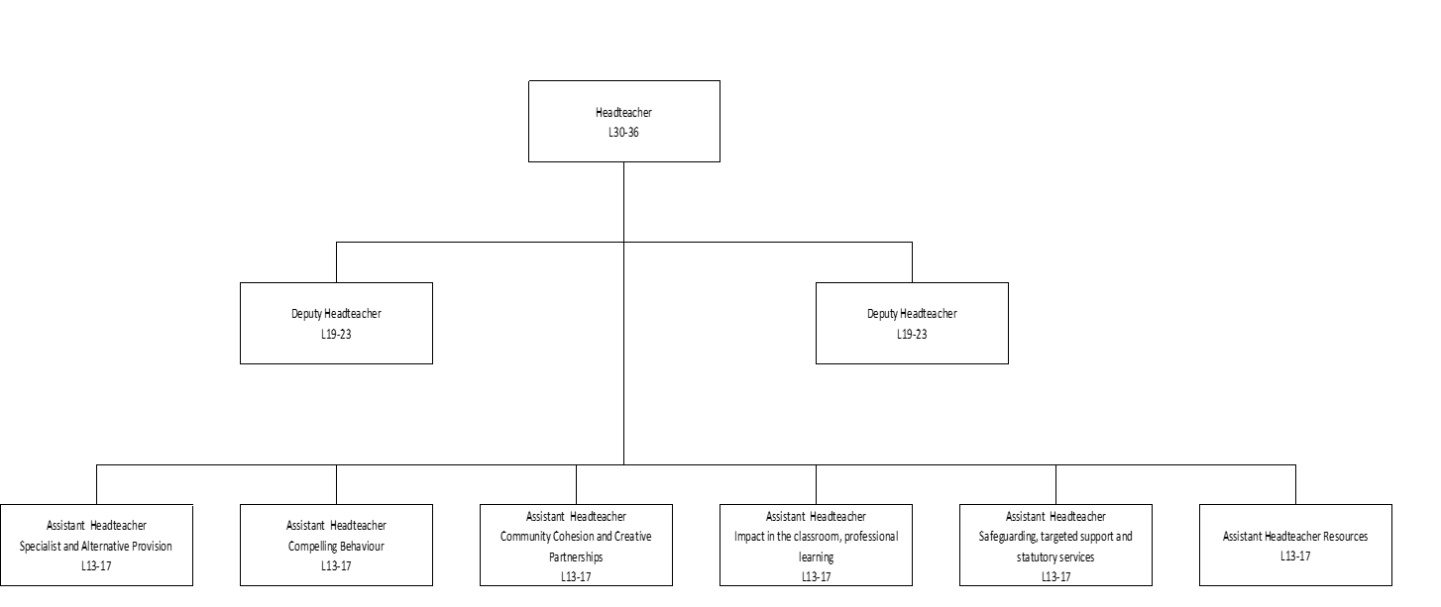

Job Purpose

- To create a compelling learning experience

- To actively commit to the school strategy of believing in people (professional learning and research) and positive relationships.

- To lead the Additional Needs Specialist and Alternative Provision and create a Centre of Excellence for Additional Needs

- To demonstrate compelling leadership as part of the senior leadership team.

Principal Accountabilities/Performance Standards

The successful applicant will be required to:

- Lead a compelling approach to learning in the specialist and alternative provision.
- Lead the SENCO, HLTAs and Lead Learning Mentor so that provision can be made for pupils who access high and supplementary provision.
- Lead and quality assure the curriculum for pupils who access high and supplementary specialist and alternative provision ensuring that it is ambitious yet meets the needs of the children who access it.
- Alongside Senior Leaders ensure there are rigorous assessment procedures that support national policy but also tell a picture of the progress of the child.
- Be outward looking and bring to the school new and innovative way of supporting young people who need extra time to access mainstream.
- Have responsibility for the behaviours and support for the children in this area – almost acting as the Head of provision – advising the Senior Leadership Team on actions to support them and families.
- Work proactively and creatively as a member of the Senior Leadership Team so that the leadership team delivers exceptional team performance and that, as an individual, you embody Compelling Leadership.
- Change roles within the Senior Leadership Team if required to do so by the Headteacher, knowing that for professional development sometimes roles may be rotated.

Additional Information
You are employed in the capacity of a teacher subject to, and with the benefits of, the conditions of employment set out, or referred to, in your letter of appointment and statement of particulars.

This Job Description identifies the responsibilities attached to your post. It is subject to the limits on working time set out in the current Teacher’s Pay and Conditions document.

This Job Description is subject to amendment from time to time within the terms of your conditions of employment, as the needs of the school/service may require, but only to an extent consistent with those conditions of employment and only after consultation with you. The agreed Grievance Procedures may be invoked in any dispute arising from this job description or subsequent amendment, in which case teachers are advised to consult their Professional Association.

The school is committed to safeguarding and promoting the welfare of children and young people and expects all staff and volunteers to share this commitment. Successful candidates will undergo an enhanced DBS check, checks of references and employment history.

Signatories:

(Both Headteacher and post holder are asked to sign and date this Job Description following consultation on its contents).

Signed: Date:
(Post Holder)

Signed: Date:
(Headteacher)

FALINGE PARK HIGH SCHOOL

ASSISTANT HEADTEACHER – ADDITIONAL NEEDS ALTERNATIVE AND SPECIALIST PROVISION

ATTRIBUTES | ESSENTIAL | DESIRABLE | HOW IDENTIFIED
Work Related Experience and Skills | - Evidence of positive impact at Middle Leader Level.  - Evidence of successful leadership which demonstrate positive outcomes for pupils.  - Excellent relationship skills.  - Evidence of successful leadership.  - Evidence of leading whole school initiatives.  - Evidence of working with external partners  - Excellent knowledge of effective curriculum design. | - Knowledge and practice of alternative qualifications.  - Knowledge of Forest School and the benefits of this. | Application Form/Letter  Interview  Lesson Observation  References
Qualifications | - Degree  - Qualified Teacher Status  - Evidence of further commitment to professional development i.e. NPQSL, NPQML, Teaching Leaders  - A willingness of commitment to professional development. | - NASENCO | Application Form  Qualifications
Specialist Skills and Knowledge | - Understanding of SEN provision and best outcomes for children and families.  - Evidence of working with children who may be on the margins of mainstream practice. | - Evidence enriched practice in supporting young people with Additional Needs.  Experience in Specialist and/or alternative provision. | Application Form/Letter  Interview  References

