assistant headteacher -
behaviour, pastoral, equality and engaging with the community

CLOSING DATE: 9am, Friday 16th May 2025
START DATE: 1st September 2025

We are seeking to appoint a full time well-qualified and enthusiastic Assistant Headteacher to join us at Erasmus Darwin Academy, a highly successful, heavily over-subscribed school which is firmly established as one of the highest performing secondary schools in the region (and in the top 10% of schools nationally for GCSE progress and attainment). In our 2023/24 outcomes, all 16 Key Performance Indicator progress and attainment measures were significantly above the national average. We gained ‘Good’ in our 2023 Ofsted inspection and as part of the Local Authority’s quality assurance strategy, we have gained Category 1 status, which is the highest category of school performance, for six years running.

Our Academy is a non-denominational and non-selective Academy, welcoming students of all backgrounds from our local community. Our mission is very clear. To provide ‘Excellence for All’ and to equip students with the knowledge, skills and character in order to prepare them for life in modern Britain. We are incredibly ambitious for our students and believe that providing students with endless opportunities will turn them into confident and determined young people. Our students’ achievements at EDA go beyond the Academic, their achievements as a person are just as important. All students, staff and families support this mission and work hard to make it come alive. We put culture first, ahead of everything else and we encourage all students and staff to live our Academy values.

We strongly believe that at our Academy, every Teacher has the right to teach and every student has the right to learn. Our curriculum is broad, balanced and aspirational for all students. Our Academy values are lived and not just laminated. Reading, writing and oracy are at the heart of our daily curriculum. Our students are taught to be confident, articulate and determined throughout their learning experiences and daily interactions with staff and peers. Our Academy’s Personal Development offer is extensive and extra-curricular activities form a huge part of our CARE curriculum. Our students are specifically taught how to behave via a well-designed behaviour curriculum which forms the core of our Culture and Ethos.

We invite applications from excellent leaders and classroom practitioners who can motivate, engage and inspire our students and work collaboratively with colleagues. In return, we offer an incredibly positive working environment, passionately believing that our human resources are our most important and valuable resources. Therefore, our staff wellbeing strategy is at the heart of our ongoing improvement work, meaning that middle and senior leaders are committed to ensuring that all staff are happy, cared for, listened to and professionally equipped to fulfil their role to the highest possible standard. Furthermore, opportunities for career progression regularly arise, with the Academy having an excellent record of training and developing our own teachers and leaders from within.

We have recently introduced Flexible Working arrangements during all PPA and non-contact periods for all Teaching Professionals, which means you can work off-site should you wish too. In addition, we also operate a friendly cover initiative. The development of our staff is core to our well-being strategy and central in ensuring that we are able to deliver our mission. We will offer you:

- High standards and high expectations whilst ensuring workload is balanced
- Professional development opportunities to develop both pedagogy and leadership
- Friendly and supportive staff body
- Highly compliant and polite students
- A work laptop
- Increased non-contact time to allow for further lesson planning and preparation
- Increased leadership time if you are applying for a leadership role
- Friendly cover arrangements
- A visible and supportive Senior Leadership Team
- A collective team of staff working under our mission to improve the Academy further

The successful candidates must demonstrate a strong passion for working with young people and a genuine desire to improve their life chances. They must demonstrate their understanding in the pedagogy of teaching and learning, alongside the skills required for effective classroom management. All candidates must demonstrate their commitment to ensure our students develop as young people and secure the best outcomes possible for their future.

We gained ‘Good’ in our 2023 Ofsted inspection and the following quotes were made by the Inspection Team:

- ‘Leaders across the school have high expectations for pupils’ academic achievement’
- ‘Leaders have placed pupils’ personal development at the heart of their curriculum. This means that pupils are well prepared for life in modern Britain’
- ‘Low level disruption is very rare, and pupils understand leader’s expectations’
- ‘Leaders in the school have a clear and precise understanding of the provision and priorities for development. They promote an honest and transparent relationship with all staff’
- ‘Staff take a proactive approach to ensure that all pupils are kept safe. They are tenacious in following up concerns’
- ‘Leaders are clear about what they want pupils with SEND to achieve’
- ‘Teachers have good subject knowledge, and support pupils well to learn the curriculum’
- ‘100% of EDA staff who completed the Ofsted questionnaire stated they were happy to work at EDA’

Salary: Pay range between Leadership Spine 11 -15 according to the Academy Pay Policy.

This position is not suitable for ECTs.

We welcome visits with the Headteacher, arranged via appointment using the email address below at the following times:

- Tuesday 13th May (9:00am – 10:00am)
- Thursday 15th May (9:00am – 10:00am)

To apply for the post, please complete the application form and return to the Headteacher’s PA, Miss Jade Skelding, either by post or email j.skelding@eda.staffs.sch.uk by 9am on Friday 16th May. For further information regarding the Academy, please visit our website at www.erasmusdarwinacademy.co.uk

OUR SENIOR TEAM STRUCTURE

Our Senior Team is currently structured with the following positions:

- Headteacher
- Deputy Headteacher
- 6 Assistant Headteachers
The strategic responsibilities, alongside the line management responsibilities can be seen in the table below:

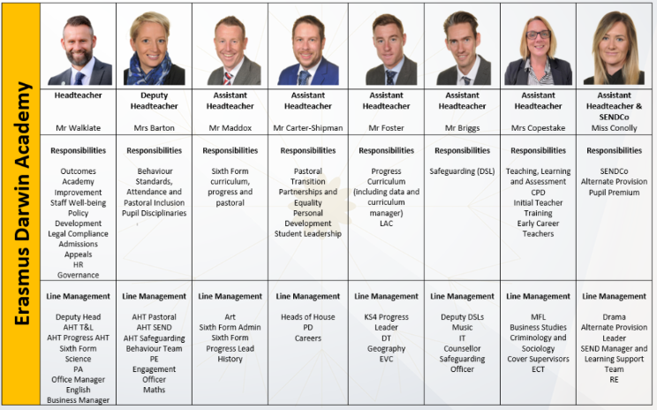

Primitas Learning Partnership is committed to safeguarding and promoting the welfare of children and young people and expects all staff and volunteers to share this commitment. As such this post is subject to a ‘disclosure’ check under the Rehabilitation of Offenders Rehabilitation of Offenders Act 1974 and satisfactory Enhanced DBS check, Online Search and references.

Further details regarding this check are available from schools or by visiting www.gov.uk/government/organisations/disclosure-and-barring-service. A copy of the school’s Safeguarding Policy can be found on our website. You will also be required to provide proof of eligibility to work in the UK, evidence of your qualifications and suitable references.

