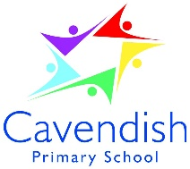

Cavendish and Knowleswood
Federation

April 2021

Dear Applicant

Assistant Headteacher

Thank you for your interest in the above post. Please find enclosed information about our school, the personnel specification and job description.

The deadline for applications is Friday, 30th April 2021 at 12pm. We will be short listing week beginning 3rd May and inviting candidates for interview soon after.

If you have not heard from us by Wednesday, 5th May please assume your application has not been successful.

You are very welcome to look around the school prior to making your application. Please contact Andrew Cheeseman, Business Manager to arrange a visit.

We look forward to receiving your application.

Yours sincerely
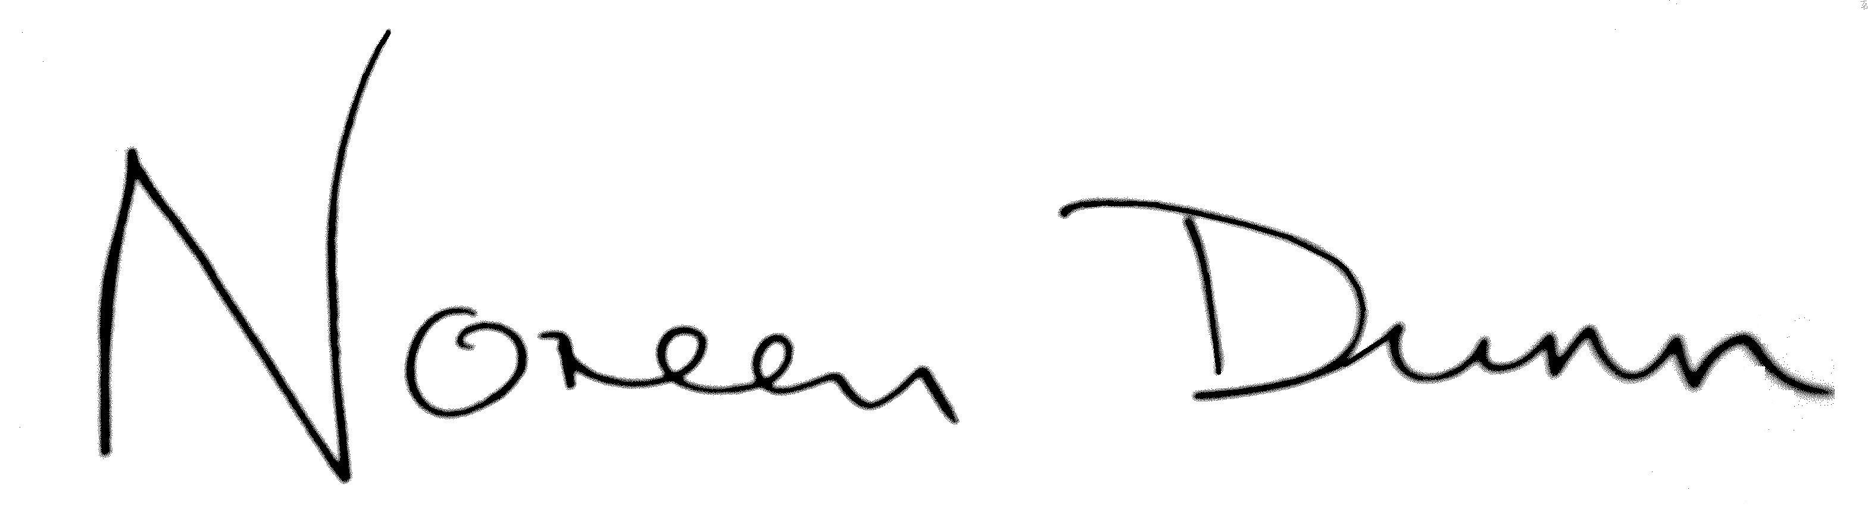

Noreen Dunn
Executive Headteacher

