

 | Job Application Pack  ASSISTANT HEADTEACHER – PRIMARY (SEND)  Leadership Scale: L11 – L15  Full-time – Permanent contract  Closing Date: 09.00 am on 29 April 2026  Interview date: Interviews will commence on Wednesday 6 May 2026 and some candidates will be invited to attend on Thursday 7 May 2026

Table of Contents

Letter from Helen Seickell, Headteacher 2
Our School Values 3
Exhall Grange Specialist School Overview 4
School Pupil Data 4
Ofsted Inspection – 2 and 3 July 2024 5
What We Are looking For 6
What We Offer 7
Application Process 8
Interview Process 8
Job Description and Person Specification 9

Letter from Helen Seickell, Headteacher

Dear Applicant,
I am delighted to be able to introduce you to Exhall Grange Specialist School, a unique 4-19 school which provides a nurturing environment and meets the needs of children and young people with Social, Communication and Interaction difficulties including Autism, Social, Emotional and Mental Health needs, Physical difficulties, Sensory impairment and Complex medical needs.
Many of our children and young people are physically or emotionally extremely vulnerable or have life limiting conditions. Some of our pupils are highly anxious and require our calm, predictable and nurturing environment in order to access school.
We are committed to ensuring all our pupils reach their full potential and encourage all of our pupils and staff to “Be Your Best Self” which encapsulates our core purpose.
All pupils follow the National Curriculum at a level appropriate to their ability and needs. We are destination driven and focus on developing the skills our pupils need for independence, employment and life.
We encourage our pupils to develop the qualities of our school values: Respect, Resilience, Confidence, Motivation, Aspiration and Integrity. This is as important to us as the academic and vocational curriculum.
Our last Ofsted inspection in July 2024 rated the school as ‘Good’.
Staff and Governors are committed to ensuring every pupil and student unlocks their true potential to be their ‘best selves’ regardless of ability or need. In order to achieve this we aim to appoint dynamic and innovative staff who can bring energy and initiative to the work of the school.
The school adapts well to the constantly evolving educational landscape and has over recent years developed a dedicated Post 16 provision, internal sensory spaces, opened an onsite resource provision, and taken over the management and delivery of the Warwickshire County Council’s outreach service for pupils with visual impairment.
We are seeking to appoint an Assistant Headteacher from September 2026, to lead and manage our diverse and complex cohort of pupils in our primary setting. The school has developed a supportive and nurturing provision and environment for pupils with complex special educational needs and require an experienced practitioner to lead our team and continue this excellent work.
This is a tremendous opportunity to make a difference to the lives of children and young people, and will suit an ambitious professional looking to make a mark. You will be joining a team of highly qualified and experienced staff who work across the age range and support the educational and holistic needs of our pupils and their families.
I thank you for your interest and we look forward to hearing from you.
Yours sincerely,
Mrs Helen Seickell
Headteacher

Our School Values

These are integral to school life and pupils and students are encouraged to develop these qualities. We prepare pupils for adult life, education and/or employment by developing these values, attributes, and attitudes. This is as important to us at Exhall Grange as the academic/ vocational curriculum. This is what our values mean to them.

 | - Talk and play with everyone even if they are different (Primary)  - Start with respect and the rest is earnt (Year 7)  - Treat others the way you want to be treated (Year 8)  - Tolerate other people even in you may not agree with them (Year 9)  - Listen to other viewpoints and perspectives (Years 10&11)  - Give people personal space (Post 16)  - Give everyone a fair chance (Pod)
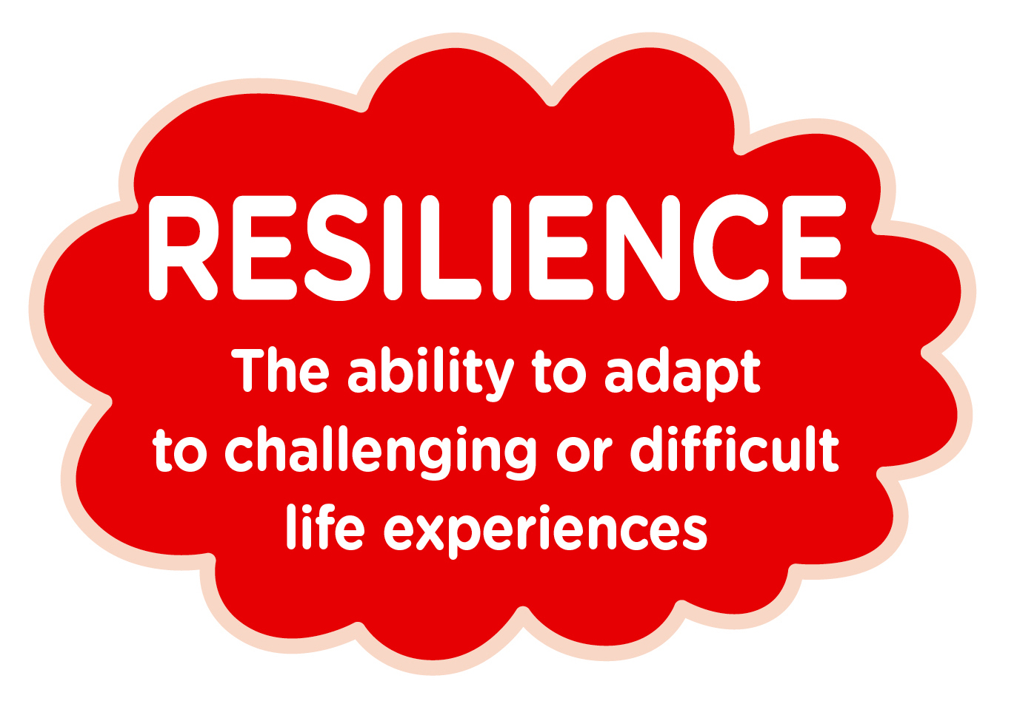 | - Do things over and over until you understand (Primary)  - Ask for help (Year 7)  - Get back up when something has knocked you down (Year 8)  - Accepting mistakes are necessary (Year 9)  - Look at challenges as opportunities (Years 10&11)  - Step out of your comfort zone (Post 16)  - Use coping strategies so that problems don’t affect you whole day/ life (Pod)
 | - Believe in yourself (Primary)  - Try new things (Year 7)  - Not being afraid to be yourself (Year 8)  - Speak up for yourself (Year 9)  - Positive mindset (Years 10&11)  - Go on work experience (Post 16)  - Belief in the future (Pod)
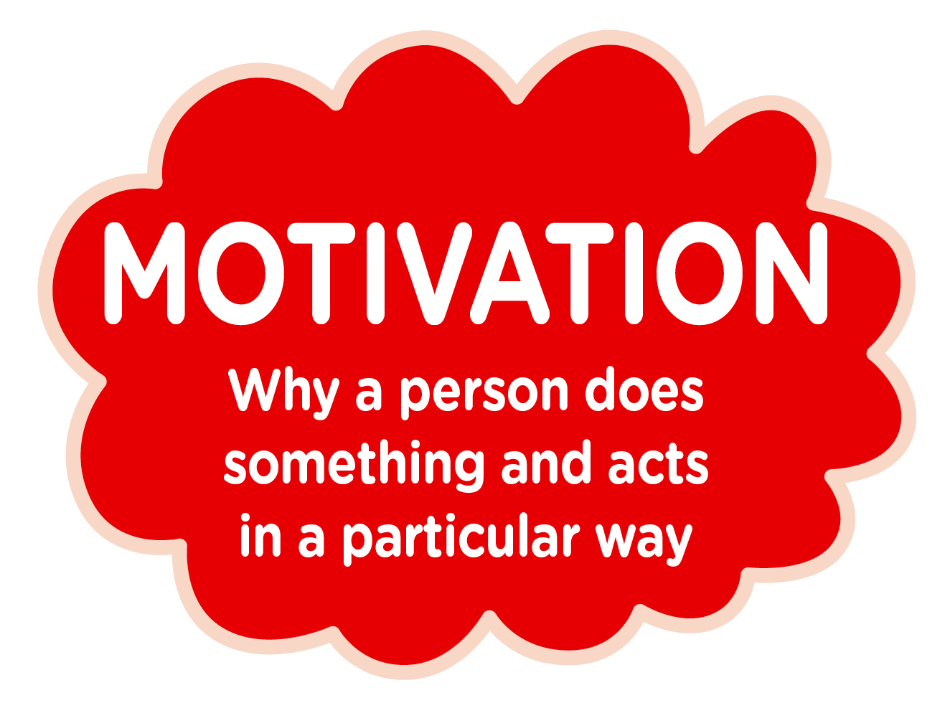 | - Learn from people and get better (Primary)  - Be able to try something even if you fail (Year 7)  - A way of being the best you can be (Year 8)  - Feeling energised and positive (Year 9)  - Persistent to achieve your goals (Years 10&11)  - Get on and do things (Post 16)  - Desire to achieve a goal you are capable of (Pod)
 | - We want to keep going and get even better (Primary)  - Make sure you believe to achieve (Year 7)  - A belief that you will become better (Year 8)  - Knowing what sort of person you want to be (Year 9)  - Push ourselves and challenge ourselves (Years 10&11)  - Better than we were last year (Post 16)  - I’m going to see that through (Pod)
 | - Know what is right and wrong (Primary)  - Do the right thing (Year 7)  - Being a good role model (Year 8)  - Do the right thing even if someone is telling you otherwise (Year 9)  - Always doing the right thing even when no one is watching (Years 10&11)  - Look after each other (Post 16)  - Not talking behind people’s back (Pod)

Exhall Grange Specialist School Overview

Our pupils come from all over Warwickshire as well as from neighbouring Authorities including Leicester, Solihull, Coventry and Birmingham. The majority of our pupils access school using Local Authority specialist transport.

Our pupils are supported by a highly qualified and experienced staff workforce.

The school employs 130 plus staff to fulfil a variety of roles to ensure the holistic needs of all our pupils are met.

The site is campus style with six separate buildings and has an exceptional range of facilities including a swimming pool, fitness suite, sensory room, soft play area and enterprise kitchen as well as design technology facilities and science laboratories. The school’s outside space comprises a large sports field, forest school area and playground areas. To support extra-curricular activities the school has a small fleet of five mini-buses.

As well as the main school supporting the primary and secondary pupils, Exhall Grange also operates a Specialist Learning Pod from a stand-alone building within the school grounds. These pupils, who are of secondary school age, have acute mental health needs arising from their complex communication and interaction presentation.

At Exhall Grange Specialist School there is also a dedicated team of specialists who provide support for visually impaired pupils across the County. The Vision Support Service is managed under a Service Level Agreement with Warwickshire County Council.

School Pupil Data

Area of School | Pupil Admission Number
Primary | 72
Secondary | 200
Learning Pod | 8
Totals | 280

Ofsted Inspection – 2 and 3 July 2024

This is the second ungraded inspection since Ofsted judged the school to be good in May 2014.

Findings:

Pupils are confident and articulate. They are proud to belong to the school. As they get older, pupils learn to understand themselves and their autism very well. They say this helps them to understand their peers, too. As a result, Exhall Grange is an inclusive and welcoming community, where pupils thrive.

Pupils have positive attitudes to learning. They know that staff want them to do well and that they go the extra mile to help them to achieve. In turn, pupils have high expectations of themselves and high aspirations for their futures.

Pupils have an extensive range of opportunities to develop their talents and interests and to provide them with a secure understanding of the world. Pupils value trips to support the curriculum, such as to television studios, castles and theatres. In the sixth form, students are prepared well for adulthood. They learn how to order food and eat at a restaurant and to navigate different workplaces, for example. The Year 9 residential helps pupils to develop their independence and this is built on through the popular Duke of Edinburgh’s Award scheme. Pupils are enthusiastic about the annual ‘Exhall’s Got Talent’ show. Pupils grow in independence and confidence as a result of the meticulously planned school enrichment programme.

The school is determined that pupils achieve well. It places a thorough understanding of pupils’ special educational needs and /or disabilities at the heart of the provision. Staff are adept at adapting the carefully considered curriculum to ensure that pupils’ learning and social and emotional needs are met. Pupils follow the academic pathways benefit from a curriculum that allows them to build successfully on their learning over time. Here, teachers help pupils to practise and apply their learning so that they can recall the important information that they have learned. Pupils in these pathways achieve well.

Pupils in sixth form benefit from a highly personalised curriculum that prepares them well for adulthood. As well as academic qualifications, students learn life skills and skills that prepare them for work. As a result of this very well-considered provision, students leaving the sixth form go on to very positive destinations.

Pupils are helped to become independent from the start of school. Children in early years learn to make choices and, by the time they finish the primary years, pupils are ready to tackle tricky tasks and to manage setbacks well. Secondary pupils flourish. They are very well prepared for their next steps. Sixth-firm students enjoy helping younger pupils. They support early years classes, listen to younger children read and support many school events. They take their responsibility seriously.

Careers are a real strength. From primary school, pupils learn about themselves and their skills. They use this to consider what jobs they may like to do. Work experience is carefully planned and, in the sixth form, students have many different experiences of the world of work. The school works closely with employers and education providers to make sure that all pupils are ready to make good decisions about their future.

Staff are committed to making sure pupils receive the best quality education. They enjoy working in the school and say that leaders are mindful of their well-being and workload. Parents are very positive about pupils’ experiences. They value the school and the opportunities that pupils receive. Governors know the school well. They understand their roles and make decisions in the best interests of pupils.

Safeguarding:

The arrangements for safeguarding are effective.

What We Are looking For

We expect candidates to have at least (please see full details in Job Description):-
• A passion for supporting pupils to learn to the best of their ability.
• Qualified Teacher Status
• Have a strong understanding on complex special educational needs and Autism and how this impacts Pupils and families.
• Have a detailed understanding of curriculum provision that support pupils with complex special educational needs.
• Have considerable experience of supporting the learning, progress and development of pupils with complex special educational needs.
• Experience working in a school environment or other educational setting.
• Experience of planning and delivering learning activities.
• Experience of using and implementing communication strategies e.g. PECS, Makaton, visual timetables, in print, objects of reference, AAC devices etc. to develop pupils understanding and communication skills.
• Experience of supporting and leading CPD for staff to develop their knowledge and skills to work directly with complex pupil cohorts.
• Experience of supporting and leading sensory provision for pupils with complex special educational needs
• As a designated safeguarding trained staff member undertake and refresh DSL training to support the Designated Safeguarding Lead in fulfilling the safeguarding requirements in line with KCSiE.

What We Offer

You will have the opportunity to work in this unique Specialist Provision where you will become a valued member of an encouraging and friendly staff group and supportive Senior Leadership Team.

SALARY: L11 (£66,368) – L15 (£73,105)

DAYS: Monday to Friday

Additional benefits include:-

- Contributions to the Teachers Pension Scheme (TPS)
- Use of the onsite fitness suite and swimming pool facilities
- Access to employee well-being services through the Employee Assistance Programme and Snowford Grange regular in person Senior Leadership Team wellbeing check-ins
- Vivup Employee portal offering car leasing options, cycle to work schemes and discounts on numerous retailers and venues.

Application Process

Closing Date for applications: 09.00 am on Wednesday 29 April 2026

Interview Date: The process will commence on Wednesday 6 May 2026. Some candidates will be invited to attend on Thursday 7 May 2026.

Please return applications by email to: recruitment@exhallgrange.co.uk

Interview Process

Stage 1 |  | Stage 2
Applicants should send their completed Exhall Grange Specialist School application form to the email address above by the closing date, ensuring that:-  - there are no gaps in their education or employment history  - they have included evidence of how they fulfil the Job Description and Person Specification. |  | Applications will be reviewed using Safer Recruitment guidelines and the requirements of the Job Description and Person Specification.  Shortlisted applicants will be invited to Stage 3 once this process has been completed.  School will undertake online searches in line with Keeping Children Safe in Education guidelines.  Where consent has been given, references will be requested.

Stage 3 |  | Stage 4
Stage 3 will take place over two days starting on the dates shown above.  Candidates will take part in the following recruitment activities:-  - a lesson observation of a Primary Teacher  - school council interview  - task – details to be provided on the day  - lunch with the Senior Leadership Team and Governors  At the end of the first day a decision will be made about progression to Stage 4. |  | Candidates will be given a topic to prepare for presentation on Day 2 of the process.  This will be followed by an interview.  Feedback from all aspects of the recruitment process will be reviewed and a final decision will be made.


Job Description and Person Specification

This form is used to provide a complete description of a specific job and defines the skills, knowledge and abilities required to undertake that job.

Role Profile
The specific role profile provides key information relating to the salary and working conditions e.g. location of a job, along with the current focus of the job role and a brief description of the main duties.

Job Title: | Assistant Headteacher
Salary Grade: | L11 to L15
School: | Exhall Grange Specialist School
Primary Location: | Primary
Responsible to: | Headteacher and Deputy Headteacher
Responsible for: | Providing a high quality educational experience for a diverse and complex cohort of pupils and for leading staff in the development of the curriculum pathways, ensuring robust assessment and high standards of learning for all. Leading on the smooth transition of pupils in Key Stage 1 and Key Stage 2.
Purpose of Role: | The post holder will :  Be learning centred;  Focus on leadership;  Reflect the highest possible professional standards;  Be part of the Leadership Team in order to secure the school’s success and improvement, ensuring high quality education for all pupils, improved standards of teaching and learning and the well being of all.  Lead and manage our diverse and complex cohort of pupils in the primary setting.
Job Description

Core Responsibilities
- To ensure the needs outlined in the EHCP are met of our complex pupils.
- To ensure, through close multidisciplinary working, a quality educational experience, excellent progress and high standards of achievement for all pupils.
- To ensure early intervention strategies are identified and implemented to meet each pupil’s individual needs and so enable them to achieve their full potential.
- To ensure that the primary curriculum is fully and appropriately implemented for all pupils to make progress from their individual starting points.
- To develop a smooth and effective transition between Key Stages.
- To be a member of the designated safeguarding team to promote pupil welfare and safety.

Accountabilities
The Post Holder will be accountable to the Headteacher and Deputy Headteacher.

- Setting the standards for the learning, development and care that every pupil should experience within the school, ensuring that every pupil makes progress to their potential
- Providing equality of opportunity, taking account of ethnicity, culture or religion, home language, family background, disabilities, gender and ability
- Creating the framework for partnership working between parents/carers and professionals and between all settings that the pupil attends
- Improving quality and consistency in Primary
- Laying a secure foundation for future learning by providing a learning experience personalised to meet each pupil’s needs, interests and learning styles and which is informed by the use of ongoing observational assessment
- To provide leadership for Primary, modelling and supporting effective practice.

Specifically this requires the post-holder to:
- Ensure that the pupil’s experience of the curriculum is relevant, stimulating, engaging and coherent, that a love of learning is fostered and that expectations placed on pupils are consistent, challenging and achievable
- Co-ordinate and support the development of long term, medium term and short term curriculum planning
- Ensure that procedures for curriculum planning, assessment, recording and reporting are appropriate to the age and ability range and are consistently applied by all staff
- Ensure that pupils’ individual needs are met and that appropriate and challenging targets and that progress towards these is carefully and regularly monitored
- Keep up to date on curriculum changes and implement necessary changes within the setting
- To support and lead on the development of communication and sensory support for all pupils in the primary setting
- Ensure that care, guidance and support is provided for all pupils
- Provide enrichment activities to enhance the pupils’ experience of school and the curriculum
- Work in liaison and partnership with parents/carers to meet their child’s needs and to help to provide support and guidance to parents/carers
- As a designated safeguarding trained staff member undertake and refresh DSL training to support the designated safeguarding lead in fulfilling the safeguarding requirements in line with KCSiE
- Liaise with other settings to build effective networks to help to improve quality and consistency of practice in meeting the needs of pupils
- Ensure an effective and positive transition to the next Key Stage
- To manage the budget effectively

Staff Development
- Support the professional development of staff through example, guidance and team meetings
- Ensure sufficient and effective deployment of staff to maximise pupil progress
- Ensure the effective and efficient management of learning resources
- Encourage high quality display in classrooms/corridors
- Ensure a stimulating but safe working environment in which risks are regularly assessed
- Lead and model effective CPD to support staff to develop confidence in working with pupils with complex sensory, physical and communication needs

Other Professional Requirements
- Establish and maintain effective working relationships with professional colleagues and parents/carers
- Lead and participate as required in meetings with professional colleagues and parents/carers in respect of the duties and responsibilities of the post
- Take responsibility for own professional development

Knowledge and understanding
- Have knowledge of and keep up to date with Curriculum and ensure its relevance to the pupils
- Understand how pupils’ learning is affected by their physical, intellectual, emotional and social development, to understand the stages of child development and make all necessary adaptations to meet these and to address the needs identified in the EHCP
- Provide clear structures for lessons and for sequences of lessons, which maintain pace, motivation and challenge
- Make effective use of assessment information on pupils’ attainment, prior learning and progress in planning future lessons approaches necessary to achieve the objectives and outcomes
- How to effectively support pupils with complex needs to develop their communication and sensory processing

Planning, teaching and class management
- Plan and teach the curriculum to a variety of primary classes in line with the school Development Plan
- Maintain a safe environment in which pupils feel confident
- Use a variety of teaching and learning styles appropriate to the needs of all pupils
- Be familiar with the Code of Practice and identification, assessment and support of pupils with Special Educational Needs
- Ensure assistive technology is used by pupils where appropriate

Monitoring, Assessment, Recording, Reporting and Accountability
- Assess and record each pupils’ progress systematically with reference to the schools’ current practice
- Mark and monitor pupil’s work, providing constructive feedback and setting targets for future progress in line with school policies
- Provide reports on individual progress as required

Specific Responsibilities
- Lead the EYFS and Primary Department
- Lead on transition year 6 to 7 programme
- Lead on CPD related to communication and sensory and curriculum provision for all pupils and pathways in primary

Notes:

This job description should not be taken as comprehensive and exclusive of any other tasks. By negotiation and agreement between the post-holder and the Headteacher other tasks which are relevant and reasonable for the post-holder may be allocated.

Adults employed to work at Exhall Grange Specialist School are vetted for their suitability to work with children in accordance with the Protection of Children Act and the DfE requirements

Person Specification
The person specification provides a list of essential and desirable criteria (skills and competencies) that a candidate should have in order to perform the job. Each of the criteria listed below will be measured through; the application form (A), teaching a lesson (T), an interview (I), a presentation (P) or documentation (D), References (R)

Essential Criteria | Assessed By;
- DfE recognised teaching qualification  - Graduate or equivalent | A, D
- Successful teaching experience  - An outstanding teacher  - Middle leadership responsibility  - Has been able to lead and manage effectively in adverse situations  - Experience of working effectively with parents/carers and other organisations  - Works effectively with Teaching Assistants/Support Staff  - Has evidence of the ability to work effectively and supportively in a team  - Has used analysis of data to inform planning  - Has worked successfully with pupils with a range of abilities and with significant and complex SEND  - Has been able to lead and manage in adverse situations  - Be willing to undertake Designated Safeguarding Lead (DSL) training. | A, T, R, I
Knows about :  - Strategies for raising achievement for pupils  - Ensuring effective pupil learning through challenging, high quality and exciting teaching  - Strategies to promote individual and team development  - The work of other agencies and opportunities for collaboration  - Strategies which encourage parents/carers to support their children’s learning  - How quality assurance and self evaluation can lead to improvements in outcomes for pupils  - Policy creation through consultation and review  - The impact of change on organisations and individuals  - The positive role of performance management within one’s own professional development and that of others  - Sensory and communication needs of pupils with complex SEND | A, R, I
Is able to :  - Meet the Preamble and Teacher Standards  - Establish and maintain an ethos in keeping with the school’s core purpose Model the values and vision of the school  - Lead and manage teams successfully  - Have awareness of current issues and a sense of vision concerning the future development of the Early Years Foundation Stage and Primary curriculum  - Plan strategically and implement the actions within given time scales  - Inspire, challenge, motivate and empower pupils  - Communicate effectively, orally and in writing, with a range of audiences  - Access, analyse and interpret information, including data, to inform evaluation  - Think strategically, build and communicate a coherent vision in a range of compelling ways  - Acknowledge excellence and challenge under-performance  - Foster an open, fair, equitable culture and manage conflict  - Demonstrate that mutual respect, challenge and praise are key to managing teacher/pupil relationships in the classroom  - Challenge, influence and motivate others to attain high goals  - Maintain a sense of perspective  - Prioritise, plan and organise oneself  - Make professional, managerial and organisational decisions based on informed judgements  - Develop and maintain effective relationships with parents/carers  - Enthuse pupils to enhance learning  - Use ICT effectively in a range of ways  - Share our belief that Every Child Does Matter  - Lead relevant CPD which supports staff to develop their skills and knowledge to support complex SEND pupils.  - Contribute creatively and knowledgeably to develop/evaluate schemes for learning  - Understand the importance of meeting deadlines and supporting others to do so  - Contribute positively and appropriately if they see a need for change in any aspect of school life | A, T, R, I
Is committed to :  - The protection and safeguarding of children and young people  - The raising of standards for all in the pursuit of excellence  - The continuing learning of all members of the school community  - The developing and sustaining of a safe, secure and healthy school environment | A, I
Qualities :  - Is flexible, committed and enthusiastic in one’s approach to the dynamics at the heart of an innovative school environment/culture  - Has a strong commitment to pursuing one’s own professional development  - Shows evidence of appropriate personal qualities and skills, particularly enthusiasm, creativity and the ability to communicate effectively | A, I
- In addition to the candidate’s ability to perform the duties of the post, the interview will also explore issues relating to safeguarding and promoting the welfare of children, including:  - Motivation to work with children and young people  - Ability to form and maintain appropriate relationships and personal boundaries with children and young people  - Emotional resilience in working with challenging behaviours and a variety of needs | A, I
Additional:
- Good health and attendance records
- This post is exempt from the provisions of the Rehabilitation of Offenders Act 1974. An Enhanced Criminal Record Disclosure will be required prior to appointment
- High quality of application, with particular regard to the formal response requested
- Reference of unequivocal recommendation

Desirable Criteria | Assessed By;
- Post graduate qualification  - Experience of employment within SEN | A, D
- Successful collaboration with other professionals  - Working successfully with key staff to improve outcomes  - Has experience of curriculum development | A, R, I
- Has evidence of a commitment to promoting and developing active teaching and learning styles across the full ability range of the school | A, I

We are committed to Safeguarding and promoting the welfare of all those we serve, as well as complying with best practice in the application of safeguarding. Therefore, as this role requires working with Children or Vulnerable Adults an Enhanced Disclosure & Barring Service (DBS) Disclosure will be required as part of the pre-employment checking process, and rechecking will be required as and when determined by the relevant policy.

Working Conditions
The working conditions relate to those non-contractual elements of the job that may impact on the holder of the position, as well as those workplace-based responsibilities that are part of this job. These are not contractual but provide a guide to the working conditions and the potential hazards and risks that may be faced.

Health & Safety at Work
To take responsibility for your own health, safety and wellbeing, and undertake health and safety duties and responsibilities for your role as specified within Warwickshire County Councils Health and Safety Policy, and all other relevant health and safety policies, arrangements, procedures, systems of work as specified for the post/ role.

Potential Hazards & Risks
The potential significant hazard(s) and risk(s) for this job are identified below. The purpose of recording this information on the job description is so that the health status of the potential and actual post-holders can be assessed with regard to the significant hazards and risks. These hazards and risks should be based on the appropriate activity, process and/or operation risk assessment whereby all of the significant risks are identified, recorded and appropriately controlled. The list below is therefore not an exhaustive list because it is the risk assessment that details all significant risks that could arise out of or in connection with the work activity, but any others will be identified in the ‘other’ section.
- Work with vulnerable children or vulnerable adults
- Moving and handling
- Significant use of computers (display screen equipment)
- Working with challenging behaviours

