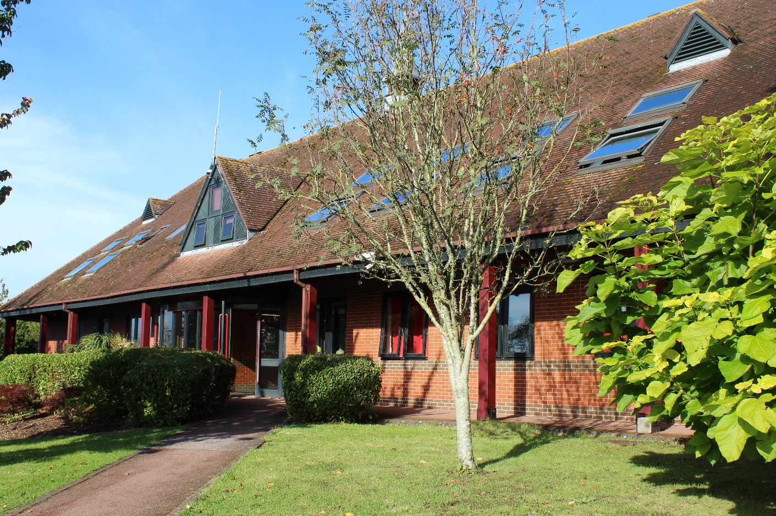
GILLINGHAM SCHOOL, DORSET

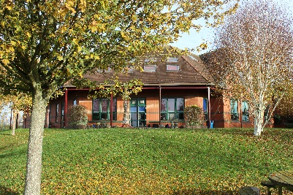
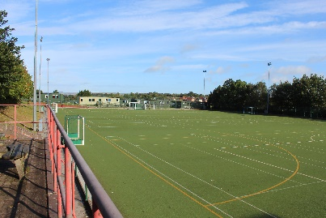
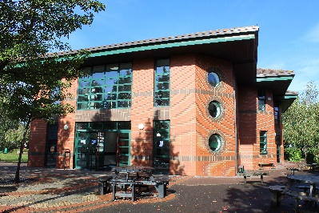

Context

Founded by benefactors in 1516, Gillingham School is proud and privileged to offer a quality and enjoyable educational experience that is open to all young people from the town of Gillingham, its surrounding villages and indeed, to young people further afield in Dorset, Wiltshire and Somerset.

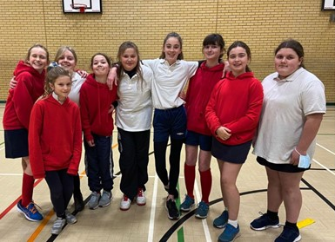
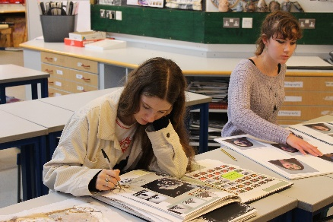
At Gillingham School, we recognise that children have many abilities, talents and personalities. Knowing that each student is different and that they learn in many ways, we aim to develop their abilities, raise their expectations and to provide the support that is necessary for success. By offering a wide range of experiences to our students both in and out of the classroom, students will receive a broad spectrum of learning.
Gillingham School, furthermore, is a friendly, welcoming and inspiring school. Characterised by good behaviour, respect towards other and enthusiasm for new experiences, the positive ethos of Gillingham School has been a feature here for years and underpins our three School Values:

- We are ambitious, take pride in our school and our learning is never disrupted.
- We treat everyone with kindness and dignity.
- We have the right to feel safe and happy.

It is our privilege as teachers to welcome children into our school and to watch them learn, grow, develop and mature into the young adults who will eventually leave us and become the next generation of our community and our country. It is a delight when we meet former students some years later and hear how they have progressed, how far they have come and how Gillingham School helped them to achieve their goals.
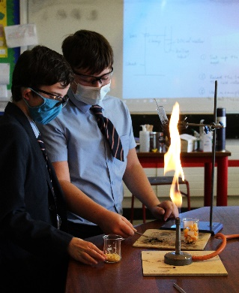
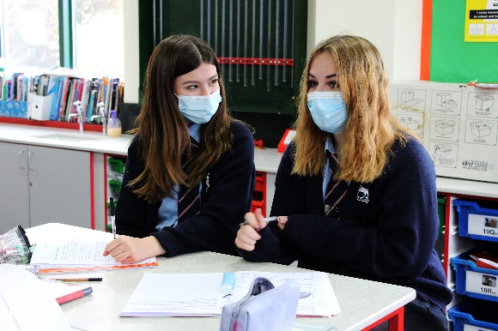
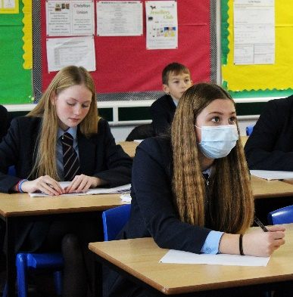

The role – Assistant Headteacher

We are seeking to recruit an outstanding and motivated Assistant Headteacher who is able to contribute to the vision and strategic leadership for our school. You will join an ambitious team who are committed to providing an outstanding learning experience for all our students.

As the Designated Safeguarding Lead, you will oversee all safeguarding arrangements in our school including training, audits, transfer of records and the Single Central Record.

Furthermore, you will oversee the majority of our inclusion provision at school including our Pastoral Hub, our work with the Local Authority and leading our critical work on attendance and how to engage with our harder to reach families.

At Gillingham School, high quality teaching and learning is an absolute priority. In this regard, you will be working with our Heads of Year to continually quality assure the quality of our curriculum. Moreover, you will also work alongside a Deputy Headteacher in specific curriculum areas.

Gillingham School is blessed with an outstanding team of colleagues. Professional generosity is important and we operate within a culture of high expectations without fear. Colleagues in the senior leadership team work alongside the wider school. We are committed to deepening leadership capacity across our school and we expect all colleagues to be stakeholders in our school improvement work. Colleagues have a shared commitment to providing the highest quality provision for all our students and wider community.

There is a commitment to continual improvement within our school. This is based upon four key pillars for school improvement, all of which you will be heavily focused on:

- Outstanding curriculum design delivered through a high quality pedagogical approach
- A first class professional development programme
- A culture of ongoing quality assurance with trust at its heart so that we are better able to understand and subsequently improve our school
- A first class personal development programme so that we are best able to prepare all of our students to succeed in the 21st century

We are proud that we have continued to thrive and improve throughout the pandemic.

However, we are aware that the impact on our most disadvantaged has been particularly profound. As Assistant Headteacher, we will expect you to be completely committed to improving the life chances of all our students and in particular our most vulnerable.
