

Hope School, 251 Hartsbourne Avenue, Liverpool, L25 2RY

Telephone: 0151 363 3130 – Email: ao@hope-school.co.uk www.hopeschool-liverpool.co.uk

ASSISTANT HEADTEACHER

Pay range: L1-L6

Hope School are looking to recruit a new Assistant Headteacher. This is a tremendous opportunity for either an existing Assistant Headteacher or an experienced teacher with a proven record in school improvement and strong leadership skills, to JOIN this ‘outstanding’ school.

Hope is a modern purpose-built school with excellent facilities and has a committed staff team of 35. It is a friendly, warm, and welcoming school and is a Local Authority maintained special school for 69 children aged 5 to 11 years who have an Educational Health Care Plan due to their Social, Emotional, and Mental Health needs.
Crucially the school has adopted attachment and trauma-informed practices (ATP) as the basis for working with its pupils. Furthermore, the school operates a non-exclusion policy and since the school opened in 2002, no child has been excluded from the school. The school has built a formidable reputation and is recognised as being a Centre of Excellence both locally and nationally winning multiple awards for the work it does.

This is an exciting opportunity for a passionate and resilient educator, enthused to work collaboratively with the Board of Governors and has good strategic and management skills. It is also essential candidates have an awareness and support the use of ATP and have the ability to further build and develop the school's strong foundations and reputation for educational and psychological innovation.

We would welcome applications from teacher or senior leaders, who have a commit to support children who have behaviours that may challenge to have the best outcomes possible.

For more information about Hope School and to look at our strategic overview and supporting information, please visit our website at: www.hopeschool-liverpool.co.uk

Welcome from our Headteacher

I am delighted to welcome you to Hope School, a place where every child is valued and supported for in their learning journey.

At Hope School, we specialise in working with children with Social, Emotional, and Mental Health (SEMH) needs. Our dedicated staff are trained to provide a safe and clear environment for all students, helping them to thrive academically and emotionally. We understand the unique challenges faced by children with SEMH needs and lined neurodevelopmental conditions and are committed to providing tailored support to meet their individual needs.

Our approach at Hope School is rooted in building positive relationships with our students and families and fostering a sense of community within the school. We believe that by creating strong connections with each child, we can create a supportive and empowering environment for their growth and development.

Additionally, we are proud to incorporate trauma-informed practices into our work at Hope School. We recognise the impact of trauma on children's lives and aim to create a school environment that is sensitive to their experiences. By promoting healing and resilience, we help our students to overcome challenges and reach their full potential.

We are an outward looking school and work across the authority with the HEARTs program, supporting schools and enhanced provision and providing outreach. We are also the first ARC learning hub.

As the Headteacher I welcome colleagues who are solution focused, positive and think creatively. I work collaboratively and want staff to be the best version of themselves.

Warm regards,

Mrs Maxine O’Neill



Welcome from our Chair of Governors
Dear Prospective Candidate,
On behalf of the Board of Governors, it is my pleasure to extend a warm welcome to you as you consider joining Hope School, a specialist provision dedicated to serving pupils with Social, Emotional, and Mental Health (SEMH) needs. As the Chair of Governors, I am honoured to introduce you to our vibrant and compassionate school community.
At Hope School, we are committed to providing exceptional education and support to our students, ensuring they have every opportunity to thrive and succeed despite the challenges they may face. As such, we are dedicated to recruiting individuals with the right skills, expertise, and most importantly, the passion and dedication to make a meaningful difference in the lives of our students.
As you explore this job application pack, I encourage you to reflect on how your skills and experiences align with our mission and values. We are seeking candidates who possess not only the necessary qualifications and expertise but also a genuine empathy and understanding of the unique needs of our students.
Hope School is more than just a place of learning; it is a community where every member is valued, supported, and empowered to reach their full potential. We believe in fostering a culture of collaboration, innovation, and continuous improvement, and we are excited about the opportunity to welcome new members to our team who share in this vision.
Thank you for considering joining the Hope School family. I look forward to the possibility of working together to make a positive impact on the lives of our students and the broader community.
Warm regards,

David Blythe

Hope School, 251 Hartsbourne Avenue, Liverpool, L25 2RY
Telephone: 0151 363 3130 – Email: ao@hope-school.co.uk www.hopeschool-liverpool.co.uk

STRATEGIC OVERVIEW OF HOPE SCHOOL

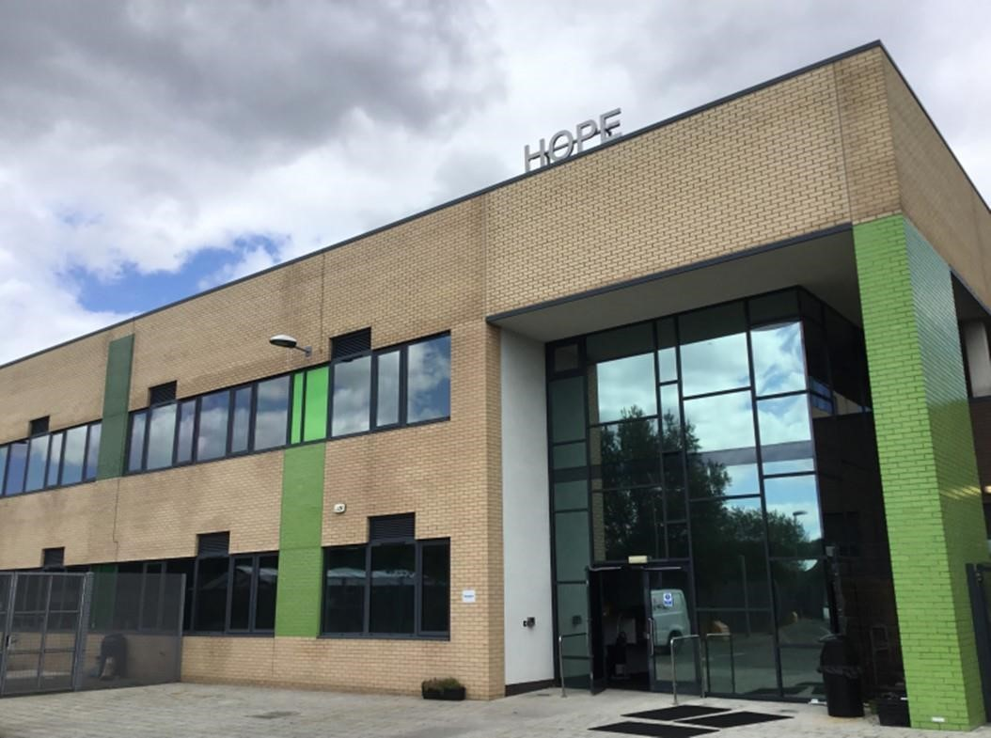
(The main entrance to Hope School)

STRATEGIC OVERVIEW OF HOPE SCHOOL

CONTENTS

- Purpose
- Introduction
- School Curriculum
- Forrest Schools/Outdoor Learning
- Performing Arts
- Therapies
- Benchmarking/External Standards
- Family Support Programme
- Pupil Voice
- Management & Staff Team
- Governance
- Summary

1.0 PURPOSE:

The key aim of this document is to provide a succinct strategic overview of Hope School, including a general understanding of the school curriculum, coupled with the support mechanisms in place that aid its pupils’ learning and development as an attachment and trauma informed therapeutic learning community.

The overarching strategic drivers are the school’s mission statement, vision, motto and core values. These are as follows:

SCHOOL VISION
Resilient, Independent Life-long Learners.

MISSION STATEMENT
At Hope School, we provide an attachment-friendly community that fosters warmth with high boundaries so that all can achieve their full potential.

SCHOOL MOTTO
If I try I can

CORE VALUES
Belonging
Summary
This represents how all those across the school community valued a sense of belonging to something special – HOPE was described as ‘a family’, ‘a community’, a place of “friendship” and shared identity.
To strengthen this sense of belonging, the school community valued the importance of supporting children to feel more secure in their relationships. It was recognised how children and families may have experienced a sense of exclusion, stigma and disconnection a result of their experiences within the education system. Staff talked about how part of ‘belonging’ was about supporting children to feel “loved”, “appreciated” and “valued”.
An important part of belonging was understanding and valuing one another: being able to ‘connect with the journey of others; hold empathy; bring care, curiosity and compassion into work; have humanity- appreciating that “we are all human”; and see the importance of being accepted for who we are. Themes of having respect toward oneself and for each other (through being kind, polite) were also identified as important.
Some examples …..
- Children identified about the importance of school offering them a sense of togetherness which came thorough opportunities for friendship, playing with one another/ joining together to eat and have fun. . They named the importance of kindness, including others, sharing with and caring for one another, and celebrating each other (e.g. birthdays, achievements). Children also valued feelings of safety and calmness offered within school and the relationships within it and how they valued being with people “that know me well”.
- Families talked about how much they (and their children) valued feeling understood and accepted within the HOPE community (“you get my child”). They felt it was recognised that previous school experiences may have been difficult and that they may feel distrustful (which could take time to shift). Language of “acceptance” came through in discussion. They also reflected on the school’s non-judgemental approach towards them, and valued the sense of openness (rather than defensiveness) displayed by staff – all of which helped strengthen their relationship with school.
- Leaders, staff and governors talked about the sense of family, togetherness, belonging and shared identity that represented being part of the HOPE school community. Leaders and govenors talked about their role in shaping this identity and modelling a sense of belonging. They reflected on the central importance of relational practice, understanding “where families are at” – strengthening feelings of safety, trust and emotional security for children and families. Staff talked about “everyone getting involved”, taking an inclusive approach. They also reflected on the importance of feeling valued themselves in their work and understanding the contribution they can make to the lives of children and families in school.

Discovery and Delight
Summary
This theme represents how school was valued as a place of ‘discovery’ – children “discovering themselves’ and what they are capable of - (understanding themselves more, and discovering their qualities, strengths and interests).
An important part of this was there being opportunities for positive, novel experiences, and the sense of fun and enjoyment that children and staff feel within school (for example, opportunities for creativeness, physical activity and fun!).
Part of enabling children to discover and learn, was a sense that they feel “happier and better” in themselves. (Perhaps feeling more settled and secure enables them to explore, take risks and get involved in new experiences).
This theme also represents the value of bringing a playful approach in building relationships with children and supporting them.
Some examples
- Children highlighted how much they enjoyed playing together, having fun, and activities such as drawing, doing art, exercise, going on the climbing wall et. They identified feeling “happier” and “better”, “feeling good” about themselves. Connected to this, they talked about feeling “proud”.

- Families talked about how much they valued their children having access to the same opportunities as their peers in mainstream school (trips, residentials and activities).

- Staff and leaders reflected on the broad range of opportunities (involving feelings of freedom, excitement, creativity, fun, inspiration and enjoyment) offered to children and how this supported a holistic approach to their development which extended beyond their educational attainment (for example - learning life skills, play skills, emotional skills). They appreciated how these opportunities enabled children to explore their qualities and strengths, develop their sense of identity – all of which could help towards shifting more negative views they may hold of themselves. They valued children having the conditions to feel safe to explore and take risks. Staf also talked about the importance of bringing playfulness into their work as a means to deescalate situations and build relationships

- Leaders also talked about the importance of those around a child knowing their story, understanding their journey, and children “knowing themselves” well.

Empowering
Summary
This value represents the importance of school strengthening a sense of power across all levels of the school community. For children this was about increasing their understanding of themselves and others (including their emotions, their strengths and needs), re-engaging them with their education, developing the skills they need to regulate themselves well and build positive relationships, and supporting them to make positive choices and decisions.
This was encouraged through the school bringing a specialist level of understanding around the application of psychologically-responsive care in education, children and families feeling their needs were well understood and addressed, families feeling their voices were valued and that they were collaborated with in the care of their children), staff feeling equipped with the knowledge and support they needed, and leaders being able to strengthen and influence good practice both within school and wider across the local authority.
Some examples….
- Children described that school helped them with “big feelings”, feeling “able to breathe”, “helping me” (and some of the ways that school help with this - so interventions like checking in and out each day, providing “space when I’m upset and angry”, and having some independence. They identified the importance of “good listening” and paying attention. They also talked about times when they are proud

- Staff talked about their focus on supporting children to develop the regulation and relational skills they needed to succeed. Crucially, seeing themselves as the agents of change (“its about the adults”) - providing children with emotional security, and supporting reflection and repair through restorative practice when things go wrong. They identified that this approach helped strengthen children’s self-esteem and skills which in turn strengthened their resilience – for example, by helping children to express themselves and their needs, build relationships, take accountability for themselves and their actions, and importantly by helping them to settle to learn. Staff also shared how improvements in children’s attendance once at HOPE empowered them further through re-engaging them with educational opportunities that they may otherwise have struggled to access.

- Staff and leaders also talked about empowering each other through “strong teamwork”, striving for “continuous improvement”, “holding high expectations” (of one another and of children), and recognising that “everyone has a role to play” in the system. Leaders reflected on how the school system was empowering through their focus on “specialist trauma and attachment responsive care” (so, there being an awareness of the impact of trauma, how this affects organisations and the people within it, understanding behaviour as a communication, feeling safe to make mistakes, encouraging “accountability” for actions). Staff and leaders talked about empowering families through “family learning and programmes” and through “good communication” and “collaboration” with families in their work.

- Leaders and Governors talked about their role in empowering others through having “high expectations”. Holding each other to account, motivating others, modelling a relational approach, asking themselves “how do we keep our adults connected to children and their work in a stressful role”), supporting the system to be reflective . Both leaders and Governors reflected on how this can be “challenging work” for staff and how important it is to empower them in their work through good training, development, supervision and support. Leaders talked about their role in inspiring others both within school and as part of the wider HEARTS project with other schools and agencies.

- Governors reflected on the role of school in empowering children and families through holding high expectations of their potential, “seeing the ability” and “bringing out the best” in them. They talked about the importance of families feeling part of discussions and decisions as part of their child’s journey at HOPE (particular given that they may have felt disempowered in previous experiences or professional relationships).

- Families talked about experiencing a “sense of relief”, and generally feeing more settled and confident in the school to contain their child’s needs (e.g. not anticipating daily phone calls as they had previously). They valued the specialist understanding and approach offered by HOPE, particularly their relational focus (empathy, trust, playfulness) alongside the specialist understanding of SEN. They valued the sense of “routine” offered by school and the “proactive approach” to “getting the right people involved”. They valued the good communication, being able to come into school and speak openly, and feeling that their voices were valued ( e.g. being “seen as experts on (their) child”.

Belief and Perseverance
Summary
This theme represents the role of all those within the school community holding on to a belief in positive change and persevering even when times are hard. This involved holding high expectations of children’s potential, “seeing their ability”, “bringing out the best” in children (especially where there might be a predominant focus on what they can’t do rather than what they can), “keeping an open mind”, and crucially “never giving up”.
Examples
Children talked about the importance of “never giving up” and “having a go”.
Staff talked about the importance of persevering and “not giving up” on children. They reflected on the importance of keeping connected with children day to day (especially when they are struggling). They shared how they persevered in their approach by drawing on the support of the team, “thinking outside the box”, “trying new ideas”, and using interventions like “solution circles” to guide their approach.
Governors also talked about “never giving up”, recognising that the approach in school is “not a quick fix”. They reflected on how often children and families have felt let down by systems around them, which reinforced their commitment to children that they will offer them a secure and inclusive environment to develop. They also reflected on the importance of “being brave” and keeping faith in the school’s relational approach, recognising that this may come under challenge from influences external to school.
Families talked about the importance of appreciating their child being seen in a positive light (not as “naughty” or a “nuisance”). They also described how they valued a “hopeful” perspective, and how “nothing is impossible” Finally, they named the importance of perseverance, describing HOPE as “always finding a way”.
Leaders talked about having “no glass ceiling”, having ambitions for all their children. They also talked about the importance of being a “non-exclusionary school” and treating school as a “new beginning”.
April 2024

2.0 INTRODUCTION:

Hope is an Ofsted outstanding educational provision for children with social, emotional and mental health needs. Our commitment is to provide exceptional quality education, alongside compassionate and holistic care. At its heart, Hope is a safe, caring, and enriching environment for the 68 children attending the school, and has built a formidable reputation, recognised as being a Centre of Excellence both locally and nationally.

As a specialist provision, we support children who can present with a complex range of needs which may include: Developmental Difficulties, Neurodiversity (including ASD, ADHD) Learning Difficulties, Sensory Processing Difficulties, Speech and Language difficulties, and Communication difficulties. We have a constantly high rate of pupils entitled to Pupil Premium (59%) and high proportion of ‘Looked after children’ 18%). Many of our children (and families) have experienced adversity and trauma in their lives, and may carry with them difficult experiences of relationships (both within and outside of school) prior to arriving with us. Consequently, we believe it is essential that we can address both the developmental and relational needs of all our children. We prioritise the quality of relationships for our children and families in all we do (particularly strengthening feelings of safety and trust) and work hard to ensure that relationships across the school community are supported and nurtured.

Hope has a team of 35 highly dedicated, motivated and specialist staff. As a staff team, we understand that our children feel safer, more secure, and ready to learn when their needs are well understood and addressed by the system of adults around them. Therefore we have committed to strengthening psychologically-responsive care at whole school level (with a focus on attachment and trauma informed practice), ensuring that we provide continuing professional development and supervision for our staff to enable them to address the needs of our children, and crucially to support their families too.

Pupils can join the school at different times throughout the year and at different stages of their education (between year 1 and year 6). Our pupils are predominantly from Liverpool Local Authority, although a small number attend from outside the area. Hope school also provides assessment places for pupils who are in the process of receiving an EHCP but at risk of permanent exclusion. A place at Hope school may be offered on a short-term basis for key stage one pupils.

As a school we also strive to be fully inclusive school and ensure that all our children are treated fairly and equally. We work in partnership with parents, carers and specialist partners to ensure our pupils receive the appropriate support they need to access all aspects of school life and to enjoy their time with us. The school operates a non-exclusion policy and we are exceptionally proud that since we opened in 2002, no child has been excluded from the school.

Several years ago, after extensive research and a comprehensive strategic review, we undertook a major change by removing our rewards and sanctions policy and embarked on a journey of implementing and developing attachment and trauma-informed practices. This is not to be mistaken for a lack of rules and boundaries. We have clear systems of ensuring high standards and reinforcing positive behaviours which, we believe, creates the sense of security and safety that our children need to learn and develop relationships with staff and each other. We believe that children need both clear boundaries and an adult that can keep open and connected to them when they need more time or support to reach our expectations and live by the school rules.

Our whole school Attachment and Trauma Response care Framework is now well established in the school and underpins all the work we undertake with our pupils, their families (parent/carers) and our wider school community. We strongly believe this approach is transforming the lives of our pupils to have the skills and resilience to become lifelong learners.

Quote from a parent of a pupil recently leaving Hope School:

“At the tender age of 12 my son has learnt who he is. He knows how to handle his emotions, he knows how to regulate himself and he also knows what situations to avoid. He knows his limits, his triggers and he understands himself”.

We are now recognised at both a city wide and national level for our Attachment and Trauma Responsive approach. Hope School is a strategic partner with Liverpool Virtual School, working in collaboration with Clinical Psychologists and other specialist partners to deliver a pioneering city wide programme for schools across Liverpool aimed at strengthening Attachment and Trauma-responsive Care within Education. Known as the HEARTS programme, it was named the 2023 gold award winner at the National Pearson Awards under the category for Impact Through Partnership and in 2024 we were awarded the NASEN SEND provision of the year. Our involvement as a partner in such a prestigious and innovative project has undoubtedly been an honour for Hope School and reflects the reputation and respect the school is held by the wider education community.

Hope is a modern purpose-built school and is co-located with Gateacre School. Although it is totally independent it does have shared grounds and utilities. It was built under the Liverpool City Council’s BSF (Building Schools for the Future) programme in 2011. It has excellent internal and external facilities, a good size playing field together with a comprehensive range of quality outdoor learning equipment, a full-size indoor climbing wall, and two interactive sensory rooms.

At its last three Ofsted inspections (November, 2014, April, 2019, December 2024), the school was graded as being ‘outstanding’.

The school is governed effectively and is proud it has consistently over the years kept within its operating parameters to ensure it remains in good order with a healthy long-term budget.

3.0 SCHOOL CURRICULUM:

The curriculum was recently reviewed and developed by taking a more holistic and specific view of the needs of our children and in particular their SEMH special needs. The school's core values are also embedded across the curriculum.
As mentioned above, the key aim is that pupils leave Hope School with the knowledge, skills, and resilience to be lifelong learners.

For core subjects, academic attainment is captured through age-related expectations. One-page profiles are also used to fill gaps in attainment, additional needs, or other supportive developments which may be required.

Preparation for adulthood or independence is a key element in the curriculum and we make use of the curriculum programs which are designed to motivate and enhance learners' confidence, self-esteem, and resilience coupled with developing core skills in teamwork and communications.

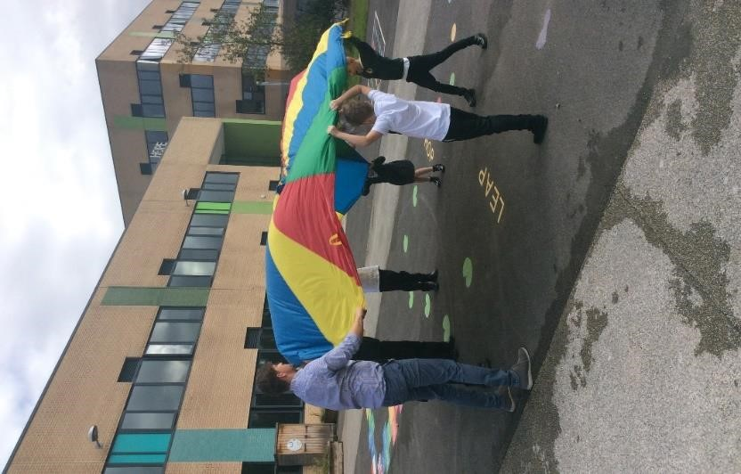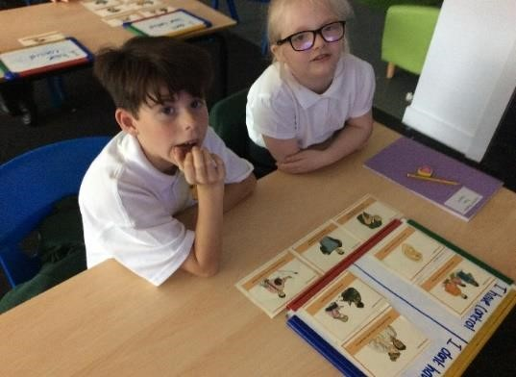

4.0 OUTDOOR LEARNING:

For many years the school has accessed for its pupils the local outdoor facilities, which has helped our children to develop many skills that are hard to teach in the classroom. It primarily encourages children to be active with the key aim of developing confidence and self-esteem through hands-on learning in a woodland environment.

Hope School has developed its own broader outdoor learning facilities and curriculum with the advantage of being on our school site.

We know our children thrive on this learning approach, and importantly we can ensure the activities are curriculum-led and focused to ensure we fully meet government requirements. Importantly, having the facilities on our school site is most beneficial as it saves valuable traveling time and enables staff to maximise on lesson time for the benefit of the children.

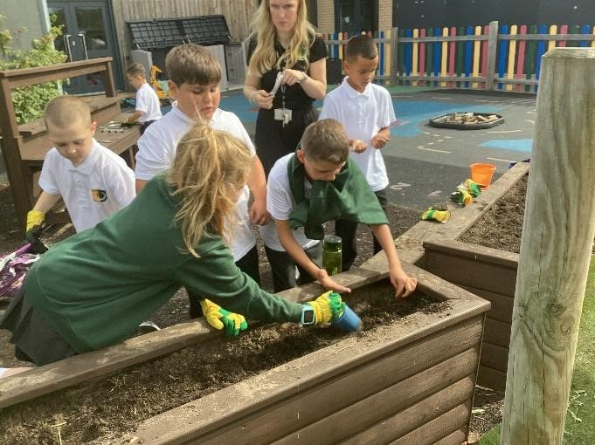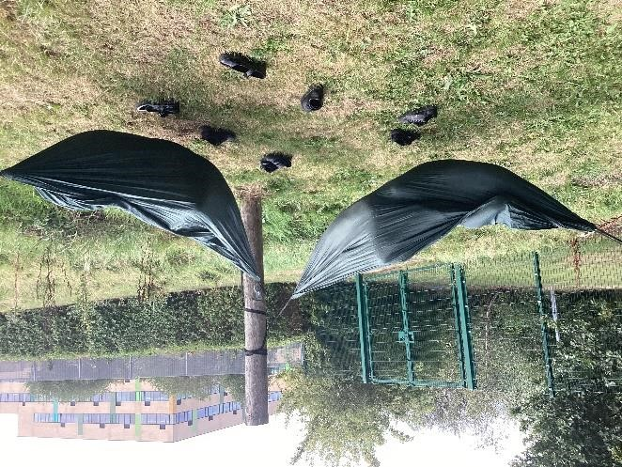

5.0 PERFORMING ARTS:

Performing arts play an important part in the pupil's school life with our most impressive feature being aerial hoops and silks. These activities do help to build confidence in children as well as having a positive effect on their physical, mental, social, and emotional development.

The celebration of these activities usually cumulates in an annual Arts week when parents and carers are invited to several events to see the children sing and perform in their various activities.

6.0 THERAPIES & SUPPORT:

Children attending the school have complex needs and we offer support through a range of support therapies as appropriate to meet the individual child’s needs. They include the following:

- Occupational Therapy, Speech & Language Therapy, Cognitive Behaviour Therapy, Educational Psychology, play therapy, theraplay and Clinical Psychology
- Mindfulness, Zones of Regulations and Thrive.

This support enhances the bespoke curriculum we offer to our children. This proactive approach contributes to helping to reduce barriers and allows children to self-regulate emotions effectively. In addition, Aerial Ninjas supports children’s bodies to be ready for sitting and writing when required and generally contributes to building up their confidence.

7.0 BENCHMARKING /EXTERNAL STANDARDS:

Hope School has developed a culture of continuous improvement and measures the impact and effectiveness of strategies, policies, and procedures the school has implemented by benchmarking against local and national standards. The independent feedback from these assessments provides opportunities to make further improvements. Examples of current re-accreditations achieved include:

- Gold Standard; Attachment & trauma sensitive schools award (ATSSA);
- An Attachment Research Community (ARC) Hub school;
- Silver Standard, Investor in People (IiP);
- Best Practice with Teaching Assistants Award (BPTAA);
- Leading Parent Partnership Award (LPPA);
- Best Practice Teaching Assistant Award (BPTAA) and
- SEND Inclusion Award (SENDIA);
- Plus various other standards

8.0 FAMILY SUPPORT PROGRAMME:

A key element to our success has been the engagement and working in partnership with parents and carers. We have a dedicated specialist Family Support Worker who can provide advice and guidance.

We also offer a range of Family Support Programmes. For example, understanding attachment and trauma practices, building on their strengths to overcome concerns, difficulties, etc., and how they can support their children at home to self-regulate and show a range of emotions appropriately.

9.0 PUPIL VOICE:

The opinions and ideas of our pupils are important to us at Hope School. We hold regular pupil voice meetings to give our children the opportunity to voice their concerns and to pass on ideas.

10.0 MANAGEMENT & STAFF:

We have a committed and dedicated management, staff teaching, and support team of 30 who strive to ensure our pupils achieve and enjoy life in school.

The well-being of staff has been pivotal in our attachment journey and the introduction of regular confidential supervision has had a profound and positive impact on the welfare of our staff and helped to identify and address issues promptly. Furthermore, all staff undertake regular training to support their professional development. For the academic year 23/24 all staff have had the option to attend psychotherapy sessions on a weekly basis for the year.

11.0 GOVERNANCE:

Strong and effective governance is critical to ensuring the success of any school and this has been provided by a challenging and supportive Board of Governors at Hope who have three termly meetings throughout the year to receive performance updates.

The governors also have individual designated lead responsibilities Safeguarding, Attachment & Trauma, Finance, Leadership & Management and Curriculum. The Head and Chair also hold regular one-to-one meetings.

The school being relatively small, governors are generally highly visible which allows them to talk regularly to pupils and staff through classroom observations, learning walks, and attending lunch breaks to obtain meaningful feedback. The governors also attend open days which are specifically for parents and carers and again this allows them the opportunity to engage with them.

An informative Termly Governors Newsletter, is sent out to parents and carers and staff to provide them with updates and how the school is progressing.

The governors have an annual review exercise to evaluate their own effectiveness and carry out some forward planning.

12.0 SUMMARY:

The foregoing overview has endeavoured to provide some understanding of Hope School’s aims, ethos, culture, and importantly how the carefully designed curriculum is delivered and supported. The report has purposely been strategically focused and not from an operational viewpoint. However, more comprehensive details and information on Hope School can be obtained on the school's website: www.hopeschool-liverpool.co.uk

It will be appreciated that safeguarding and the welfare of our pupils are given the highest priority. Whilst our curriculum fully reflects the importance of literacy and numeracy, overall it has been adapted to meet the specific SEMH needs of our pupils. Furthermore, Hope regularly develops ways to support our pupils to discover a real passion for learning.

Adopting attachment and trauma-informed friendly practices have undoubtedly been highly successful in helping drive up educational standards, and the personal development of our pupils. It is most important the school’s development approach continues and is fully supported by Hope’s future strategic partners.

It’s important to mention that there is an excellent working relationship between the governors, the Head, and his senior leadership team. The governors firmly believe the school is led by a highly committed and inspirational leadership team with the pupil's best interest at the heart of its decision-making.



Hope School, 251 Hartsbourne Avenue, Liverpool, L25 2RY
Telephone: 0151 363 3130 – Email: ao@hope-school.co.uk
www.hopeschool-liverpool.co.uk

Assistant Headteacher Job Description

Job Description: Assistant Headteacher

Reports to: Headteacher

Pay Range: L1 – L6

Status of Post: This is a senior post within the school’s staffing structure which carries with it membership of the Senior Leadership Team (SLT). This post carries a teaching commitment as well as SLT responsibilities.

Purpose of the Job
The post holder will:
- Support the Headteacher and Deputy Headteacher with the leadership and management of the school in order to promote effective education and care and contribute to the learning, personal development and well-being of all students.
- Be an integral member of the Senior Leadership Team (SLT) discharging individual responsibilities to a high standard as well as supporting the work of the team at all times.
- Work closely with the Headteacher, SLT and colleagues to ensure the school is compliant with statutory regulation.

Key Result Areas
The post holder will:
- Support the management of systems, routines and processes to work effectively in line with legal requirements.
- Support the Quality of Education in the management, organisation and administration of the school, with a particular focus on student progress and exams.
- Work with the Headteacher and SLT to lead and manage strategic areas of school development.
- Be proactive in establishing communications which foster good relations with all stakeholders, external agencies, individuals and organisations and which, through consultation, seek their positive support and active involvement in the school.
- Provide information and advice in accordance with Governance arrangements and support proper accountability processes throughout the school.

General Responsibilities
The post holder will:
- Safeguard and promote the welfare of children and young people.
- Work in accordance with professional practice, statutory and legal requirements and the policies of the School.
- Line manage middle leadership staff and act as a Team Leader for Performance Management.
- Reflect on their personal contribution to school achievements and take account of feedback from others.
- Take on specific tasks related to the day to day administration and organisation of the school.
- Take whole school responsibility for specific areas of work which will be reviewed annually.
- Take on any additional responsibilities which might from time to time be determined.
Duties and Accountabilities

Strategic Direction, Leadership and Management
The post holder will:
- Work with the Headteacher and SLT to ensure the vision for the school is clearly articulated, shared and acted upon by all.
- To lead the school in the absence of the Headteacher and Deputy Headteacher.
- Work with others to translate this vision into agreed objectives and operational plans which support and sustain improvement and growth.
- Support the implementation of an integrated school improvement plan and take sole responsibility for appropriately delegated aspects of it.
- Support staff and stakeholders in achieving the priorities and targets the school sets for itself.
- Support the evaluation of the effectiveness of the school’s policies and developments.
- Lead groups of staff in development activities, delegate appropriately and evaluate outcomes.
- Remain up to date with new legislation and frameworks and use these to inform work and practices.

Leading and Managing Staff
The post holder will:
- Support SLT in developing positive working relationships with and between all staff and provide and sustain motivation.
- Plan, delegate and evaluate work carried out by teams and individuals to ensure a consistent approach across the curriculum.
- Maintain a culture of high expectations for self and for others and take appropriate action when performance is unsatisfactory.
- Have an active commitment to CPD and lead by example in this area.
- Manage his or her own workload and that of others to enable an appropriate work/life balance to be achieved.

Leading learning and teaching
The post holder will support the Deputy Headteacher on Quality of Education:
- Ensure a consistent and continuous school-wide focus on pupil achievement, using data and benchmarks to monitor progress in every student’s learning.
- Ensure that learning is at the centre of strategic planning and resource management.
- Ensure a culture and ethos of challenge and support where all pupils can achieve success and become engaged in their own learning.
- Demonstrate and articulate high expectations and monitor the stretching targets set for the whole school community.
- Technologies to enhance and extend the learning experiences of pupils.
- Assist the SLT in monitoring, evaluating and reviewing the quality of learning and teaching across the curriculum.
- Challenge underperformance at all levels and ensure effective corrective action and follow-up is put in place and has an impact on improvement.

Leading assessment & pupil progress
The post holder will:
- Take a whole school lead role in establishing and maintaining an effective assessment and target setting framework.
- Develop, monitor and evaluate school policy and practice in the areas of assessment, recording, reporting, target setting and use of data.
- Develop and implement systems for recording and tracking the progress of individuals and groups from entry to exit.
- Collect, collate, interpret and present specialist assessment data and co-ordinate the annual target setting process.
- Ensure individual needs are being met though effective planning and assessment.

Other Duties and Responsibilities

- Co-ordinate the management of serious and/or notifiable incidents
- Liaise with outside agencies as appropriate
- Complete, countersign and monitor necessary documentation
- Support the external inspection process and be available to regulatory bodies as requested and/or required

This job description forms part of the contract of employment of the person appointed to the post. It reflects the position at the present time only and may be reviewed in negotiation with the employee in the future.

A job description can never be fully descriptive and exhaustive of unforeseen changes or circumstances. It is expected that staff will, within reason, respond to unforeseen circumstances and emergencies as they arise, commensurate with their qualifications, experience and the situation.

Person Specification: Assistant Headteacher | Essential | Desirable | Method of Assessment  A = Application form  I = Interview
Education & Training
Degree in an appropriate subject |  |  | A
Qualified Teacher Status or equivalent |  |  | A
Higher degree qualification, postgraduate course, recognised special education qualification |  |  | A
Professional development relevant to the post |  |  | A, I
Completion of NPQSL or willingness to do so |  |  | A, I
Willingness to extend personal and professional development |  |  | I
Experience
Leadership and management experience gained in middle management post |  |  | A
Experience in an SEMH/PRU or similar setting working with challenging behaviour |  |  | A
Demonstrate a clear understanding and rational for behaviour management and a proven track record of the effective implementation of a range of behaviour management strategies |  |  | A, I
Experience of School Improvement processes and practice |  |  | A, I
Experience of recruiting, managing and inducting staff |  |  | A, I
Experience of curriculum leadership and development |  |  | A, I
Proven experience of reviewing, evaluating and leading improvements in teaching and learning to raise standards which have positively impacted on outcomes for all children including those with SEND |  |  | A, I
Attachment and Trauma Informed practice experience |  |  | A, I
Significant teaching experience within the relevant in the Primary/secondary phases |  |  | A, I
Experience of multi-disciplinary and multi-agency working |  |  | A, I
Experience of leading a curriculum / specialist area |  |  | A, I
Experience of working with complex young people with additional and autism |  |  | A, I
Knowledge & Understanding
Understanding of safeguarding requirements |  |  | A, I
Knowledge of Education Acts and other legislation relevant to special education |  |  | A, I
Understanding of OfSTED framework |  |  | A, I
Sound working knowledge of the SEN Code of Practice |  |  | A, I
Understanding of the statutory curriculum and other educational initiatives and requirements |  |  | A, I
Knowledge and understanding of the restorative justice approach and attachment and trauma in formed practice |  |  | A, I
Experience of working with and engaging positively with parents to promote the caring family/community culture and ethos of the school |  |  | A, I
Demonstrate a good awareness of current national and local educational policy and strategy |  |  | A, I
Membership of a professional association |  |  | A, I
Skills
Ability to lead and provide a clear vision |  |  | A, I
Ability to plan, monitor and evaluate policy and programmes and make judgements about their impact |  |  | A, I
Ability to apply and practice quality assurance and control mechanisms |  |  | A, I
Ability to identify and promote pupils’ academic, personal and social progress, and maximise ways of evidencing them |  |  | A, I
Ability to motivate and develop people and the confidence to exercise delegated authority in a lead role |  |  | A, I
Effective organisational skills including:  - the ability to construct and present clear, accurate and succinct reports  - good time management  - management of meetings |  |  | A, I  A, I  A, I
Ability to think strategically and analytically including the collation and application of data to inform planning and development |  |  | A, I
Effective communication and interpersonal skills including sensitivity and awareness of others’ needs |  |  | A, I
Team working skills |  |  | A, I
Competent in the use of ICT |  |  | A, I
Ability to manage people and resources to good effect |  |  | A, I
Ability to plan, organise and lead training & development activity |  |  | A, I
Ability to manage financial and budgetary processes effectively |  |  | A, I
Attitudes and Attributes
Highly motivated and demonstrated commitment and enthusiasm |  |  | A, I
Ability to enthuse and motivate others |  |  | A, I
A positive and energetic approach to work |  |  | A, I
Flexible, approachable and resilient under pressure |  |  | A, I
Commitment to working with other agencies to support young people’s education and care |  |  | A, I
A desire to enable each young person to achieve their personal best and resolute in challenging barriers to their success |  |  | A, I
Commitment to the development of all staff |  |  | A, I

Hope School, 251 Hartsbourne Avenue, Liverpool, L25 2RY

Telephone: 0151 363 3130 – Email: ao@hope-school.co.uk
www.hopeschool-liverpool.co.uk

Application Dates
- Recruitment Time Line – Key Dates
Closing Date for Applications | 24th April 2026
Shortlisting | 27th/28th April 2026
Interviews | 1st May 2026
Start Date | 1st September 2026
All applications will be acknowledged
References will be sought for shortlisted candidates prior to the interview date
The successful candidate will be required to complete an enhanced DBS and Barred List check

- Arranging a school visit
Visits to the school are encouraged and welcomed.
Please contact the school office on 0151 363 3130 and ask for Helen Stewart to arrange a visit appointment.

- Safer Recruitment in Education
Hope school is committed to safeguarding and promoting the welfare of children and young people. Our school has an equal opportunities policy. For selection and recruitment in accordance with its safeguarding policy, the successful candidate will be required to have an enhanced DBS check along with a check against the DBS children's barred list. All posts are subject to statutory pre-employment checks and satisfactory references.

This post is exempt from the provisions of the Rehabilitation of Offenders Act 1974 (as amended in 2013 & 2020) and shortlisted candidates will be required to disclose any relevant criminal history prior to interview. Please see the document “Guidance for Completing an Application Form” for further information.

d. Submitting an application
The following application documents are downloadable from the advert page on the School Improvement Liverpool website and school website: Job description / Person Specification / Application form / Equal Opportunities Monitoring Form / Application overview / Guidance for completing an application. Also for your information the school`s Child Protection Policy and the staff Code of Conduct.

Applications are by the Liverpool Local Authority Standardised Application form and will be managed electronically. Applicants should not submit CVs in lieu of the application form as these will not be considered.

The application form must be fully completed and legible and must be accompanied by the Equal Opportunities Monitoring form – both downloadable as above. The supporting statement should be no more than 2 A4 pages (font size 11 minimum) and should be clear, concise and related to the post and setting applied for, paying attention to the Person Specification.

Completed application forms and monitoring forms should be emailed to Helen Stewart, School Business Manager, by 12.00 midday on Friday 24th April 2026.

h.stewart@hope-school.co.uk

Please “Subject” your email DHT Application and confirm your full name, address and preferred email address for contact.

e. A problem or question?

Maxine O’Neill Headteacher and Helen Stewart, School Business Manager are on hand to support and can be contacted on the above email address.

