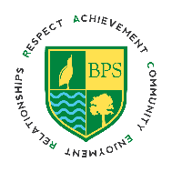 |  | Bitterne Park School  Dimond Road  Southampton, SO18 1BU  Telephone 023 80 325200  info@bitterneparkschool.org.uk  Headteacher: Stewart Roderick |  | 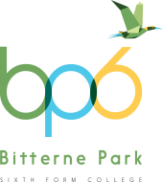
Assistant Headteacher (Inclusion)
Leadership 17 – 21

Bitterne Park School is a large and expanding comprehensive school. We are committed to ensuring our core values of Respect, Achievement, Community, Enjoyment and Relationships permeate all aspects of everyday life in school.

Following some internal restructuring, we are wishing to appoint an Assistant Headteacher to have strategic oversight of our inclusive provision for children with additional needs. You will lead and manage our extensive inclusion provision.

Application procedure
Please refer to the Role Description, Person Specification and Recruitment Pack. Completed applications (with supporting statement) should be submitted to rodway.meldrum@bitterneparkschool.org.uk

Visits to the school, as part of the recruitment process, are welcomed. Please email Charley Baines, Executive Assistant: charley.baines@bitterneparkschool.org.uk if you would like to arrange a tour with our Headteacher prior to making an application.

Closing date: 9am, Monday 11th October 2021
Provisional interview date: Friday 15th October 2021

This school is committed to safeguarding; all applicants will be expected to undergo an enhanced DBS check along with other relevant pre employment checks.

We are an equal opportunities employer.

