At the Windmill Federation, if we all smile and believe we will succeed.

Application Pack

For the role of Assistant Headteacher (Inclusion)
at The Windmill Primary Federation

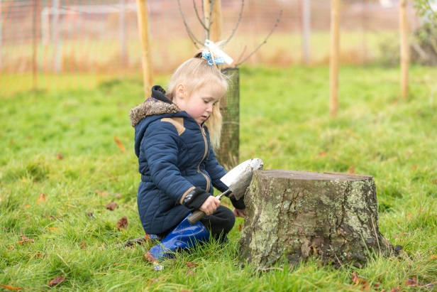

Vision and Values

Our vision:
Staff, children, parents and the wider community working together to create a happy, inspiring and safe place where every child is able to grow and learn.
We believe in:
- Mutual respect
- Equal opportunities for all
- Spiritual, moral, social and cultural awareness
- Having a voice and listening to others
- Raising aspirations
- Learning to love learning
So that our children are:
- Engaged and motivated pupils
- Confident, determined and resilient individuals
- Successful learners for life
- Responsible citizens
- Challenging thinkers
- Kind and caring friends
At the Windmill Federation, if we all smile and believe we will succeed.

Smile Believe Succeed

The Windmill Primary Federation

Why Choose The Windmill Primary Federation?

The Windmill Primary Federation provides a wonderful opportunity for someone with drive and ambition to contribute to the leadership a unique four school Federation – working alongside forward-thinking, lively and optimistic staff, who share a strong vision.

The vacancy provides the successful candidate with a fantastic opportunity. They will work at the heart of small, rural, village communities, whilst at the same time contributing to the leadership and management of a large scale organisation with over 100 staff members and a budget approaching £2 million.

Children are polite and their behaviour is excellent. Pupils display positive attitudes to learning, are supportive of each other and are proud to belong to their individual schools and the wider Federation community. Whilst the children are delightful, many live in areas of rural deprivation. As a result, the vacancy offers an opportunity to excite, motivate and challenge children from a diverse range of backgrounds, raising their personal aspirations and making a real difference.

The schools are proud of the rich, stimulating, learning environments that they offer. Across the Federation, dedicated and creative staff have high expectations for the pupils in their care. This means that children are routinely challenged and all are pushed to achieve their full potential. Positive learning behaviours are promoted and these are evident in all classes. Staff are committed to securing the best outcomes for every child regardless of their individual starting points. All stakeholders, including parents and carers, place what is best for the children at the heart of all they do.

If you want to join the forward-thinking Windmill Primary Federation team and have the passion, commitment and determination to make a difference, we look forward to hearing from you.
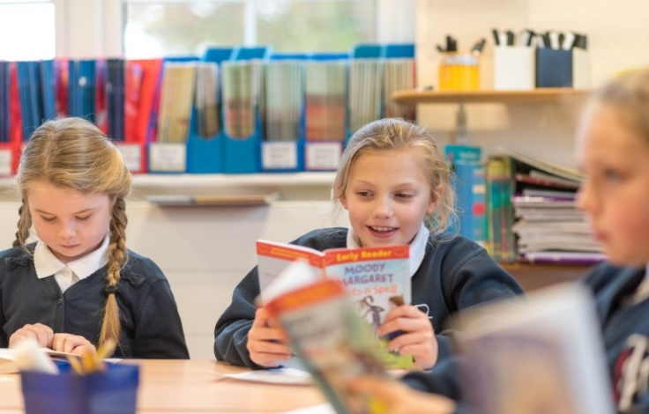

An Overview of the Federation

The Windmill Primary Federation has just over 400 pupils on role across four schools which make it one of the biggest primary organisations in West Norfolk. It is an unusual grouping of schools, in that West Walton is much larger than the other three, with 226 pupils on roll. Tilney St. Lawrence, Walpole Highway and Terrington St. John are three smaller schools, with just two or three classes each. The schools are geographically close to each other, sited approximately within a three mile radius. The schools work closely together and formally federated in June 2014, sharing an Executive Headteacher and a single Governing Board.

Each individual school and the combined Federation has made significant progress during recent years as a result of the drive, energy and ambition of the whole staff team; The Windmill Primary Federation enjoys a very positive reputation locally and across the county.

The Structure of the Federation

One advantage of the scale of the Federation is that it creates more opportunities for leadership roles than is possible in individual schools. The Executive Headteacher takes the overall lead of the four schools. Presently, we are reviewing the middle tier of leadership to maximise the impact upon our pupils. We are unique in that we have parallel subject leaders: a member of staff from West Walton works together with a member of staff from the three smaller schools. This means that opportunities exist for collaborative monitoring, discussion of emerging priorities and the development of a shared vision that takes account of the diverse needs across the Federation. We have developed a team of staff to offer a range of provision that covers focused support for families and children.

Opportunities Within the Federation

We take pride in ensuring that we offer the best training to our staff, often buying in services to visit the Federation instead of sending staff across the county to engage in professional development opportunities. Professional relationships between staff have flourished since the inception of the Federation; they enjoy working together when planning, completing observations in each other’s classes, engaging with Federation staff meetings and subject development. Staff recognise the value of belonging to a larger organisation, while their individual schools retain the unique ethos - an ethos that is valued by the wider school community and Federation leaders.

The Federation offers huge potential for children to meet together in bigger groups – introducing them to wider peer groups; offering greater scope for Competition and Challenge. Children have developed firm friendships across the schools as a result of a number of collaborative events: our annual Federation Day; numerous year group specific events (maths days, technology days and newspaper days); a drama, dance, art and literature initiative centring upon the local legend: Tom Hickathrift; annual sport celebrations and a joint weekend residential. Exciting times!

Our Unique Schools

Terrington St. John Community Primary School

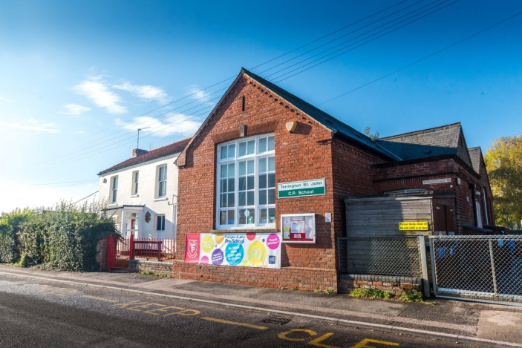
Terrington St. John has 55 pupils currently on roll – split between two classes. The school has a very low number of pupils eligible for the receipt of Free School Meals, with English as an Additional Language or from ethnic minority backgrounds. The school has a slightly lower than national stability factor and a slightly higher than national deprivation indicator.

The latest Ofsted inspection (May, 2017) reflects the journey that the school has been on since it was placed into special measures in April 2013. The report praises outstanding personal development, behaviour and welfare; also celebrating the strength of leadership and the positive relationships between teachers and pupils.

Tilney St. Lawrence Community Primary School

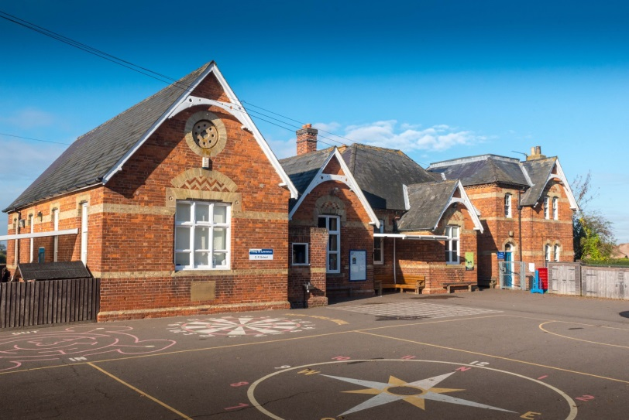
Tilney St. Lawrence has 68 pupils currently on roll – split between three classes. The school has a slightly higher percentage of pupils that are eligible for Free School Meals, when compared with the national figure, and very low numbers of pupils with English as an Additional Language and from ethnic minority backgrounds. The number of pupils with SEND support or with a statement of SEND is in line with national figures. The school has a slightly lower than national stability factor and is in line with the national deprivation indicator.

We are proud that during its most recent Ofsted inspection, in December 2013, the school was judged to be Good in every category.

Walpole Highway Community Primary School

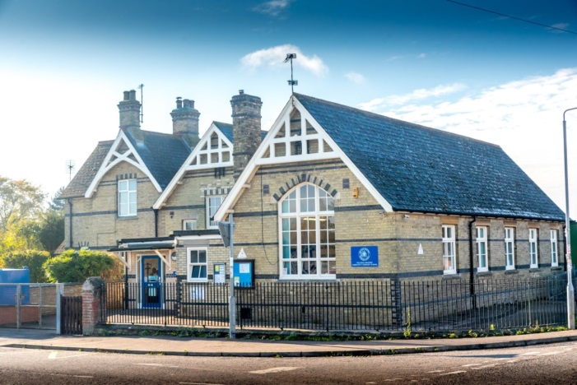
Walpole Highway has 55 pupils currently on roll – split between three classes. The school has a high percentage of pupils that are eligible for Free School Meals and a high percentage of pupils with a statement for SEN. There are no pupils from ethnic minority backgrounds and no pupils with English as an Additional Language. The school has a low stability factor and is in an area of higher than national deprivation.

Although Walpole has previously been placed into Special Measures, huge improvements in the quality of teaching and learning and the outcomes for pupils mean that the most recent inspection, in September 2016, judged that the school Requires Improvement. The school was praised as a result of positive behaviour and the high level of care that is provided for each and every individual in a very nurturing and inclusive environment.

West Walton Community Primary School

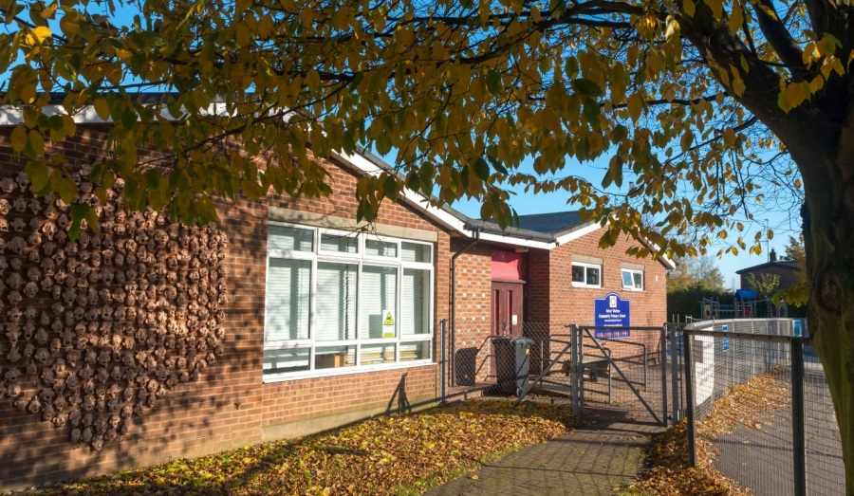
West Walton has 226 pupils currently on roll – split between eight classes, including the onsite nursery. The school has a slightly lower percentage of pupils eligible for Free School Meals, when compared with the national figure, and very low numbers of pupils with English as an Additional Language and coming from ethnic minority backgrounds. The percentage of pupils receiving SEND support is below the national figure. The school has a stability factor and deprivation indicator that are in line with national.

The school received Good judgements, with aspects of Outstanding, for each Ofsted inspection in recent years. This was reaffirmed in March 2016, when the school was once again judged to be Good. Pupil behaviour was praised, along with the school’s determination to foster excellence, through the provision of an enriching curriculum that caters very well for all groups of pupils.

More About Us

Staffing structure

The Executive Headteacher has the overall lead of the four schools. Presently, we are reviewing the middle tier of leadership to maximise the impact upon our pupils. Each school has a Senior Teacher, who supports with behaviour management and the smooth day-to-day running of each school.

Finance

In April 2015, the school budgets joined under a single budget. This decision was taken by the Governing Board to ensure that the budget was maximised and to enable greater flexibility and enhanced continuity when managing the budget across the four schools. In depth budgeting, long term planning and monitoring, completed by the Federation Business Manager, ensures that we continue to manage our finances efficiently and effectively for the benefit of our children. The single budget allows for a creative approach when tackling larger projects across the Federation. Our school finances support the needs of The Windmill Primary Federation at this time.

The Governing Board

Governors are dedicated and committed to working with the leadership team to improve the schools that make up The Windmill Primary Federation. They are frequently represented at staff training sessions and conduct regular and focused monitoring visits. They share the findings of their monitoring and are very clear that they must make every effort to find out information for themselves to evidence school improvement or to identify where improvements need to be made. Governors review their practice regularly and manage their meetings very effectively to allow them to monitor progress against school improvement priorities.

They request presentations by leaders, other than executive leaders, and they ask to see information on assessment to hold the Executive Leadership Team to account regarding the progress made by individuals and groups of learners. They are familiar with published data and regularly review internal data.

What Our Children Love About Our Schools

What we love about Terrington St. John:

- It is a friendly school.
- All of the children and adults are trustworthy.
- We make friends with new people very quickly.
- We welcome new people with open arms.
- We learn lots of new things in a fun way – like history.
- The teachers are friendly, kind and generous.
- We learn lots of new things from our teachers.
- All of the adults in our school make sure we are safe.
- It is a small school and we don’t get lost.
- It is fun.

What we love about Tilney St. Lawrence:

- Other children are there when you need cheering up.
- All of the teachers are friendly.
- The School Council members look out for all of the younger children.
- The whole school community is kind.
- Our school is easy to navigate – it is not too big or too small.
- The staff are kind and helpful.
- We have brilliant teachers that teach us well.
- All of the children that attend the school are good.
- It is a small school that is part of a bigger federation.
- There is always someone that you can talk to.

What we love about Walpole Highway:

- We are like one big, happy family.
- The children at the school make everyone feel welcome.
- We treat other people how we would like to be treated.
- Every day that we come to school, we learn new things.
- All of the children have good friends.
- There is no bullying.
- The staff are always there to help.
- We feel safe all of the time.
- We enjoy being able to go swimming.
- Every day is different and we do lots of fun things.

What we love about West Walton:

- We have great staff, who make learning fun.
- There are a variety of clubs, for example, art, cookery and sport.
- We have a wide selection of apparatus that keeps us entertained at break time.
- We have displays on our walls to share our learning.
- West Walton pupils are kind and focussed.
- The School Council supports different charities and run fundraising events.
- We go on lots of different trips.
- Our lessons are Interesting.
- The school rules are simple and easy to follow.
- Our School Association offer discos and other events that we all enjoy.
- The school is a happy place, where everyone feels safe.

Qualities our children would like to see in their new Assistant Headteacher:

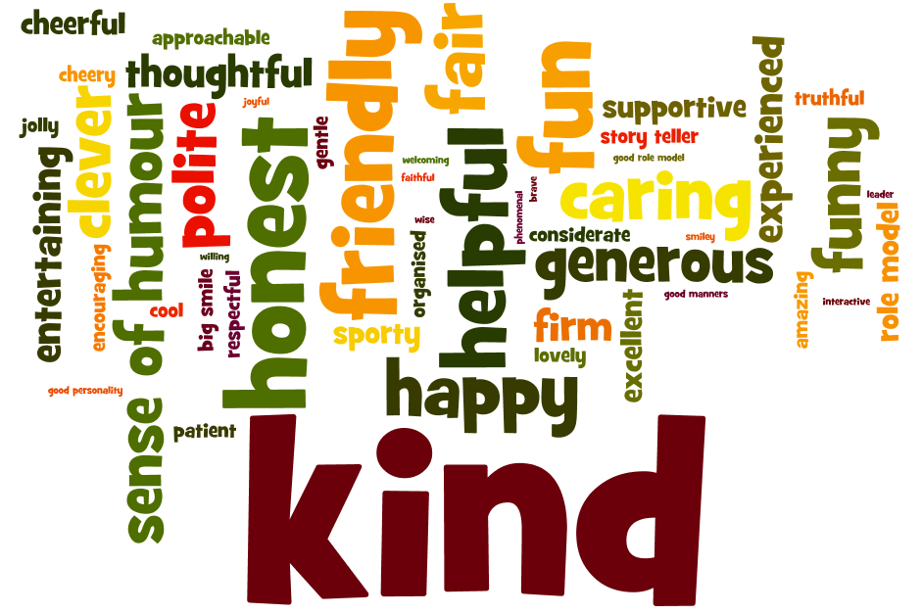

Job Description

Responsible to: Executive Headteacher

Responsible for:
- Coordinating the strategic direction, development and provision of inclusive education within the Federation.
- Collect and analyse data and use information to drive initiatives to improve outcomes for pupils.
- Ensure entitlement and enrichment within the curriculum for all children within the Federation.

Job purpose: The postholder has a key role to play in developing and managing the implementation of the Federation’s Inclusion Policy which includes SEN, disadvantaged and other vulnerable pupils. The role is to oversee the Federation’s inclusive provision and promote approaches that raise the quality and achievements of inclusive education for all pupils.

Strategic direction and development of the Federation
- Work with the Executive Leadership Team to contribute to a strategic view for the Federation in its community; analyse and plan for its future needs and further development within the local, national and international context.
- Demonstrate high standards of personal integrity, loyalty, discretion and professionalism
- Publicly support all decisions of the Executive Headteacher and Governing Body.
- Support inclusion across the Federation.

Main Duties
- Those duties listed in the current Teachers’ Pay and Conditions document.
- Support the vision, ethos and policies of the Federation which secure effective teaching, successful learning and promote high levels of achievement and self-esteem for all pupils irrespective of background, ethnicity, gender and ability.
- Help lead and manage the creation and implementation of the Federation strategic plan which identifies priorities and targets for ensuring pupils achieve high standards and make progress. Take responsibility for appropriately delegated aspects of it, in the first instance SEN and disadvantaged pupils.
- Support the Executive Headteacher in increasing teachers’ effectiveness and securing school improvement through modelling and coaching.
- To oversee and monitor delivery against EHC Plans and chair all annual reviews.
- To coordinate all intervention programmes for pupils with additional needs and oversee liaison with other agencies related to learning interventions.
- Formulate and present school policies and documentation relating to Inclusion to relevant parties including governors, parents, teachers and the community.

- Ensure the effective and proficient use of pupil data from a variety of sources both internal and external in the process of target setting.
- Liaise and coordinate the contribution of external agencies.
- Assist in the monitoring and evaluation of the effectiveness of teaching and learning and quality assure the SEN, EAL provision across the Federation through a programme of learning walks, book monitoring and student voice.
- Liaise with Pastoral Assistant Head where behaviour, attendance or safeguarding issues are barriers to learning to find ways to improve pupil outcomes.
- Monitor the outcomes and impact of Pupil Surgeries.
- Be a member of the Senior Leadership Team.

Teaching and Learning
- Identify and model the most effective teaching approaches for pupils with SEN/EAL and PP.
- Monitor teaching and learning activities to ensure they meet the needs of pupils with SEN and disadvantaged pupils.
- Identify and teach skills that will develop pupils’ ability to work independently.
- Develop effective liaison with other schools to ensure continuity of support and learning when transferring children with additional needs.
- Develop and maintain systems of monitoring and recording pupil progress in relation to targets set and in line with the Federation policy.
- Attend parent evenings, keep parents informed about their child’s progress and ensure positive working relationships with parents to promote pupils’ learning.

Recording and Assessment
- Set targets for raising achievement among pupils with SEN, EAL and PP and any other identified group.
- Set up and maintain efficient systems for identifying, assessing and reviewing pupils with SEN/EAL needs and any other identified group including PP.
- Update the Executive Headteacher and Governing Body on the effectiveness of provision for pupils with SEN and disadvantaged pupils.
- Develop others’ understanding of learning needs and the importance of raising achievement among all pupils.

Leadership
- Contribute to school self-evaluation and the strategic direction of the Federation as a member of the Senior Leadership Team.
- Encourage all members of staff to recognise and fulfil their statutory responsibilities to pupils with SEN/EAL needs and other identified groups including Pupil Premium.
- Provide training opportunities for colleagues and disseminate best practice in meeting SEN, disadvantaged and other vulnerable group.
- Line-manage a team of support staff to ensure effective intervention with SEN/EAL needs.

- Monitor the effective use of resources needed to meet the pupils with SEN/disadvantaged pupils, and advise the Executive Headteacher of priorities for expenditure.
- Lead on the implementation of statutory policies as required.
- Monitor the outcomes and impact of Pupil Surgeries.

Standards and Quality Assurance
- Contribute to the development of a positive inclusive ethos.
- Set a good example in terms of dress, punctuality and attendance.
- Attend and participate in parents’ evenings.
- Uphold the Federation’s behaviour code and uniform regulations.
- Participate in staff training and lead training where appropriate.
- Attend team and staff meetings and lead where appropriate.
- Develop links with governors, local authority and neighbouring schools.
- Able to think creatively and generate solutions to problems.
- Set high expectations and standards for self and others.
- Able to adapt to changing circumstances and needs.
- Able to reflect constructively on practice and manage change.
- Able to motivate others to seek improvement.
- Able to remain calm and positive under pressure
- Willing to contribute to whole school development
- Sensitive to the needs of others; a supportive colleague.
- Be aware of and uphold, appropriate levels of confidentiality at all times.

Other duties and responsibilities
Act up in the absence of the Executive Headteacher for short periods of time as and when required.

Person Specification

This document identifies the criteria against which the selection panel will assess each applicant using the following assessment tools: application form; interview and selection activities; references and other employment checks.

Qualifications | Essential or Desirable | Determined by
 |  | Application | Interview | Reference
Completed training with primary age range/QTS at graduate level. DfES reference number. | E | X
Competent use of ICT. | E | X | X
National Award for SEND or willingness to complete the qualification. | E | X | X
Continued training relevant to primary sector. | E | X
Further professional study related to SEND/disadvantaged pupils. | D | X
Led INSET and given effective presentations. | D | X | X
Leadership
Excellent ability to lead and work within a team. | E | X | X | X
Effective organisational, interpersonal and communication skills. | E | X | X | X
An ability to inspire, motivate and support the development of a range of adults and children. | E | X | X | X
Skills required to develop use of ICT as a tool for record keeping and measuring progress. | E | X | X
Knowledge
Good knowledge required of SEND code of practice, assessments and referral procedures to develop Inclusion across the school. | E | X | X
Knowledge of recent developments in primary education and curriculum. | E | X | X
Knowledge of National Curriculum and assessment arrangements. | E | X | X

Experience
Evidence of substantial, excellent, successful classroom teaching across the primary age range. | E |  | X
An ability to plan and provide a high quality learning environment in order to raise achievement and ensure pupil progress. | E | X | X | X
Experience of working with a range of agencies. | E |  | X | X
Curriculum leadership experience and setting targets to measure progress. | E |  | X
Management experience. | D | X | X
Evidence of experience in formulating, implementing school improvements/initiatives. | D | X | X
Experience of small schools and mixed age teaching. | D | X
Motivation and Personal Qualities
Commitment to Equal opportunities. | E | X | X
Commitment to working effectively with parents and carers and the wider communities. | E | X | X
Have a strong commitment to promoting and assisting in the strategic direction and leadership of the Federation. | E | X | X
High expectations of pupil’s achievement/ability to raise outcomes for all pupils. | E | X | X | X
Additional Comments
As a member of the leadership team the following qualities are essential.  - Energy and enthusiasm  - A positive, consistent approach  - Flexibility  - Sense of humour | E | X | X | X

The Local Area

Wisbech

Wisbech, the Capital of the Fens, is renowned for its elegant Georgian architecture, a legacy from an era when the town was a booming trade centre. Stroll along the Brinks or around the Crescent to see fine examples of Georgian houses. Wisbech also boasts one of the oldest surviving Georgian Theatres in the country. The Angles Theatre, which has just 112 seats, offers a variety of drama, dance and music performances in a cosy space.

King’s Lynn

Brim full of history and with a vibrant town centre, King’s Lynn offers a superb mix of history, shopping and entertainment.

The Hanseatic town of King’s Lynn was one of England’s most important ports from as early as the 12th century and this maritime past is still very much in evidence today. Fine old merchants’ houses stretch down to the river between cobbled lanes and the elegant Custom House overlooks the harbour. The town’s heritage is reflected in an amazing array of historic buildings and at two magnificent market places: The Saturday Market Place, where St Margaret’s Church is surrounded by splendid buildings and The Tuesday Market Place, quite possibly one of England’s grandest squares.

King’s Lynn offers a fine programme of cultural and entertainment events and facilities including impressive live entertainment at the Corn Exchange, performances and special events at the King’s Lynn Arts Centre and the Majestic Cinema. The renowned King’s Lynn Festival and popular free festival ‘Festival Too’ are just some of the great annual events in this festival town. The town’s added sports and leisure facilities and its award winning park and gardens all add to the experience that locals can enjoy.

King’s Lynn’s popular town centre offers an extensive pedestrianised shopping area with ample parking close by. The Vancouver Quarter offers a modern shopping experience that sits well next to the traditional shopping areas of the town and is complemented by the regular markets which take place in its two historic market places.

The Countryside around the Fens

The Fens is an area of around 200 square miles of extremely flat, mostly agricultural land, west and south of The Wash. The Fens is an area renowned for its wildlife, quiet roads, perfect for cycling, and extensive network of rivers and dykes.

