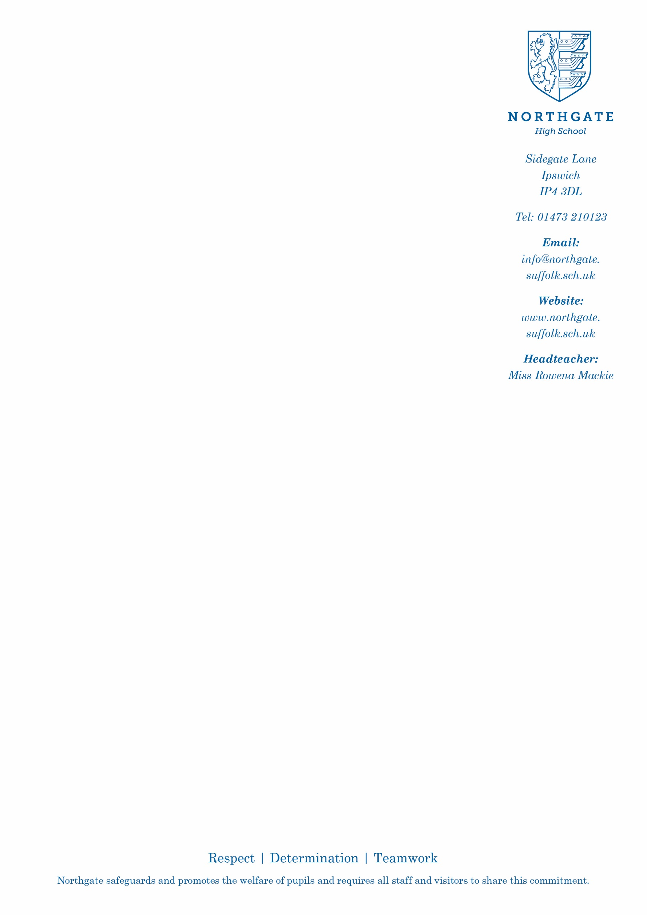
January 2022
Dear Colleague
Re: Assistant Headteacher Learning Support, Leadership Range L12 to L16
Thank you for your interest in Northgate High School’s Assistant Headteacher Learning Support post.
I am excited by the prospect of welcoming a new colleague into our leadership team to take oversight of Learning Support and Attendance – two key areas of school life that, when right, ensure young people leave us with the skills and confidence to pursue their future individual pathways. To help you to find out a little more about the role, and the characteristics I am seeking in the successful candidate, you will find a Job Overview and Person Specification that you can readily download, along with an application form, on our website.
The Senior Leadership Team works collaboratively and with passion to provide the best for our students and our staff. It is vital that you are able to work effectively as part of a team and that you have the confidence, experience and knowledge to contribute to the work of the Senior Team in our collective undertaking to provide high quality education, care and staff support as standard in our school. If you believe that you have the requisite skills and abilities to undertake this senior post, I hope that you will feel excited by the prospect of working at Northgate. If so, before completing your application please contact Trish Finch, my Personal Assistant, to obtain a further document that will provide you with additional information about the school’s strategic vision. When making this request I ask that you respect the sensitivity of the information contained within this document.
When completing your application form and writing your accompanying letter of application, which should be no longer than two sides of A4, font size 12, please illustrate that you have the qualities needed to successfully undertake the roles described in the job overview and that you fulfil the personal requirements outlined in the person specification. For the right candidate, we will support any additional training and development that you need to enable you to carry out this key role effectively and successfully. The email address to return completed documents is adverts@northgate.suffolk.sch.uk
I will send short-listed candidates further, relevant information to support the interview process closer to the time. Please be aware that we have scheduled interviews to take place during the week beginning Monday, 7 February. Following this, some candidates will be invited back for a second selection day.
Once again thank you for your interest in our post. I look forward to hearing from you.
Yours sincerely
Miss R Mackie
Headteacher

