**Shipston High School**

**___________________________**

***High achieving - Student-centred***



**Assistant Headteacher: Pastoral**

***Attendance, behaviour & safeguarding***

**Candidate Information Brief**

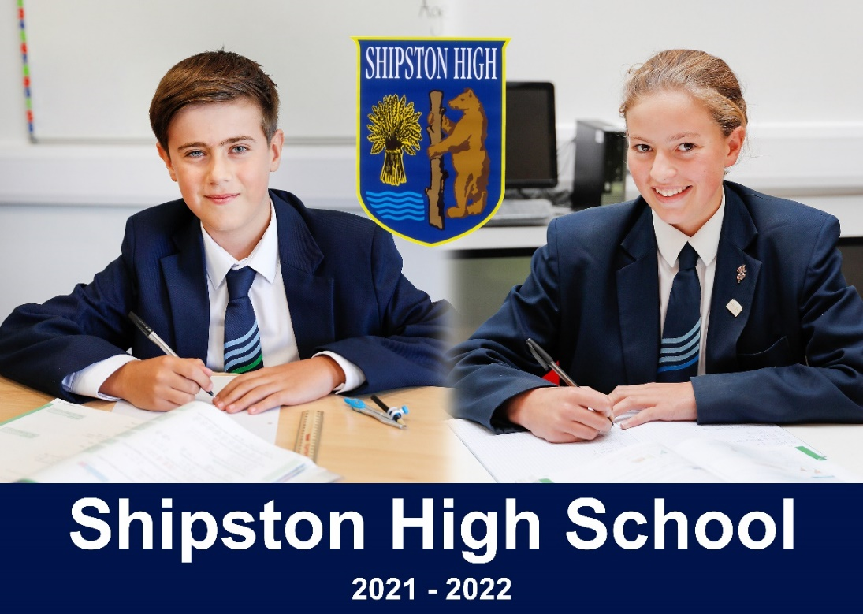

**Darlingscote Road**

**Shipston on Stour**

**CV36 4DY**

**01608 661833** [**www.shipstonhigh.co.uk**](http://www.shipstonhigh.co.uk)

June 2023

Dear Candidate,

**Post of Assistant Headteacher: Pastoral**

Thank you for your interest in this post. Shipston High School is a fantastic place to work, and I very much hope that you will wish to apply for this exciting job opportunity. The assistant headteacher post is a full time, permanent post. It has arisen at an exciting time for the school and reflects our very deliberate focus on pastoral care as central to securing progress for pupils.

Shipston High School has a unique atmosphere, arising from our high expectations and our student-centred ethos. It is an ethos in which our teachers are able to focus on the wellbeing and academic progress of our young people. As a result, both students and teachers flourish. This post offers the successful candidate an exceptional opportunity for career development and will be of interest to colleagues seeking a whole school leadership role.

In our search for an outstanding practitioner we are seeking a leader with a commitment to academic excellence and high classroom standards. The successful applicant will have a good knowledge and understanding of pastoral matters and will be able to demonstrate excellent practice. A specific teaching subject is not designated for this role, but the successful candidate can expect an appropriate teaching timetable. The person appointed will have a significant part to play in the school’s development, and will be the lead for pastoral matters in the school and a fully contributing member of the senior team. The successful candidate will be the school’s Designated Senior Lead (DSL) for safeguarding.

Safeguarding, behaviour for learning and attendance are important to all stakeholders at Shipston High School. The dedicated pastoral team are highly effective practitioners and are well supported by staff and respected by students.

This is a hugely exciting time for the school. At this point of significant national change in education, we are highly ambitious for our students and we recognise that our staff are essential to their success. Examination results and student destinations are consistently impressive and, as a result, the school is regularly oversubscribed.

Our students are our best advertisement. They are motivated, hardworking and well behaved. In March 2018, Ofsted noted that ‘pupils are a credit’ to the school, describing their conduct as ‘commendable’ and ‘unfailingly polite’.

This is a specific role. However, we will include the successful candidate in reviewing the precise details of the role upon appointment, dependent on the skills of the appointee.

For an informal, confidential discussion about the post or to arrange a visit please contact the Headteacher’s Secretary on 01608 661833 or at [apunt@shipstonhigh.co.uk](mailto:apunt@shipstonhigh.co.uk). Visits to the school are encouraged, and you will be most welcome. I wish you all the best with your application and very much look forward to hearing from you.

Yours sincerely,

Gavin Saunders

Headteacher

**INFORMATION ABOUT APPLYING FOR THE POST**

Please complete an application form and forward it by post or e-mail to Paul Hunt, Business Manager, at HAYS Recruitment:

Address: 3rd Floor

1 Colmore Square

Birmingham

B4 6AJ

Telephone: 0121 236 4476

Email: shipstonhigh@hays.com

Further information about the post and an application form are available from HAYS Recruitment and are also on the school’s own website.

In your application please indicate (no more than 2 sides of A4) how you feel your experience to date has prepared you for this post and what strengths you feel you could offer the school. Please include specific examples of where your work has supported pupils and their access to the curriculum.

The closing date for applications is 9.00 a.m. on 26th June 2023 with interviews planned for shortly afterwards.

**INFORMATION ABOUT THE PASTORAL TEAM**

Pastoral care is an important part of our student centred ethos. As a school, we know that students who feel supported and secure in school will be able to access the curriculum and focus on their academic progress. The team work hard to care for the needs of our students to ensure that they have a strong foundation for future learning and are able to access the next steps in their education and careers.

The pastoral team is lively, enterprising and collaborative. The school runs a house system where all students belong to a form group allocated to one of our four houses, named Badger, Hart, Mayo and Sheldon. Form groups are year group specific, with all year groups represented in each house.

Each house is managed by a Head of House (HoH) who is responsible for the pastoral care of the students in their house, and this team will be led and managed by the successful candidate. Currently, two HoH colleagues are teachers with timetables, and two are non-teaching staff. All are skilled and dedicated pastoral professionals.

The school safeguarding team includes pastoral colleagues, plus both our SENCO and student services manager and a member of the PE teaching team. We are currently recruiting a Child Protection Officer for September 2023 to be the key manager of safeguarding in the school. All staff in the school receive regular safeguarding training, often led internally by the DSL.

The majority of teaching staff are form tutors. The team of tutors for each house work closely with the Heads of House in supporting pastoral activities and being alert to safeguarding. The school assembly rota, overseen by the senior leader for pastoral, involves pastoral and senior staff in delivering a planned program of house assemblies. Assemblies enable reflection on a range of issues and promote the ethos and values of the school.

The team is always keen to try new resources and ideas, constantly striving to improve the quality of care and the learning experience the pupils at Shipston High receive. The team regularly work with outside agencies and colleagues from other institutions to further assist students’ success.

The team share ideas and resources regularly and understand the importance of collaborative working. This includes close relationships with the Learning Support Department, and our inclusion colleagues. The team provide also support students who experience a range of barriers to learning, including emotional and mental health related matters.

The pastoral team are active, effective, and important to the school. The current team are strong practitioners of impressive commitment. Students trust and respect the care they receive. This vacancy is a unique career opportunity for the right candidate.

**INFORMATION ABOUT THE SENIOR TEAM**

The senior leadership team at Shipston High School is constructed as follows:

* Head teacher
* Deputy Head teacher (Curriculum)
* Assistant Head teacher (Teaching & Learning)
* Assistant Head teacher (Pastoral) (*the advertised vacancy)*
* School Business Manager

Whilst each member of the team has distinct expertise and responsibilities, there are common features for all. For example, all members of the team line manage one or more subject areas or support teams and are involved in appraisal and quality assurance monitoring.

As a team we work collaboratively, all taking part in strategic planning and discussing whole school issues. The team are supportive of each other and work together on projects where appropriate. We are forward thinking and ambitious for our school. The team are strategic in vision whilst retaining a student centred connection with daily issues in the school.

The head teacher regularly meets senior colleagues individually to plan and stay informed of developments across the school. The team meet together for a senior meeting once each week, and schedule longer planning days throughout the year.

SLT members each have key delegated responsibilities for which they are both accountable and entrusted to fulfill; we work together to fulfill our student centred ethos.

The team are well supported by the governing body. Link governors liaise with staff on priority areas, and senior staff attend main governors’ and subcommittee meetings to present the school’s progress on relevant points from the annual School Development Plan. There are three subcommittees which meet each term on Resources, Teaching and Learning and Pastoral matters.

|  |  |
| --- | --- |
| **SHIPSTON HIGH SCHOOL**  **JOB DESCRIPTION**  **POST: Assistant Headteacher - Pastoral** | |
| Post Title: | Deputy Headteacher - Pastoral |
| Purpose: | To raise standards of pupil attainment and achievement through the leadership and development of pastoral care. |
| Reporting to: | Headteacher |
| Core tasks and responsibilities (in addition to those of a classroom teacher):   * To be responsible for leading and developing the school’s pastoral, well being and safeguarding systems. * To be responsible for leading and developing systems to enable pupil progress. * To develop the school towards the ‘Outstanding‘ criteria as defined by the most recent OFSTED inspection framework. * The role will be characterised by priority setting, leadership, oversight, monitoring and evaluation. * To actively promote and model the values of the school * To deputise for the Headteacher and Deputy Headteacher as required | |
| Strategic Direction and Development: | * To identify school priorities. * To implement School Policies and Procedures. * Contribute to school development planning and evaluation. |
| Pupil achievement: | To utilise academic, attitude to learning and attendance data in order to support the personal and academic development of students.  To ensure the highest standard of behaviour within the school through a structured system of behaviour management.  Monitor and develop pupil achievement via line management of specified teams. |
| Leading and Managing | * Lead and develop the pastoral team – heads of house, pastoral support staff and form tutors * Chair heads of house & pastoral meetings. Lead the agenda to ensure a focus on well being and pupil progress. * Advise the senior team on any training needs resulting from pastoral development. * Lead Inset as appropriate * Lead and develop effective communication for all stakeholders on pastoral matters * Keep the Headteacher regularly advised on pastoral developments and legal requirements pertaining to pastoral care. * Advise the Headteacher on the staffing implications of pastoral planning. * To lead and monitor all school uniform and dress regulations * Lead and develop, with senior colleagues, data systems related to pupil engagement * To lead the school’s assembly program * To lead and develop transition systems for each key stage |
| Safeguarding | * Undertake all the responsibilities of a Designated Senior Lead (DSL) for safeguarding in the school * Oversee the appropriate safeguarding training and annual updates for all staff. Keep up to date records of the training. * Ensure compliance with current safeguarding regulations, guidance and best practice * Establish a caring and nurturing culture of safeguarding in which pupils feel confident to talk to someone if they have a problem and where staff feel able to pass on any safeguarding concerns * Maintain up to date records of pupils requiring support, including CLA and those on the child protection register |
| Behaviour & wellbeing | * Lead all systems related to pupil wellbeing * Lead and develop systems for behaviour management * Lead and manage the provision of daily duty teams * Lead liaison with relevant external agencies and partners * Lead liaison for managed moves and exclusions |
| DAFT s heaant head?)ransition systems for each key stage pastoral mattersect The post holder will be subject to appraisal objectives which will be agreed and reviewed annually. The post holder is expected to carry out such other duties as may reasonably be assigned by the Headteacher. | |

**SHIPSTON HIGH SCHOOL**

**PERSON SPECIFICATION**

**POST: Assistant Headteacher – Pastoral**

|  |  |  |
| --- | --- | --- |
| **Factor** | **Essential** | **Desirable** |
| 1. **SKILLS, KNOWLEDGE AND APTITUDES** | * A clear understanding of the role of the pastoral team in raising standards of achievement * Excellent organisational and communication skills * Effective record keeping practices * Ability to relate well to students in teaching and pastoral roles | * Experience of working with changing roles and circumstances * Awareness of a range of approaches to managing pastoral and raising achievement agendas. |
| **2. QUALIFICATIONS AND TRAINING** | * A degree or equivalent * Qualified Teacher Status * A professional development record including a focus on pastoral and management issues | * Evidence of further study * Evidence of working as a reflective practitioner, using a variety of approaches to secure ongoing professional development * DSL Safeguarding Training |
| **3. EXPERIENCE** | * Evidence of a long term interest in pastoral work * Evidence of leadership and teamwork activities * Experience of working with external agencies * Good track record of teaching at secondary level * Working in partnership with parents * Experience of analysing and interpreting data to ensure effective student outcomes * Experience supporting whole-school behaviour management and tutor teams and/or anti-bullying and/or student leadership outside the classroom setting * Experience of successfully developing and implementing whole-school strategies in an aspect directly relevant to this role e.g. whole-school behaviour management, sanctions and rewards policies, Tutor Time programs, student leadership, anti-bullying, effective academic mentoring strategies etc. | * Experience of day to day operational management responsibility for the work of other staff * Experience of leadership/management in a school e.g. Head of Year, Head of Department, Inclusion & Behaviour Manager * Demonstrable evidence of innovating and adapting curriculum to engage children and enable them to reach their potential * Experience of activities designed to improve attendance, behaviour and/pastoral care * Experience of investigating and applying fixed term or permanent exclusions. |
| **4. PERSONAL QUALITIES** | * Ability to respond consistently and professionally to challenging behaviour of all kinds * Resilience * A sense of humour * Commitment to success in education * Good team worker * Prepared to accept responsibility and take initiative * Good organisational skills * Ability to form and maintain appropriate relationships and personal boundaries with students | * An interest in and commitment to, the whole school community * Ability to motivate students * Highly motivated and enthusiastic * A positive response to approaching change and tackling new challenges. |
|  |  |  |

## INFORMATION ABOUT THE SCHOOL

Shipston High School is a non-selective 11-16 mixed High School with a very special ethos and character. Our students are high achieving and increasingly successful. The school itself is located on an attractive site on the outskirts of Shipston-on-Stour in South Warwickshire. Our buildings are spacious and offer a wealth of specialist and general accommodation. Significant development of the site saw a first phase of new classrooms open in 2015, with a further teaching and reception block completed in the summer of 2018.

Visitors frequently remark on the distinctive ethos of Shipston High School. In particular, they praise the obvious energy and enthusiasm of staff and students, the excellent relations, and the happy and mutually respectful atmosphere. They also express admiration for the unusual confidence and maturity of our students and the way they rise to the challenge of taking on increasing levels of responsibility.

### Some recent highlights

* The school has year on year been improving its examination results. In our most recent (2022) results over 74 % of students achieved standard passes in both Maths and English. Our increasing proportion of extremely able students has led to a rising proportion of GCSE passes at the very top grades of 7, 8 and 9; over 25 % of the cohort in Maths and English.
* In our 2018 Ofsted inspection the school was judged to be good overall with our students seen as ‘a credit’ to the school.
* The school has achieved positive progress 8 outcomes in the majority of years this measure has been active.
* Owing to its continuing success the school has become increasingly popular and is now regularly oversubscribed. Numbers on roll are rising. We currently have nearly 600 students in the school but plan to expand over the forthcoming few years.
* The school became a new Academy on 1st September 2012 and has developed an imaginative and ambitious project to redevelop the entire school in phases. The first phase, a new £1.6M state-of-the-art teaching block, opened in September 2015, with the second £2.25M building opened in the summer of 2018. A further £10.5 million investment has recently been confirmed and is due to commence this year.

**Teaching and Learning**

We put learning at the heart of everything we do. Staff have high expectations of all students, whatever their backgrounds or abilities, and we expect students to make the most of the many opportunities the school provides. Class sizes are kept as small as possible so that we cater effectively for every student’s needs. We believe firmly in the importance of academic work and independent study as important to help our students become successful, self-motivated learners.

#### Resources for Learning

The range and quality of our facilities ensure that teaching and learning is varied, interesting and successful. ICT facilities throughout the school have been increased and upgraded significantly during recent years.

All classrooms are equipped with audio visual technology; our students are learning in high quality, well-equipped subject environments.

*The teaching was most enthusiastic and drew interested and involved responses from the students. The oral responses were particularly impressive. How well (the teachers) know their classes!*

*Visiting Governor*

#### The School Curriculum

All National Curriculum subjects are taught through both Key Stages 3 and 4. Students are initially grouped by ability in most subjects at Key Stage 3. At Key Stage 4 all students follow a core curriculum and then choose from a wide range of options. The curriculum is robust, and fulfills national accountability measures whilst enabling a personalised program for our learners.

### Pastoral Care and Guidance

All students are expected to meet the very high standards of behaviour required of them. There is a very experienced pastoral team based on a House system that looks after the needs of all our students. We also rely on the support of parents to maintain our high standards.

We place a strong emphasis on establishing a caring community that encourages growth and confidence in all our students. Each student is assigned to a form and a form tutor whose purpose is to enable youngsters to obtain the best out of all aspects of the school life. The positive relationships that exist with our partner primary schools ensures that we have detailed information about students as they transfer at 11 years old.

During Years 10 and 11 students are encouraged to take on leadership roles by applying to become school prefects. They take on responsible duties and are expected to use their own initiative in helping with the day-to-day running of the school. Senior prefects are appointed annually.

#### Celebrating Achievement

Our school is founded on the belief that all students have talents and can achieve. We make it our mission to bring out the talents of our individual students and to celebrate their endeavour and successes at all levels. The school takes a proactive stance with regard to rewarding students for good behaviour, achievement, motivation and service to the school and wider community. Our system of rewards is designed to encourage positive attitudes above and beyond normal working expectations. Some examples of the many ways that we reward achievement include:

* Individual praise
* The award of merit points
* Letters, postcards and certificates sent home
* Celebration in House and whole school assemblies
* Special, end of term “Celebration Assemblies”
* Letter of commendation from the Headteacher
* The “Shipston Award” scheme
* An award at our annual Awards Evening when students receive public recognition for their efforts and achievements

### Extra curricular Activities

A wide range of opportunities exist for the students to be involved in sporting, dramatic, computing and musical activities. Our student participation rate is exceptionally high. We regularly compete on the sports field with neighbouring schools and youngsters are involved both locally and with county teams. We have staged many dramatic productions of varying types, along with regular music concerts. Opportunities also exist for students to take part in a wide range of educational visits ranging from local to international locations.

*From the first telephone conversation to your school we were met with the utmost courtesy and attention and the boys who showed us round are to be particularly commended. They were truly ambassadors to your school and their knowledge, interest and enthusiasm for the school was clearly obvious to see. The comment from our son afterwards was that Shipston High School was his number one choice.*

*Prospective parent visiting the school*

### Communication with Parents

We are keen to see parents involved in helping their youngsters to learn. Much of this contact is achieved as issues arise. On a more formal level, regular consultation sessions take place including termly reports home.

### Post 16 Destinations

On completion of their GCSEs the significant majority of our students leave school to follow a wide range of A level and other post 16 courses at local sixth form centres and colleges. Many then go on to university and higher education in order to enter a wide range of professions and careers.

**Our Vision & Mission**

**Mission**

The mission of Shipston High School is to prepare young people to play an active part in society by providing them with the exceptional skills, qualifications and attitudes that will benefit themselves and others, locally, nationally and internationally.

Our mission: High Achieving – Student Centred

**Values**

Learning

Respect

Ambition

Achievement

**Vision**

**A school offering an outstanding education where:**

All students make exceptional progress, becoming fully equipped for life; professionally, personally and as members of the community.

Our vision is for a school that is:

**Growing** – As a school of good reputation in a thriving area, we will provide sufficient capacity to meet local needs (forecast to be 650 places by 2021); enhancing both our school and the local community.

**Outward facing** – We will collaborate widely and openly with schools and community partners to develop our provision and share our expertise.

**Modern** – Shipston High School will develop its physical environment to provide a contemporary and relevant resource for the community; a 21st century learning space.

**Exceptional** – Targeting excellence in all aspects of school provision, to provide an outstanding education for our students.

*Shipston High School’s vision is enabled by clear strategic direction and detailed development planning.*

**Strategic Direction**

To achieve our vision, we will prioritise:

* Developing high-quality learning and teaching to raise standards for all pupils
* Enhancing pastoral systems to support all pupils
* Strengthening character for all pupils through the school values
* Maintaining a broad, balanced and contemporary curriculum
* Securing a financially sustainable future
* Improving the school site to provide state of the art accommodation
* Increasing the capacity of the school to serve the growing community
* Developing leadership at all levels
* Achieving outstanding governance

**SHIPSTON HIGH SCHOOL’S SAFE RECRUITMENT PROCEDURE**

Shipston High School is committed to safeguarding and promoting the welfare of children and young people and expects all staff and volunteers to share this commitment.

**Disclosure**

Shipston High School requires all employees to undertake an enhanced DBS check. You are required, before appointment, to disclose any unspent conviction, cautions, reprimands or warnings under the Rehabilitation of Offenders Act 1974 (Exceptions) Order 1975.

Non-disclosure may lead to termination of employment. However, disclosure of a criminal background will not necessarily debar you from employment – this will depend upon the nature of the offence(s) and when they occurred.

**Shortlisting**

Only those candidates meeting the right criteria will be taken forward for interview.

**Interview**

1. Shortlisted candidates will be subject to an in-depth interview process including a lesson observation
2. Candidates will be asked to address any discrepancies, anomalies or gaps in their application form

**Reference checking**

References from the previous and current employer will be taken up for shortlisted candidates, and where necessary employers may be contacted to gather further information.

**Probation**

All new staff will be subject to a probation period of three months (which may, in certain circumstances, be extended by up to a further three months). The probation period is a trial period to enable the assessment of an employee’s suitability for the job for which they have been employed. It provides the school with the opportunity to monitor and review the performance of new staff in relation to various areas, but also in terms of their commitment to safeguarding and relationships with students.